Module 2: Excel Data Analysis Techniques

Dataset Example
The following dataset represents sales data used for Excel analysis.
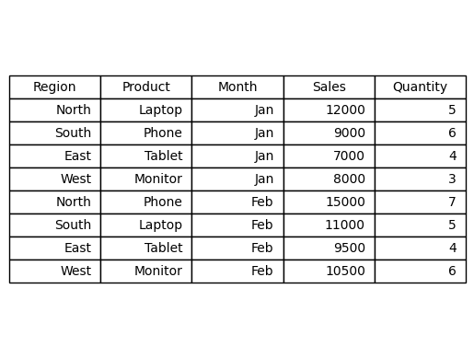

Data Formatting in Excel
Formatting helps make datasets easier to read and analyze. Common formatting techniques include currency formatting, percentage formatting, and highlighting important values. Proper formatting improves readability and prevents errors during analysis.

Sorting and Filtering
Sorting organizes data in ascending or descending order. Filtering allows analysts to display only selected records. For example, an analyst may filter the dataset to show only North region sales.

Conditional Formatting
Conditional formatting automatically changes the appearance of cells based on conditions. For example, sales above 10000 can be highlighted to identify high performing regions.

SUM Function
The SUM function calculates the total of numbers in a range.
Formula: =SUM(E2:E9)
Use case: Calculate total revenue.
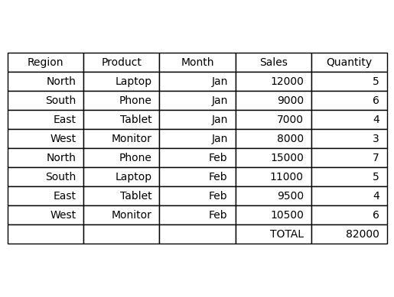
Advantages:
- Quickly calculates totals
- Useful for financial and sales analysis
Disadvantages:
- Incorrect ranges may produce errors

IF Function
The IF function performs logical tests and returns values depending on conditions.
Example formula: =IF(E2>10000,"High Sales","Low Sales")
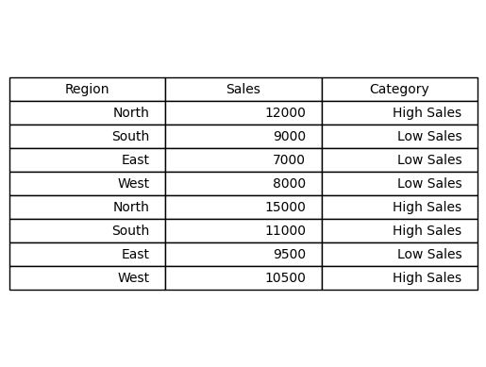

Lookup Functions
Lookup functions are used to retrieve data from tables.
VLOOKUP:
Formula: =VLOOKUP(A2,Sheet2!A:B,2,FALSE)
Used to search values in vertical tables.
INDEX MATCH:
Formula: =INDEX(B2:B10,MATCH(E2,A2:A10,0))
More flexible than VLOOKUP.
Advantages:
- Helps retrieve data quickly
Disadvantages:
- Incorrect references lead to errors

Pivot Tables
Pivot tables summarize large datasets quickly. Analysts use pivot tables to calculate totals, averages, and counts across categories.
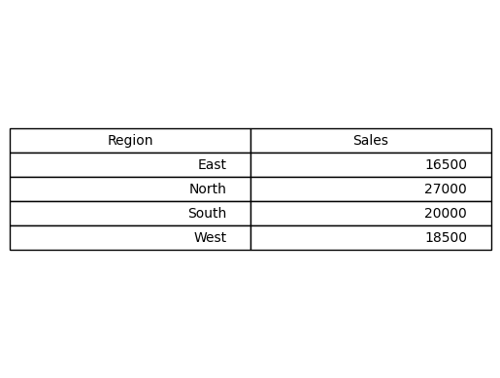
Advantages:
- Quick summarization
- Interactive analysis
Disadvantages:
- Requires structured data
- Beginners may find configuration complex

Charts and Data Visualization
Charts convert data into visual insights.

Bar Chart
Best used for comparing categories such as sales by region.
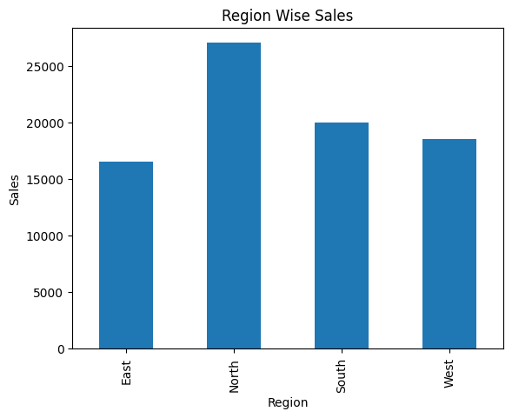

Line Chart
Best used for trends over time.
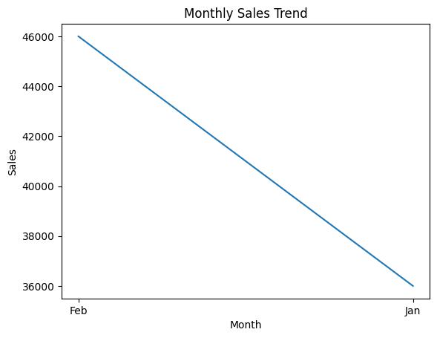

Pie Chart
Used to show proportions of a whole.
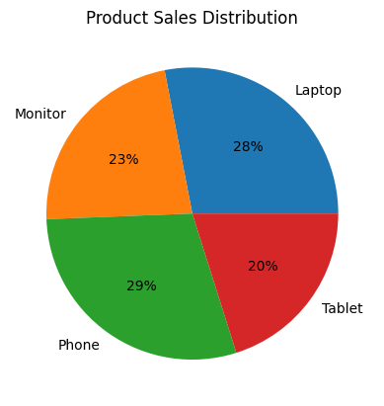
Advantages of Charts:
- Easy to understand
- Helps identify patterns quickly
Disadvantages:
- Too many charts can confuse users

Mini Dashboards
A dashboard combines charts, pivot tables, and slicers on one page. It allows decision makers to monitor key performance indicators quickly.
Typical dashboard components:
- KPI metrics
- Region sales chart
- Monthly trend
- Product performance chart

