SQL for Data Analytics – Core Concepts and Queries

Introduction to Databases
A database is an organized collection of data that can be stored, managed, and accessed electronically. Databases allow organizations to store large amounts of structured data such as customer records, sales transactions, and inventory details.

Tables, Rows, and Columns
In relational databases, data is stored in tables. Each table consists of rows and columns.
• Table – collection of related data
• Row – a single record
• Column – a specific attribute of the record
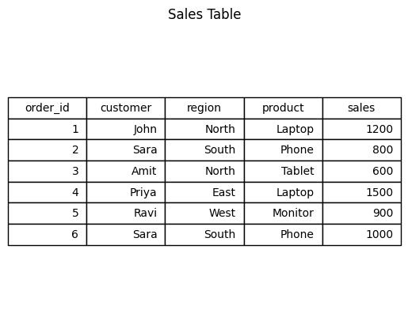

Basic SQL Queries

SELECT Statement
Retrieve all data from a table.
SELECT * FROM sales;

WHERE Clause
Filter records based on conditions.
SELECT * FROM sales WHERE region = 'North';
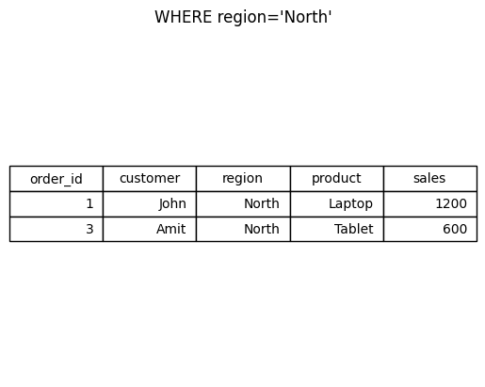

ORDER BY
Sort results in ascending or descending order.
SELECT * FROM sales ORDER BY sales DESC;
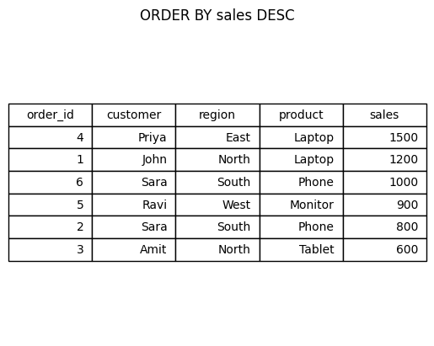

GROUP BY and HAVING
GROUP BY aggregates data by categories.
SELECT region, SUM(sales) FROM sales GROUP BY region;
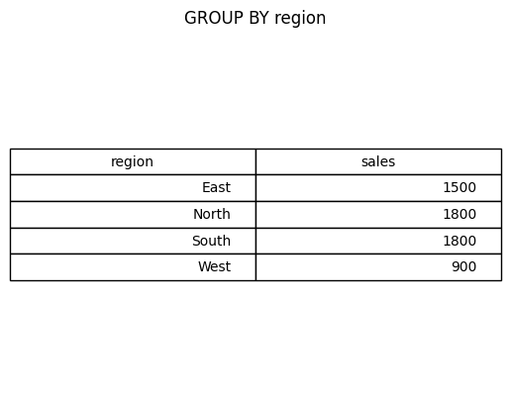
HAVING filters aggregated results.
SELECT region, SUM(sales) FROM sales GROUP BY region HAVING SUM(sales) > 1000;
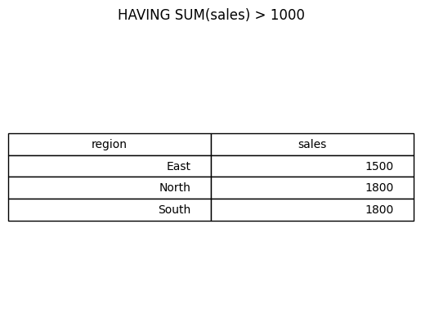

JOIN Operations
JOINs combine data from multiple tables.
INNER JOIN returns matching rows in both tables.
SELECT c.name, o.order_id, o.amount FROM customers c INNER JOIN orders o ON c.customer_id = o.customer_id;
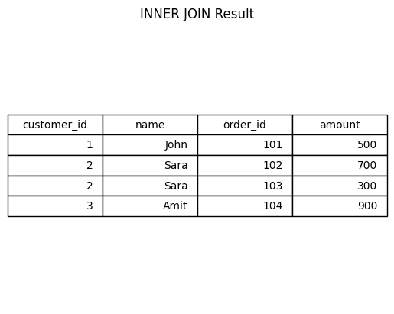
LEFT JOIN returns all rows from the left table and matching rows from the right.
SELECT c.name, o.order_id FROM customers c LEFT JOIN orders o ON c.customer_id = o.customer_id;
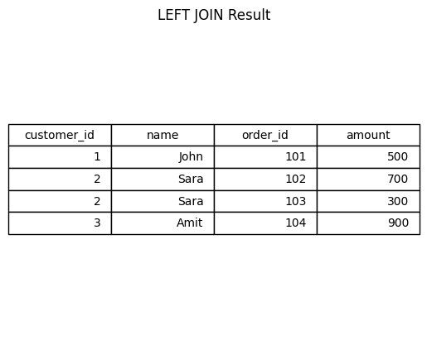
RIGHT JOIN returns all rows from the right table and matching rows from the left table.

Subqueries
A subquery is a query nested inside another query.
Example:
SELECT * FROM sales WHERE sales > (SELECT AVG(sales) FROM sales);

Window Functions
Window functions perform calculations across a set of rows related to the current row.
Example:
SELECT customer, sales, RANK() OVER (ORDER BY sales DESC) as rank_sales FROM sales;
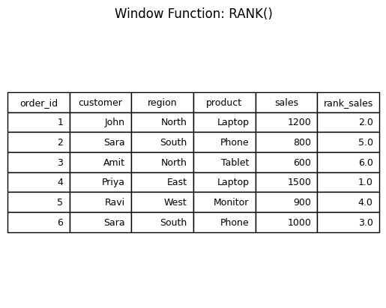

Case Study Practice Questions
1. Find the total sales by region.
2. Identify the top selling product.
3. Calculate average sales per region.
4. Find customers with sales higher than the average sales.
5. Rank products based on total sales using window functions.

Conclusion
SQL is one of the most important tools used by data analysts to retrieve and analyze data stored in relational databases. Understanding SQL queries, joins, aggregations, and window functions allows analysts to perform powerful data analysis.

