COFFEE SALES
Analysis Report
Turning sales data into practical business decisions

Focus | Product performance, payment behaviour and sales timing
Period | 2024–2025, with hourly sales detail
Prepared from | The supplied sales analysis and visual summaries

1. Executive Summary
The numbers tell a fairly clear story: customers are not buying every coffee equally, most reported sales are happening through cards, and demand changes noticeably depending on the time of day. The strongest product in the supplied product-level analysis is Americano with Milk, while 10 AM stands out as the busiest sales hour.
For a manager, the most useful takeaway is not simply which number is largest. It is where the business can act on the pattern. Stock and staffing should be strongest around the periods when customers are already buying heavily, while quieter periods provide room for targeted promotions.
At a glance
Americano with Milk leads the product table; 10 AM is the strongest hour at 10,994.52; card payments represent about 97.2% of the reported payment value.

2. What We Looked At
The analysis brings together four views of the sales data: what customers buy, how they pay, when sales happen during the day, and how the reported annual figures compare between 2024 and 2025.
These views work together. Product analysis helps with inventory and menu decisions. Payment analysis helps with checkout operations. Hourly analysis helps with staffing and promotions. Yearly analysis provides a broader performance signal.

3. Product Performance
The product numbers show a noticeable difference in customer preference. Americano with Milk and Latte sit at the top of the supplied table, while Espresso is considerably lower. This gives the business a useful starting point for thinking about what should be protected, promoted, or investigated.
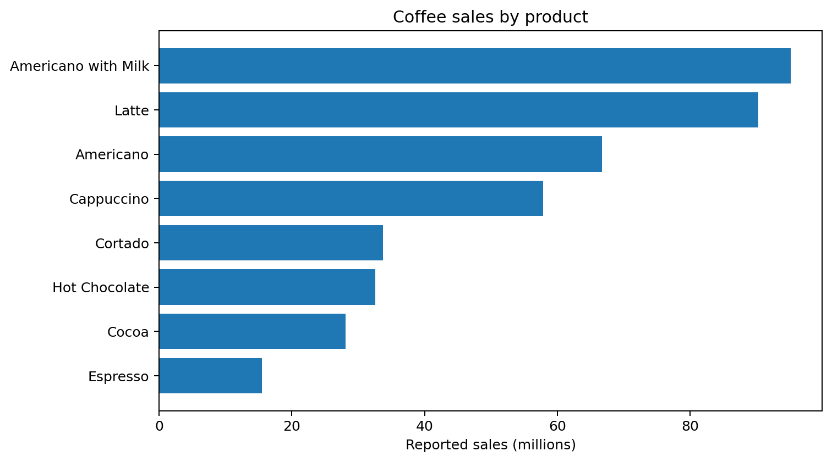
Figure 1. Reported sales by coffee type.
The top three products are Americano with Milk, Latte, and Americano. Americano with Milk has reported sales of 95,115,621.92, followed by Latte at 90,267,495.56 and Americano at 66,719,453.24.
A sensible next step would be to understand why these products perform well. That could be driven by customer preference, price, availability, promotions, or a combination of these factors. The current analysis shows the pattern, but it does not by itself explain the reason.

4. Payment Behaviour
The payment mix is heavily weighted toward cards. Reported card sales are 112,245.58 compared with 3,186.00 in cash. In practical terms, this means the checkout experience depends strongly on reliable electronic payments.
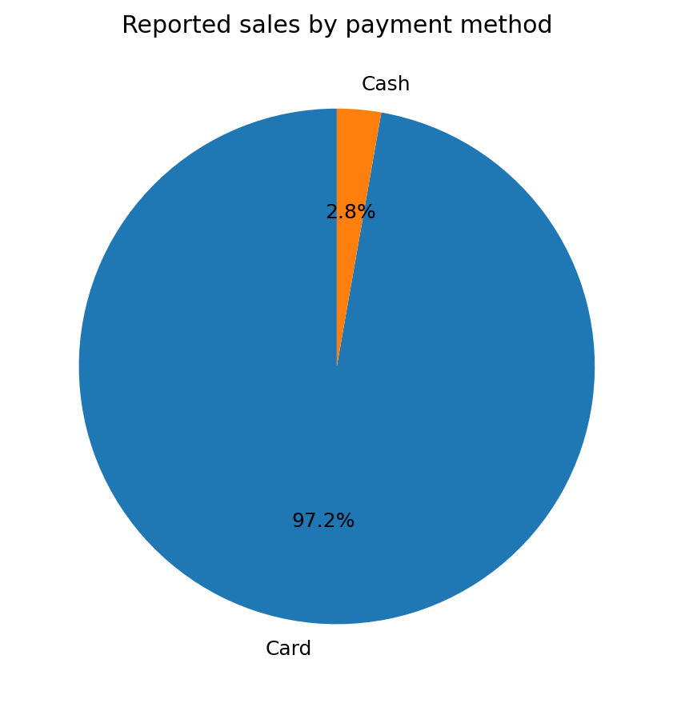
Figure 2. Reported payment mix.
Card payments account for approximately 97.2% of the reported payment value, while cash accounts for approximately 2.8%.
What this means for the business
Keeping card machines and payment processing reliable is important. A payment outage could affect a large share of transactions, so payment availability should be treated as an operational priority.

5. When Customers Buy
The hourly pattern is one of the most actionable parts of the analysis. Sales build quickly after opening, reach their highest point at 10 AM, then remain active through the afternoon before easing later in the evening.
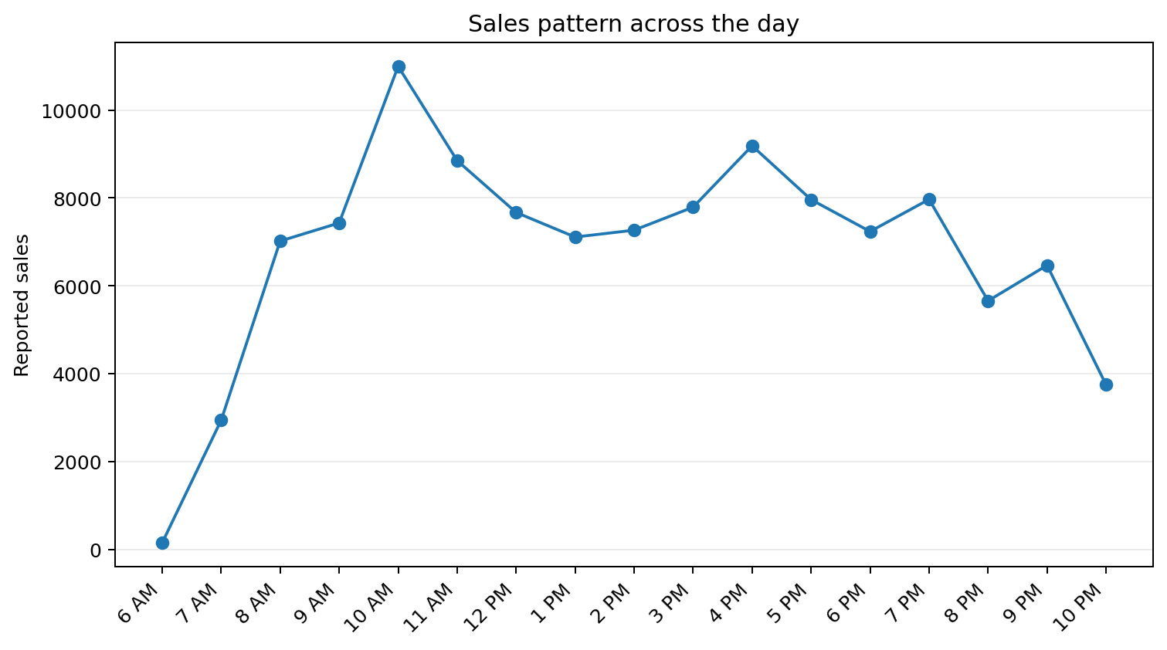
Figure 3. Reported sales across operating hours.

The morning rush
From 8 AM to 11 AM, the reported sales total 34,290.78. The clear high point is 10 AM, at 10,994.52. This is the period where having enough staff, popular products and smooth checkout processes is most likely to matter.

A second opportunity later in the day
The 4 PM–7 PM window also performs strongly, with reported sales of 32,349.16. That suggests the business has a second meaningful demand period rather than relying only on the morning rush.

6. Year-on-Year View
The supplied year-level table reports 8,728.02 for 2024 and 6,334.24 for 2025. On those reported figures alone, 2025 is approximately 27.4% lower than 2024.
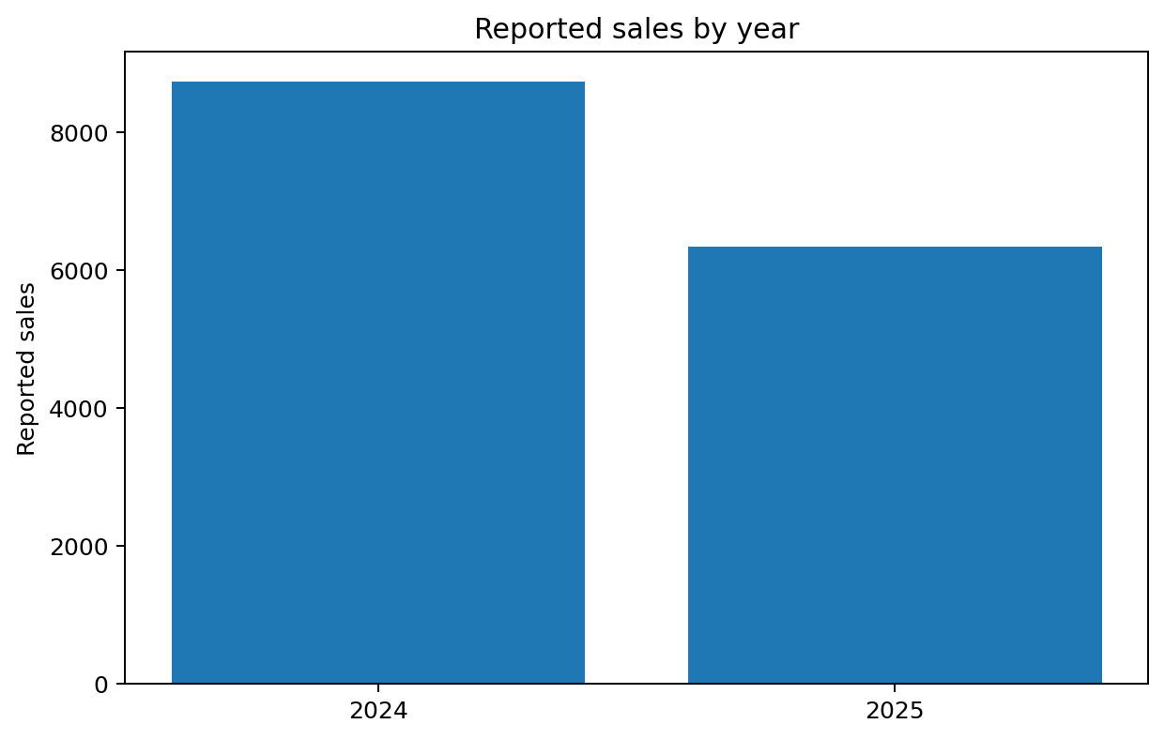
Figure 4. Reported annual sales figures.
Important interpretation note
The annual figures should be treated as a signal rather than a final business KPI. The supplied analysis contains different aggregation totals across its tables, so the filters, units and aggregation level should be checked before making a firm claim about an overall sales decline.

7. Key Insights in Plain English
What we found | Why it matters | What to consider next
Americano with Milk leads the product table. | Demand is concentrated around a few products. | Protect availability and investigate what drives preference.
Cards account for about 97% of reported payment value. | Checkout depends heavily on electronic payments. | Keep payment systems reliable and monitor failures.
10 AM is the strongest sales hour. | The morning period is operationally important. | Align staffing and stock with the morning peak.
4 PM is another strong point. | There is meaningful afternoon demand too. | Consider targeted offers or staffing around 4–7 PM.
Reported 2025 sales are lower than 2024. | There may be a performance issue worth investigating. | Validate filters and aggregation before acting on the decline.

8. Recommendations
1. Keep the best sellers available — Americano with Milk and Latte should receive particular attention in inventory planning because they lead the supplied product table.
2. Staff for the demand, not just the opening hours — The 8–11 AM period is especially important, with another useful window from 4–7 PM. Staffing can be planned around these patterns.
3. Use quieter periods more deliberately — Rather than treating every hour the same, consider small promotions or bundles during weaker periods to encourage additional visits.
4. Protect the card-payment experience — With most reported payment value coming through cards, reliable payment infrastructure is essential to day-to-day sales.
5. Validate the annual trend — Before presenting the 2024–2025 decline as a headline KPI, reconcile the different totals and confirm that the same filters and units are being used.

9. Conclusion
Overall, the analysis gives the business a useful picture of customer behaviour. A small group of products appears to drive much of the reported product-level sales, customers overwhelmingly use cards, and sales have clear peaks during the day—especially around 10 AM and again in the late afternoon.
The biggest opportunity is to turn these observations into routine decisions: keep the strongest products available, match staffing to demand, protect the payment experience, and use quieter periods more intentionally. At the same time, the underlying data should be reconciled before the annual trend is used as a formal performance KPI.

Appendix: Reported Figures Used
Product-level sales:
Coffee | Reported sales
Americano | 66,719,453.24
Americano with Milk | 95,115,621.92
Cappuccino | 57,831,221.58
Cocoa | 28,049,873.94
Cortado | 33,706,021.36
Espresso | 15,467,831.72
Hot Chocolate | 32,551,705.56
Latte | 90,267,495.56

Source note: Figures in this report are based only on the supplied analysis tables. No external data has been added.

