Restaurant Management System
Entity Relationship Diagram (ERD) Documentation
This document explains the database schema, entities, primary keys, foreign keys, and relationships represented in the Restaurant Management System ERD.
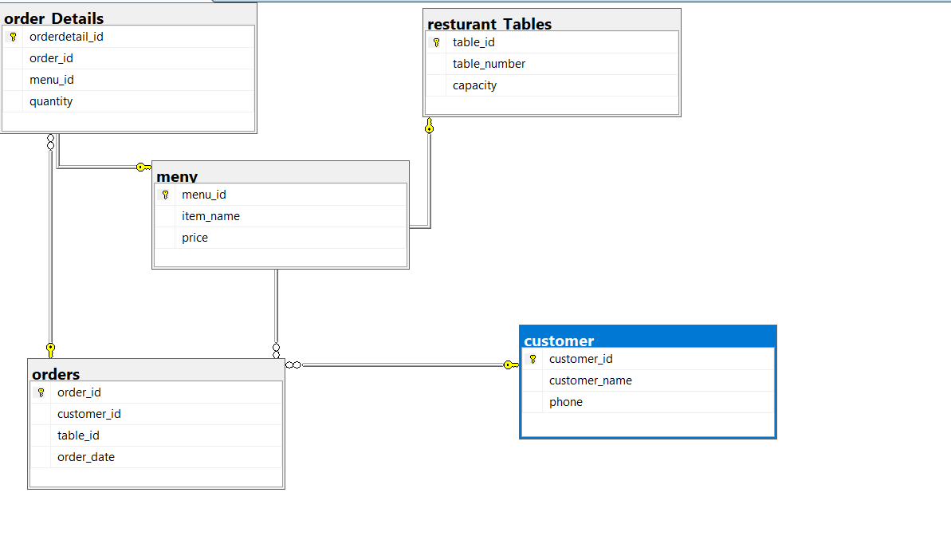
Figure 1: Restaurant Management System ERD

1. Overview
The database is designed to manage restaurant operations including customers, restaurant tables, menu items, orders, and the individual items contained in each order. The design follows normalization principles by separating related data into different tables connected through primary and foreign keys.

2. Entity Descriptions

Customer
Column | Key | Description
customer_id | Primary Key | Unique identifier for each customer.
customer_name |  | Customer's full name.
phone |  | Customer contact number.

Restaurant Tables
Column | Key | Description
table_id | Primary Key | Unique identifier for each restaurant table.
table_number |  | Displayed table number.
capacity |  | Maximum seating capacity.

Menu
Column | Key | Description
menu_id | Primary Key | Unique menu item identifier.
item_name |  | Food or beverage name.
price |  | Price of the menu item.

Orders
Column | Key | Description
order_id | Primary Key | Unique order identifier.
customer_id | Foreign Key | References Customer.customer_id.
table_id | Foreign Key | References Restaurant Tables.table_id.
order_date |  | Date and time when the order was placed.

Order Details
Column | Key | Description
orderdetail_id | Primary Key | Unique identifier for each order line.
order_id | Foreign Key | References Orders.order_id.
menu_id | Foreign Key | References Menu.menu_id.
quantity |  | Quantity ordered.

3. Relationships Between Tables

Customer → Orders (1:M)
One customer can place many orders, but each order belongs to exactly one customer. The foreign key Orders.customer_id references Customer.customer_id.

Restaurant Tables → Orders (1:M)
One restaurant table can be associated with many orders over time, while each order is linked to one table through Orders.table_id.

Orders → Order Details (1:M)
A single order may contain multiple menu items. Each item is stored as a separate row in Order Details using order_id.

Menu → Order Details (1:M)
A menu item can appear in many different customer orders. Order Details.menu_id links each ordered item to the Menu table.

Orders ↔ Menu (Many-to-Many)
The many-to-many relationship between Orders and Menu is resolved through the Order Details junction table.

4. Data Flow
1. A customer visits the restaurant.
2. The customer is seated at a restaurant table.
3. An order record is created in the Orders table.
4. Every ordered menu item is recorded in the Order Details table.
5. Menu prices are retrieved from the Menu table.
6. Reports can be generated using the relationships among these tables.

5. Referential Integrity
Foreign key constraints ensure that:
• Every order references a valid customer.
• Every order references a valid restaurant table.
• Every order detail references an existing order.
• Every order detail references an existing menu item.
This prevents orphan records and maintains database consistency.

6. Advantages of the Database Design
- Reduces data redundancy through normalization.
- Supports multiple items in one order.
- Tracks customer order history.
- Maintains accurate table allocation.
- Improves scalability for future modules such as billing, payments, reservations, and employees.
- Maintains data integrity through primary and foreign keys.

7. Conclusion
The ERD provides a normalized and scalable database model for a Restaurant Management System. It clearly defines the relationships between customers, restaurant tables, orders, menu items, and order details, allowing efficient storage, retrieval, and reporting while ensuring referential integrity.

