**Lab Practical #01:**

Perform various Linux commands and configure kali Linux with Virtual Machine.

**Practical Assignment #01:**

**1.Perform various Linux commands**

1. **File and Directory Management:**

* pwd – Show the current working directory.

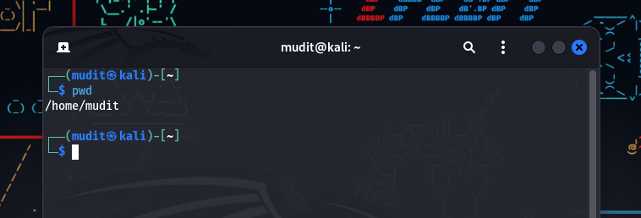

* ls – List files and directories.

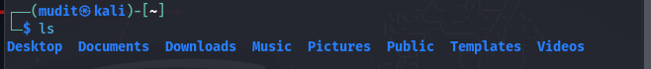

* cd – Change directories.

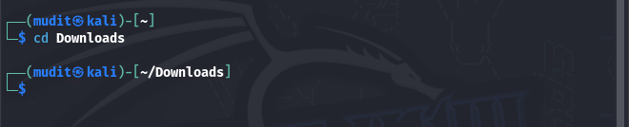

* mkdir – Create a new directory.

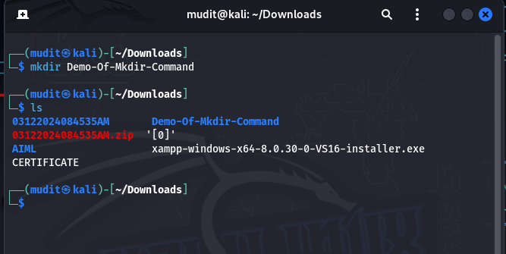

* rm – Remove files or directories.
  + Example: rm file.txt or rm -r directory/.

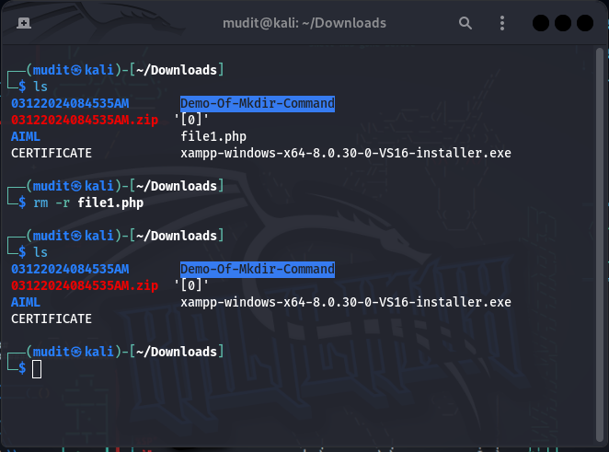

* cp – Copy files or directories.

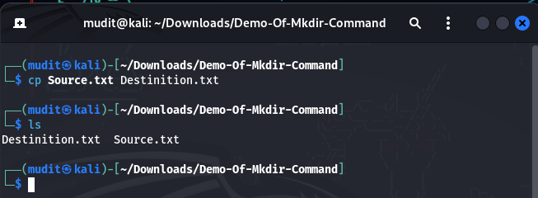

* mv – Move or rename files.

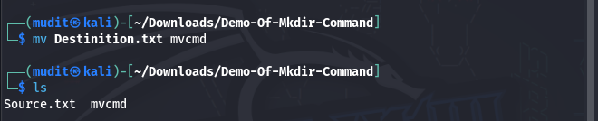

**2.File Viewing and Editing:**

* cat – View file contents.

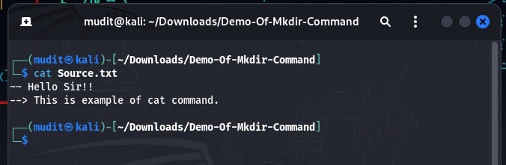

* less – View file contents one screen at a time.



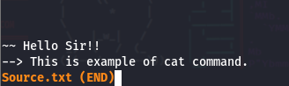

* nano – Simple text editor.



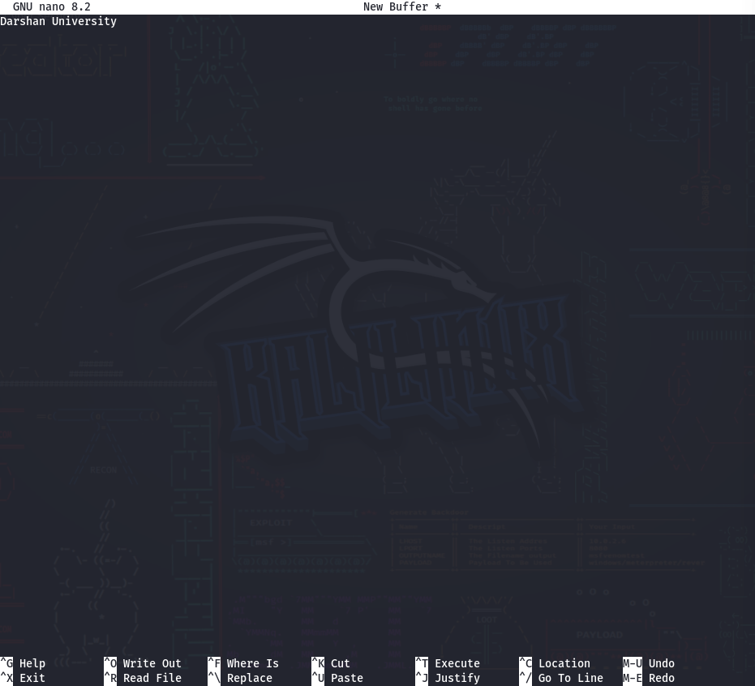

* vi or vim – Advanced text editor.

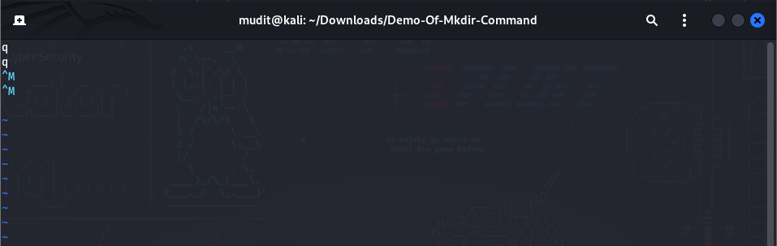

* head – Show the first few lines of a file.

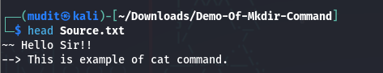

* tail – Show the last few lines of a file (use tail -f for live updates).



3.File Permissions and **Ownership**:

* chmod – Change file permissions.



* chown – Change file ownership.



* ls -l – View permissions and ownership.

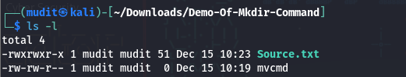

**System Information.**

* uname -a – Show system information.



* hostname – Display or set the system hostname.

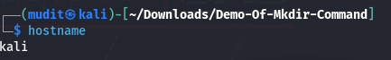

* df -h – Show disk usage in human-readable format.

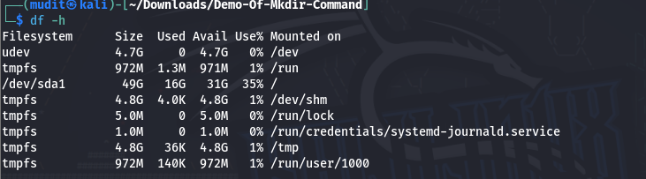

* du -sh – Show size of a directory.



* free -h – Display memory usage.

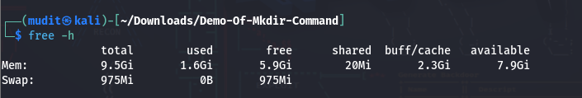

* top or htop – Monitor system processes in real-time.

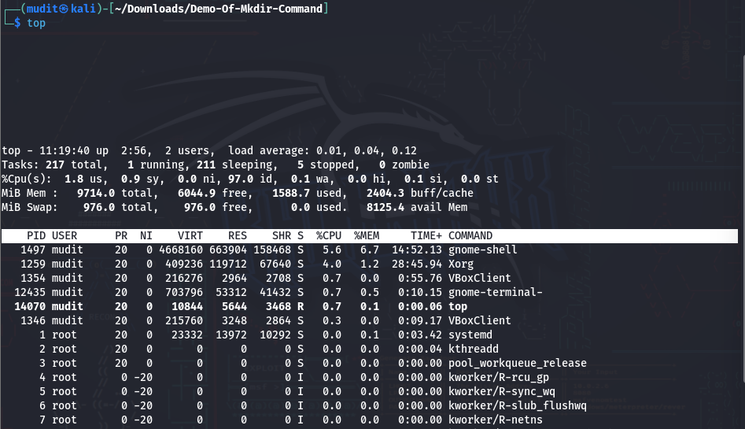

* whoami – Show the current logged-in user.

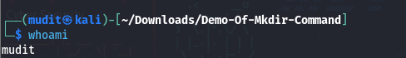

**Networking Commands**

* ifconfig / ip addr – Display network interfaces.

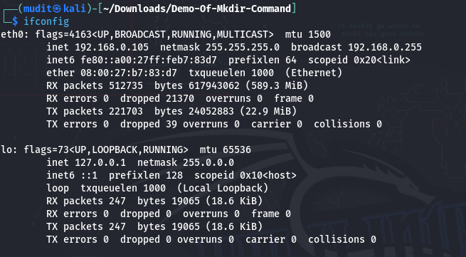

* ping – Test network connectivity.

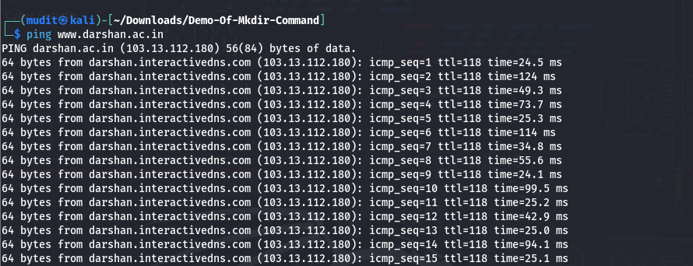

* netstat – Show network connections.

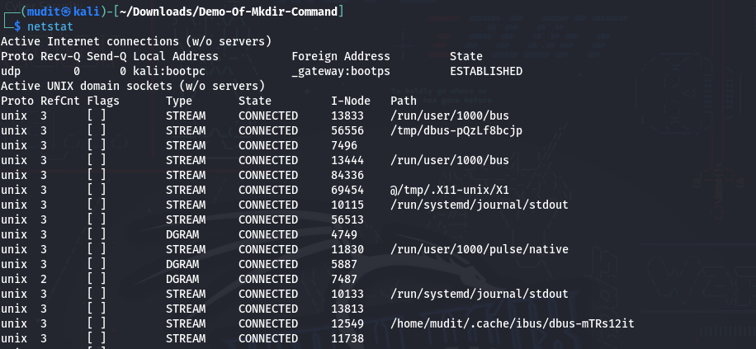

* nmap – Network scanning (pre-installed in Kali Linux).

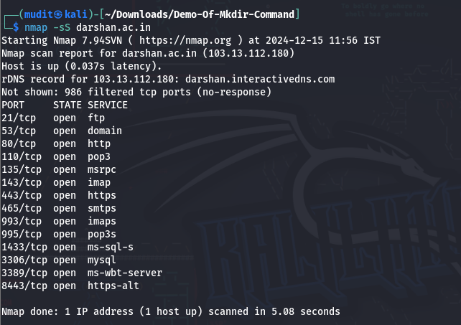

* wget – Download files from the internet.

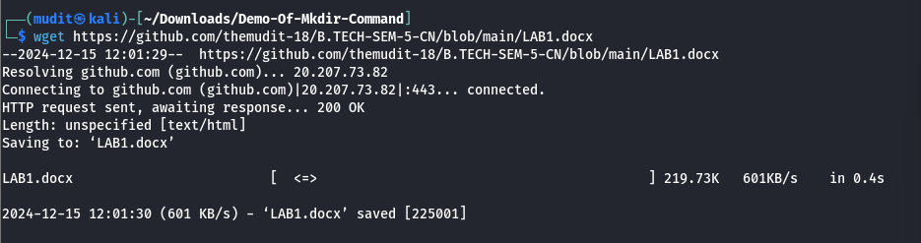

* curl – Transfer data from URLs.

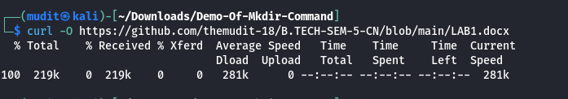

**Package Management**

* apt update – Update package lists.

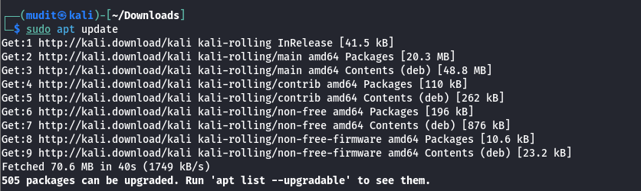

* apt remove – Uninstall a package.

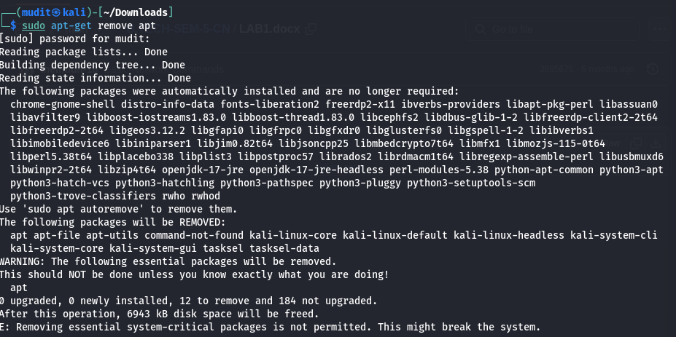

* apt install – Install a package.

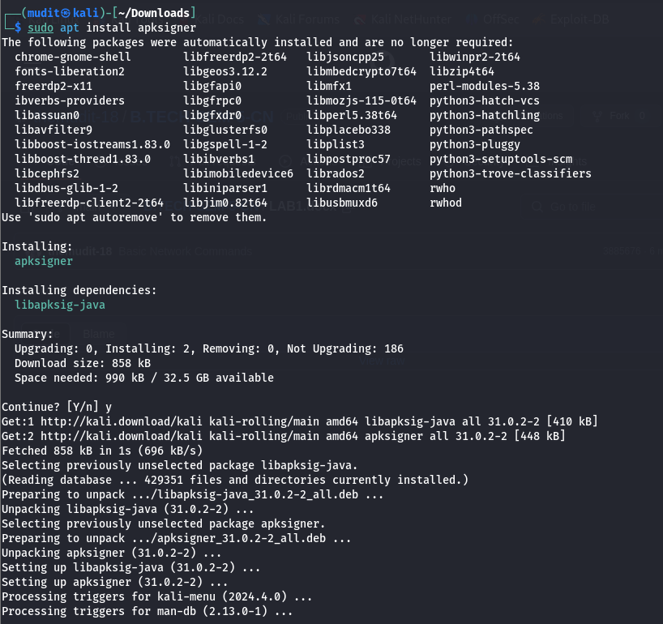

**Process Management**

* ps – View running processes.

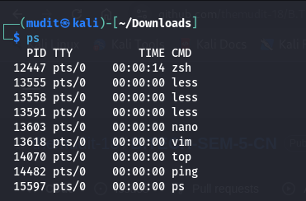

* kill – Terminate a process.



* jobs – List background jobs.

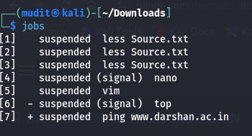

* bg / fg – Resume jobs in background/foreground.

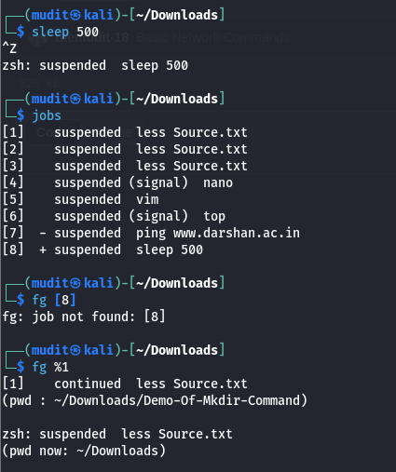

Scripting and Automation

* bash script.sh – Run a bash script.

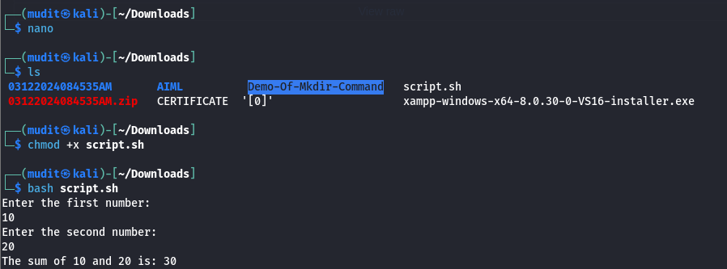

* crontab -e – Edit cron jobs for scheduling tasks.

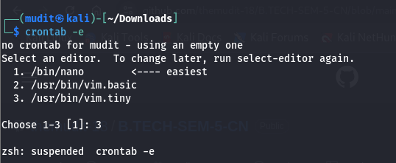

* grep – Search text in files.

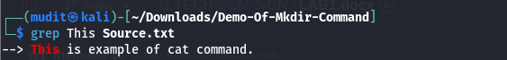

* find – Search for files.



1. Configure kali Linux with Virtual Machine.

Here are the brief steps to configure Kali Linux with a Virtual Machine:

1. Download Required Software

• Download a Virtual Machine software Oracle VirtualBox.

• Download the Kali Linux ISO file or the Kali Linux VirtualBox image from the official Kali Linux website.

1. Install Virtual Machine Software

• Install VirtualBox on your host machine by following the installation prompts. 3. Create a New Virtual Machine

• Open VirtualBox and click New.

• Enter a name (e.g., "Kali Linux") and select Linux as the type and Debian (64-bit) as the version.

1. Allocate Resources

• Assign the RAM (minimum 2 GB, recommended 4 GB or more).

• Set the Processor count (2 or more cores for optimal performance).

• Create a new Virtual Hard Disk (20 GB or more recommended).

* Attach Kali Linux Image

• Go to Settings > Storage and add the Kali Linux ISO to the optical drive.

6. Start the Virtual Machine

• Boot the virtual machine, and it will load the Kali Linux installer or live environment. • Follow the on-screen instructions to install or run the live version of Kali Linux.

7. Install Kali Linux

• Choose Graphical Install or Text Install (recommended: Graphical Install).

• Set language, time zone, and keyboard layout.

• Partition the disk (choose Guided - use entire disk for simplicity).

• Create a user account and set a strong password.

• Wait for the installation to complete.

8. Update Kali Linux

• Open a terminal and run: sudo apt update && sudo apt upgrade -y

9. Start Using Kali Linux

• Reboot the virtual machine if needed, and start exploring Kali Linux.