Class04.R

muditg19

2024-10-11

#my first Rscript  
x <- 1:50  
plot(x)

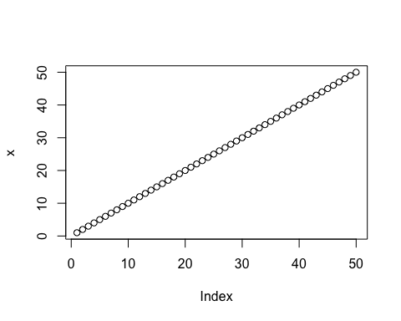

plot(x, sin(x), typ="l", col = "blue")

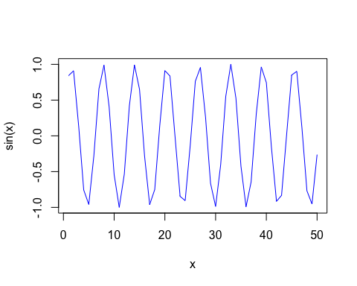

plot(x, sin(x), typ="l", col = "blue", lwd = 2)

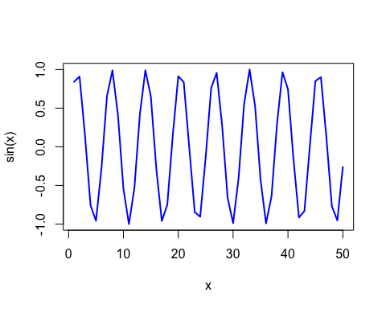

log(10, 10)

## [1] 1