Data turned out to be seasonality and decreasing trend

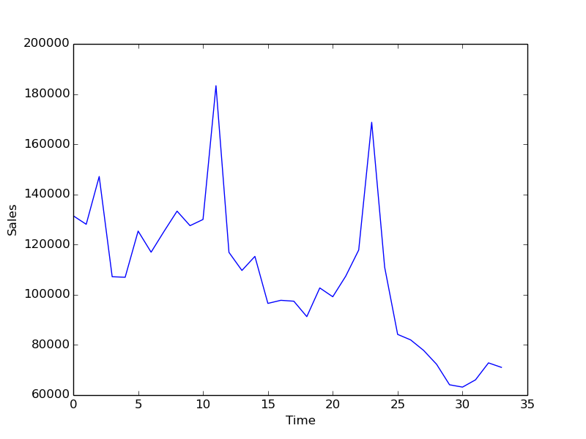

Clubbing all the months together with sales yield following -

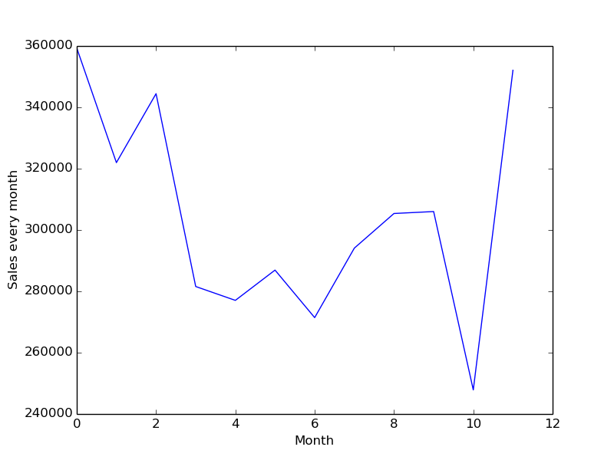

Since this is time series data and with decreasing trend, we need to make it stationary.

In order to check if its stationary or not, we need to perform dicker fuller test.

Following is the output of our initial data:

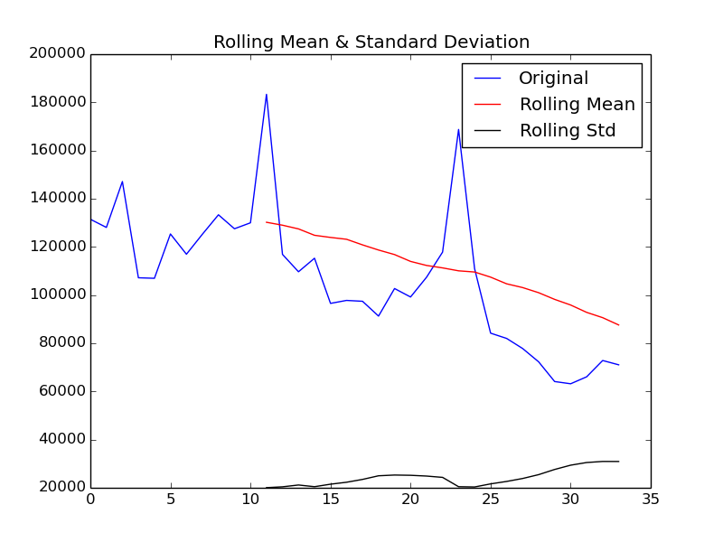

Results of Dickey-Fuller Test:

Test Statistic -2.395704

p-value 0.142953

#Lags Used 0.000000

Number of Observations Used 33.000000

Critical Value (5%) -2.954127

Critical Value (1%) -3.646135

Critical Value (10%) -2.615968

dtype: float64

The mean and std of the series is a function of time. Hence we need to smoothen it. We need to reduce the trend.

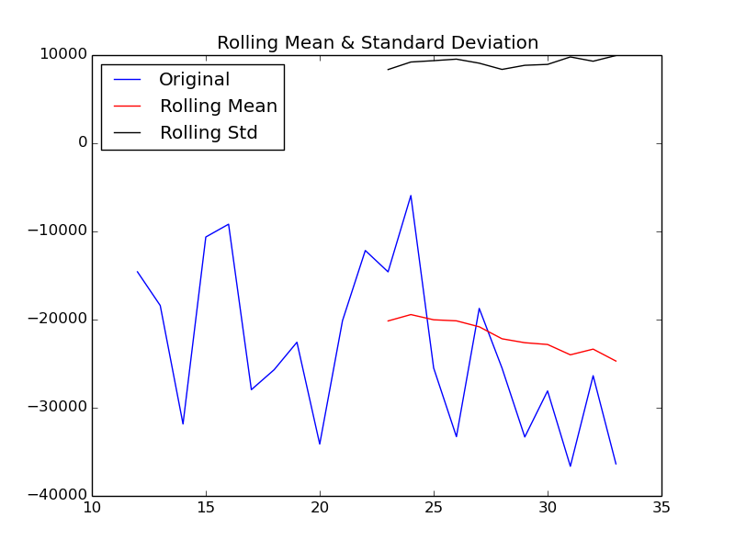

Test Statistic -1.886803

p-value 0.338295

#Lags Used 0.000000

Number of Observations Used 33.000000

Critical Value (5%) -2.954127

Critical Value (1%) -3.646135

Critical Value (10%) -2.615968

dtype: float64

**References:**

<https://towardsdatascience.com/how-to-predict-a-time-series-part-1-6d7eb182b540>

<http://www.blackarbs.com/blog/time-series-analysis-in-python-linear-models-to-garch/11/1/2016#AR=>

<http://www.blackarbs.com/blog/time-series-analysis-in-python-linear-models-to-garch/11/1/2016#AR=>