**(Q. 01)**

**Code:-**

package Q_01;  
  
  
import javax.swing.JFrame;  
  
 public class sample {  
 public static void main(String[] args) {  
  
 JFrame frame = new JFrame("Welcome to Java");  
 frame.setSize(800, 600);  
 frame.setDefaultCloseOperation(JFrame.*EXIT_ON_CLOSE*);  
 frame.setVisible(true);  
 }  
 }

**Output:-**

**(Q. 02)**

**Code:-**

package Q_02;  
  
import javax.swing.*;  
import java.util.*;  
  
class Name {  
 public static void main(String[] args) {  
 Scanner scanner = new Scanner(System.*in*);  
 String firstname , lastname , fullname;  
 System.*out*.println("Enter your firstname : ");  
 firstname = scanner.next();  
 System.*out*.println("Enter your lastname : ");  
 lastname = scanner.next();  
 fullname = firstname + " " + lastname ;  
  
 JFrame myWindow;  
 myWindow = new JFrame();  
 myWindow.setSize(800,600);  
 myWindow.setTitle(fullname);  
 myWindow.setVisible(true);  
 }  
}

**Output:-**

**(Q. 03)**

**Code:-**

package Q_03;  
  
  
import java.util.Scanner;  
  
class NameOrder {  
  
 public static void main(String[] args) {  
 Scanner scanner = new Scanner(System.*in*);  
 String firstname;  
 String middlename;  
 String lastname;  
 String fullname;  
 char middle_name_initial;  
  
 System.*out*.println("Enter your firstname :");  
 firstname=scanner.next();  
  
 System.*out*.println("Enter your middlename :");  
 middlename=scanner.next();  
 middle_name_initial = middlename.charAt(0);  
  
 System.*out*.println("Enter your lastname : ");  
 lastname = scanner.next();  
  
 fullname = firstname+" "+ middle_name_initial +". "+ lastname +"." ;  
 System.*out*.println(fullname);  
  
 }  
}

**Output:-**

**(Q. 04)**

**Code:-**

package Q_04;  
  
import java.text.SimpleDateFormat;  
  
class DATE {  
 public static void main(String[] args) {  
 java.util.Date today = new java.util.Date();  
 SimpleDateFormat simpleDateFormat = new SimpleDateFormat("dd MMMM yyyy");  
  
 System.*out*.println(simpleDateFormat.format(today));  
 }  
}

**Output:-**

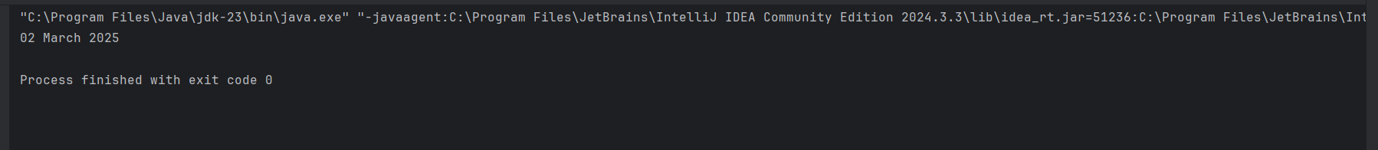

**(Q. 05)**

**Code:-**

package Q_05;  
  
  
import java.text.SimpleDateFormat;  
import java.util.Date;  
  
class DATEnew {  
 public static void main(String[] args) {  
 Date today = new Date();  
 SimpleDateFormat simpleDateFormat = new SimpleDateFormat("EEEE, MMMM d, yyyy");  
  
 System.*out*.println(simpleDateFormat.format(today));  
 }  
}

**Output:-**

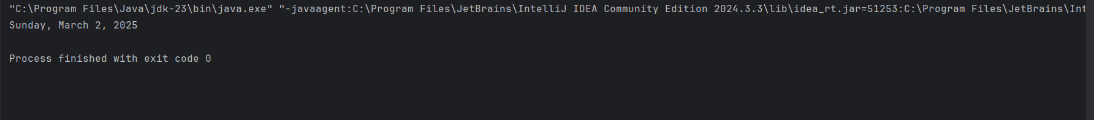

**(Q. 06)**

**Code:-**

package Q_06;  
  
  
import javax.swing.*;  
import java.util.*;  
  
class Framewindow {  
 public static void main(String[] args) {  
 Scanner scanner = new Scanner(System.*in*);  
  
 int w,h;  
 String title;  
 System.*out*.println("Enter the title of the window:");  
 title = scanner.nextLine();  
 System.*out*.println("Enter the width of the window:");  
 w = scanner.nextInt();  
 System.*out*.println("Enter the height of the window:");  
 h = scanner.nextInt();  
  
  
 JFrame myWindow;  
 myWindow = new JFrame();  
 myWindow.setSize(w,h);  
 myWindow.setTitle(title);  
 myWindow.setVisible(true);  
 }  
}

**Output:-**

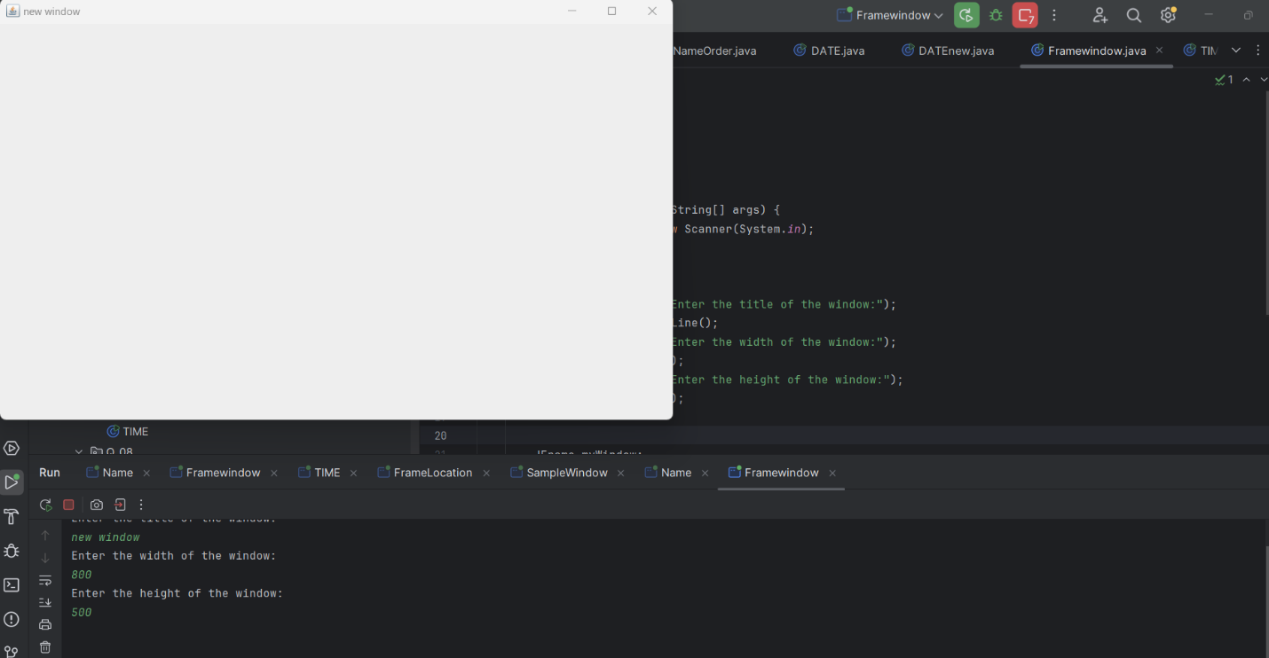

**(Q. 07)**

**Code:-**

package Q_07;  
  
import java.text.SimpleDateFormat;  
import java.util.*;  
import javax.swing.*;  
  
class TIME {  
 public static void main(String[] args) {  
  
 Date today;  
 SimpleDateFormat sdf;  
 today = new Date( );  
 sdf = new SimpleDateFormat("hh:mm:ss a.");  
 //System.out.println(sdf.format(today));  
  
 JFrame myWindow;  
 myWindow = new JFrame();  
 myWindow.setSize(600,400);  
 myWindow.setTitle(sdf.format(today));  
 myWindow.setVisible(true);  
 }  
}

**Output:-**

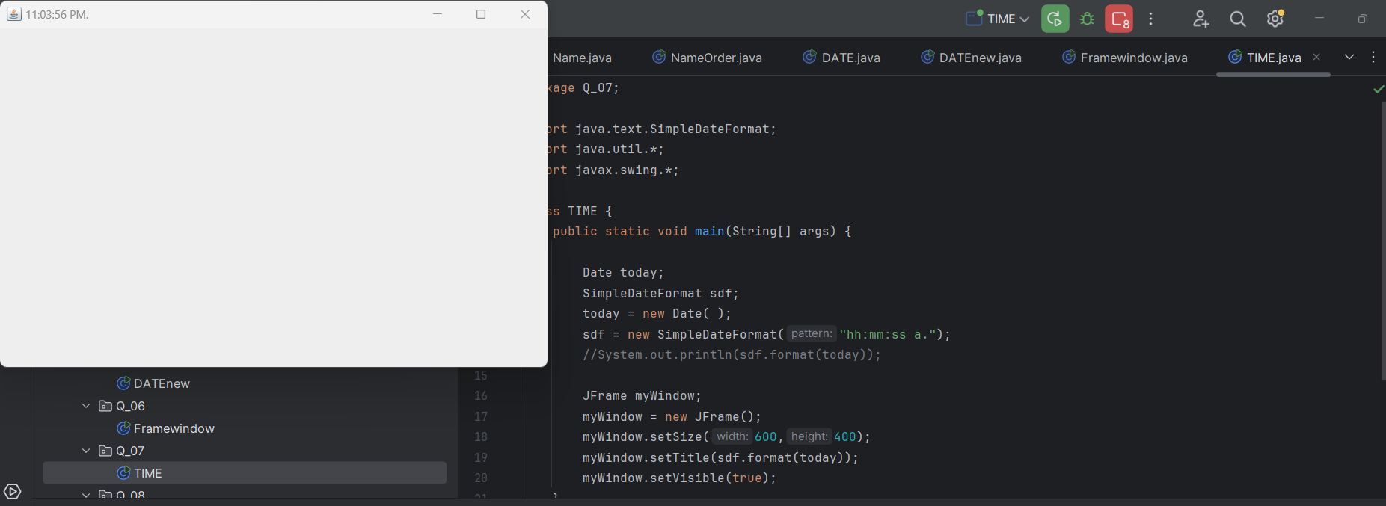

**(Q. 08)**

**Code:-**

package Q_08;  
  
import java.util.*;  
class Question {  
 public static void main(String[] args) {  
 String word ,a,b ;  
 //new array  
 Scanner scanner = new Scanner(System.*in*);  
 System.*out*.println("Enter the word :");  
 word = scanner.nextLine();  
  
 String[] sentence = word.split("!",2);  
  
 if (sentence.length == 2){  
 System.*out*.println(sentence[0].trim());  
 System.*out*.println(sentence[1].trim());  
 }  
 }  
}

**Output:-**

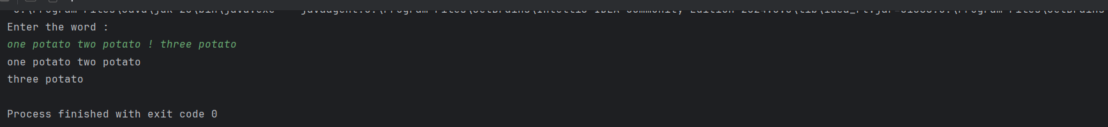

**(Q. 09)**

**Code:-**

package Q_09;  
  
  
import java.util.*;  
  
class CountChar {  
 public static void main(String[] args) {  
 Scanner scanner = new Scanner(System.*in*);  
 System.*out*.println("Enter the text : ");  
 String text = scanner.nextLine();  
 int length = text.length();  
  
 System.*out*.println(length);  
 System.*out*.println(text.charAt(0));  
 System.*out*.println(text.charAt(length-1));  
  
 }  
}

**Output:-**

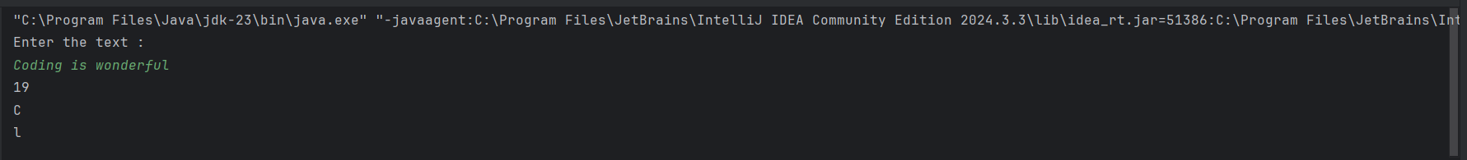

**(Q. 10)**

**Code:-**

package Q_10;  
  
  
import java.util.Scanner;  
  
class MiddleChar {  
 public static void main(String[] args) {  
 Scanner scanner =new Scanner(System.*in*);  
 System.*out*.println("Enter the odd length String : ");  
 String text = scanner.nextLine();  
  
 int length = text.length();  
 char middle_letter;  
 middle_letter = text.charAt((length / 2));  
 System.*out*.println(middle_letter);  
 }  
}

**Output:-**



**(Q. 11)**

**Code:-**

package Q_11;  
  
import java.util.*;  
  
class NameFormat {  
 public static void main(String[] args) {  
 Scanner scanner = new Scanner(System.*in*);  
 System.*out*.println("Enter the full name (first middle last) with spaces :");  
 String text = scanner.nextLine();  
 System.*out*.println(text);  
  
 String[] parts = text.split(" ");  
 String fname = parts[0];  
 String mname = parts[1];  
 String lname = parts[2];  
  
 System.*out*.println(lname+","+" "+fname+" "+mname.charAt(0)+".");  
  
 }  
}

**Output:-**

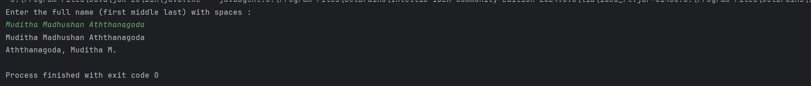

**(Q. 12)**

**Code:-**

package Q_12;  
  
  
import javax.swing.*;  
  
class FrameLocation {  
 public static void main(String[] args) {  
 JFrame myWindow;  
 myWindow = new JFrame();  
 myWindow.setSize(300,200);  
 myWindow.setLocation(50,100);  
 myWindow.setTitle("My First Frame");  
 myWindow.setVisible(true);  
  
 }  
}

**Output:-**

**(Q. 13)**

**Code:-**

package Q_13;  
  
import javax.swing.*;  
class SampleWindow {  
 public static void main(String[] args) {  
 JFrame myWindow;  
 myWindow = new JFrame();  
 myWindow.setSize(500, 250);  
 myWindow.setTitle("UOK");  
 myWindow.setVisible(true);  
 try {Thread.*sleep*(500);} catch(Exception e) { }  
 myWindow.setVisible(false);  
 try {Thread.*sleep*(500);} catch(Exception e) { }  
 myWindow.setVisible(true);  
 }  
}

**Output:-**

