**Question 01**

**Code:**

package question_01;

public class question_01 {

public static void main(String[] args) {

// 1st part

int A = 2;

int B = 4;

int C = 8;

double answer_a = Math.sqrt( Math.pow(B,2) + (4 * A * C) );

System.out.println(answer_a);

// 2nd part

int X =100;

int Y =5;

double answer_b = Math.sqrt( X+(4*(Math.pow(Y,3))));

System.out.println(answer_b);

// 3rd part

double answer_c = Math.cbrt(X*Y);

System.out.println(answer_c);

// 4th part

int Radius = 14;

double answer_d = Math.PI*Math.pow(Radius, 2);

System.out.println(answer_d);

}

}

**Output:**

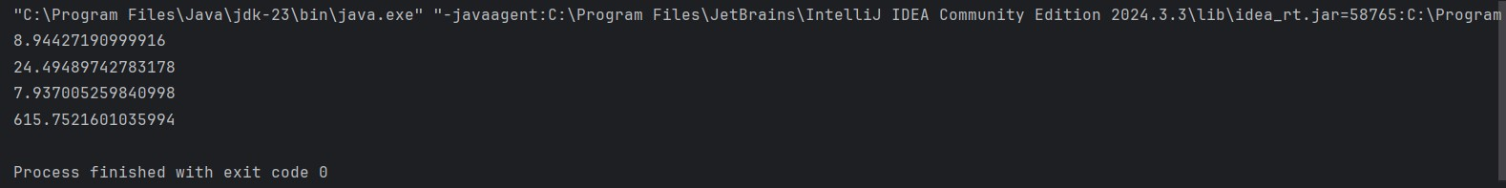

**Question** **02**

**Code:**

package question_02;

import java.util.Scanner;

public class question_02 {

public static void main(String[] args) {

Scanner sc = new Scanner(System.in);

System.out.print("Enter your Length in Centimeters: ");

double cm = sc.nextDouble();

int feet = (int) (cm / 30.48);

double remainder = cm % 30.48;

double inch = remainder / 2.54;

System.out.printf("Your entered length in feet and inches: %d ft and %.2f inch%n", feet, inch);

}

}

**Output:**

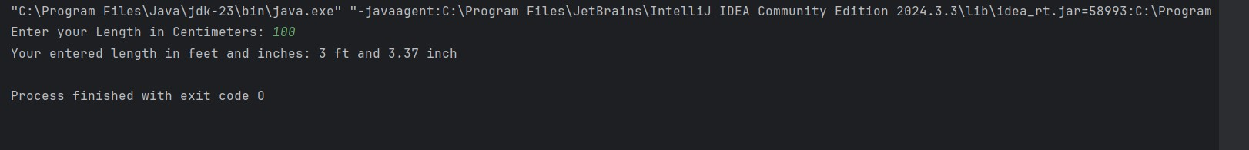

**Question** **03**

**Code:**

package question_03;

import java.util.Scanner;

public class question_03 {

public static void main(String[] args) {

Scanner input= new Scanner(System.in);

System.out.print("Enter the temperature in Celsius: ");

double cel = input.nextDouble();

double fah = (1.8 * cel) + 32;

System.out.printf("Temperature in Fahrenheit: %.2f" ,fah );

}

}

**Output:**



**Question** **04**

**Code:**

package question_04;

import java.util.Scanner;

public class question_04 {

public static void main(String[] args) {

Scanner sc = new Scanner(System.in);

System.out.print("Enter your weight of body: ");

double bodyWeight = sc.nextDouble();

double calories = bodyWeight * 19;

System.out.println("You need approximately " + calories + " calories per day");

}

}

**Output:**

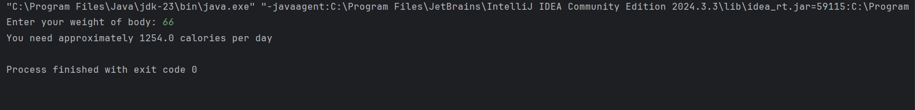

**Question** **05**

**Code:**

package question_05;

import java.util.Scanner;

public class question_05 {

public static void main(String[] args) {

Scanner input= new Scanner(System.in);

System.out.print("Enter the temperature in Fahrenheit: ");

double fah = input.nextDouble();

double cel = (5.0 / 9.0) * ( fah - 32) ;

System.out.printf("Temperature in Celsius: %.2f" ,cel );

}

}

**Output:**

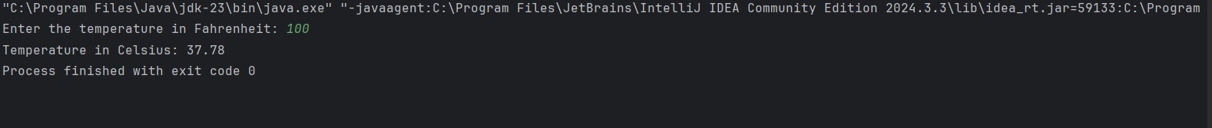

**Question** **06**

**Code:**

package question_06;

import java.util.GregorianCalendar;

import java.util.Scanner;

public class question_06 {

public static void main(String[] args) {

Scanner input = new Scanner(System.in);

System.out.print("Enter your birth year: ");

int birthyear = input.nextInt();

GregorianCalendar cal = new GregorianCalendar();

int current_year = cal.get(GregorianCalendar.YEAR);

int age = current_year - birthyear;

System.out.printf("You were born in %d and will be %d years old this year", birthyear, age);

}

}

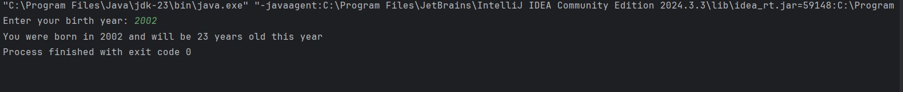**Output:**

**Question** **07**

**Code:**

package question_07;

import java.util.Scanner;

public class question_07 {

public static void main(String[] args) {

Scanner input = new Scanner(System.in);

System.out.print("Enter Your Height in Centimeters: ");

int height = input.nextInt();

System.out.print("Enter Your Weight in kilograms): ");

int weight = input.nextInt();

double BMI = weight / (Math.pow( (height / 100.0), 2));

System.out.printf("Your BMI value is: %.3f%n" ,BMI);

if (BMI >= 20 && BMI <= 25) {

System.out.println("Your BMI value is normal");

} else

System.out.println("Your BMI value is not in the healthy range");

}

}

**Output:**

**Question** **08**

**Code:**

package question_08;

import java.util.Scanner;

public class question_08 {

public static void main(String[] args) {

Scanner input = new Scanner(System.in);

System.out.print("Enter the radius of the sphere: ");

double r = input.nextDouble();

double PI = 3.14;

double v = (4.0 / 3.0) * (PI * Math.pow(r, 3));

System.out.printf("Volume of the sphere is: %.3f%n" ,v);

}

}

**Output:**

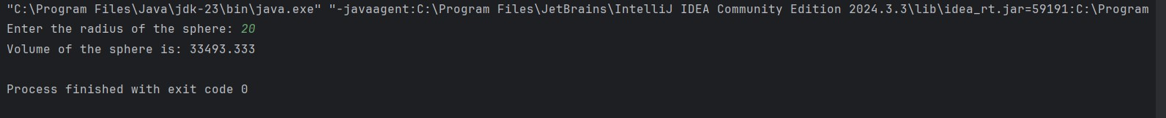

**Question** **09**

**Code:**

package question_09;

import java.util.Scanner;

public class question_09 {

public static void main(String[] args) {

Scanner input = new Scanner(System.in);

System.out.print("Enter the amount of investment: ");

double P = input.nextDouble();

System.out.print("Enter the annual interest rate(%): ");

double R = input.nextDouble();

System.out.print("Enter the number of years for the investment: ");

double N = input.nextDouble();

double grow = P * (Math.pow ( (1 + (R / 100)), N));

System.out.printf("The amount of money you will earn after %.0f years is: $ %.2f" , N, grow);

}

}

**Output:**

**Question** **10**

**Code:**

package question_10;

import java.util.Scanner;

public class question_10 {

public static void main(String[] args) {

Scanner input = new Scanner(System.in);

System.out.print("Enter the loan amount: ");

double l_amount = input.nextDouble();

System.out.print("Enter the annual interest rate(%): ");

double a_i_rate = input.nextDouble();

System.out.print("Enter the loan period(in years): ");

double l_period = input.nextDouble();

double months = 12.0;

double m_i_rate = (a_i_rate / 100.0 / months) ;

System.out.printf("The monthly interest rate for the loan: %.6f%%%n", m_i_rate);

double no_payments = (l_period * months);

System.out.printf("Number of payments: %.0f%n", no_payments);

double m_payment = (l_amount * m_i_rate) / (1 - Math.pow( (1 / (1 + m_i_rate)), no_payments));

System.out.printf("The monthly payment amount: $ %.2f%n", m_payment);

double t_payment = m_payment * no_payments;

System.out.printf("The total payment amount: $ %.2f%n", t_payment);

}

}

**Output:**

