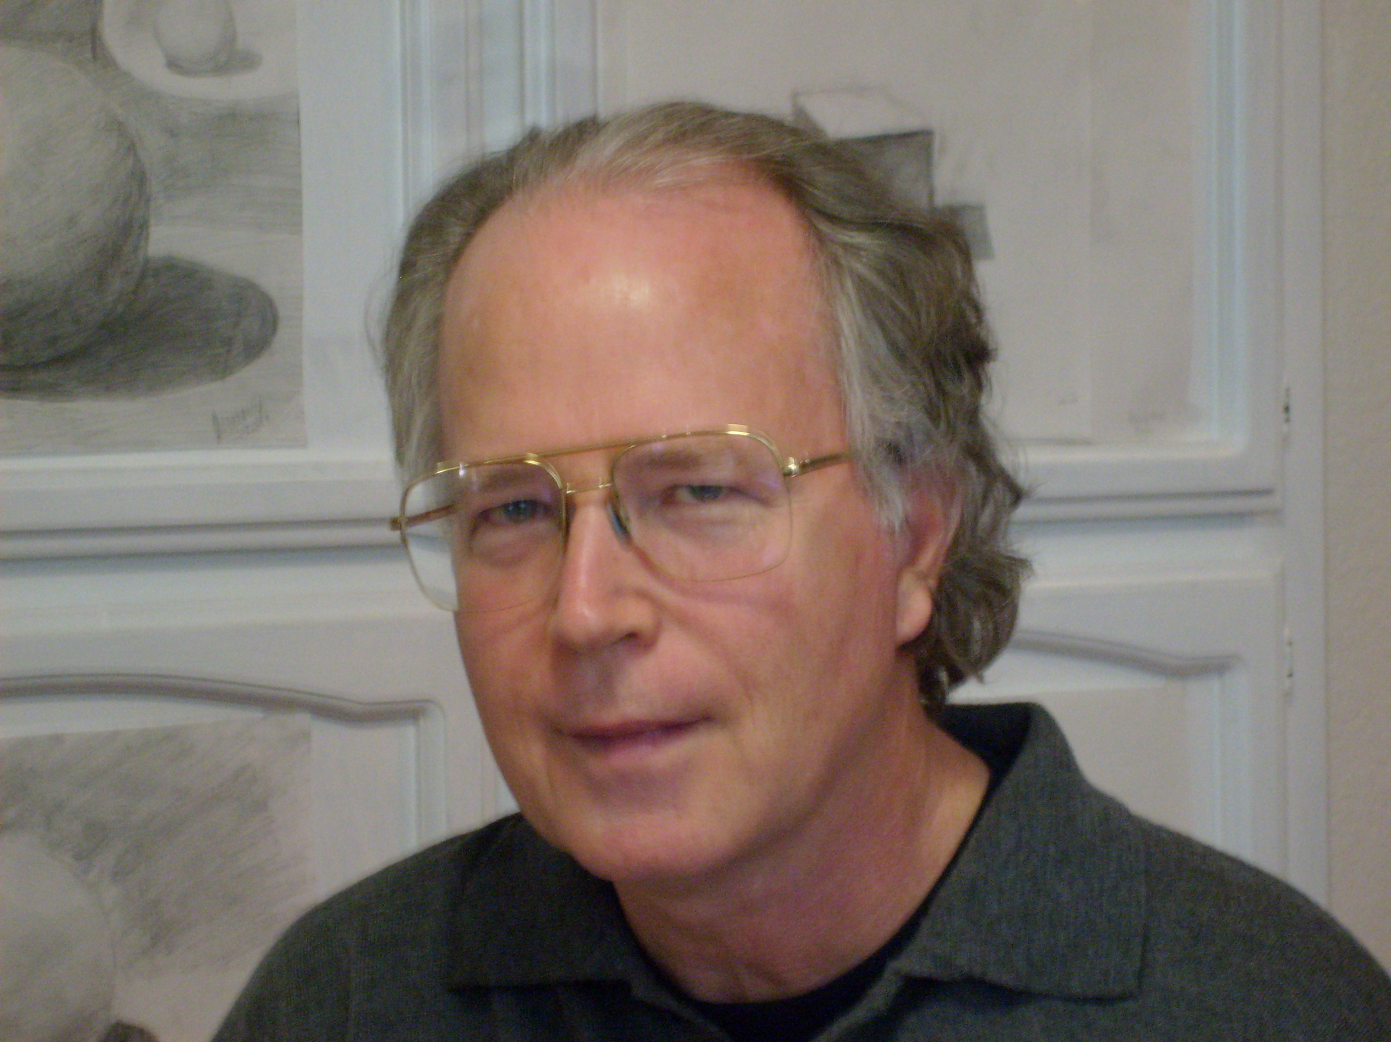

Band Director: David Leese

Woodwind instructor: Flute, Clarinet, Saxophone

David Leese started playing flute at age nine. He continued playing throughout high school and received a Bachelor
of Music degree in Flute performance from California State University, Northridge. He has studied flute with Gretel Shanley and John Heitmann. His clarinet/saxophone teachers include Bill Calkins, Guido Fazio and Tim Devine. In 2008, Mr Leese completed a Master’s Degree in Conducting through the American Band College program at Southern Oregon University.
David Leese has taught music (Flute, Clarinet, Saxophone) throughout the San Francisco Bay Area for 24 years. His experience includes general music, woodwind instruction and bands. As band director at Newark Memorial High School and later San Leandro High School (SLHS), his bands and jazz ensembles have performed at Disneyland on numerous occasions and have received excellent and superior ratings throughout Northern California. He has been the director of bands at San Leandro High school since 2001. Please visit his home page at SLHS http://www.slhs.net/20021061131352620/site/default.asp The SLHS band has almost tripled in enrollment during his tenure. In addition to his duties as band director, Mr Leese also maintains a busy schedule as a woodwind player and instructors. He has performed with Hayward Municipal Band, Castro Valley Adult School Band, various Chabot College Instrumental Ensembles (Wind Ensemble, Community Band, Jazz Orchestra) and the Bay Area Big Band. He has performed in pit orchestras for literally dozens of productions with Hayward Little Theater, Stage One as well as various schools and churches throughout the East Bay. He taught woodwind instruments (Flute, Clarinet and Saxophone) as private lessons over 10 years. He is a professional player and great music instructor.

Teaching Philosophy
The love and appreciation of music and the arts is one of the greatest gifts that we can give to each other. Learning
music includes attaining the discipline to master a skill as well as a new language. This is a skill that (unlike many physical skills) is life-long and actually increases throughout a lifetime. Most importantly, learning to make music
with others is a joy unlike any other. In addition to gaining an appreciation of music, lifelong friendships are often
made through musical ensembles, bands and orchestras. I have been able to share my love of music for the past 24
years throughout the San Francisco Bay Area. There is nothing else that is as rewarding and fulfilling than seeing
the enjoyment of music in the eyes of students.

Message for students and parents:
Choosing an instrument and ply in a band that the student enjoys is the key to the child’s willingness to practice regularly. Good eye-hand coordination is crucial to any instrument (especially the flute) so care must be taken to pay attention to details (posture, hand position, breath support etc) at all times when practicing. Remember, playing any instrument is hard work at first but the rewards are great for the student that does not give up and to reach the performance level.

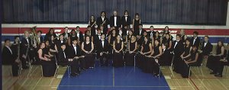

San Leandro High School Band

