Artist: Pang Yen Chou

Gallery
- Carmel Fine Art Gallery , Carmel.CA

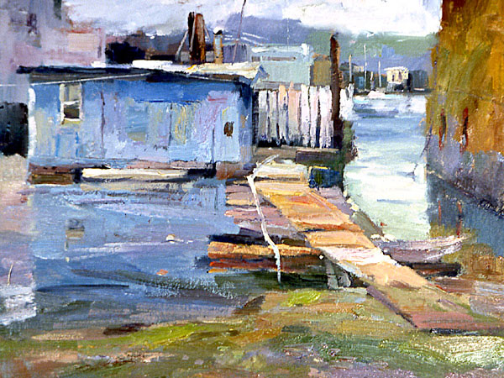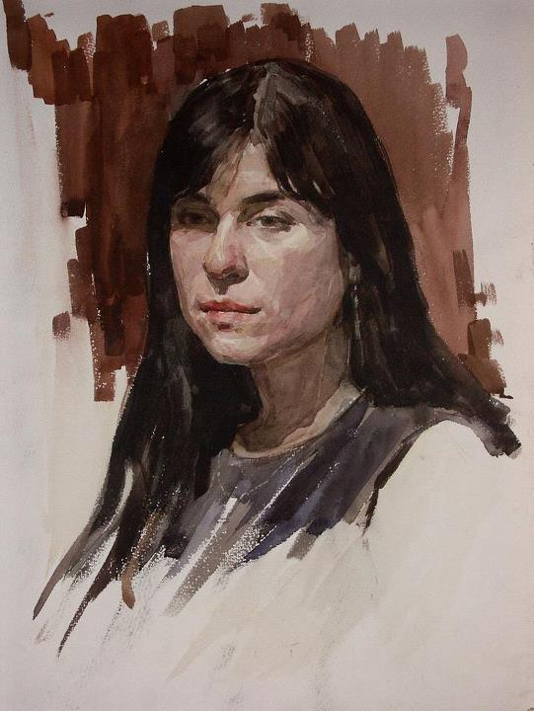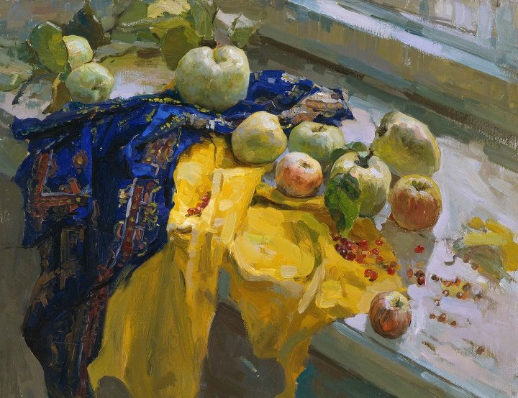

Membership
- Oil Painters of America (OPA), Signature Member.
- Rocky Mountain Plein Air Painters ,Signature Member.
- Laguna Plein Air Painters Association.
- California Art Club.

Education
Feb.1999~Jun.2002 Academy of Art University, San Francisco, USA
Major: Oil Painting (Master of Fine Arts)
Feb.1993~Jun.1996 National Taiwan College , Taiwan , Taipei
Major: Chinese Painting (Bachelor of Fine Arts)

Exhibitions
- May-2012 Carmel Art Festive Plein Air Competition
- Aug-2008 Crystal Cove Invitational Art Exhibition &Sale.CA
- Jul - 2007 Annual Laguna Beach Plein Air Painting Invitational,
Laguna Art Museum ,CA
- Jun- 2006 Annual Sonoma Plein Air,CA
- May-2006 Marin/Scapes Exhibition and Sale of Landscape Art,
Landscape Art, Larkspur ,CA
- May-2006 Annual Sedona Plein Air Festival, AZ
- Feb-2006 Just Plein Fun Balboa Island Invitational, Debra
House Gallery ,CA
- Nov-2005 San Luis Obispo Plein Air Painting Festival ,CA
- Jul - 2005 Rocky Mountain Plein Air Painting -6th Annual
National Event Winter Park ,CO
- Jun-2005 Salon International-Greenhouse Gallery,
San Antonio
- Apr-2005 Plein Air Painting in Sherwood Forest Competition,
Chico, CA
- Jul- 2004 The Best of Plein Air ,Laguna Plein Air Painter
Association , Laguna Beach ,CA
- Aug-2003 OPA Regional Juried Exhibition.
- Feb-2003 The Gatos Art Association 4th Anniversary Show
- Jun-2002 OPA National Juried Exhibition.

Awards
- 2011 Honorary Mentions, Carmel Art Festival ,CA
- 2006 Honorary Mentions, Carmel Art Festival ,CA
- 2005 Second Place Award ,Rocky Mountain Plein Air Paint-Fall
Colors, Estes Park, CO
- 2005 Second Place Award ,Estes Park Plein Air Competition2005,CO
- 2005 Best of show in Oil Painters of American.
- 2005 West Regional Juried Exhibition of Tradition Oils.Waterhouse
Gallery.

- 2003 Selected By the 20th Annual Artist’s Magazine’s Art Competition
- 2003 First Place at Carmel Art Festival 10th Plein Air Painting
Competition.

- 2003 Selected by Oil Painters of American 12th National Juried
Exhibition, New Mexico.

- 2002 The Glaser Frames Award of Excellence at Oil Painters of
American 11th National Juried Exhibition, Chicago IL.
- 2002 Selected by International Museum of Contemporary Master of
Fine Art Salon International.

Publication
- Jan- 2004 International Artist Magazine: How did you paint in 100 way
To paint FAVORITE SUBJECTS VOLUME 1.
- Jun-2206 Fine Art Connoisseur.
- Feb-2006 Southwest Art Magazine.

