RC CAR
Bachelor of Technology

I Year (CSE)
By

Himanshu Malviya (PCEA25CS118)
Saniya bansal (PCEA25CR055)
Mudit Jain (PCEA25CS108)
Moksh khokhawat (PCEA25CS106)


(Session 2025-26)
Poornima College of Engineering
( ISI-6, RIICO Institutional Area, Sitapura, Jaipur – 302022)

INDEX

Sr. No. | TITLE | Page No.
1. | INTRODUCTION | 1
 | 1.1 What is RC Car? | 1
 | 1.2 Objective | 2
2. | METHODOLOGY | 3
 | 2.1 Component List | 3
 | 2.1.1 Relay Module | 4
 | 2.1.2 Gear Motor | 4
 | 2.1.3 Node MCU | 5
 | 2.1.4 Lippo Battery | 6
 | 2.1.5 Jumper Wire | 7
 | 2.1.6 L Clamps | 8
 | 2.2 Concept Used | 8
 | 2.2.1 Differential Drive | 8
 | 2.3.1 Soldering | 9
 | 2.3.2 Drilling | 10
 | 2.3.3 Filing | 11
 | 2.3.4 Fitting | 11
 | 2.3.5 Tools required | 12
 | 2.4 Construction and Working | 14
 | 2.4.1 Relay Module Connections | 15
 | 2.4.2 Node MCU Connections | 15
 | 2.4.3 Node to Relay Connections | 15
 | 2.5 Source Code | 16
3. | FUTURE WORK | 19
 | 3.1 Applications of RC Car | 19
4. | CONCLUSION | 19
5. | REFRENCE | 20

CANDIDATE DECLARATION

We, team RC SCORER, with students of First Year, B.Tech. (CSE ), Poornima College of Engineering as team members here by declare that this project report is the record of authentic work carried out by us during the whole period and not copied from anywhere. The references are provided in the report from where we have taken help.

Name of members

- Himanshu malviya
- Saniya bansal
- Mudit jain
- Moksh Khokhawat

CERTIFICATE FROM PROJECT GUIDE

This is to certify that team RC SCORER with students of Cyber Security, B.Tech., Poornima College of Engineering has successfully completed the project work titled “RC Car” for Non-Syllabus Project (NSP) Program as prescribed by Poornima College of Engineering, Jaipur.
This project report is the record of authentic work carried out by the team during the whole period. And they had worked under my guidance.
Miss. Richa Choudhary
Assit. Prof., Poornima College of
Engineering, Jaipur
(Project Guide)

ACKNOWLEDGEMENT

We would like to express our profound gratitude to Mr. Rahul Singhi, Director of Poornima Group, Dr. Mahesh Bundele, Principal and Director, Poornima College of Engineering, Dr. Pankaj Dhemla, Vice Principal, Poornima College of Engineering and Dr. Rekha Nair, Dean, 1st Year Department, Poornima College of Engineering, Jaipur for their contributions to the completion of our project. We are grateful to Dr. Ratnesh Kumar Sharma, Dy. HOD, 1st Year Department, Poornima College of Engineering, Jaipur for their support and encouragement in making this project work a success.
We are also deeply indebted to our guide Richa Chaudhary3. Professor, Poornima College of Engineering, Jaipur, who provide his support and guidance for working on this project on every step.
We want to convey our heartfelt gratitude to Mr. Sugreev Choudhary, Technical Officer, Poornima College of Engineering, Jaipur for their valuable advice and motivation which enabled us to accomplish our task effectively.

We are also thankful to our supportive seniors from ZIRCON CLUB for their precious guidance. And finally, we are thankful to our all the team members who had shown their full enthusiasm in making this project a victory.

Thank You.

ABSTRACT

This report outlines the design, development, and optimization processes of a remote-controlled car (RC car) aimed at improving its performance, functionality, and user experience. The project focuses on integrating advanced features and employing efficient design principles to achieve superior maneuverability and control.
The RC car's design encompasses a robust chassis, high-performance motors, responsive steering mechanisms, and intelligent sensor systems. These components are orchestrated by a microcontroller unit (MCU) that interprets commands from the remote controller, facilitating precise control and seamless interaction between the user and the car.
Throughout the development process, emphasis is placed on iterative design, prototyping, and testing to identify and address performance bottlenecks and optimize system efficiency. Simulation tools and realworld testing scenarios are employed to validate the RC car's performance under diverse operating conditions.
The report concludes by highlighting the significance of the project as a platform for experiential learning, innovation, and exploration in the fields of robotics, mechatronics, and remote control systems. By integrating cutting-edge technologies and design methodologies, the RC car serves as a compelling educational tool and recreational device, inspiring curiosity and creativity among enthusiasts and hobbyists alike.
In summary, the report presents a comprehensive overview of the design, development, and optimization processes involved in creating an advanced RC car, showcasing the integration of modern engineering principles and emerging technologies to enhance performance and functionality in remote-controlled vehicles..

- INTRODUCTION:
1.1 WHAT IS RC CAR?
Remote-Controlled (RC) cars are miniature vehicles that enthusiasts can manipulate from a distance using a handheld transmitter or a smartphone app. These cars come in various sizes, designs, and functionalities, ranging from realistic replicas of real-life vehicles to fantasy models. RC cars are powered by electric motors or combustion engines and are equipped with specialized components such as receivers, servos, and batteries to facilitate remote control.

The appeal of RC cars lies in their versatility and the thrill they offer. Enthusiasts can race them on tracks, navigate them through challenging terrains, or showcase their driving skills in elaborate stunt performances. Some RC cars are designed for speed, reaching impressive velocities that rival full-sized vehicles, while others prioritize agility and maneuverability for precision driving.

Beyond pure entertainment, RC cars also serve as educational tools, providing enthusiasts with opportunities to learn about electronics, mechanics, and physics through experimentation and customization. Hobbyists often tinker with their RC cars, modifying components, and experimenting with different setups to optimize performance or achieve specific driving characteristics.

The RC car community is vibrant and diverse, with enthusiasts of all ages participating in races, competitions, and social events centered around their shared passion for remote-controlled vehicles. From casual hobbyists to dedicated professionals, RC car enthusiasts come together to share knowledge, exchange tips and tricks, and celebrate their love for the hobby.

In summary, RC cars are more than just toys; they are miniature marvels that combine technology, craftsmanship, and passion to deliver endless hours of excitement and enjoyment for enthusiasts around the world.

1.2 OBJECTIVE: -
The primary objective of RC cars is to provide entertainment, excitement, and enjoyment to enthusiasts of all ages, ranging from young children to adults who enjoy technical hobbies. These miniature vehicles recreate the real-life experience of driving in a smaller, safer, and more accessible form. They allow users to feel the thrill of speed, control, and competition without dealing with the limitations, costs, or risks associated with full-sized vehicles. Whether used casually at home, in open spaces, or on specially designed tracks, RC cars offer a unique and engaging driving experience that captures the imagination of hobbyists.
In addition to entertainment, RC cars serve as highly effective educational tools. They help individuals explore and understand various concepts related to electronics, mechanics, physics, and engineering. By assembling, repairing, customizing, or upgrading their RC vehicles, users gain hands-on experience in areas such as motor functioning, battery management, aerodynamics, gear mechanisms, and remote-control technology. This makes RC cars not only a fun pastime but also a valuable learning platform that encourages curiosity, creativity, and problem-solving. Many students and beginners develop technical skills and practical knowledge that can even support future careers in engineering or robotics.
Moreover, RC cars contribute significantly to social interaction and community engagement. They bring people together through organized races, competitive events, hobby groups, and local or online communities where enthusiasts share experiences, tips, modifications, and achievements. These activities create a sense of teamwork, friendly competition, and belonging among participants. Whether racing with friends, joining clubs, or attending large-scale RC competitions, individuals form meaningful connections and celebrate their shared passion for remote-controlled vehicles.
Ultimately, the objective of RC cars is to offer a versatile, educational, and deeply engaging recreational experience that appeals to people with diverse interests and backgrounds. They combine fun, learning, creativity, and social connection into one hobby, making them a popular choice for anyone seeking entertainment, skill development, or a sense of community.

2. METHODOLOGY: -

2.1 COMPONENT LIST
- Relay Module ×1
- Gear motor slide shaft ×4
- Node MCU ESP8266/ 32Wifi ×1
- Lippo Battery
- L-clamp ×4
- Jumper wires
- Black and Red wires (1.5mm): 1-1.5m
- Tyres (60mm) ×4
2.1.1. Relay Module: -
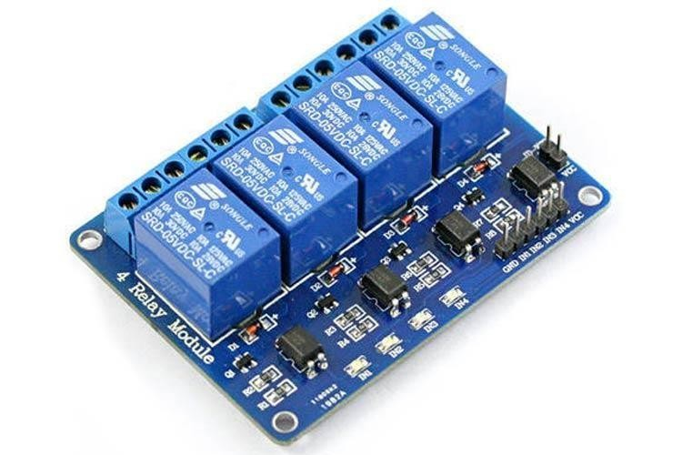
A power relay module is an electrical switch that is operated by an electromagnet. The electromagnet is activated by a separate low-power signal from a micro controller. When activated, the electromagnet pulls to either open or close an electrical circuit.

2.1.2. Gear motor

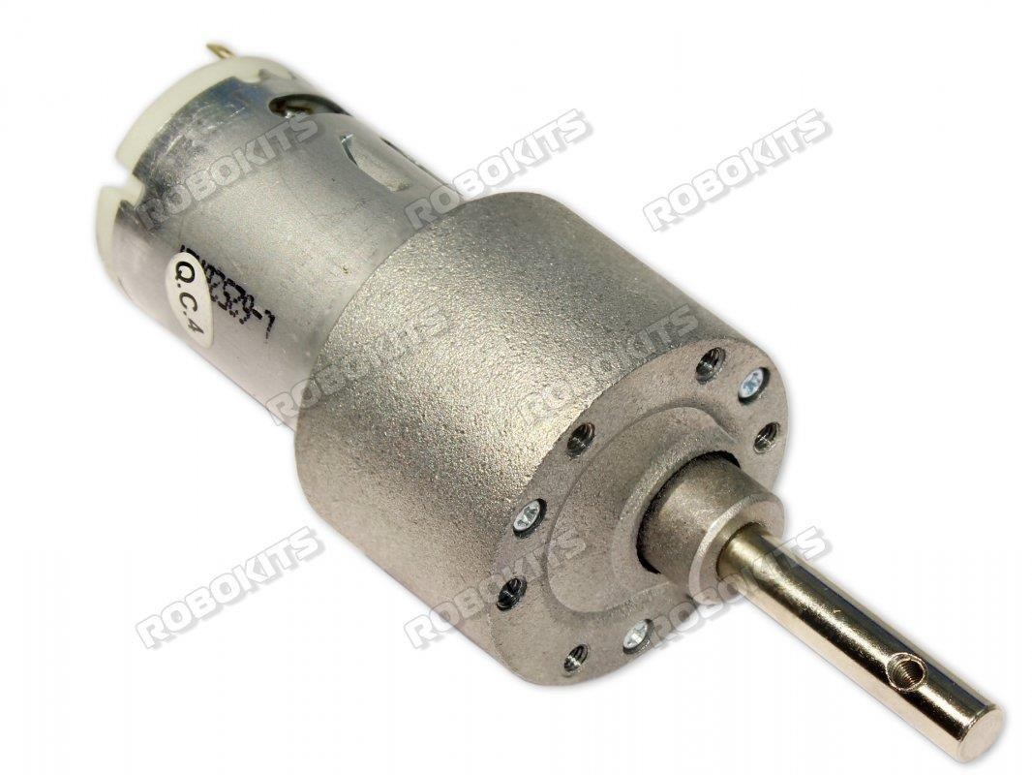

GEAR MOTOR
A gearmotor (or geared motor) is a small electric motor (AC induction, permanent magnet DC, or brushless DC) designed with an integral (non-separable) gear reducer (gearhead) attached. The end shield on the drive end of the motor (light blue, below) is designed to provide a dual function. Their main purpose is to allow the reduction from an initial high speed to a lower one without negatively affecting the mechanism. In addition to this adjustment, a gear motor is in charge of adjusting the mechanical power of a system.

2.1.3. Node MCU ESP8266/ 32Wifi

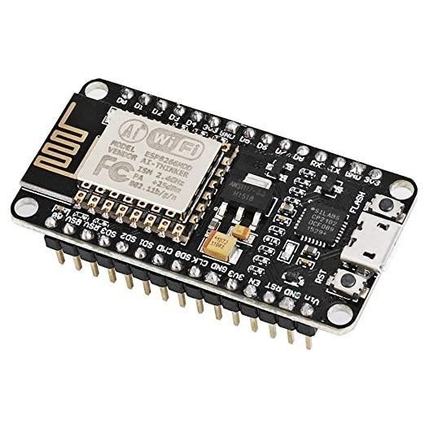

NODE MCU

Node MCU is an open-source Lua based firmware and development board specially targeted for IoT based Applications. It includes firmware that runs on the ESP8266 Wi-Fi SoC from Espressif Systems, and hardware which is based on the ESP-12 module.

2.1.4. Lippo Battery
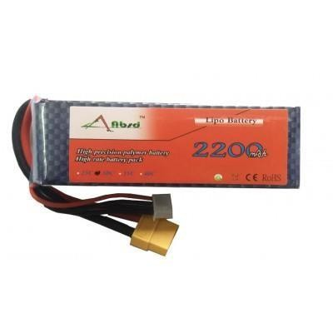

LIPO BATTERY
Lippo Battery, its full name is lithium polymer battery, people also called Li-po battery, or more correctly lithium-ion polymer battery (abbreviated as LiPo, LIP, Lipoly and others). Lippo is a rechargeable battery of lithium-ion technology using a polymer electrolyte instead of a liquid one. High conductivity semisolid polymers form this electrolyte. These Lippo batteries provide a higher specific energy than other lithium-battery types. It is a newer type of battery now used in many consumer electronics devices. They have been gaining in popularity in the radio control industry over the last few years, and are now the most popular choice for anyone looking for long run times and high power.
Lippo battery is widely used in robotics because of their light weight, high discharge rates and relatively good capacity, except the voltage ratings are available in increments of 3.7 V.

2.1.5. Jumper wires

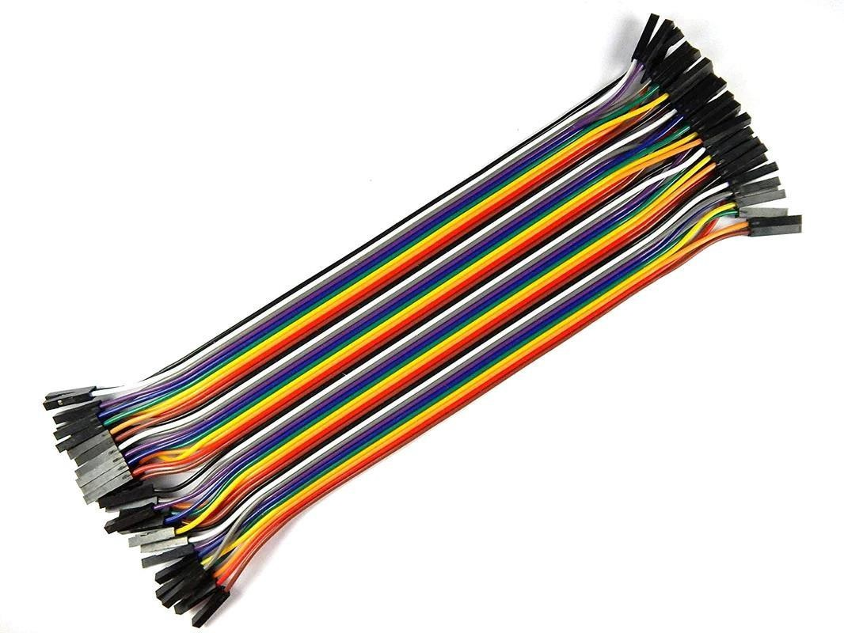

JUMPER WIRE

Jumper wires are simply wires that have connector pins at each end, allowing them to be used to connect two points to each other without soldering. Jumper wires are typically used with breadboards and other prototyping tools in order to make it easy to change a circuit as needed.

2.1.6 L Clamps

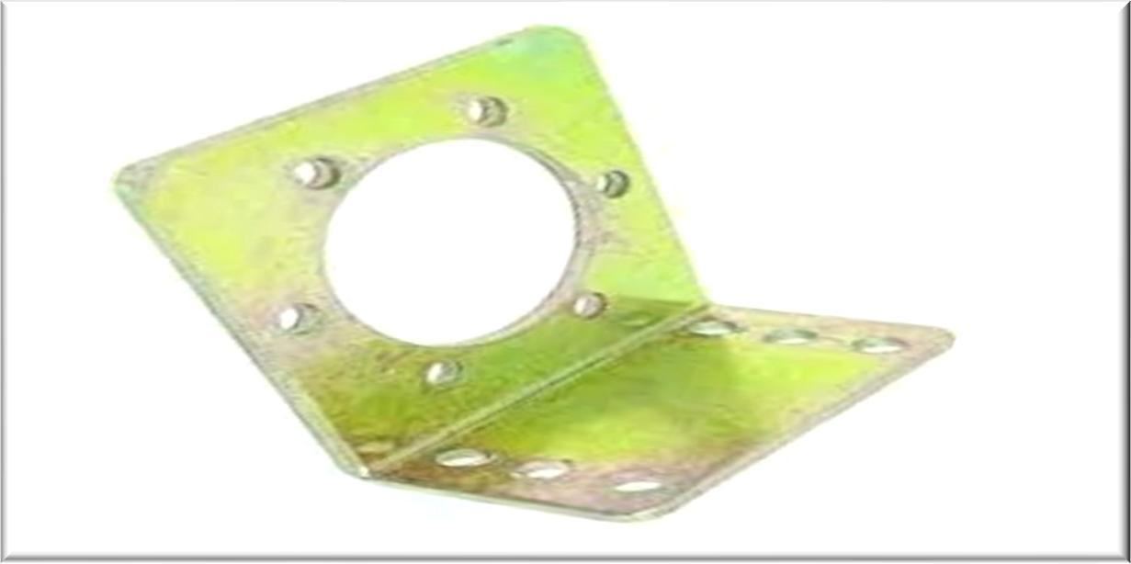

L CLAMPS

(L clamps) typically refer to a type of woodworking or metalworking clamp that has an L-shaped design. These clamps are used to hold two pieces of material together at a right angle, forming an "L" shape.

2.2 CONCEPT USED: -
The underlying mechanical principal used in this project is differential drive four omni-directional wheels are a part said to be drive.

2.2.1 DIFFERNTIAL DRIVE: -
The differential drive is a two-wheeled drive system with independent actuators for each wheel. The name refers to the fact that the motion vector of the robot is sum of the independent wheel motions, something that is also true of the mechanical differential (however, this drive system does not use a mechanical differential). The drive wheels are usually placed on each side of the robot and toward the front.
Straight-line motion is accomplished by turning the drive wheels at the same rate in the same direction, although that's not as easy as it sounds. In-place (zero turning radius) rotation is done by turning the drive wheels at the same rate in the opposite direction. Arbitrary motion paths can be implemented by dynamically modifying the angular velocity and/or direction of the drive wheels. In practice, however, complexity is reduced by implementing motion paths as alternating sequences of straight-line translations and in-place rotations.

2.3.1 SOLDERING
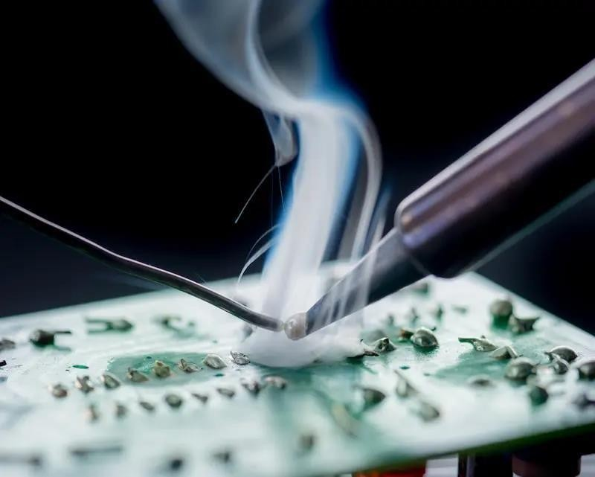

SOLDERING
Soldering is a joining process used to join different types of metals together by melting solder. Solder is a metal alloy usually made of tin and lead which is melted using a hot iron. The iron is heated to temperatures above 600 degrees Fahrenheit which then cools to create a strong electrical bond.

2.3.2 DRILLING
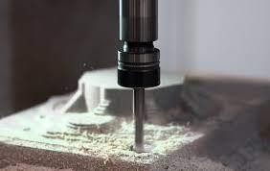

DRILLING
Drilling is a cutting process where a drill bit is spun to cut a hole of circular crosssection in solid materials. The drill bit is usually a rotary cutting tool, often multipoint. The bit is pressed against the work-piece and rotated at rates from hundreds to thousands of revolutions per minute.

2.3.3 FILING
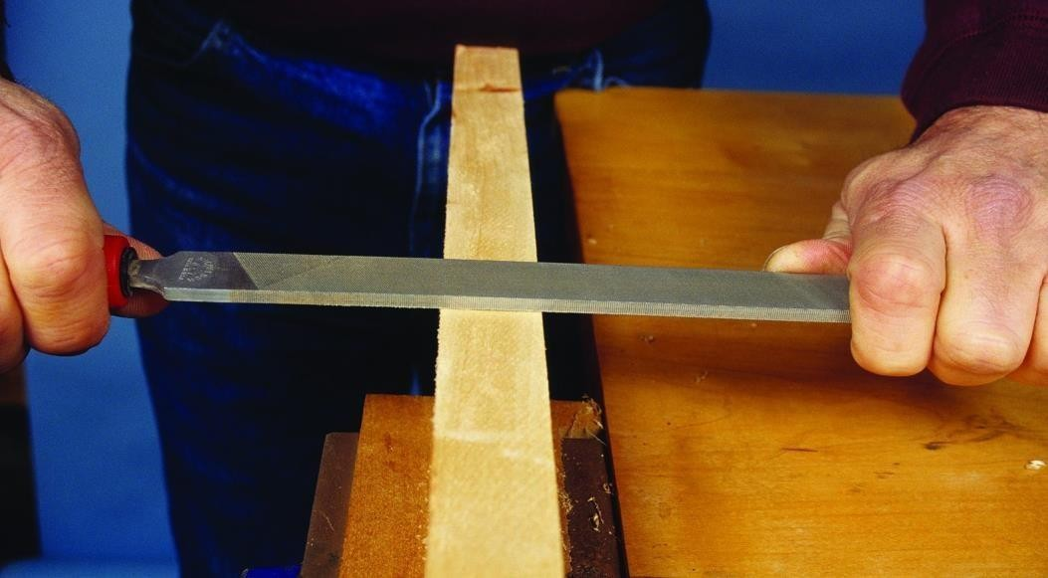
FILLING
Filing is a material removal process in manufacturing. Similar, depending on use, to both sawing and grinding in effect, it is functionally versatile, but used mostly for finishing operations, namely in deburring operations. Filing operations can be used on a wide range of materials as a finishing operation. Filing helps achieve workpiece function by removing some excess material and deburring the surface. Sandpaper may be used as a filing tool for other materials, such as wood.

2.3.4 FITTING
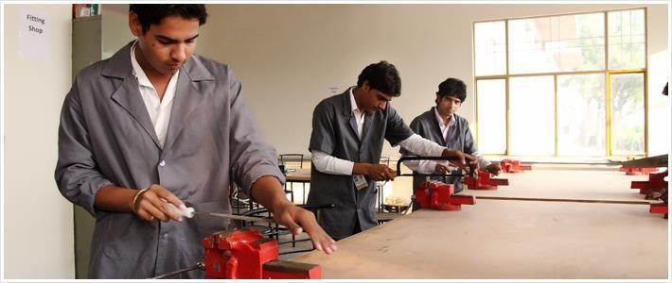
FITTING
Fitting is the assembling together of parts and removing metals to secure the necessary fit is called fitting. An operator who does the fitting job is called fitter. Fitting involves certain amount of bench work using hand tools or power operated tools. The various operations involved in fitting are filing, marking, sawing, chipping, drilling, reaming, tapping, etc.

2.3.5 TOOLS REQUIRED
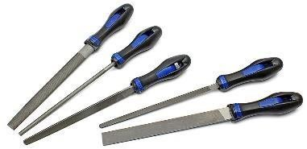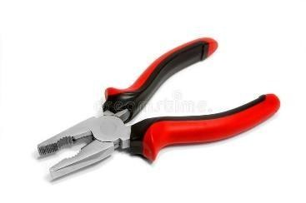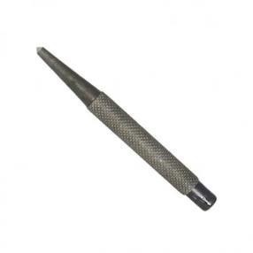

FILES PILERS CENTE PUNCH

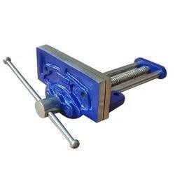
CARPENTARY VICE BALL PEEN HAMEER


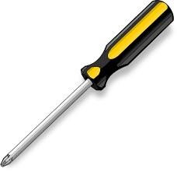
SAWS SCREWDRIVER

TYPES OF FILES
FLAT FILE
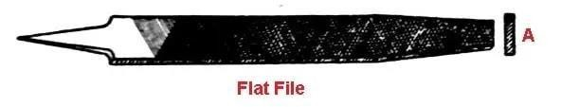
This file is of rectangular cross-section in shape. It is made slightly tapered both in width and thickness. Double cut teeth are cut on the face and simple-cut teeth are cut on the edge. These are used to reduce flat surface by filing of finishing.

HAND FILE
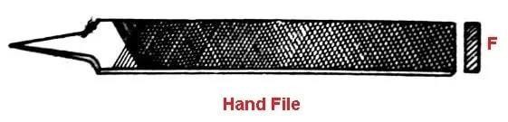
This file is almost similar to the flat file. It is used for filing of internal right-angle side of a job. It is also called safe edge file.
ROUND FILE
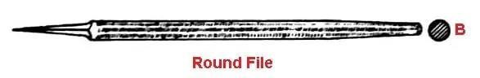
This type of file has a round section. It is used for rubbing or finishing keyhole of small diameter.

HALF ROUND FILE
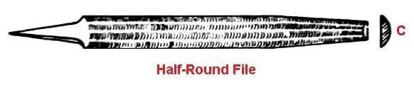
It is a file which is on the side and curved on the other side. Double cut dents are cut on it and like a round file, it is also tapered. With this file, the damaged hole can be set in order again.
SQUARE FILE
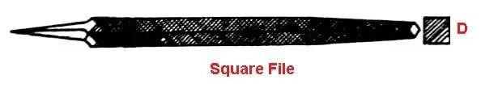
It is square in shape and is somewhat tapered. Filing of rectangular, square groove, slots and key-way is done with this file.

2.4 CONSTRUCTION AND WORKING OF BOT
We are using Wood for designing the base and jaws of the bot, this will manage the weight according to the rules of the game.
The 4 300rpm 12V dc motors will be connected in parallel connections to each other for better working of the bot. The back jaw is made of metal curved to the required design.
A WIFI operated Node MCU and relay module is also placed in the bot.
To first solder red wires to all positive terminals of all DC motors then black wires to all negative terminals of DC motors. Check the connections by connecting the wires to a battery.

2.4.1 Relay Module Connections
Connect the Red wires on the positive terminals of the relay module and black wires to the negative terminal of the relay module

2.4.2 Node MCU Connections
Coding is done in node MCU is done as follows:
- Connect node mcu to computer using USB cable, we see blue onboard led flicker when powered up
- Install COM
- Install Arduino IDE 1.6.4
- Install ESP8266 board package
- Open Arduino IDE- >File- >Preferences- >Settings.
- Enter the link and click OK to save the changes. Now install ESP8266 package.

2.4.3 Connections from Node MCU to Relay module are as follows:
- GND-GND
- VCC-VV
- IN1-D1 4. IN2-D2 5. IN3-D3
6. IN4-D4
Install ESP8266 application on the mobile to be used as remote controller
Connect it to the node MCU via WIFI
When the button showing arrow to move forward is clicked, all the four tires move and the bot moves forward and visa-versa to move backwards.
To move the bot right or left the specific arrow is pressed and tire pair of the same

side only moves.

2.5 SOURCE CODE

#define PIN1 2 // L298N in3 motors Left GPIO2(D4)
#define PIN2 0 // L298N in4 motors Left GPIO0(D3)
#define PIN3 4
#define PIN4 5

#include <ESP8266WiFi.h>
#include <WiFiClient.h>
#include <ESP8266WebServer.h>
String command; //String to store app command state.

const char* ssid = "HIGH
HORSEPOWER";
const char* password= "DMD@12345";

ESP8266WebServer server(80);

void setup() {

pinMode(PIN1, OUTPUT); pinMode(PIN2, OUTPUT); pinMode(PIN3, OUTPUT); pinMode(PIN4, OUTPUT);

Serial.begin(115200);

// Connecting WiFi

WiFi.mode(WIFI_AP);
WiFi.softAP(ssid,password);

IPAddress myIP = WiFi.softAPIP();
Serial.print("AP IP address: ");
Serial.println(myIP);

// Starting WEB-server
server.on ( "/",
HTTP_handleRoot );
server.onNotFound ( HTTP_handleRoot );
server.begin();
}

void goAhead(){  digitalWrite(PIN1, HIGH); digitalWrite(PIN2, HIGH); digitalWrite(PIN3, LOW); digitalWrite(PIN4, LOW);  }  void goBack(){  digitalWrite(PIN1, LOW); digitalWrite(PIN2, LOW); digitalWrite(PIN3, HIGH); digitalWrite(PIN4, HIGH);  }  void goLeft(){  digitalWrite(PIN1, HIGH); digitalWrite(PIN2, HIGH); digitalWrite(PIN3, HIGH); digitalWrite(PIN4, LOW); | 17 | }  void goRight(){  digitalWrite(PIN1, HIGH); digitalWrite(PIN2, HIGH); digitalWrite(PIN3, LOW); digitalWrite(PIN4, HIGH);  }  void goSLeft(){  digitalWrite(PIN1, LOW); digitalWrite(PIN2, HIGH); digitalWrite(PIN3, HIGH); digitalWrite(PIN4, LOW);  }  void goSRight(){  digitalWrite(PIN1, HIGH); digitalWrite(PIN2, LOW); digitalWrite(PIN3, LOW); digitalWrite(PIN4, HIGH);

}  void goStop(){  digitalWrite(PIN1, LOW); digitalWrite(PIN2, LOW); digitalWrite(PIN3, LOW); digitalWrite(PIN4, LOW);  }  void loop() { server.handleClient();  command = server.arg("State"); if (command == "F") goAhead(); else if (command == "B") goBack();  //NORMAL TURNS  else if (command == "L") goLeft(); else if (command == "R") goRight();  //SHARP TURNS else if (command == "G") goSLeft(); else if (command == "I") goSRight();  else if (command == "S") goStop();  }  18 | void HTTP_handleRoot(void) {  if( server.hasArg("State") ){  Serial.println(server.arg("State" ));  }  server.send ( 200, "text/html", "" ); delay(

- FUTURE WORK
3.1 Application Of RC Car :-
The application of RC cars extends beyond just leisure and hobbyist pursuits. Here are several practical applications of RC cars:
- *Education and STEM Learning*: RC cars can be used as educational tools to teach principles of science, technology, engineering, and mathematics (STEM). They provide handson learning experiences in areas such as electronics, mechanics, and physics.

- *Research and Development*: RC cars serve as valuable platforms for testing and prototyping new technologies and concepts in automotive design, such as electric drivetrains, autonomous driving systems, and advanced materials.
enforcement training exercises to simulate vehicle operations and tactical maneuvers in a controlled environment. They allow 3. *Military and Law Enforcement Training*: RC cars are used in military and law personnel to practice driving skills, coordination, and teamwork without the risks associated with full-sized vehicles.

4. CONCLUSION
In conclusion, RC cars offer a dynamic and engaging hobby experience for enthusiasts of all ages. These miniature vehicles incorporate a wide range of technologies, including remote control systems, electric motors, differential drives, and battery technology, to deliver thrilling and immersive driving experiences.
From high-speed racing to precise maneuvering and intricate customization, RC cars provide endless opportunities for experimentation, learning, and fun. Moreover, they foster social interaction and community engagement through races, competitions, and shared hobbies, bringing enthusiasts together to celebrate their passion for remote-controlled vehicles.
Whether it's mastering the intricacies of vehicle dynamics, experimenting with advanced tuning techniques, or simply enjoying the thrill of driving, RC cars continue to captivate and inspire hobbyists around the world. With their versatility, accessibility, and endless potential for creativity, RC cars remain a beloved pastime for generations to come.

19

5. REFERNCES
- https://link.springer.com/chapter/10.1007/978-3-642-40849-6_10
- https://papers.ssrn.com/sol3/papers.cfm?abstract_id=3353197
- https://ieeexplore.ieee.org/abstract/document/8806152
- https://ieeexplore.ieee.org/abstract/document/5558606
- https://link.springer.com/chapter/10.1007/978-1-4842-9376-8_14
- https://iopscience.iop.org/article/10.1088/1742-6596/1361/1/012035/meta

20

