**App Screens & Layouts (Wireframe)**

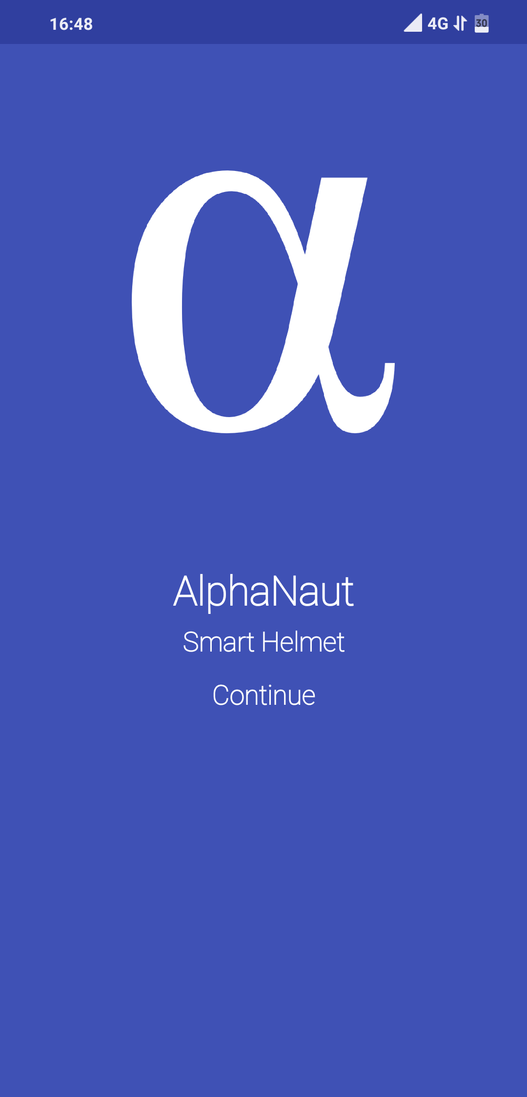

**Login Screen:**

 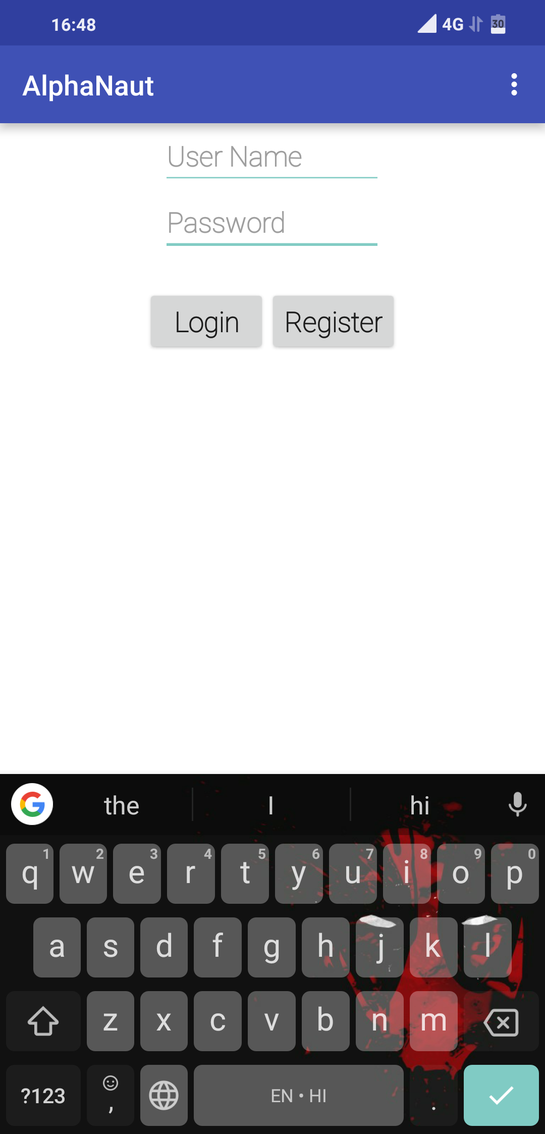

* User will be greeted with the welcome screen
* Then the user needed to login to the app to continue
* The user authentication is done using Google Firebase

**Home Screen**:

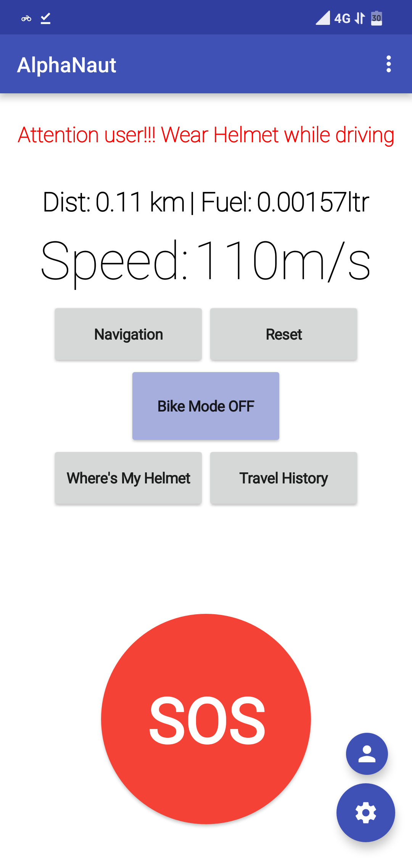

* After login the user will be welcomed with home screen having all the basic data
* The user can see current speed, distance travelled and fuel consumption
* It shows an alert if the user is not wearing helmet
* In case of emergency press SOS button to alert nearby people then call and send message to your relatives

**Navigation:**

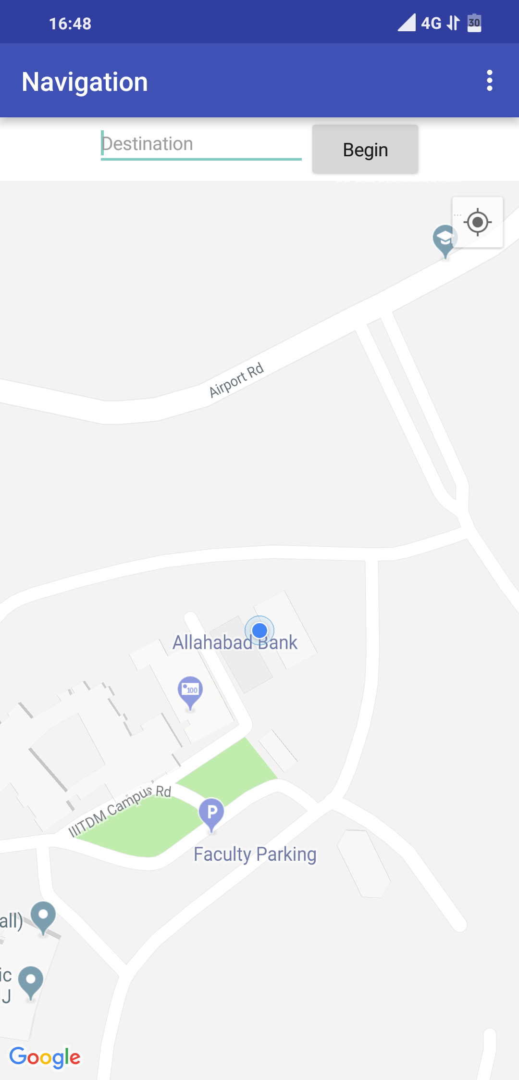 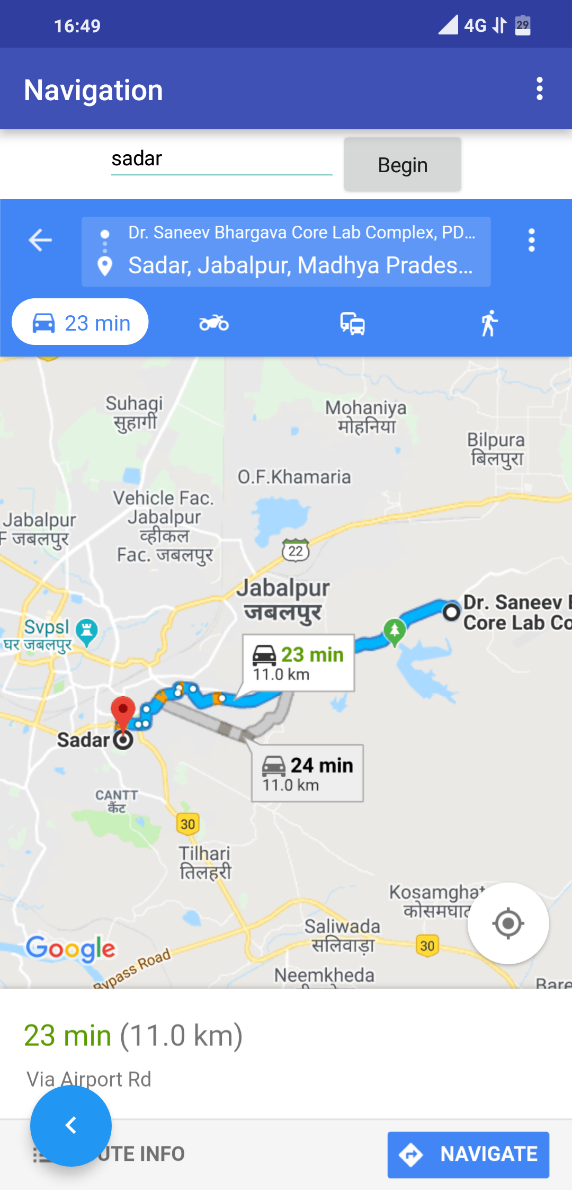

* Navigation Screen gives live location tracking of the user using the mobile GPS.
* The user can also start the navigation to the place he/she wanted to go directly from the app.
* It used google API for this purpose.

**Where’s My Helmet:**

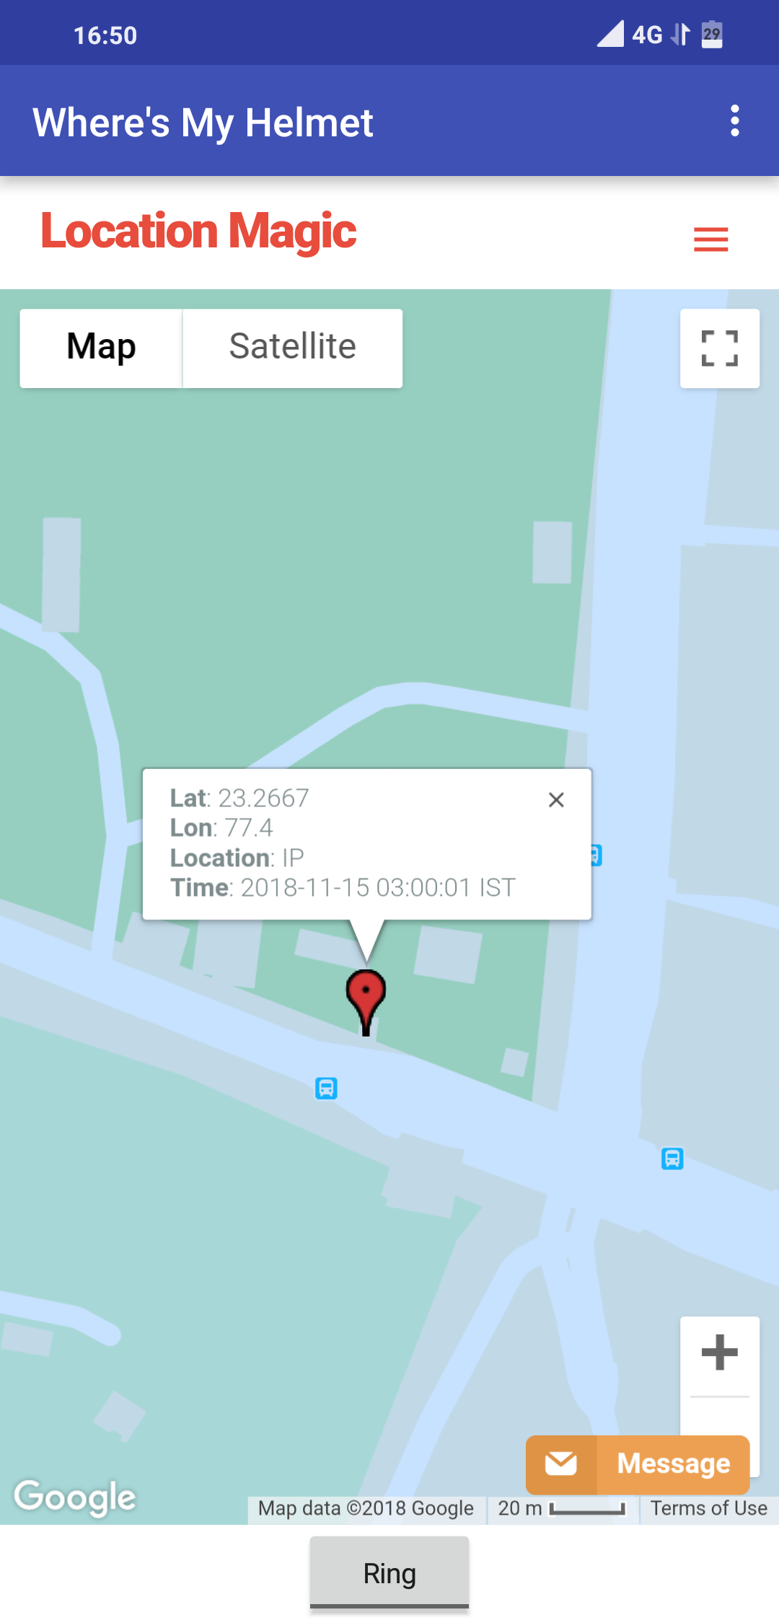

* This screen show the location of the helmet using its IP Address, and nearby cell towers and open wifi networks
* The have the option to ring the helmet if user lost it nearby
* Location magic API used for the purpose

**Settings:**

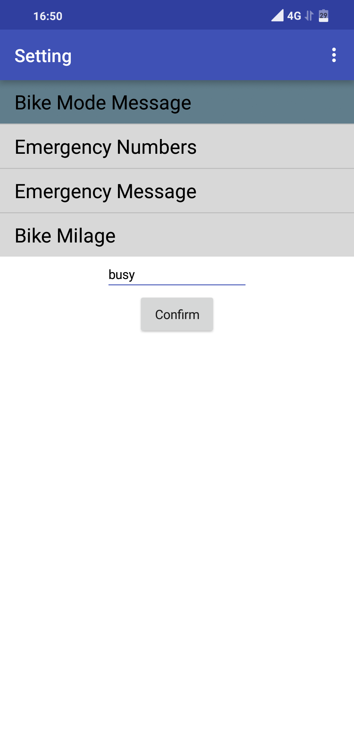 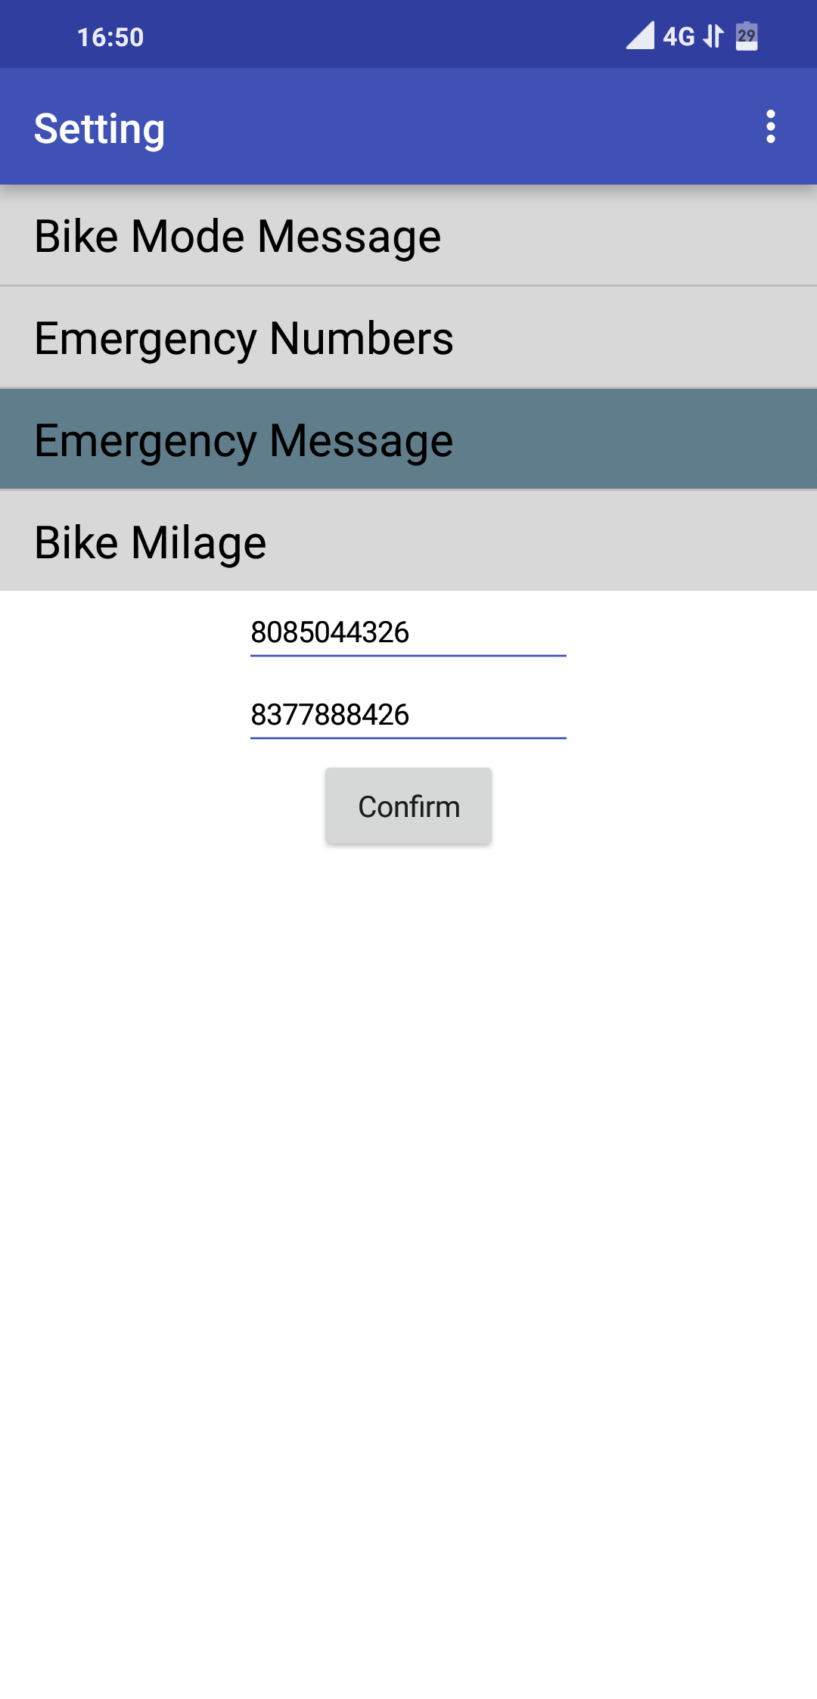

* Under the setting user can change messages to be sent, change emergency numbers and mileage of your bike for calculating fuel consumption.
* Data is store locally as well as on cloud.

**SOS Message:**

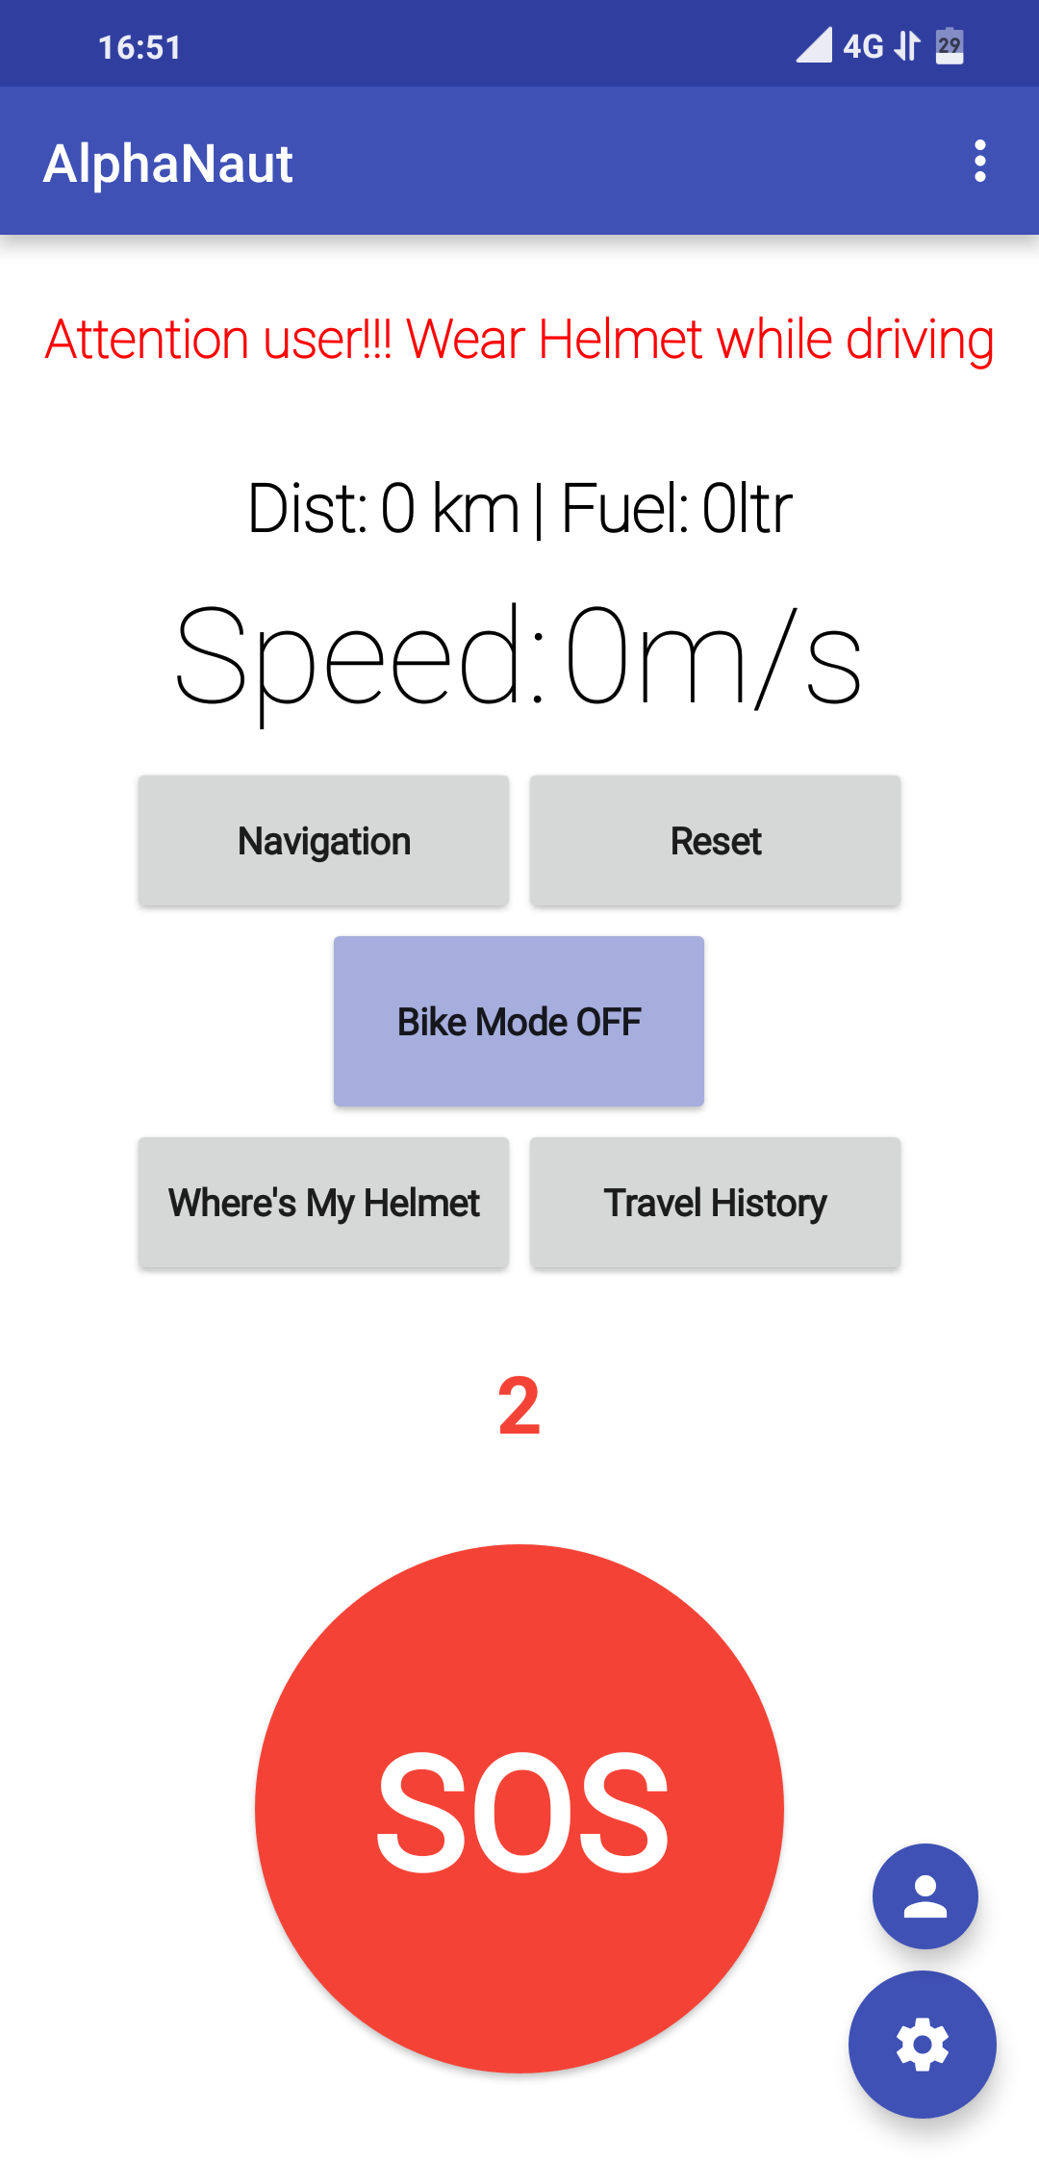 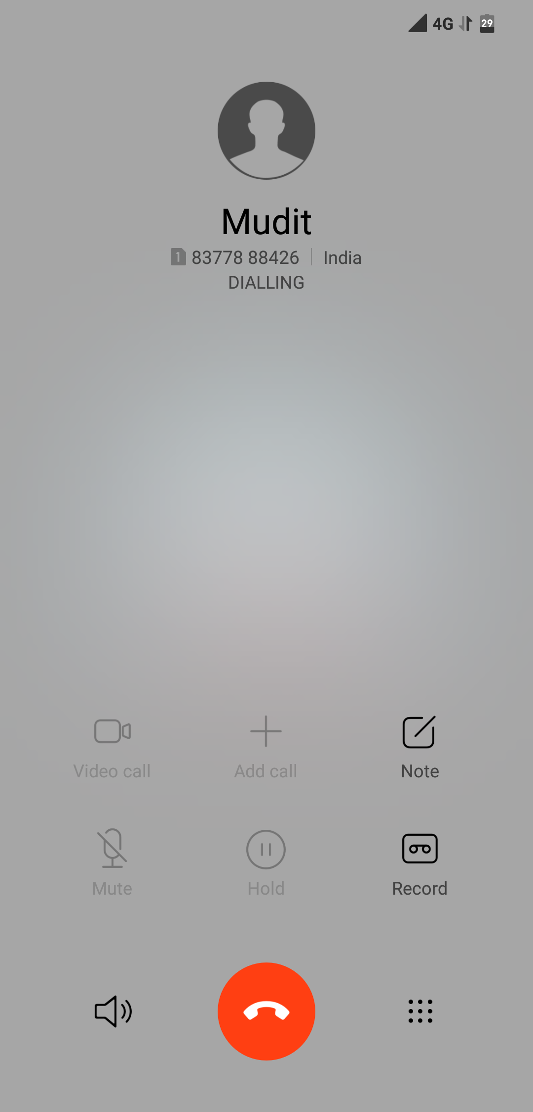

* SOS message can be called in two case :
  + Automatically when accident detected
  + By user by repeatedly pressing SOS button 5 times
* Emergency message with the user’s location will be sent via message and one of his/her relative will be called
* Sound and Torch used in case if user is in dark to alert others.

**Bike Mode:**

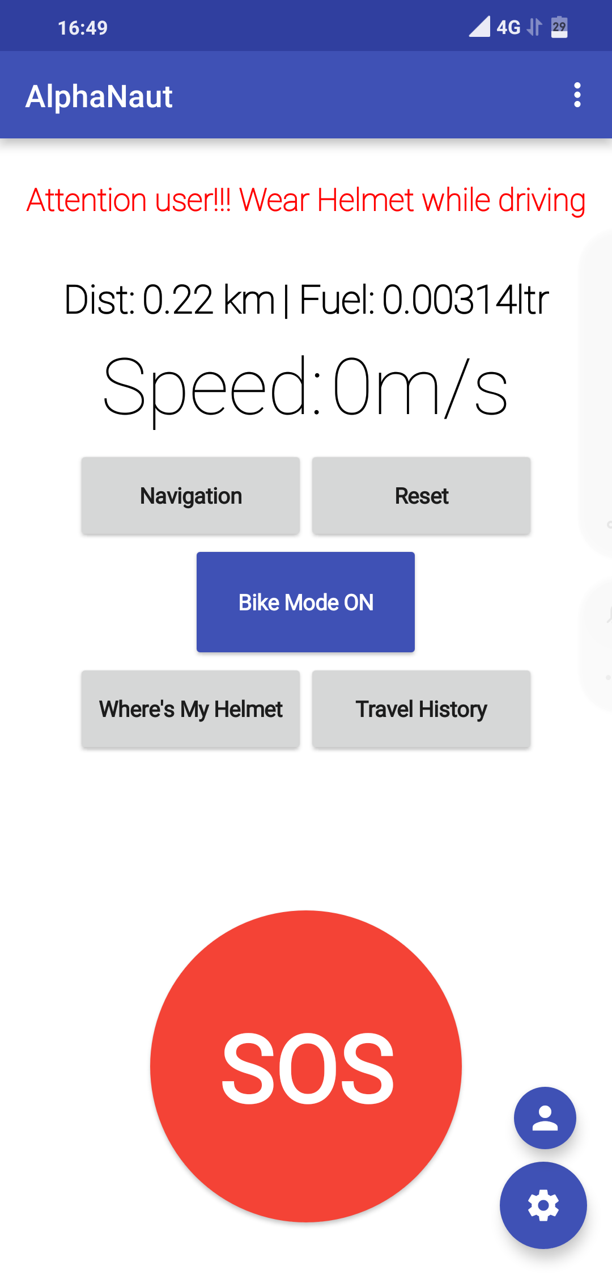

* Bike Mode allows user to silent all type of sounds, to prevent from being distracted.
* When an another person calls user his/her call will be rejected with the appropriate message to the caller.