Plotting & Visual Storytelling
Install and Set Up Matplotlib
1. What is Matplotlib?
Matplotlib is a Python library for creating static, animated, and interactive visualisations. It is the most widely used plotting library in the Python data science ecosystem.
Key facts:
- Created by John Hunter in 2003
- Built on NumPy arrays
- Powers the default plotting in Pandas, and is the backend for Seaborn
- Works in Jupyter notebooks, scripts, and web applications

2. Installing Matplotlib
Using pip:
pip install matplotlib
Using conda (Anaconda/Miniconda):
conda install matplotlib
In a Jupyter notebook cell:
!pip install matplotlib
To check the installed version:
import matplotlib
print(matplotlib.__version__)

3. Importing matplotlib.pyplot
Matplotlib is typically used through its pyplot submodule. The standard import alias is plt:
import matplotlib.pyplot as plt
Always use plt as the alias — it is a universal convention across all documentation, tutorials, and codebases.

4. The Figure and Axes Model
Matplotlib uses a two-layer structure:
Component | Description
Figure | The entire window or canvas. One figure can hold multiple plots.
Axes | A single plot within a figure. Contains the x-axis, y-axis, data, title, and labels.
You will most often interact with plt directly (which manages the current Axes automatically), but understanding Figure and Axes is essential for subplots and advanced customisation.
fig, ax = plt.subplots() # create a Figure with one Axes
ax.plot([1, 2, 3], [4, 5, 6])
plt.show()
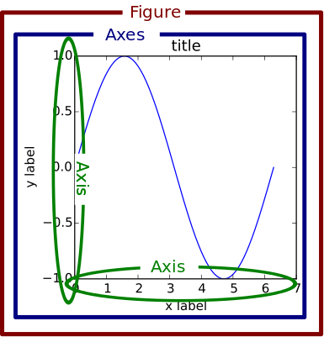

5. Verifying the Installation
Run the following to confirm Matplotlib is installed and working:
import matplotlib.pyplot as plt

plt.plot([1, 2, 3], [1, 4, 9])
plt.title("Setup Check")
plt.xlabel("x")
plt.ylabel("y")
plt.show()
Expected output: A window or inline cell displaying a curved line rising from bottom-left to top-right.
If you see the plot — installation is confirmed.
Common issue: In some environments, plt.show() opens a separate window. In Jupyter, add %matplotlib inline at the top of the notebook to render plots inline.

Install and Use Seaborn for Statistical Visualisation
1. Installing and Importing Seaborn
Seaborn is a third-party library, typically installed alongside Pandas and Matplotlib. In your terminal or Jupyter notebook, you can install it using pip:
pip install seaborn
By convention, Seaborn is imported with the alias sns (a reference to Samuel Norman Seaborn from the show The West Wing).
import seaborn as sns
import matplotlib.pyplot as plt
import pandas as pd
2. Applying Seaborn Themes
Even if you are only writing Matplotlib code, you can use Seaborn to instantly upgrade the visual aesthetics of your plots by calling sns.set_theme(). This applies modern background grids and color palettes.
sns.set_theme() # Applies the default Seaborn aesthetic
3. Working with Pandas DataFrames
Matplotlib usually requires you to extract data into isolated lists or arrays. Seaborn, however, is designed to read Pandas DataFrames directly. You simply provide the data parameter and specify which column names correspond to x and y.
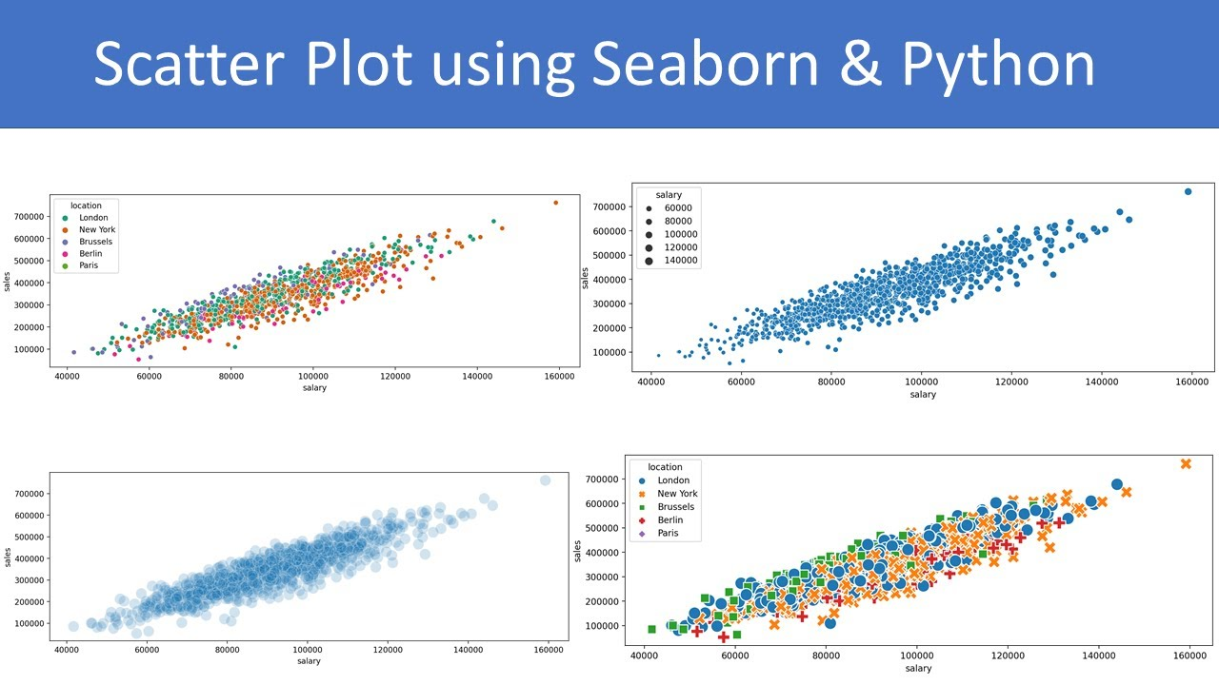
# Sample DataFrame
df = pd.DataFrame({
'Experience': [1, 2, 3, 4, 5],
'Salary': [40000, 45000, 60000, 65000, 80000],
'Department': ['IT', 'HR', 'IT', 'HR', 'IT']
})

# Creating a scatter plot using Seaborn
# Notice how we pass column names as strings, and the dataframe to 'data'
sns.scatterplot(x='Experience', y='Salary', data=df)

# Matplotlib functions still work!
plt.title("Experience vs Salary")
plt.show()
4. The Hue Parameter
One of Seaborn's most powerful features is the hue parameter. By assigning a categorical column to hue, Seaborn automatically colors the data points based on that category and instantly generates a clear legend.
# Automatically color points by 'Department'
sns.scatterplot(x='Experience', y='Salary', hue='Department', data=df)
plt.show()

Create Line Plots Using Matplotlib
1. The plt.plot() Function
plt.plot(x, y) is the core function for creating line plots. It connects data points in order, drawing a continuous line.
Minimum required arguments:
- x — sequence of x-values (list, array, Pandas Series)
- y — sequence of y-values (same length as x)
import matplotlib.pyplot as plt

x = [1, 2, 3, 4, 5]
y = [10, 25, 20, 40, 35]

plt.plot(x, y)
plt.show()

2. Plotting a Single Line
months = ["Jan", "Feb", "Mar", "Apr", "May", "Jun"]
revenue = [45000, 52000, 48000, 61000, 70000, 68000]

plt.plot(months, revenue)
plt.title("Monthly Revenue")
plt.xlabel("Month")
plt.ylabel("Revenue (USD)")
plt.show()
Key functions:
- plt.title() — adds a title above the chart
- plt.xlabel() / plt.ylabel() — labels the axes
- plt.show() — renders and displays the figure

3. Plotting Multiple Lines on the Same Axes
Call plt.plot() multiple times before plt.show(). Each call adds a new line:
months = [1, 2, 3, 4, 5, 6]
product_a = [300, 350, 400, 370, 420, 460]
product_b = [200, 230, 280, 310, 340, 390]

plt.plot(months, product_a, label="Product A")
plt.plot(months, product_b, label="Product B")
plt.legend()
plt.title("Product Sales Comparison")
plt.xlabel("Month")
plt.ylabel("Units Sold")
plt.show()
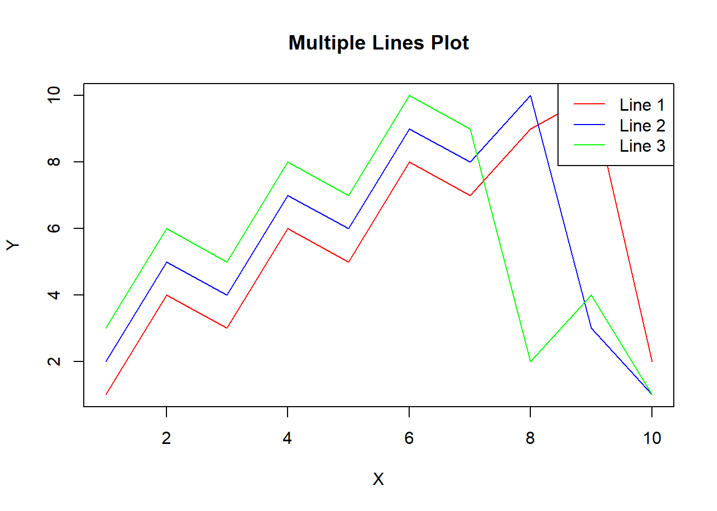
plt.legend() displays the labels defined in each label= argument.

4. Customising Line Appearance
Common styling parameters for plt.plot():
Parameter | Description | Example
color | Line colour | color='red', color='#2196F3'
linestyle | Line style | linestyle='--' (dashed), linestyle=':' (dotted)
linewidth | Line thickness | linewidth=2
marker | Data point marker | marker='o' (circle), marker='s' (square)
alpha | Transparency (0–1) | alpha=0.7
label | Legend label | label='Revenue'
plt.plot(months, revenue,
color='steelblue',
linestyle='--',
linewidth=2,
marker='o',
label='Revenue')
plt.legend()
plt.show()

5. Common Pitfalls
- Missing plt.show(): The plot is built in memory but never displayed. Always include plt.show() at the end of a plot block.
- Mismatched lengths: x and y must have the same number of elements. A mismatch raises a ValueError.
- Calling plt.show() too early: All plt.plot() calls must come before plt.show(). After plt.show(), the figure is cleared.
- Forgetting plt.legend(): If you pass label= to plt.plot(), call plt.legend() or labels will not appear.

Create Bar Charts Using Matplotlib
1. The plt.bar() Function
A bar chart represents categorical data as rectangular bars whose heights are proportional to the values they encode. In Matplotlib the function is plt.bar().
Minimum required arguments:
import matplotlib.pyplot as plt

categories = ['North', 'South', 'East', 'West']
sales = [45000, 62000, 38000, 71000]

plt.bar(categories, sales)
plt.title("Regional Sales")
plt.xlabel("Region")
plt.ylabel("Sales (USD)")
plt.show()
- First argument (x): the category labels or numeric positions along the x-axis.
- Second argument (height): the numeric value each bar reaches.
The bars are drawn in the order the data is supplied. Matplotlib automatically scales the y-axis to fit the tallest bar.
Key optional parameters:
Parameter | Default | Effect
width | 0.8 | Fractional width of each bar relative to the tick spacing
color | next in cycle | Fill colour of all bars
edgecolor | None | Outline colour of each bar
align | 'center' | Whether the bar is centred on its x position or starts at it
label | — | Legend label for this series
plt.bar(categories, sales,
width=0.6,
color='steelblue',
edgecolor='black',
label='Q1 Sales')
plt.legend()
plt.show()

2. Customising Bar Width, Color, and Alignment
Per-bar colours can be passed as a list:
colors = ['steelblue', 'coral', 'mediumseagreen', 'goldenrod']
plt.bar(categories, sales, color=colors)
plt.show()
Each element in colors corresponds to one bar in order. This is useful for highlighting a specific bar (e.g., the best-performing region):
colors = ['steelblue', 'steelblue', 'steelblue', 'coral'] # highlight West
plt.bar(categories, sales, color=colors)
plt.show()
Bar width controls visual density. Narrower bars (width=0.4) add whitespace and feel lighter; wider bars (width=0.9) feel heavier and more compact. Use the default 0.8 as a starting point.
align parameter:
- 'center' (default): the x tick marks the middle of the bar.
- 'edge': the x tick marks the left edge of the bar. Rarely needed unless you are manually placing bars at numeric positions.

3. Grouped Bar Charts (Side-by-Side)
When you have two or more numeric series for the same categories, a grouped bar chart places bars side by side at each category position. Matplotlib does not have a single "grouped bar" function; you build it by plotting multiple plt.bar() calls at offset x-positions.
import numpy as np
import matplotlib.pyplot as plt

categories = ['North', 'South', 'East', 'West']
q1_sales = [45000, 62000, 38000, 71000]
q2_sales = [51000, 59000, 44000, 68000]

x = np.arange(len(categories)) # [0, 1, 2, 3]
width = 0.35 # half-width of each bar

fig, ax = plt.subplots()
ax.bar(x - width/2, q1_sales, width, label='Q1', color='steelblue')
ax.bar(x + width/2, q2_sales, width, label='Q2', color='coral')

ax.set_xticks(x)
ax.set_xticklabels(categories)
ax.set_title("Q1 vs Q2 Regional Sales")
ax.set_xlabel("Region")
ax.set_ylabel("Sales (USD)")
ax.legend()
plt.show()
How the offset works:
- np.arange(len(categories)) produces evenly spaced integer positions.
- Subtracting width/2 shifts the first series left; adding width/2 shifts the second series right.
- ax.set_xticks(x) and ax.set_xticklabels(categories) place the category names between the two bars.
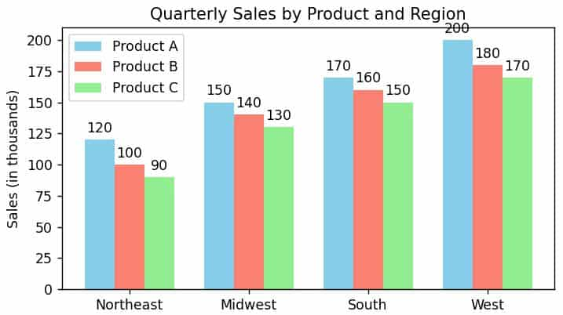

4. Annotating Bars with Value Labels
Placing the exact value above or inside a bar removes the need for the reader to read the y-axis precisely.
Using ax.bar_label() (Matplotlib ≥ 3.4, the recommended approach):
fig, ax = plt.subplots()
bars = ax.bar(categories, sales, color='steelblue')
ax.bar_label(bars, fmt='%d', padding=3)
ax.set_title("Regional Sales with Labels")
ax.set_ylabel("Sales (USD)")
plt.show()
- ax.bar() returns a BarContainer object assigned to bars.
- ax.bar_label(bars) reads the heights from that container and places the text above each bar.
- fmt='%d' formats the number as an integer. Use fmt='%.1f' for one decimal place, or fmt='${:,.0f}'.format for currency.
- padding=3 adds 3 points of vertical space between the bar top and the label.
Using plt.text() for full manual control:
for i, (cat, val) in enumerate(zip(categories, sales)):
plt.text(i, val + 500, str(val), ha='center', va='bottom', fontsize=9)
This iterates over each bar, placing text at the x-position i and y-position val + 500 (slightly above the bar top). ha='center' centres the text horizontally over the bar.

5. When to Use Bar Charts vs Line Charts
Scenario | Preferred Chart
Comparing discrete, unordered categories (regions, products, teams) | Bar chart
Showing change over continuous or ordered time (months, years) | Line chart
Ranking items from highest to lowest | Bar chart (or horizontal bar chart)
Showing trend and momentum | Line chart
A small number of time periods (e.g., 4 quarters) presented as distinct snapshots | Bar chart is acceptable
Rule of thumb: if the x-axis represents time and the data is continuous (every point is measured), use a line chart. If the x-axis represents named categories where the order is arbitrary or the gaps between categories are not meaningful, use a bar chart.
A common mistake is using a line chart for categorical data (e.g., connecting "North → South → East → West" with a line implies a continuous relationship between those regions, which does not exist).

Create Histograms to Visualize Data Distributions
1. What is a Histogram? (vs Bar Chart)
A histogram visualises the frequency distribution of a single continuous numerical variable. It divides the data range into equal-width intervals called bins and draws a bar for each bin whose height represents the number of data points (or frequency) that fall within that interval.
Histogram vs Bar Chart — key distinctions:
Feature | Bar Chart | Histogram
Data type | Categorical (discrete named groups) | Numerical (continuous)
x-axis | Category names | Numeric range (bin edges)
Bar spacing | Gaps between bars (categories are separate) | No gaps (continuous range)
y-axis | Count or value per category | Frequency (count per bin)
Purpose | Compare magnitudes across categories | Reveal distribution shape
A bar chart answers "which category is largest?" A histogram answers "where is most of my data concentrated, and what shape does it form?"
Distribution shapes to recognise:
- Normal (bell-shaped): peak in the middle, symmetric tails. Exam scores often follow this shape.
- Right-skewed: peak on the left, long tail extending right. Income distributions are typically right-skewed.
- Left-skewed: peak on the right, long tail extending left.
- Bimodal: two distinct peaks. Suggests two subpopulations (e.g., men and women's heights combined).
- Uniform: roughly flat. Each bin has approximately equal frequency.

2. The plt.hist() Function
import matplotlib.pyplot as plt
import numpy as np

np.random.seed(42)
scores = np.random.normal(loc=68, scale=12, size=200).clip(0, 100).astype(int)

plt.hist(scores, bins=15, color='steelblue', edgecolor='black')
plt.title("Distribution of Exam Scores")
plt.xlabel("Score")
plt.ylabel("Frequency")
plt.show()
Key parameters:
Parameter | Default | Effect
x | — | The data array (required)
bins | 10 | Number of equal-width bins, or explicit bin edges
color | next in cycle | Fill colour of the bars
edgecolor | None | Outline colour of each bar
alpha | 1.0 | Transparency (0 = invisible, 1 = opaque)
density | False | If True, y-axis shows probability density instead of count
label | — | Legend label for this series
Unlike plt.bar(), you pass the raw data array to plt.hist(), not pre-computed counts. Matplotlib counts how many values fall in each bin automatically.

3. Choosing the Right Number of Bins
The number of bins fundamentally changes what the histogram communicates:
- Too few bins (e.g., 3): over-smoothed; the shape appears deceptively flat or simple, hiding important structure.
- Too many bins (e.g., 100): under-smoothed; bars become narrow spikes, and random noise dominates over signal.
Common rules of thumb:
Rule | Formula | For n=200
Square root | bins = int(√n) | ≈ 14
Sturges' rule | bins = 1 + log₂(n) | ≈ 9
Rice rule | bins = 2 × n^(1/3) | ≈ 12
In practice, try 10–15 bins as a starting point and adjust until the distribution shape is clear without excessive noise.
fig, axes = plt.subplots(1, 3, figsize=(12, 4))
for ax, b in zip(axes, [5, 15, 50]):
ax.hist(scores, bins=b, color='steelblue', edgecolor='black')
ax.set_title(f"bins={b}")
ax.set_xlabel("Score")
ax.set_ylabel("Frequency")
plt.tight_layout()
plt.show()

4. Normalised Histograms (density=True)
By default, plt.hist() shows raw counts on the y-axis. Setting density=True converts the y-axis to probability density, where the area of all bars sums to 1.
plt.hist(scores, bins=15, density=True, color='steelblue', edgecolor='black', alpha=0.7)
plt.title("Exam Score Distribution (Density)")
plt.xlabel("Score")
plt.ylabel("Probability Density")
plt.show()
When to use density=True:
- When comparing two histograms with different sample sizes. Raw counts would be misleading if one dataset has 200 points and another has 1,000.
- When overlaying a theoretical probability density function (e.g., a normal curve from scipy.stats).
What density means mathematically: Each bar's area (height × bin width) equals the fraction of data in that bin. The total area across all bars equals exactly 1.0. The y-axis unit is "density per unit of x", not a count or a percentage.

5. Overlapping Histograms for Comparison
To compare the distributions of two groups, draw two histograms on the same axes using alpha to make them partially transparent so both are visible where they overlap.
import numpy as np
import matplotlib.pyplot as plt

np.random.seed(0)
pre_training = np.random.normal(loc=58, scale=10, size=150).clip(0, 100).astype(int)
post_training = np.random.normal(loc=74, scale=9, size=150).clip(0, 100).astype(int)

plt.hist(pre_training, bins=20, alpha=0.5, color='coral',
edgecolor='black', label='Pre-Training')
plt.hist(post_training, bins=20, alpha=0.5, color='steelblue',
edgecolor='black', label='Post-Training')

plt.title("Exam Scores: Pre vs Post Training")
plt.xlabel("Score")
plt.ylabel("Frequency")
plt.legend()
plt.show()
Key points:
- Both plt.hist() calls use the same bins count so bin widths are consistent between the two series.
- alpha=0.5 makes each histogram 50% transparent. Where they overlap, the blended colour signals the overlap region clearly.
- label= with plt.legend() identifies which colour corresponds to which group.
- Even with the same number of bins, the actual bin edges may differ if the two datasets have different ranges. To force identical bin edges, compute them explicitly: bins = np.linspace(0, 100, 21).

Create Box Plots Using Matplotlib
1. Anatomy of a Box Plot
A box plot provides a visual summary of data through quartiles. The "box" spans from Q1 to Q3, encompassing the middle 50% of the dataset—a range known as the Interquartile Range (IQR). A line inside the box marks the median. Lines extending from the box ("whiskers") indicate the lower and upper bounds of typical data. Points beyond the whiskers are flagged as outliers.
2. Using plt.boxplot()
Creating a basic box plot in Matplotlib is straightforward using plt.boxplot(). You pass an array or list of numerical data.
import matplotlib.pyplot as plt

data = [20, 22, 24, 25, 25, 26, 28, 40]
plt.boxplot(data)
plt.title("Age Distribution")
plt.ylabel("Age")
plt.show()
3. Customizing the Box Plot
By default, plt.boxplot() draws vertical boxes, highlights the median with a line, and shows outliers as empty circles. You can customize orientatation, notch shapes, and outlier marker styles using arguments.
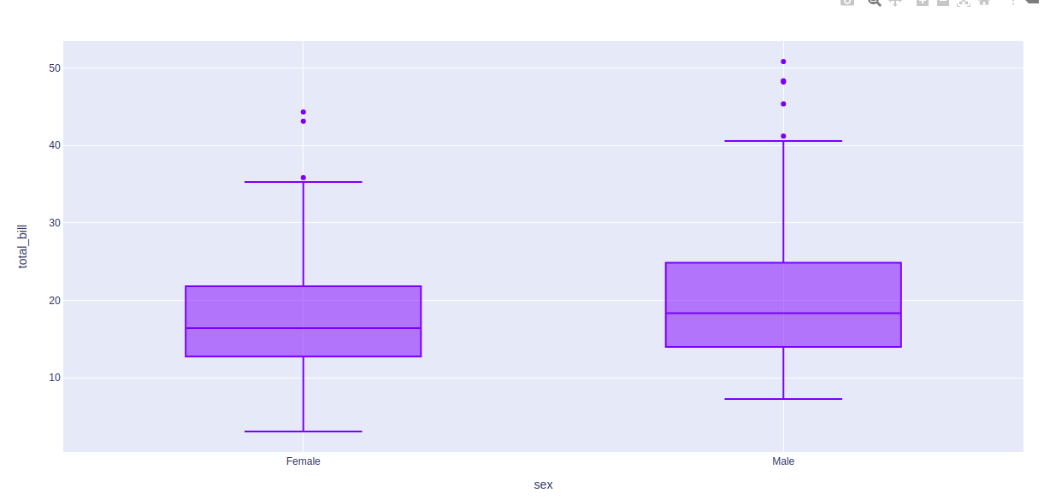
import matplotlib.pyplot as plt

data = [10, 15, 12, 18, 14, 85, 11] # 85 is an outlier

# Create a horizontal boxplot with custom outlier symbols
plt.boxplot(data, vert=False, flierprops={'marker': 'x', 'color': 'red'})

plt.title("Data with Explicit Outliers")
plt.xlabel("Values")
plt.show()
4. Comparing Multiple Distributions
A massive advantage of box plots is comparing multiple datasets side-by-side. If you pass a list of lists (or a 2D array) to boxplot(), it will render multiple boxes on the same axes.
group_a = [1, 5, 8, 10, 15]
group_b = [5, 10, 12, 18, 20]
group_c = [2, 4, 6, 8, 30] # Includes an outlier

data_list = [group_a, group_b, group_c]
labels = ['Group A', 'Group B', 'Group C']

plt.boxplot(data_list, labels=labels)
plt.title("Side-by-Side Boxplots")
plt.ylabel("Scores")
plt.show()

Create Scatter Plots Using Matplotlib
1. The plt.scatter() Function
The plt.scatter(x, y) function is the primary way to create scatter plots in Matplotlib. Unlike plt.plot(), which connects points with a line, plt.scatter() renders each (x, y) pair as an independent marker.
Basic syntax:
import matplotlib.pyplot as plt

x = [1, 2, 3, 4, 5]
y = [10, 24, 18, 35, 29]

plt.scatter(x, y)
plt.xlabel('X Variable')
plt.ylabel('Y Variable')
plt.title('Basic Scatter Plot')
plt.show()
Key distinction from plt.plot():
Feature | plt.plot() | plt.scatter()
Connects points? | Yes (by default) | No
Supports per-point colour? | No | Yes (c= list)
Supports per-point size? | No | Yes (s= list)
Best for | Trends over time | Two-variable relationships

2. Styling Scatter Points (c, s, alpha, marker)
Each parameter controls a distinct visual property of the scatter points.
s= — Point size:
- Accepts a scalar (all points same size) or a list (variable sizes).
- Units are in points², so s=100 is a 10×10 point marker.
sizes = [50, 200, 100, 350, 80]
plt.scatter(x, y, s=sizes)
c= — Point colour:
- Accepts a single named colour, a hex string, or a list of values mapped through a colourmap.
plt.scatter(x, y, c='tomato') # single colour
plt.scatter(x, y, c=[1, 2, 3, 4, 5], cmap='Blues') # mapped values
alpha= — Transparency:
- Range: 0.0 (fully transparent) to 1.0 (fully opaque).
- Useful when points overlap — lower alpha reveals density.
plt.scatter(x, y, alpha=0.4)
marker= — Point shape:
- Common options: 'o' (circle), '^' (triangle), 's' (square), '+' (cross), '*' (star), 'D' (diamond).
plt.scatter(x, y, marker='^')
edgecolors= — Marker border:
plt.scatter(x, y, edgecolors='black', linewidths=0.8)

3. Using Colour to Encode a Third Variable
When your dataset has a third variable — a category, a score, a tier — you can encode it visually using point colour. This allows a 2D chart to communicate three dimensions of information simultaneously.
Categorical third variable (discrete colours):
segment = ['Budget', 'Premium', 'Budget', 'Premium', 'Budget']
colour_map = {'Budget': 'steelblue', 'Premium': 'coral'}
colours = [colour_map[s] for s in segment]

plt.scatter(x, y, c=colours, s=100, alpha=0.8)
Continuous third variable (colour gradient):
scores = [0.2, 0.8, 0.5, 0.95, 0.3]
sc = plt.scatter(x, y, c=scores, cmap='viridis', s=100)
plt.colorbar(sc, label='Score')
The plt.colorbar() call adds a legend bar showing the colour-to-value mapping.
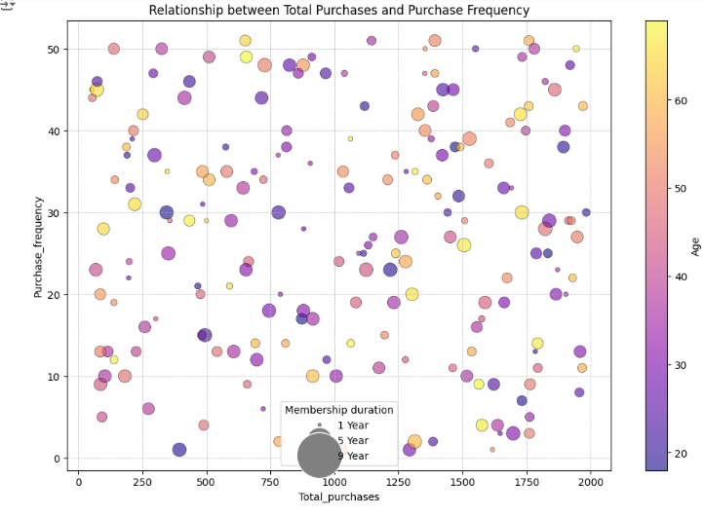

4. Identifying Outliers Visually
Scatter plots are one of the fastest ways to spot outliers — data points that fall far from the main cluster. A point with an unusually high y value for a given x, or one that sits completely isolated from the rest, is immediately visible.
Annotating an outlier:
x = [2, 4, 3, 7, 5, 8, 6, 9, 1, 10, 45]
y = [15, 40, 25, 80, 55, 95, 70, 110, 10, 130, 5]

plt.scatter(x, y, alpha=0.7)
plt.annotate('Outlier?', xy=(45, 5), xytext=(30, 30),
arrowprops=dict(arrowstyle='->', color='red'), color='red')
plt.show()
plt.annotate() draws text and an optional arrow pointing to any (x, y) coordinate on the chart.

5. Scatter vs Line Plots — When to Use Each
Choosing between a scatter plot and a line plot is a question of data structure, not aesthetics.
Use a Scatter Plot When | Use a Line Plot When
Both variables are continuous | One axis is time or an ordered sequence
You want to show the relationship between two measurements | You want to show how a value changes over time
Data points are independent (no natural ordering) | Data points are ordered and connected
Looking for clusters or outliers | Looking for trends or seasonality
Example decisions:
- Height vs weight of 200 people → scatter plot (independent measurements)
- Monthly revenue for 12 months → line plot (ordered time sequence)
- Advertising spend vs revenue by campaign → scatter plot (two measured quantities per campaign)
- Page views per day over a quarter → line plot (ordered time series)

Plotting & Visual Storytelling - II
1. Establishing The Environment
Setting a global theme first (sns.set_theme()) means every subsequent chart inherits consistent grid lines, typography, and colour palette — no per-chart restyling needed. Loading the dataset and printing 3 rows anchors the analysis to real column names before any plotting begins.
import pandas as pd
import seaborn as sns
import matplotlib.pyplot as plt

# 1. Apply a global modern theme immediately
sns.set_theme(style="whitegrid", palette="muted")

# 2. Load the dataset
diamonds = sns.load_dataset('diamonds')
print(diamonds.head(3))
2. Phase 1 — Discovery: Correlation Heatmap
Before plotting anything blindly, we let mathematics surface the strongest relationships. A heatmap shows all pairwise correlations simultaneously — far more efficient than trying every combination manually. The darkest square intersecting price tells us exactly where to focus next.
# Compute correlation strictly on numerical columns
numeric_data = diamonds.select_dtypes(include=['float64', 'int64'])
corr_matrix = numeric_data.corr()

plt.figure(figsize=(8, 6))
sns.heatmap(corr_matrix, annot=True, cmap='coolwarm', vmin=-1, vmax=1)
plt.title("Diamond Feature Correlation Matrix")
plt.show()
# Insight: We see 'carat' and 'price' have a massive 0.92 correlation!
3. Phase 2 — Drilling: Faceted Hypothesis Test
We know carat correlates with price (0.92). The next question is whether this holds across every cut quality or whether certain cuts behave differently. relplot(col='cut') creates 5 subplots with shared axes — making direct comparisons possible without any manual looping.
# Build a 5-column scatter plot array, one for each diamond 'cut'
sns.relplot(
data=diamonds,
x='carat',
y='price',
hue='color', # Add a third dimension via color
col='cut', # Shatter into 5 subplots
col_wrap=3,
alpha=0.5
)
# The axes are shared automatically, confirming visually that 'Ideal' cuts
# reach higher prices at lower carats than 'Fair' cuts!
4. Phase 3 — Polishing: Presentation-Ready Output
With the insight confirmed, exploration is done. A boxplot summarises price distributions per cut quality more cleanly than a scatter plot for a non-technical audience. sns.despine(left=True) removes chart borders so the boxes appear to float. bbox_inches='tight' ensures no axis labels are cropped in the exported image.
plt.figure(figsize=(10, 6), dpi=300)

sns.boxplot(data=diamonds, x='cut', y='price', palette='vlag')
sns.despine(left=True) # Remove left, right, and top borders

plt.title("Diamond Price Distributions Segmented By Cut Quality", fontsize=16)
plt.ylabel("Price in USD")
plt.xlabel("") # Remove the word 'cut' because it is obvious

plt.savefig("final_insight.png", bbox_inches='tight')
plt.show()

1. What is Plotly and Why Interactive?
Matplotlib produces static images (PNG, SVG). Plotly produces HTML-based interactive charts that live in the browser or a Jupyter notebook. Every Plotly chart ships with built-in:
- Hover tooltips — shows exact values when you mouse over a data point
- Zoom and pan — click-drag to zoom; double-click to reset
- Legend toggle — click a legend item to hide/show that series
- Download button — one-click PNG export via the toolbar
This makes Plotly the default choice for exploratory analysis (where you need to inspect values quickly) and for sharing results with non-technical stakeholders.
2. Installing and Importing Plotly Express
Install via pip:
pip install plotly
The standard import convention:
import plotly.express as px # high-level API — use this for most charts
import plotly.graph_objects as go # low-level API — for advanced customisation
Plotly Express (px) is the recommended starting point. It accepts Pandas DataFrames directly and requires far less boilerplate than graph_objects.
3. Creating Your First Chart with px
Every Plotly Express function follows the same pattern: pass the DataFrame, specify column names for x and y, and call fig.show().
import plotly.express as px
import pandas as pd

df = pd.DataFrame({
'Quarter': ['Q1', 'Q2', 'Q3', 'Q4'],
'Sales': [42000, 55000, 48000, 63000]
})

fig = px.bar(df, x='Quarter', y='Sales', title='Quarterly Sales')
fig.show()
fig is a Plotly Figure object. fig.show() renders the chart inline in Jupyter or opens it in a browser tab when run from a script.
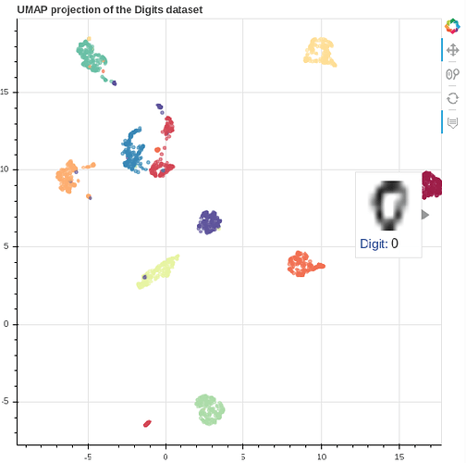
4. The Standard Plotly Express Chart Gallery
Chart Type | Function | Common Use Case
Bar chart | px.bar() | Comparing categories
Line chart | px.line() | Trends over time
Scatter plot | px.scatter() | Relationships between two numeric variables
Histogram | px.histogram() | Distribution of a single numeric variable
Box plot | px.box() | Distribution + outliers by category
Pie chart | px.pie() | Proportional composition
All functions share the same data, x, y, color, title interface — learning one transfers directly to the others.
5. Adding Dimensions: color, size, symbol, hover_data
px.scatter() supports encoding additional data dimensions without writing extra code:
df = pd.DataFrame({
'Experience': [1, 3, 5, 7, 9, 2, 4, 6],
'Salary': [35, 50, 70, 90, 110, 40, 60, 80],
'Department': ['IT', 'HR', 'IT', 'IT', 'HR', 'HR', 'IT', 'HR'],
'Projects': [2, 3, 5, 8, 6, 2, 4, 7],
'Name': ['Alice', 'Bob', 'Carol', 'Dave', 'Eve', 'Frank', 'Grace', 'Hank']
})

fig = px.scatter(
df,
x='Experience',
y='Salary',
color='Department', # colour by category — auto legend
size='Projects', # point size proportional to numeric column
hover_data=['Name'], # extra column visible only in tooltip
title='Salary vs Experience'
)
fig.show()
Key parameters at a glance:
Parameter | Purpose | Accepts
color | Colour points/bars by category or numeric range | Column name (str)
size | Scale marker size by a numeric column | Column name (str)
symbol | Change marker shape by category | Column name (str)
hover_data | Add extra columns to the hover tooltip | List of column names
facet_col | Split into side-by-side subplots by category | Column name (str)

1. Displaying Figures Inline with fig.show()
fig.show() renders a Plotly figure in the current environment:
- Jupyter Notebook / JupyterLab / VS Code: outputs the interactive chart inline in the notebook cell
- Python script: opens a new browser tab automatically
- Google Colab: renders inline (may require fig.show(renderer='colab') in older versions)
import plotly.express as px

fig = px.bar(x=['Q1', 'Q2', 'Q3', 'Q4'], y=[42, 55, 48, 63], title='Quarterly Sales')
fig.show() # auto-detects environment
fig.show(renderer='notebook') # explicit notebook renderer
fig.show(renderer='browser') # force open in browser
You rarely need to specify a renderer manually. If fig.show() produces no output in your environment, try fig.show(renderer='notebook').
2. Exporting to Static Images with write_image()
For use in presentations, Word documents, or printed reports. Requires the kaleido package:
pip install kaleido
# Basic export — PNG at default size (700×500 px)
fig.write_image("chart.png")

# High-resolution export
fig.write_image("chart.png", width=1200, height=600, scale=2)
# → outputs a 2400×1200 px image (scale multiplies both dimensions)

# Other supported formats
fig.write_image("chart.svg") # vector — scales to any size
fig.write_image("chart.pdf") # PDF — single page containing the chart
fig.write_image("chart.jpg") # JPEG — slightly smaller file than PNG
Key parameters for write_image():
Parameter | Purpose | Default
width | Output width in pixels | 700
height | Output height in pixels | 500
scale | Pixel density multiplier | 1
format | Override format (if not inferred from extension) | inferred
Note: write_image() raises ValueError if kaleido is not installed. Install it before attempting any static export.
3. Exporting to Standalone HTML with write_html()
Produces a single .html file containing the complete interactive chart. No Python, no server, no dependencies required to open it — just a web browser.
# Basic export
fig.write_html("dashboard.html")

# Exclude Plotly.js library (reduces file size if the target page already loads it)
fig.write_html("dashboard.html", include_plotlyjs='cdn')
# → loads Plotly.js from CDN instead of embedding it (~3 MB saving)

# Include multiple figures in one HTML file
with open("report.html", "w") as f:
f.write("<h1>Monthly Report</h1>\n")
f.write(fig1.to_html(full_html=False, include_plotlyjs='cdn'))
f.write(fig2.to_html(full_html=False, include_plotlyjs=False))
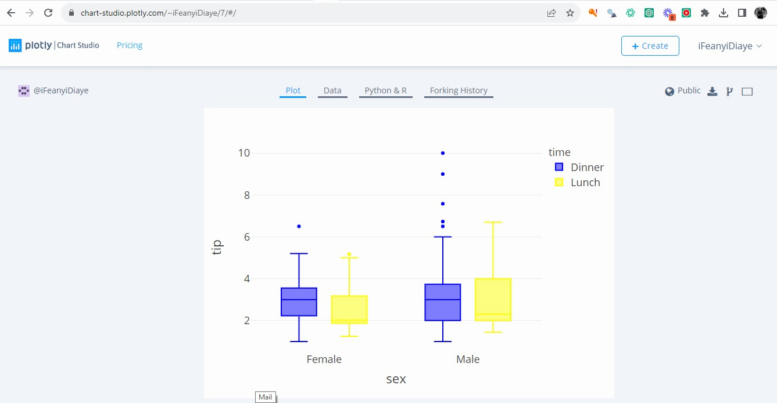
include_plotlyjs options:
- True (default) — embed the full Plotly.js (~3.4 MB) inside the file; self-contained, works offline
- 'cdn' — load from the Plotly CDN; much smaller file, requires internet
- False — omit entirely; use when the page already loads Plotly.js
4. Embedding in Reports and Dashboards
Multi-chart HTML report: Use fig.to_html(full_html=False) to get just the <div> snippet for each chart, then assemble them into a single page:
fig1 = px.bar(df, x='Month', y='Sales', title='Monthly Sales')
fig2 = px.scatter(df, x='Month', y='Returns', title='Monthly Returns')

html_content = f"""
<html>
<head><script src="https://cdn.plot.ly/plotly-latest.min.js"></script></head>
<body>
<h1>Sales Report</h1>
{fig1.to_html(full_html=False, include_plotlyjs=False)}
<h2>Returns</h2>
{fig2.to_html(full_html=False, include_plotlyjs=False)}
</body>
</html>
"""

with open("full_report.html", "w") as f:
f.write(html_content)
Plotly Dash (brief mention): For fully interactive web dashboards with dropdowns, sliders, and callbacks, Plotly's companion framework Dash (pip install dash) allows building data applications entirely in Python. The Plotly figures you create with px work directly inside Dash layouts.

