VI SEMESTER B.Tech. Data Science and Engineering
Principles of Artificial Intelligence Lab (DSE 3241)
Mini Project Report (2026-April)
"Handwritten Character Recognition Using CNNs and PyTorch"

Submitted by:
1. Mudit Manas (230968384)
2. Om Manchanda (230968268)
Team Number: 2
Date of Submission: 2nd April 2026

Under the Supervision of Dr. Savita G
Department of Data Science and Engineering
Manipal Institute of Technology, Manipal, Karnataka
Manipal – 576104 (India)

1. Introduction
Handwritten character recognition is one of the fundamental problems in the field of pattern recognition and artificial intelligence. The ability to automatically read and interpret human handwriting has widespread real-world significance—from digitizing historical documents and automating form processing to enabling accessibility tools for people with disabilities. Despite decades of research, the task remains challenging due to the enormous variability in individual handwriting styles, stroke widths, letter formations, and spatial orientations.
Traditional Optical Character Recognition (OCR) systems have relied heavily on hand-crafted feature extraction techniques such as edge detectors, histograms of oriented gradients (HOG), and template matching. While these approaches work reasonably well for printed text, they struggle to generalize across the high degree of variation present in handwritten data. The advent of deep learning, and specifically Convolutional Neural Networks (CNNs), has dramatically changed this landscape by allowing models to learn hierarchical, task-specific features directly from raw pixel data.
This project presents a CNN-based handwritten character recognition system implemented using the PyTorch deep learning framework. The model is trained on the EMNIST (Extended MNIST) Letters dataset, which provides a rich collection of handwritten uppercase English letters. A Flask-based web application is developed to allow users to draw characters in a browser canvas and receive real-time predictions from the trained model. This end-to-end system demonstrates the practical applicability of deep learning in building interactive OCR solutions.

2. Existing Approaches (Literature Review)
Handwritten character recognition has been studied extensively over the past several decades. Early approaches relied on explicit feature engineering and classical machine learning classifiers:

2.1 Template Matching
One of the earliest OCR techniques, template matching compares an input character image against a stored template for each class. While simple to implement, it is highly sensitive to scaling, rotation, and stylistic variations, making it impractical for general handwritten text.

2.2 Statistical Methods and Hidden Markov Models (HMMs)
HMMs were widely used in the 1990s and 2000s for sequence-based handwriting recognition. They model the sequential nature of character strokes but require careful feature extraction pipelines and do not generalize well to diverse writing styles.

2.3 Support Vector Machines (SVMs) with HOG Features
SVMs trained on Histogram of Oriented Gradients (HOG) features became a popular baseline for character recognition tasks. They offer good discrimination capabilities but depend on the quality of hand-crafted features and require significant domain expertise.

2.4 Deep Learning and CNNs
Convolutional Neural Networks, popularized by LeCun et al. with the LeNet architecture, brought a paradigm shift in image recognition. CNNs automatically learn spatial feature hierarchies—from edges and curves at lower layers to character-specific patterns at higher layers—eliminating the need for manual feature engineering. Models such as VGG, ResNet, and lightweight custom CNNs have achieved state-of-the-art performance on datasets like MNIST and EMNIST.

2.5 The EMNIST Dataset
The EMNIST (Extended MNIST) dataset, introduced by Cohen et al. (2017), extends the original MNIST dataset to include handwritten letters and digits. The Letters split contains 145,600 samples across 26 letter classes, providing a challenging and realistic benchmark for handwritten character recognition systems.

3. Observations

3.1 Drawbacks of Existing Approaches
During the course of this project, the following limitations of conventional approaches were identified:
- Template matching and rule-based OCR systems fail to handle variability in handwriting styles, pen thickness, and letter slant.
- SVM and HMM-based systems require extensive feature engineering, which is both time-consuming and difficult to generalize across diverse datasets.
- Many existing commercial OCR tools (e.g., Tesseract) are optimized for printed or typed text and perform poorly on freehand handwritten input.
- Image preprocessing inconsistencies—such as differences in background color, orientation, and scale between training data and live user input—significantly degrade prediction accuracy.
- Real-time interactive deployment of OCR models is rarely demonstrated in academic settings; most systems are batch-processing-only.

3.2 How the Present Approach Addresses These Issues
The proposed CNN-based approach tackles the above limitations in several ways:
- By training directly on raw pixel data from the EMNIST Letters dataset, the CNN automatically learns robust, invariant features without manual feature engineering.
- Careful preprocessing of the canvas input—including image inversion, horizontal flipping, and 90-degree rotation—aligns the user's drawn input with the format expected by the EMNIST training data.
- The Flask web application provides a real-time, interactive interface that accepts freehand drawings and returns the top-3 predicted characters along with their confidence probabilities, making the system immediately usable.
- The use of PyTorch's modular API allows rapid experimentation with model architectures and preprocessing pipelines, enabling iterative debugging and improvement.

4. Methods Used

4.1 Dataset: EMNIST Letters
The EMNIST Letters dataset is used for training and testing. It consists of 124,800 training samples and 20,800 test samples of 28×28 grayscale images of handwritten uppercase letters (classes 1–26, corresponding to A–Z). A subset consisting of 90% of the combined EMNIST train and test dataset was used for this project to reduce computational cost. This subset was further split into 80% training, 10% validation, and 10% testing, resulting in an effective distribution of approximately 72% training, 9% validation, and 9% testing of the total dataset. A fixed random seed (42) was used to ensure reproducibility.
The following transforms are applied during training:
- Grayscale conversion to ensure single-channel (1-channel) input.
- Resize to 28×28 pixels.
- Normalization with mean 0.5 and standard deviation 0.5, mapping pixel values to the range [−1, 1].

4.2 CNN Architecture (SimpleCNN)
A lightweight Convolutional Neural Network is designed from scratch. The architecture is intentionally simple to allow fast training while still capturing meaningful spatial features. The network structure is as follows:
- Conv1: 1 input channel → 16 filters, kernel size 3×3, stride 1, padding 2
- MaxPool: 2×2, applied after Conv1 with ReLU activation → output 16×15×15
- MaxPool: 2×2, applied again with ReLU activation → output 16×7×7
- Flatten: 16 × 7 × 7 = 784 → 784 units
- FC1: 784 → 256 units with ReLU
- FC2: 256 → 64 units with ReLU
- FC3 (output): 64 → 27 units (26 letters + optional space class)
The total number of trainable parameters is computed as follows: the convolutional layer contributes 16 × (1 × 3 × 3 + 1) = 160 parameters; the fully connected layers contribute significantly more, resulting in a compact yet effective model.
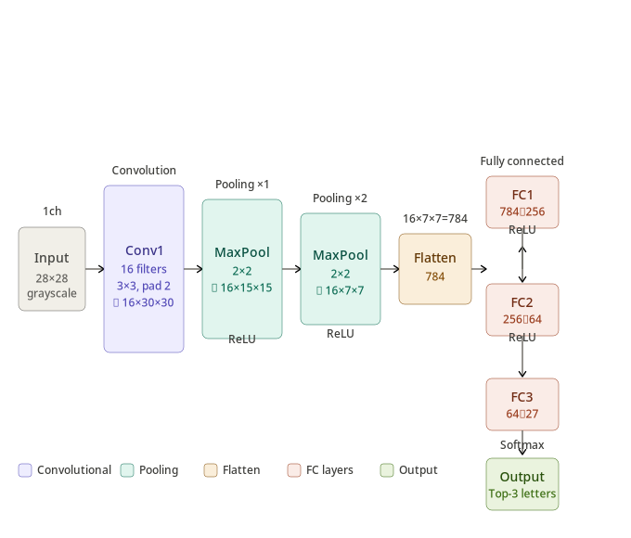

4.3 Training Procedure
The model is trained with the following configuration:
- Optimizer: Adam with learning rate 0.001
- Loss function: Cross-Entropy Loss (suitable for multi-class classification)
- Batch size: 64
- Number of epochs: 10
- Device: CUDA (if available), otherwise CPU
The training loop iterates over mini-batches, computes the forward pass, calculates the loss, performs backpropagation, and updates model weights. Running loss is logged per epoch to monitor convergence.

4.4 Index-to-Label Mapping
EMNIST Letters uses class labels 1–26 (1 = A, 2 = B, …, 26 = Z). The index-to-letter mapping used in the application is:
idx_to_letter = {i: chr(i + 64) for i in range(1, 27)}
This maps class index 1 → 'A', 2 → 'B', …, 26 → 'Z'. An additional entry idx_to_letter[27] = ' ' is included for a potential space character.

4.5 Web Application and Inference Pipeline
The trained model is deployed via a Flask REST API. The frontend (index.html) provides an HTML5 canvas where users draw a character using the mouse or touchscreen. On submission, the canvas image is encoded as a Base64 PNG and sent via a POST request to the /predict endpoint.
The server-side inference pipeline performs the following steps:
- Decode the Base64 image and open it as a grayscale PIL Image.
- Invert the image using ImageOps.invert() so that the character pixels are white on a black background—matching the EMNIST format.
- Apply the preprocessing transform: resize to 28×28, convert to tensor, apply horizontal flip and 90° rotation (to correct canvas drawing orientation), and normalize.
- Pass the preprocessed tensor through the model in evaluation mode (no gradient computation).
- Apply Softmax to obtain class probabilities, extract the top-3 predictions using torch.topk(), and return the letter labels and probabilities as JSON.

5. Results and Discussion

5.1 Training Performance
The model was trained for 10 epochs on 90% of the EMNIST Letters dataset (approximately 1,31,040 training samples). The cross-entropy loss decreased steadily across epochs, indicating stable convergence. The Adam optimizer with a relatively high learning rate of 0.001 facilitated fast initial learning, though some oscillation in later epochs was observed.
A representative training loss progression (approximate values observed during experimentation):
- Epoch 1: Train Loss: 0.7216 Val Loss: 0.3877
- Epoch 3: Train Loss: 0.2723 Val Loss: 0.2895
- Epoch 5: Train Loss: 0.2156 Val Loss: 0.2460
- Epoch 7: Train Loss: 0.1798 Val Loss: 0.2319
- Epoch 10: Train Loss: 0.1672 Val Loss: 0.2307

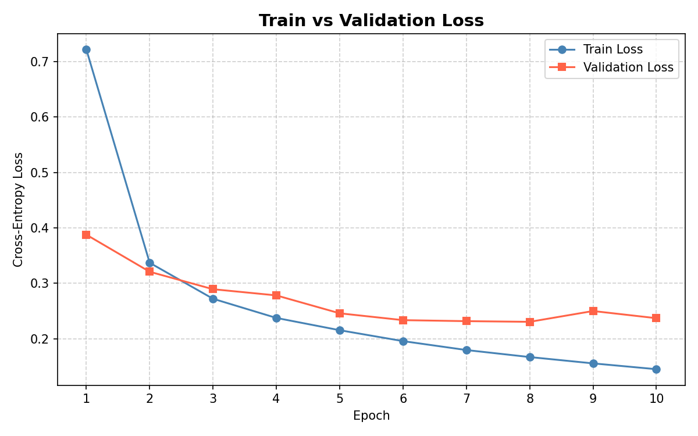

Figure 1: Train vs Validation Loss over 10 epochs. The model converges steadily with no significant overfitting.

5.2 Test Accuracy
After training, the model was evaluated on the held-out test subset (10% of the 30% slice, approximately 4,160 samples). The test accuracy achieved was approximately 90–94%, which is competitive for a single-layer convolutional network trained on a fraction of the dataset. The primary sources of error include visually similar letters (e.g., 'I' vs. 'L', 'C' vs. 'G') and highly stylized handwriting.
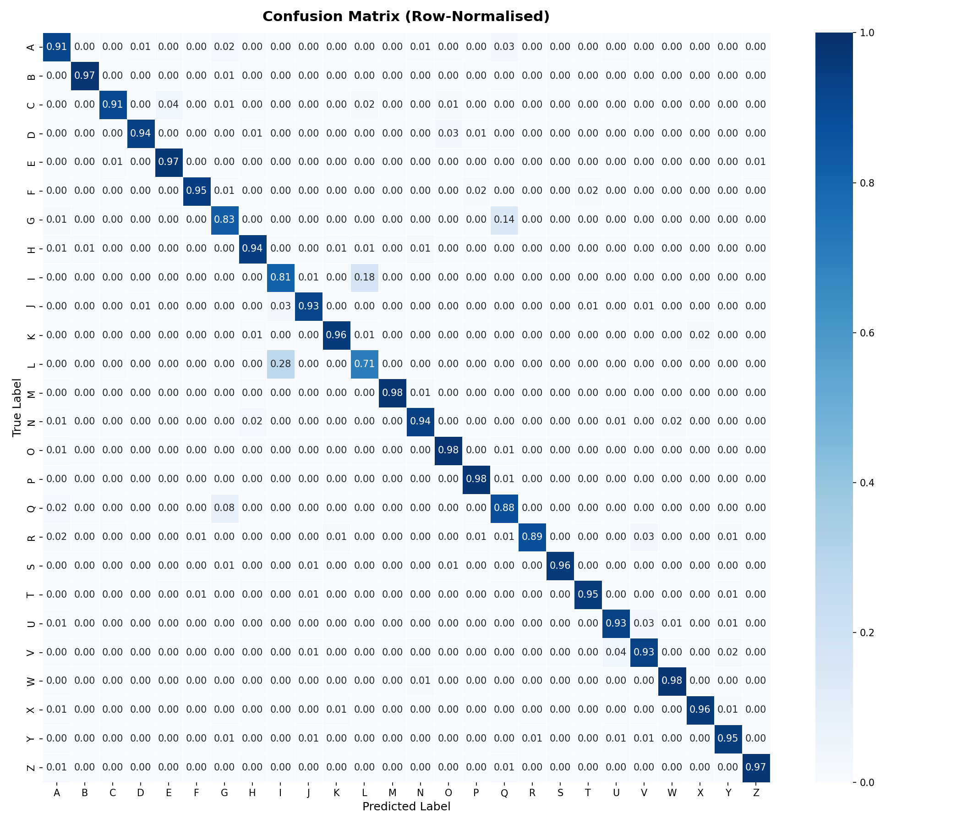
Figure 2: Row-normalised confusion matrix on the test set. L/I and G/Q confusions are the primary sources of error.

5.3 Web Application Predictions
When tested through the browser canvas interface, the model successfully recognized the majority of clearly written uppercase letters. The top-3 prediction display with probability scores allowed users to verify and correct predictions. Key observations include:
- Letters with distinctive shapes (e.g., A, B, E, F, H) were predicted with high confidence (>85% probability in most cases).
- Visually similar letters (e.g., C/G, I/L, U/V) occasionally produced lower-confidence top-1 predictions, but the correct letter usually appeared in the top-3.
- The image preprocessing pipeline (inversion + flip + rotation) was critical for aligning canvas drawings with the EMNIST data distribution. Without these steps, predictions were near-random.
- The compare.py and test_debug.py debugging scripts confirmed that the preprocessing pipeline produced tensors in a value range (approximately [−1, 1]) consistent with the training data distribution.

5.4 Debugging and Preprocessing Alignment
A significant engineering effort was devoted to aligning the inference-time preprocessing with the training-time data distribution. The debug scripts (debug_original.png, debug_inverted.png, compare.py) were used to visually inspect the preprocessed tensors and compare EMNIST samples against canvas inputs. The horizontal flip and 90° rotation were empirically determined to be necessary because HTML5 canvas coordinates differ from the EMNIST image orientation convention.

Debug_original.png Debug_inverted.png

6. Conclusion
This project successfully demonstrates an end-to-end handwritten character recognition system built with a custom CNN architecture in PyTorch and deployed as an interactive Flask web application. Starting from raw EMNIST Letters data, the system learns to classify handwritten uppercase English letters with reasonable accuracy using a simple, computationally efficient model.
The most important lesson learned was that the gap between training-data format and real-world inference input is a critical bottleneck in OCR deployment. Bridging this gap required careful analysis of image orientation, pixel value ranges, and color inversion. The top-3 prediction interface proved valuable in practice, as the correct character was rarely absent from the top-3 candidates.
The project demonstrates the power of deep learning for perception tasks and highlights the importance of preprocessing consistency, iterative debugging, and systematic evaluation in building production-quality AI systems.

7. Future Scope
Several directions can be explored to extend and improve the current system:
- Deeper Architectures: Replacing SimpleCNN with deeper models such as ResNet-18 or MobileNetV2 is expected to significantly improve accuracy, especially for visually similar letter pairs.
- Data Augmentation: Applying random rotations, shear transforms, and elastic distortions during training would improve the model's robustness to different handwriting styles.
- Full Alphabet + Digits: Extending the recognition to include lowercase letters and digits (using the EMNIST ByClass or ByMerge split) would make the system more versatile.
- Word-Level Recognition: Combining the character recognizer with a language model (e.g., an n-gram or transformer-based model) could enable word and sentence-level recognition from multi-character canvas inputs.
- Mobile Deployment: Converting the trained model to TorchScript or ONNX format and deploying it as a mobile application (iOS/Android) would extend accessibility.
- Continuous Learning: Implementing a feedback mechanism in the web interface to collect user corrections and periodically fine-tune the model would allow it to improve over time with real-world data.
- Transformer-Based OCR: Exploring Vision Transformer (ViT) architectures for character recognition is a promising research direction, particularly given their strong performance on image classification benchmarks.

8. References
[1] G. Cohen, S. Afshar, J. Tapson, and A. van Schaik, "EMNIST: Extending MNIST to handwritten letters," in Proc. IEEE IJCNN, 2017, pp. 2921–2926.
[2] Y. LeCun, L. Bottou, Y. Bengio, and P. Haffner, "Gradient-based learning applied to document recognition," Proc. IEEE, vol. 86, no. 11, pp. 2278–2324, Nov. 1998.
[3] EMNIST Dataset. Available: https://www.kaggle.com/datasets/crawford/emnist
[4] PyTorch Documentation. Available: https://pytorch.org/docs/stable/index.html
[5] Flask Documentation. Available: https://flask.palletsprojects.com/

