Laplace transform table:

|  |  |  |  |
| --- | --- | --- | --- |
| 1 | 1/s | $$δ(t-c)$$ | $$e^{-cs}$$ |
| t | $$1/s^{2}$$ | $$e^{ct}f(t)$$ | $$F(s-c)$$ |
| $$e^{at}$$ | $$1/(s-a)$$ | $$t^{n}e^{at}$$ | $$\frac{n!}{{\left(s-a\right)}^{n+1}}$$ |
| $$\sin\left(at\right)$$ | $$\frac{a}{s^{2}+a^{2}}$$ | $$e^{at}sin⁡(bt)$$ | $$\frac{b}{{\left(s-a\right)}^{2}+b^{2}}$$ |
| $$\cos\left(at\right)$$ | $$\frac{s}{s^{2}+a^{2}}$$ | $$e^{at}cos⁡(bt)$$ | $$\frac{s-a}{{\left(s-a\right)}^{2}+b^{2}}$$ |
| $$\frac{dy\left(t\right)}{dt}$$ | $$sY\left(s\right)-y(0)$$ | $$t sin(at)$$ | $$\frac{2as}{{\left(s^{2}+a^{2}\right)}^{2}}$$ |
| $$\frac{d^{2}y\left(t\right)}{dt^{2}}$$ | $$s^{2}Y\left(s\right)-sy\left(0\right)-y'(0)$$ | $$t cos(at)$$ | $$\frac{s^{2}-a^{2}}{{\left(s^{2}+a^{2}\right)}^{2}}$$ |
| $$\sinh\left(at\right)$$ | $$\frac{a}{s^{2}-a^{2}}$$ | $$e^{at}\sinh\left(bt\right)$$ | $$\frac{b}{{\left(s-a\right)}^{2}-b^{2}}$$ |
| $$cosh(at)$$ | $$\frac{s}{s^{2}-a^{2}}$$ | $$e^{at}cosh(bt)$$ | $$\frac{s-a}{{\left(s-a\right)}^{2}-b^{2}}$$ |
| $$F\left(t\right)*G\left(t\right)$$ | $$F\left(s\right)G(s)$$ | F(t).G(t) | F(s)*G(s) |

$$L[\int{f\left(t\right)dt ]}=\frac{F\left(s\right)}{s}+\int{f\left(t\right)dt (at t=0)}$$

Convolution: $F\left(t\right)*G\left(t\right)=\int_{0}^{t}{f\left(τ\right)g\left(t-τ\right)dτ}$

Fundamental theorem of calculus and product rule:

$\frac{d}{dt}\int_{0}^{t}{A(x})dx=A(t)$ These hold for matrix functions

**Leibniz rule holds for matrix functions:**

$$\frac{d}{dt}\int_{f(t)}^{g(t)}{A\left(t,σ\right)dσ}=A\left(t,g\left(t\right)\right)g^{'}\left(t\right)-A\left(t,f\left(t\right)\right)f^{'}\left(t\right)+\int_{f(t)}^{g(t)}{\frac{δ}{δt}A\left(t,σ\right)dσ}$$

General solution of $\dot{X}=AX+BU$ is given by:

$$X\left(t\right)=\int_{t_{0}}^{t}{e^{A\left(t-τ\right)}Bu\left(τ\right)dτ}+e^{A\left(t-t_{0}\right)}X\left(t_{0}\right)$$

If asked to prove that this is solution, use Leibniz rule.

To get the state-space representation of a given differential eqn, first assume states x1, x2,…, xn. Then take derivatives of all these states to get X_dot. Then for xn_dot find equation in terms of all other states. Make matrix from the state equations obtained.

**Properties of LTI system:**

A system is jointly linear in the initial condition response (u=0) and the force response (x(t0)=0), if the following conditions hold:

$y\left(t,αx_{1}+βx_{2},0\right)=αy\left(t,x_{1},0\right)+βy(t,x_{2},0)$

$y\left(t,αx,βu\right)=αy\left(t,x,0\right)+βy\left(t,0,u\right)$

$y\left(t,0,c_{1}u_{1}+c_{2}u_{2}\right)=c_{1}y\left(t,0,u_{1}\right)+c_{2}y\left(t,0,u_{2}\right)$

A system is jointly time-invariant if a delay of τ in th state or input produces corresponding time delay in the output. Essentially, the behaviour of the system doesn’t change with time. A, B, C, D are not functions of time.

If the system is both jointly linear and time-invariant, then it is a Linear Time Invariant System (LTI).

**For time varying systems**, solution is given by:

$x\left(t\right)=∅\left(t,t_{0}\right)X_{0}+\int_{t_{0}}^{t}{∅\left(t,σ\right)B\left(σ\right)u\left(σ\right)dσ}$ $y\left(t\right)=C(t)∅\left(t,t_{0}\right)X_{0}+\int_{t_{0}}^{t}{C(t)∅\left(t,σ\right)B\left(σ\right)u\left(σ\right)dσ}$

**State transition matrix** is given by the Peano-Baker series:

$∅\left(t,t_{0}\right)=I+\int_{t_{0}}^{t}{A\left(σ_{1}\right)dσ_{1}}+\int_{t_{0}}^{t}{A\left(σ_{1}\right)\int_{t_{0}}^{σ_{1}}{A\left(σ_{2}\right)dσ_{2}}dσ_{1}}$ +..

$∅\left(t,t_{0}\right)=e^{\int_{t_{0}}^{t}{A\left(σ\right)}dσ}$

**Properties of transition matrix:**

If A(t)=A (const. matrix),

||

||

The order of an ODE is the highest derivative in it, and the degree is the power of highest derivative.

$\frac{d^{3}y}{dx^{3}}+{\left(\frac{dy}{dx}\right)}^{2}=a$-> Order is 3 and degree is 1.

**Stability of 2nd order systems: $\dot{X}=AX+BU$**

$\ddot{y}\left(t\right)+a_{1}\dot{y}\left(t\right)+a_{0}y\left(t\right)=u\left(t\right)$ A = [0 1; -a0 -a1]

The A matrix is as above, and eigen values of A are,

$λ=-α±√∆$ $α=\frac{a_{1}}{2}$ $∆=α^{2}-a_{0}$

If a system has a pole in right hand plane, then it is unstable. Else, it can be stable or critically stable.

For critically stable system, atleast one pole has 0 real part.

To compute eigen values use: det(lambda.I – A) = 0.

To **derive the eigen value decomposition** of a matrix, consider the matrix as $A=UVU^{-1}$. Write $e^{At}$ by taylor expansion. Substitute A. Simplify to get $e^{At}=Ue^{λ}U^{-1}$ (the state transition matrix can also be obtained).

**Eigen value stability test:**

$\lim_{t→inf}{∅(t)}=0$ The system is produces a bounded output for a bounded input. All the eigen values of A have negative real part.

**Diagonalization of a matrix:**

Find eigen values using $\det\left(A-λI\right)=0$. For each eigen value, find eigen vectors using $\left(A-λI\right)X=0$, where $X=\left[x_{1},x_{2},x_{3}\right]$  
 . The eigen vectors obtained are the columns of S matrix. Then using $S^{-1}AS$ get the diagonalized matrix.

**LU Decomposition:**

A = LU = $\left(\begin{matrix}1 & 0 & 0 \\ L_{21} & 1 & 0 \\ L_{31} & L_{32} & 1\end{matrix}\right)\left(\begin{matrix}U_{11} & U_{12} & U_{13} \\ 0 & U_{22} & U_{23} \\ 0 & 0 & U_{33}\end{matrix}\right)$

Use this equation to get values of L’s and U’s. Then the solution for Ax = b, for constant A and b can be found using: Ly = b and then Ux = y.

Det(A) = Det(LU) = Det(L)*Det(U).

**Independent Joint Control:**

Mechanical dynamic equations:

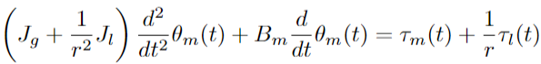

m is for the motor and l is for the load. r is the gear ratio.

Internal dynamics of the motor:





We can rewrite these equations as:





For a simplified model, we can take L/R << Jm/Bm. Reobserve the equations, get ia in terms of V and dtheta_m. You can then get the modified A & B matrices.

The goal is to design the cntrl to reduce the tracking error theta_d – theta_m. Linear state feedback control:



The state space representation of the closed loop is:

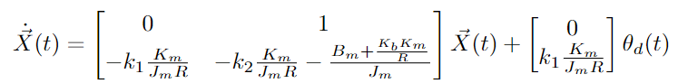

You can check stability by stab. of 2nd order systems.

Analysis of static gain and error for closed-loop systems:

Including the disturbance as an additional input:



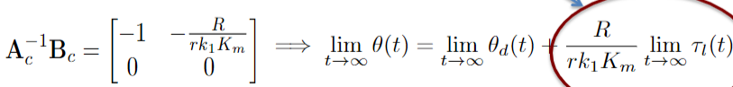

The circled part is tracking error.

**General State feedback:**

U=KX is the state feedback. K is mxn gain matrix. Bk is nxm

The closed loop state space representation is:

 

Stability of closed loop is found by eig vals of A+B*K

**Controllability and Stability:**

The pair A,B is controllable if any of the following hold:

-The eig vals of A+B*K can be placed anywhere by K.

-Given any initial state X(0) and a desired state Xd(t*), in the absence of disturbances there is a control signal Uk(t) that takes the system’s state to the desired state at any time t*.

-The Controllability Grammian is invertible (+ definite).

**For time invariant systems:**

You can just find the rank of nxnm controllability matrix:

$rank\left(\left[B AB A^{2}B…A^{n-1}B\right]\right)=n$

**For time varying systems (when A is const. but not B):**

Find $∅\left(t\right)=e^{At}=L^{-1}({\left[sI-A\right]}^{-1})$

Find the controllability Grammian by:

To prove this, put $U_{k}\left(τ\right)$ in the general solution of X(t*):

$$X\left(t^{*}\right)=e^{At^{*}}X\left(0\right)+\int_{0}^{t^{*}}{e^{A\left(t^{*}-τ\right)}BU_{k}(τ)dτ }$$

Simplify this, and get $X\left(t^{*}\right)=X_{d}(t^{*})$

**Definition of controllability:**

The linear state equation is called controllable on finite interval [t0,tf] if given any initial state x(t0)=x0 there exists a continuous input signal u(t) such that the corresponding solution satisfies x(tf) = 0.

**Caley Hamilton Theorem:**

$A^{n}=a_{o}I+a_{1}A+a_{2}A^{2}+…+a_{n-1}A^{n-1}$

Using this we get the following property of matrix exp:

$e^{At}=\sum_{l=0}^{n-1}{α_{l}\left(t\right)A^{l}}$ where alpha’s are scalar anal fns.

**Prove every SISO nth order LTI system is controllable:**

-Take general nth order linear ODE in y and u.

-Write A and B matrices of the system.

-Find controllability matrix [B AB A2B …].

-Show that all the columns are linearly independent.

-Hence, the system is controllable.

**You can also be asked to show that independent joint model is controllable.** To show this find the controllability matrix using A and B in first image and show it is full rank.

**For two mass spring damper assemblage:** take the x1, x1_dot, x2, x2_dot as states, use Newton’s laws of motion to get equations of motion, get state space representation and then check for controllability using ctrb matrix.

**PBH (Popov-Belevitch Houtus) test:**

$Rank\left[\left(λI-A\right) B\right]=n$ for all λ, -> Controllable

$Rank\left[\left(λI-A\right) B\right]=n$ for all +ve real{λ}, -> Stabilizable

**Standard form for uncontrollable systems:**

If the pair A,B is not controllable, we can separate the controllable and uncontrollable parts of the system using a similarity transformation.

$\hat{A}=S^{-1}AS$ $\hat{B}=S^{-1}B$ where S is given by:

$S=[v_{1} v_{2}…v_{nr} S_{n-nr} ]$

v1 to v_nr columns are nr LI columns from the controllability matrix of A,B. The remaining columns are n-nr LI columns different from v’s.

**To show that A,B is uncontrollable iff there’s a 1xn vector v != 0, such that v[λI-A B]=0.**

-Take a non-zero vector v s.t. vA=λv, vB = 0.

-Multiply v with ctrb matrix.

-Substitute vA with λv, and vB=0.

-You get a zero matrix, proves that system is not ctrb.

**Lyapunov Stability for LTI systems in State-space form:**

A function V(x) is a Lyapunov fn if:

-V(x)>0 for x!=0. V(x)=0 for x=0.

-In absence of external inputs,

$\frac{d}{dt}V\left(X\left(t\right)\right)<0 when X(t)≠0$, means the gradient is negative & the fn will converge to a global minimum.

LTI system in state space form is stable iff it has a Lp fn.

**Lyapunov Equation:**

An LTI system specified in State-Space form is stable iff for any symmetric positive definite matrix Q there exists a symmetric positive definite P s.t. Lyapunov eqn holds:

$A^{T}P+AP=-Q$

For this case, $V\left(X\right)=X^{T}PX$ is a **Lyapunov Function**.

If the system is stable, $P=\int_{o}^{∞}{e^{A^{T}t}}Qe^{At}dt$

And $X^{T}\left(0\right)PX\left(0\right)=\int_{0}^{∞}{X^{T}QXdt}$ is energy of system at t=0

**The stability of a system can be cast as the LMI:**

$-A^{T}P-PA>0 and P=P^{T}>0$, > is +ve def sense.

**Convex set:**

Set C is convex if for any 2 points in set x1, x2 we have:

$θx_{1}+\left(1-θ\right)x_{2}∈C$ or the line segment x1, x2 is in C.

**Convex function:**

$f\left(θx+\left(1-θ\right)y\right)≤θf\left(x\right)+\left(1-θ\right)y$

Geometrically this means, line segment is above f.

The pair A,B is stabilizable can be cast as the following optimization problem: $-{\left(A+BK\right)}^{T}P-P\left(A+BK\right)>0$

**LQR: Linear Quadratic Regulator**

We loop for optimal K that minimizes the cost function:

$J\left(K,X\left(0\right)\right)=\int_{0}^{∞}{X^{T}\left(t\right)QX\left(t\right)+U^{T}RU\left(t\right)dt}$ Q & R are +d

The optimal solution: $K= -R^{-1}B^{T}P$, where P is soln of

**Stationary Ricatti equation:**

$A^{T}P+AP-PBR^{-1}B^{T}P=-Q$

The optimal cost: $J(K,X\left(0\right)=X^{T}(0)PX(0)$

Also P is soln of the following Lyapunov Equation:

${\left(A+BK\right)}^{T}P+P\left(A+BK\right)=-(Q+K^{T}RK)$

To write Ricatti eqn from Lyapunov equation use:

$$P^{T}B{\left(R^{-1}\right)}^{T}RK+P^{T}B{\left(R^{-1}\right)}^{T}RR^{-1}B^{T}P=0$$

For optimal reference tracking using LQR: $\tilde{X}\left(t\right)=X\left(t\right)-X_{d} \tilde{U_{k}}(t)=U_{k}\left(t\right)-U_{∞}$

And we will get optimal control as: $\tilde{U_{k}}(t)=k\tilde{U}(t)$

Laplace transform: $L\left\{f\left(t\right)\right\}=\int_{0}^{∞}{e^{-st}f\left(t\right)dt}$

Inverse laplace transform: $f(t)=\frac{1}{2πi}\int_{s^{'}-i∞}^{s^{'}+i∞}{e^{st}F(s)dt}$

**LQR to get 0 state error for constant disturbance:**

Consider equilibrium point: $AX_{d}+B_{k}U_{∞}=0$

Start with: $\tilde{\dot{X}}=A\tilde{X}\left(t\right)+B_{k}\tilde{U_{k}}\left(t\right)+B_{D}U_{D}(t)$

Augment state to obtain the integral term in state:



X_I is integral of X_tilda.

This works because at steady state we get x(t) as x_d:

$\dot{\tilde{X}}\left(t\right)=0 \tilde{X}\left(t\right)=0 X\left(t\right)=X_{d}$

I can apply LQR to design $\overline{K}$ that minimizes the cost:



For the system:



The optimal closed-loop system describing the tracking err

We are using the following optimal control:



If U_D is a constant vector will have X_1(t) bounded.

Also augment B_D with zero.

Luenberger Observer’63 in state-space representation is:



The estimation error state space representation is:



And estimation error is: $X_{e}(t)=X\left(t\right)-\hat{X}(t)$



When can we select L, s.t. estimation error is stable?

Key observation: the matrix A-LC is stable if and only if

${\left(A-LC\right)}^{T}=A^{T}-C^{T}L^{T}$ is stable.

If the pair ${(A}^{T},C^{T})$ is stabilizable, then (A,C) is detectable.

If the pair ${(A}^{T},C^{T})$ is controllable, then (A,C) is observable

**Definition of Observability (for the LTV system):**

The linear state equation is called observable on [t0,tf] if any initial state x(t0)=x0 is uniquely determined by the corresponding response y(t), t belongs to [t0,tf].

**Theorem:** The linear state equation is observable on [t0,tf], iff the nxn observability grammian is invertible, i.e. full rank.

$M\left(t_{0},t_{f}\right)=\int_{t_{0}}^{t_{f}}{∅^{T}\left(t,t_{0}\right)\text{C^T}\text{ (t)C(t)∅(}\text{t,}\text{t_0)}dt}$

**For the time invariant case:** the state is observable if & only if the npxn observability matrix has rank n:

$$rank\left(\left[\begin{matrix}C \\ CA \\ CA^{2}\end{matrix}\right]\right)=rank\left(\left[\begin{matrix}C^{T} & A^{T}C^{T} & {{(A}^{T})^2 C}^{T} \end{matrix}\right]\right)=n$$

Suppose we design K and L such that the full state feedback

system and the Luenberger observer are both stable. Will the corresponding output feedback be stable? -> Yes. This is known as **separation principle**.

The following is the ss representation of the closed-loop:

is stable if and only if both (A + BK) and (A – LC) are stable

**Kalman-Bucy Filter (1961):**

Continuous time version of the Kalman Filter.





Where UD(t) and V(t) are independent mean white Gaussian processes with covariance $\sum{D}\&\sum{V}$ respectively





A real valued continuous time process X(t) is a Gaussian process, if each finite dimensional vector (X(t1),X(t2)… X(tn))T has the multivariate normal distribution N(u(t),SIGMA(t)) for some mean vector u and some covariance matrix sigma which may depend on t=(t1..tn)T

**White Noise:** A process is said to be white noise in the strongest sense if x(t) for any t is statistically independent of its entire history before t.

White noise is rndm signal having const pwr spectral dnsity

In our context we get:





$Cov\left(U_{D}\left(l\right), U_{D}\left(j\right)\right)=E\left[U_{D}\left(l\right) U_{D}{\left(j\right)}^{T}\right]=\sum_{D}{δ(l-j)}$

$Cov\left(V\left(l\right), V\left(j\right)\right)=E\left[V\left(l\right)V{\left(j\right)}^{T}\right]=\sum_{V}{δ\left(l-j\right)}$

$Cov\left(U\left(l\right), V\left(j\right)\right)=0$

**LQG (Linear Quadratic Gaussian Method):**

Again consider the state space equations in Kalman-Bucy

We consider the case when U_D and V are independent zero mean white gaussina processes with SIGMA_D and SIGMA_V covariances. We want to minimize the cost:



The structure of the optimal solution is given by the standard output feedback configuration with the Luenberger Observer and the optimal K and L are computed separately using the LQR and Kalman-Bucy methods — this is called the separation principle.

**Methods of solving ODEs:**

**-Variable Separable Equation:**

$\frac{dy}{dx}=f\left(x\right)g(y)$ write eqn in this form and then separately integrate f(x) and g(y) to get the solution of ODE.

**-Exact Equations:**

First write eqn in for Adx + Bdy=0. Then check if it is exact, by $\frac{δA}{δy}=\frac{δB}{δx}$. Then, find $U\left(x,y\right)=\int{Adx}+F\left(y\right)=c_{1}$.

Differentiate U(x,y) w.r.t. y and equate it to B(x,y). Solve for F(y), and put it in U(x,y), to get the final solution.

**-Bernoulli’s Equation:**

$\frac{dy}{dx}+P\left(x\right)y=Q\left(x\right)y^{n}$, n != 0. This is a non-linear equation that can be made linear by substituting $v=y^{1-n}$ and

$\frac{dv}{dt}=\left(1-n\right)y^{-n}\frac{dy}{dx}$ divide the original eqn by y^n. And solve for v. Then resubstitute v in terms of y.

**-Homogeneous Differential Equation:**

$$\frac{dy}{dx}=\frac{F\left(x,y\right)}{G\left(x,y\right)}=F\left(\frac{y}{x}\right)$$

Put y = vx, dy/dx = v + x.dy/dx.

How to make inexact eqn, exact: Multiply original equation by $u=e^{\int{\frac{1}{B}}(\frac{δA}{δy}-\frac{δB}{δx})}$

**-Method of Integrating Factors (IF):**

$\frac{dy}{dx}+P\left(x\right)y=Q\left(x\right)$ form of eqn. Integrating factor is defined as: $α=e^{\int{P\left(x\right)dx}}$. Multiply original eqn by IF, the LHS can is of the form P(x)y’ + P’(x)y, which can be combined to get d(P(x).y)/dx = Q(x), solve to get ODE soln.

**-Method of undetermined coefficients:**

Used to solve higher order ODEs. Involves finding the complementary solution y_c and particular soln y_p.

Y_c is found by LHS by assuming $f=Ae^{λt}$ and RHS = 0.

If initial conditions are given find singular soln of y_c.

Next, find y_p by taking y_p as some multiple of e and sin and cos. Eg. For RHS = $e^{-t}cos⁡(3t)$, we can take

$y_{p}=ae^{-t}\left(b.cos\left(3t\right)+c.sin\left(3t\right)\right)$ Next put this in original diff equation and find yp. Final solution is yc+yp.

**-Method of Variation of Parameters:**

First, get yc similar to method of undeter. Coeff. Then assume $y_{p}=K_{1}\left(x\right)a_{1}+K2\left(x\right)a_{2}$ by observing yc on yc. Then impose conditions, most common is yp=0. Differentiate yp once and twice, put in original equation and get values of K1(x) and K2(x). Combine yc & yp for ans.

**-Laplace Transform:**

Take Laplace transform of equation, then simplify it. Then take inverse laplace transform to get final solution.

**Integration by parts:**

$\int{u.vdx}=u\int{vdx}-\int{u^{'}}\left(\int{vdx}\right)dx$

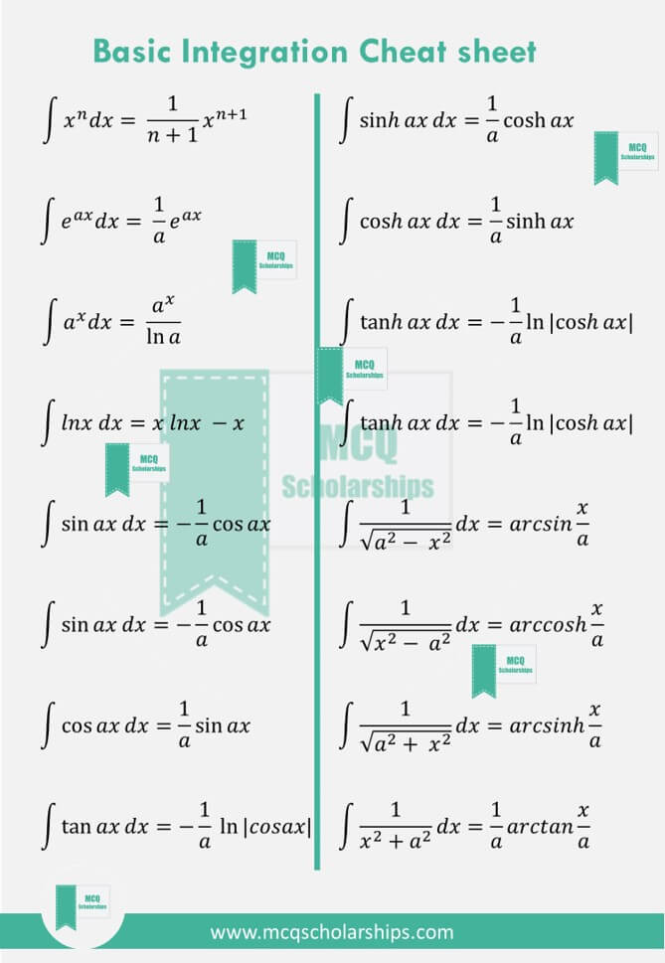

Find transfer function of a system:

