**Future power plant control - Integrating process & substation automation**

**into one system**

**Author:**

**Joerg Orth, ABB AG, Mannheim, Germany**

# ABSTRACT

Today’s power plants are highly automated. All subsystems of large thermal power plants can be controlled from a central control room. One subsystems area is the electrical auxiliaries for the unit transformer, the grid connection, excitation, synchronization, generator/unit protection, auxiliary transformers, HV-, MV- and LV-switchgear. In the past, these electrical devices were all hardwired to the DCS and I/Os. To this day, horizontal communication between electrical devices is still hardwired. In the last decade, serial communication protocols were introduced. Unfortunately, standardization of these protocols went in different directions. Today there are several standards on the market. Most of them are incompatible with others. In substation automation, the newly developed IEC 61850 standard was released in 2004. IEC 61850 defines interoperable function blocks, called logical nodes, that communicate over a network with other functions, regardless on which suppliers' device they are implemented. IEC 61850 separates application and communication layers, which enables one part to be changed without impacting the other part. New future communication technologies can be easily adapted to IEC 61850 which will make applications future proof over their service life. In future, it will be possible to modify or extend electrical without replacing the entire substation automation system. IEC 61850 is expected to be a future standard in power plant electrical systems, at least for HV and MV. It will have application- specific extensions; e.g., IEC 61850-7-420 (formerly IEC 62344) for hydro power applications. This results in new requirements for state-of-the art power plant control systems. Users can seamlessly monitor and operate electrical devices the same way they do the process control. This paper discusses various aspects of the implementation of the standard in power plants and shows how devices integrate into ABB's control system environment.

ABSTRACT 2

ONE SYSTEM FOR PROCESS & ELECTRICAL CONTROL 3

POWER PLANT ELECTRICAL SYSTEMS 9

ELECTRICAL CONTROL SYSTEM REQUIREMENTS 12

BASICS OF IEC 61850 14

IMPACT OF IEC 61850 ON THE CONTROL SYSTEM

STRUCTURE 18

EXAMPLE: GENERATOR PROTECTION ABB REG 670 19

SUMMARY / CONCLUSION 23

REFERENCES 23

# ONE SYSTEM FOR PROCESS & ELECTRICAL CONTROL

Traditional power plant control systems focus on controlling the process operation of the power plant. The power plant control system controls the different processes to achieve maximum power output at lowest operational cost. Today’s state-of-art control systems are highly automated, and in many installations, allow one operator in a central control room to manage the entire production. In the past, electrical systems were already coupled to the process control system using parallel copper cable hardwired interfaces. Due to cabling and engineering costs, the bandwidth of this kind of interface is very limited; e.g., enabling the display of a single line diagram (SLD) overview in the central control room. For additional signals, the number of I/O boards and the number of DCS marshalling racks increases.

With the introduction of intelligent electronic devices (IEDs) in the auxiliary power system and the generator auxiliary systems, these systems provide much more information, which can

be utilized for cost efficient operation and maintenance. As one consequence, serial interfaces were introduced in substation automation, enabling access to all device information. As traditional process control systems do not support these serial interfaces, today’s practice is to install, besides the power plant control system, a separate substation automation system to control and monitor the electrical systems.

Control Room

**2**

Control Room Workplace

Control Room Workplace

Plant network



Control System

Control System Server

SCADA

Server

**1** Control network

Automation

Automation Controller

Fieldbus

Automation Controller

Local I/O

Protocol 1

Gateway / Protocol Converter

Protocol 2

Protocol 3

Field

**1 1**

IED

**2 2**

**1**

IED

**2**

IED

Turbine, Water + Steam Cycle, Unit Control, Boiler, FGP …

Time Synchronization Engineering / Expert Tool



**1**

**2**

Marshalling Rack

Generator Protection, Transformer Protection, MV / HV Switchyard, Excitation, Synchronization

Figure 1 Separate system for the electrical systems

Today’s state-of-the-art technology-based power plant control systems allow integrating both process and electrical control into one consistent system. This makes a separate HSI system for the electrical part unnecessary, providing a couple of benefits to generation companies:

* One user interface

Having one system environment makes it possible to implement a consistent operating philosophy. Process operators and electricians / electrical engineers work with same system and can use the same graphic displays.

Consistency of data presentation and operating procedures mean a significant improvement of operation quality.

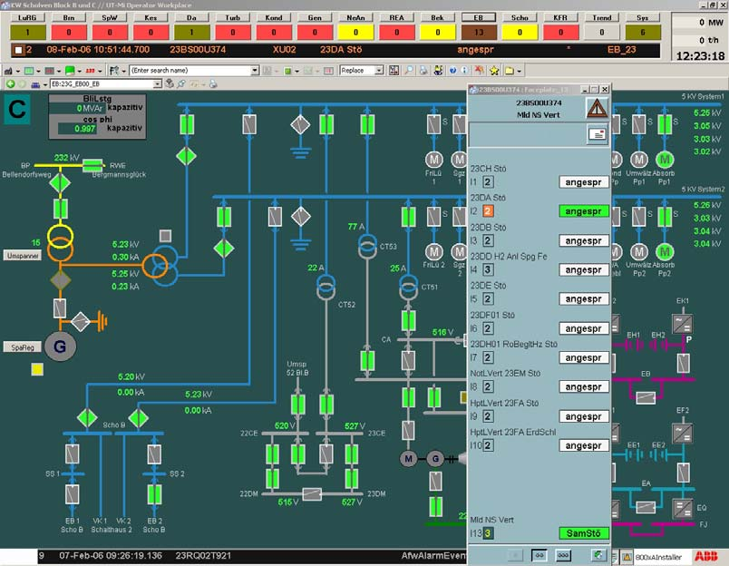

Figure 2 Electrical systems overview display

* Access to all data from all screens

Electrical systems can be operated from every system work station according to user access rights. That means that information is available when and where it is needed. Electrical systems information is not limited to dedicated screens.

* Data recording and archiving

Collecting all data from process and the electrical systems in one database means data is recorded uniformly and based on that, analysis and reporting are also.

Having one system means also having a plant-wide sequence of events.

* Lower training cost

Training for control room operators, plant maintenance personnel and system administrators is reduced since there is only one instead of two system environments.

* System administration

Having one system simplifies system administration tasks like user management, backup procedures and, for example, maintenance of signal data and graphic displays

* System security

To maintain high security, system-specific concepts and procedures have to be implemented by the system owner. Having one system allows a comprehensive IT security concept to be set up.

* Engineering and documentation

The number of engineering tools is reduced, avoiding multiple entry of the same data and providing consistent documentation.

* Spare parts

Even though today's systems are based on standard PC hardware and operating systems, there are always specific parts necessary. Combining process control and electrical control in one system reduces the number of required spare parts.

* Interfaces to enterprise level systems

To make a power plant competitive nowadays, the automation systems have to be connected to higher level systems and enterprise level networks. Applications to be supported on that level are

* + access to plant data from office PCs (e.g., for environmental reporting)
  + automatic transfer of real-time data to computerized maintenance management systems (CMMS)
  + access to CMMS data (e.g., spare part availability) from control system workplaces
  + remote connection to central dispatch centers
  + remote access for system support purposes
  + automatic transfer of process data to central PIMS (plant information management systems)

A constraint when process control and electrical control systems are separate is that all these interfaces must be implemented twice. Reducing to one control system saves significant implementation and maintenance efforts for interfaces.

It is obvious that all these arguments in favor of having one integrated system lead to lower cost of ownership.

Looking at the control system market, one notices that completely different standards are established in the process automation and the substation automation domains. The fieldbus standards Fieldbus Foundation and Profibus are established on the process-automation-driven

side. State-of-the-art process control systems provide consistent integration of field bus technology. E.g. control system users can directly perform diagnosis or configure devices connected to the system.

In the area of electrical systems, driven by substation automation, several serial protocols were introduced in the last decade: IEC 60870-5-10x, DNP3.0, LON, ModbusRTU plus vendor-specific protocols like SPA (ABB).

Control Room

Plant network

Control System Server

**2**

Control Room Workplace

Control System



**1**

Control network

Automation Automation

Controller Controller

Gateway / Protocol Converter

Protocol 1 Protocol 3

Fieldbus

Local I/O

Protocol 2

**1**

IED

**2**

**1**

**2**

IED

**1**

**2**

IED

Marshalling Rack

Automation

Field

Turbine, Water + Steam Cycle, Unit Control, Boiler, FGP …



**1**

**2**

Time Synchronization Engineering / Expert Tool

Generator Protection, Transformer Protection, MV / HV Switchyard, Excitation, Synchronization

Figure 3 Integrated system with gateway to diverse protocols

The challenge for integration of process control and electrical control is to support all these standards. Incompatibilities mean interfaces must be implemented and maintained on a project-by-project or even device-by-device basis. Integration becomes expensive due to the diversity of the individual standards. Gateways or protocol converters lead to additional hardware, maintenance and increasing engineering cost as such devices have to be configured, tested, documented, etc.

Issues with today's solution

* Engineering requires specific tools from the supplier of the particular device.

Even for different devices from the same supplier, the engineering and maintenance

tools are device specific. This applies also for different generations of a device product family.

* Standardized documentation for the devices' engineering data is not available. Exchanging data between the different tools is complicated.
* Maintenance and service need specialists who understand different tools and communications protocols
* Devices cannot communicate with each other. For horizontal communication, hardwiring or a substation control system is required.
* It is very expensive to integrate the many protocols on the power plant control systems side
* Lacking capabilities of interfaces and protocols; e.g., not all protocols support time stamping, provide measuring values in engineering units or fulfill data transfer time requirements.
* Time synchronization requires device specific solutions

A big step forward in simplifying the integration of electrical systems is the introduction of the substation automation standard IEC 61850. IEC 61850 does not replace the field busses for process automation, but it is capable of replacing all of the diverse protocols in the substation automation domain. With IEC 61850, future power plant control systems can be based on two pillars: field bus standards on the process automation side and IEC 61850 on the electrical side.

# POWER PLANT ELECTRICAL SYSTEMS

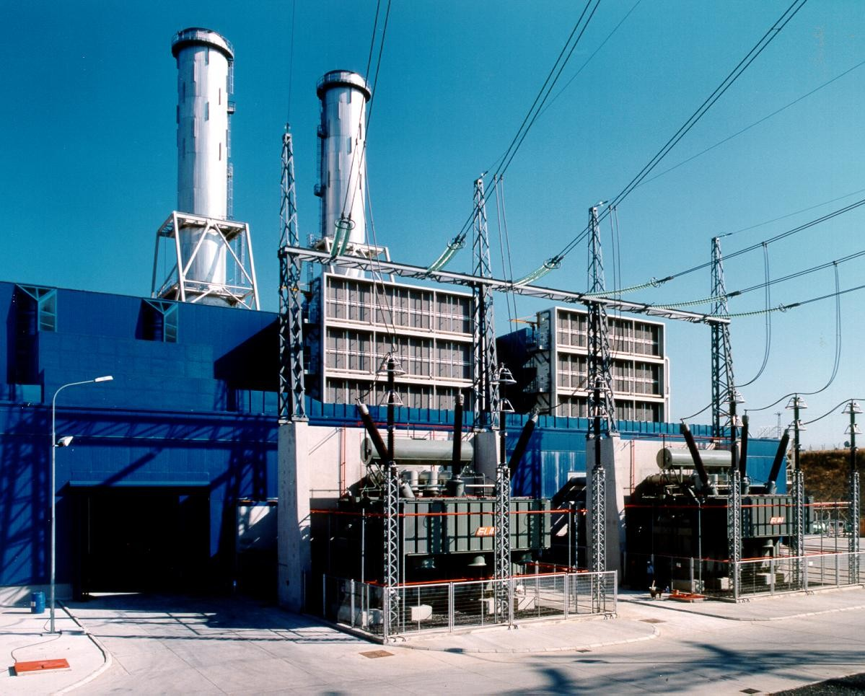

Figure 4 Unit transformers of a combined-cycle power plant

This article deals mainly with thermal plants such as steam power units, gas-fired combined- cycle power plants and waste incineration plants.

Figure 5 shows a single line diagram of a power plant. Depending on the specific plant type some other components, such as a static starter system in GT-plants or emergency / black start diesel generators, are not shown in this example.

For the integration of electrical systems it is important to identify the typical elements of the single line diagram. The requirements regarding integration have to be identified for each element and an integration concept has to be defined.

10 kV

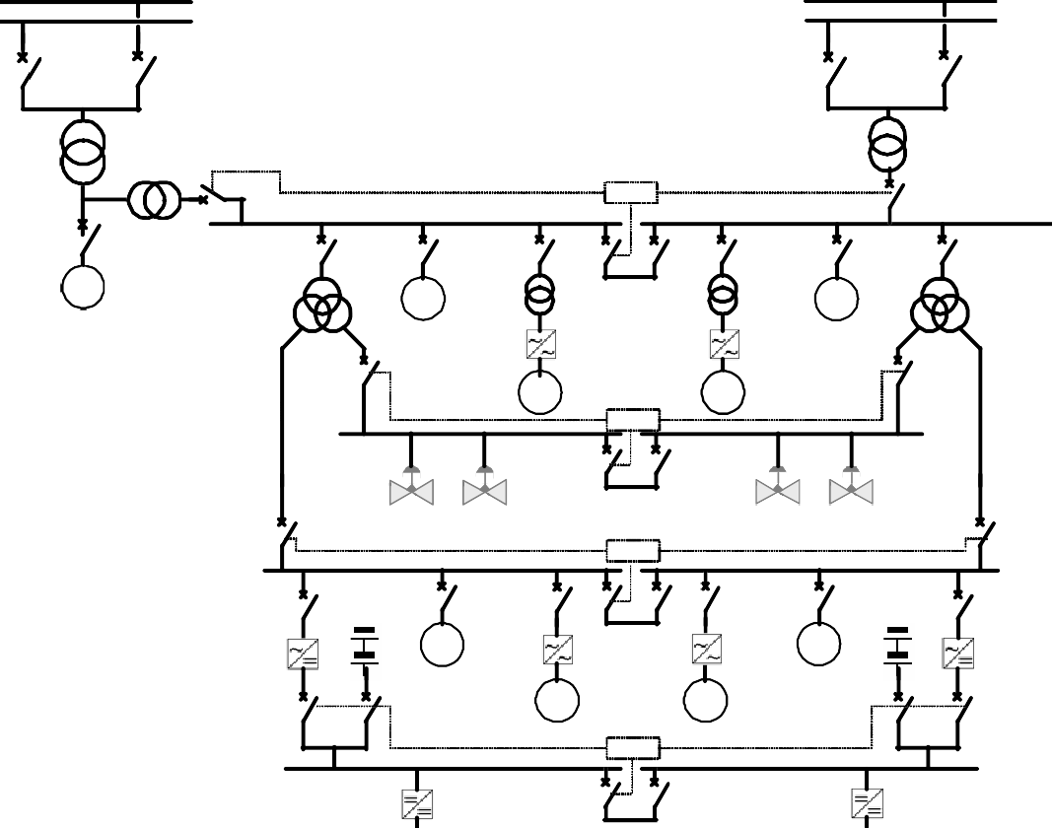

>110 kV

>1

Grid Connection

Unit Transformer

Emergency Supply

Automatic transfer system

ATS

20kV

**G**

Auxiliary Power Transformer

**M**

**M**

Generator

MV Motors

**M**

**M**

400 V AC

ATS

Actuators

ATS

690 V AC

Battery

**M**

**M**

**M**

**M**

LV Motors

ATS

220 V DC

24 V DC

10kV

Figure 5 Simplified single line diagram (SLD) of a thermal power plant

As already mentioned above there is currently no common standard available for the entire power plant application. The availability of products on the market supporting specific communication standards has to be considered, e. g. low voltage motor controllers and intelligent control drives are available with fieldbus interfaces. Only those devices typically coming from medium or high voltage substations are supporting IEC 61850. Table 1 defines a concept how typical elements of the single line diagram (Figure 5) can communicate:

|  |  |  |  |  |
| --- | --- | --- | --- | --- |
| Electrical System | Function | Process  Control | Electrical  System | Remarks |
| Field bus +  I/Os | IEC 61850 |
| Generator | Generator protection |  | x | The generator incl. the generator circuit breaker and the generator bus duct - there are several systems around the generator that are not visible on the single line diagram: the generator protection, the excitation and the synchronization system. |
| Excitation |  | x*) |
| Synchronization |  | x*) |
| Grid connection | Protection + Control |  | x | Redundant connection from 110 kV / 380k V bus bars to the unit (step-up) transformer, circuit breakers, disconnectors, earthing switches. For control and protection the breakers / switches are each equipped with an IED. |
| Unit transformer | Protection +  Step-Changer-Control |  | x | To re-act according to the particular grid code of the grid operator the transformer step-changer is controlled by an IED. The transformer is protected by redundant IED  configuration. |
| Auxiliary power  transformer | Protection |  | x | Connects the auxiliary power system to  the 20kV system. |
| Emergency auxiliary power supply | Protection + Control |  | x | Provides auxiliary power if the auxiliary power transformer and / or the grid connection is out-of-service |
| Medium voltage  busbars | Protection |  | x |  |
| Automatic busbar  transfer systems | Control |  | x | Switches over between redundant feeders |
| Medium voltage  motor feeders | Protection + Control |  | x**) | Feeders for large motors, e.g. feedwater  pump, coal mills, etc. |
| Medium voltage  feeders to frequency converters | Protection + Control |  | x | Connects medium voltage frequency converters to the medium voltage busbar |
| Medium voltage  frequency converters | Protection + Control | x |  | Converter for variable speed drives |
| Medium voltage transformer feeders | Protection + Control |  | x | Transformer connecting low voltage busbars (400V and 690V AC) to the medium voltage busbars |
| Low voltage | Control | x | x***) |  |
| Low voltage busbars | Protection | x | x***) |  |
| Low voltage motors  and drives | Protection + Control | x |  | Motors & drives controlled by the process |
| DC systems | Control | x |  | 220 V and 24 V DC secure supplies for control room and control system |

*) requires use of hydro extension IEC 61850-7-420

**) Motor protection not defined in IEC 61850

***) Currently no IEC 61850 products available on the

Table 1 Interface concept for electrical systems

# ELECTRICAL CONTROL SYSTEM REQUIREMENTS

For the integration of the electrical systems as described in the chapter above the control system has to be designed to fulfill some important requirements:

* Monitoring

Monitoring of the electrical system has to be possible at workplaces of the control room, workplaces dedicated to control of the electrical system and workplaces for maintenance planning. Graphic displays have to be available presenting the status of the overall or parts of the electrical system.

To be able to take immediate action in case of disturbances, it is also important to be aware of all alarms and have a quick overview in which part / area alarms are active.

* Manual (remote) operation

The manual (remote) operations of electrical devices have to be supported by consistent means; e.g., faceplates in the control room or locally at the device cubicle using push-buttons or control panels. Switching between remote and local operation has to be secured by locking and release mechanisms.

* Automatic operation

From a power plant control system point-of-view, automatic operation means that electrical devices are part of automatic control sequences executed in an automation controller. This requirement applies only for those devices that interact with process control. For this interaction, the automation controller and those electrical devices have to communicate using a common interface.

* Recording

For purposes of disturbance analysis, documentation, reporting and optimization, the plant control system has to be capable of recording electrical system status signals, alarms, events and measured values.

* Plant-wide sequence-of-events (SOE)

Fatal failures of the electrical system have an impact on the overall plant operation; e.g., may lead to a plant trip. For analysis of such failures a plant-wide chronological sequence-of-events is needed. To cover every type of failure, a time stamp accuracy with 1 ms time accuracy is needed.

* Events have to be recorded in chronological order. For analysis of faults, a time resolution and an accuracy of 1 ms is required. As state-of-art electronic devices do provide time stamped events, it is obvious that these time stamps created at the source of data have to be used throughout the entire communication path.
* Besides the communication part, this requirement imposes accurate time synchronization with a plant-wide master clock on the electronic devices.
* Analysis of disturbance logs by experts from remote workplaces

Fast transient data cannot be transferred through a network or the automation system due to performance reasons. Disturbance logs are stored as files in the IED. The user can upload disturbance logs to the control system workplace. From there the logs can be evaluated and archived.

* Calculation of performance characteristics

For various purposes (performance parameters for condition assessment, summation of parameters for reporting, etc.) the control system has to be capable of performing calculations based on values coming from electrical devices.

* Asset management

Collection of maintenance-relevant data and automated diagnosis for preventive maintenance.

* Engineering

The communication engineering of the electrical system should automatically generate all necessary configuration data in the power plant control system, so that the electrical system data can used in the same way as data from the process field bus etc. No duplicate data entry should be necessary.

# BASICS OF IEC 61850

IEC 61850 is much more than a protocol. The general scope of the standard is designed to support the communication of all functions being performed in a substation. Its main goal is interoperability; this is the ability for IEDs from one or different manufacturers to exchange information and use the information for their own functions.

Providing data transfer is normally a one-way procedure with data flowing from a simple sender to a highly sophisticated receiver, which interprets complex data. This is very often a human being that can read and understand the data with the help of a comprehensive background. An example is the master-slave communication commonly used in the past, like the information interface of protection devices according to IEC 60870-5-103.

Interoperability as provided by IEC 61850 is much more than simple data transfer, but provides for information exchange between two or more devices of similar intelligence. The receiver has to understand not only the structure of the data (syntax), but also its meaning; i.e., the semantics based on the data attributes received in a communication.

Interoperability does not mean interchangeability, but it is a prerequisite for it. Interchangeability without impacting the system behaviour would require devices of identical functionality. This would imply the standardization of functions, which is outside the scope of IEC 61850, as it would hinder further development of functions for substation automation.

The standard separates the functionality represented by the data model and the related communication services from the communication implementation (stack). This makes the standard future-oriented, taking into consideration that the development in communications technology is moving quicker than the development of the functionality in the field of substation automation including protection.

The data model of the standard is an object–oriented one, grouping the data into the smallest possible sets referring to the smallest possible functions to be implemented independently.

**IEC 61850 / Logical Nodes**

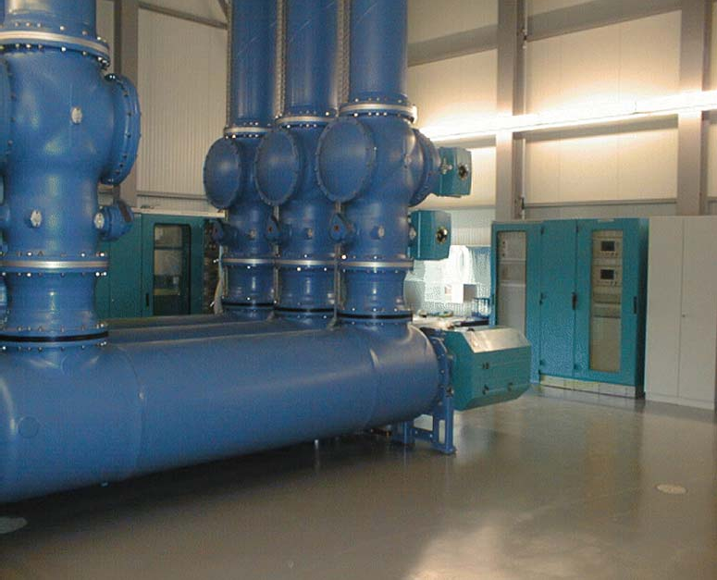

***Control***

**QA1/CSWI QC1/CSWI QB9/CSWI**

**Hardware Objects**

***Grounding Switch***

**QB9_L1/XSWI**

***Gas density mon.***

**QB9_L1/SIMG**

***Isolator***

**QC1/XSWI**

***Circuit breaker***

**QA1_L1/XCBR**

***Gas density mon.***

**QA1_L1/SIMG**

***Distance protection***

**PDIS**

Figure 6 IEC 61850 modelling of hardware and functions

These smallest possible data groups or functions are named Logical Nodes (LN). The Logical Nodes and all data and attributes contained are named according to a standardized semantic, which is mandatory.

The data model uses terminology familiar to any power system engineer. In addition, this part contains a device model, which describes the function allocation as well as the properties of each physical device. Clear rules facilitate extensions in applications.

The integration of third party equipment is facilitated and the use of a common language (SCL) avoids ambiguities. Each IEC 61850-compliant IED may be configured using its dedicated tool. However, all these IED-tools have to be compliant with IEC 61850. This means that the reading, handling, and writing of configuration files has to be according to the Substation Configuration description Language (SCL) of IEC 61850 as regards the standardized data model, the data access (services) and all communication connections. This allows a system integrator to use understandable data from all devices (independently of the supplier) to build a complete system and to assure data consistency.

Complete Single line



Substation Structure

=XW1

=QE1

=QC1

LNs

Relation between & single line

=QB2

=QB1

=QB2

=QB1

=WB1 Busbar 1

=WB2 Busbar 2

=Q1 line bay / feeder

IEDs with loaded LNs

=E1 Voltage level 110kV

=QC1 =QE1

**=S1CSWI1**

=QA1

**=S1CSWI1**

=QA1

**IED** -SB1

**IED** -SB1

=Q2 line bay / feeder

Communication Subnetwork

Figure 7 SCL describing all aspects of the electrical system

The information according to SCL may be stored together with the system documentation and re-used in any maintenance situation as well as in case of evolving tools or changing responsibilities for system maintenance, if the system is compliant with IEC 61850.

Engineering data stored as SCL files can be reused; e.g., in case of extensions (additional bays) or refurbishment.

The communication procedures are described by the seven-layer ISO/OSI model, called stack. The selected stack is MMS (Manufacturing Message Specification) over TCP/IP and Ethernet as used in mainstream communication technology. It is the use of mainstream means that allows benefiting from the fast advancing communication technology. The performance and safety requirements dedicated to substation automation are considered.

**Application**

**Data Model (Objects,Services)**

**Sampled Values**

**GOOSE\***

**Client Server Communication**

|  |  |
| --- | --- |
|  | **Realtime – Priority communication** |
| **MMS** |
|  |
| **TCP** |
| **IP** |
| **Ethernet Link Layer** | |
| **Ethernet Physical Layer with Priority tagging (100 Mbit/s)** | |

*Stack selection according to the state-of-the-art Communication technology*

Stack Interface

Abstract Communication Services Interface (ACSI)

**ISO/OSI – Stack**

Hierarchical set of

Rules how information is coded for transmission

According to state-of-the art communication technology

**Mapping (split data model from communication)**

* **G**eneric **O**bject **O**riented **S**ubstation **E**vent

Figure 8 IEC 61850 communication model

The data model and the communication stack are linked by means of standardized mapping, which is the only item to be adapted in case changes in communication technology are implemented. This has no impact on the functions and databases in the system.

Station control and monitoring are the basic tasks of a substation automation system. This comprises:

* + Local operation of the switchgear and other medium-/ high-voltage equipment
  + Acquisition of switchgear information and power system measurements
  + Handling of events and alarms.

This application is related to human operation of the station. The data communication for this application is directed vertically; i.e., from station control level down to bay level (commands of any kind from the operators place) or reverse (binary indications like breakers or isolators position, measured values from instrument transformers and other sensors, events, alarms).

This vertical communication (bay - station) is based on a client-server concept using reporting, command and file transfer services.

# IMPACT OF IEC 61850 ON THE CONTROL SYSTEM STRUCTURE

Introducing IEC 61850 for integration of electrical systems leads to simplified system structures. The Ethernet based IEC 61850 station bus replaces hardwired and serial cabling for process communication. Besides the process communication, Ethernet allows time synchronization, file transfer and engineering tool access on one physical cable.

Figure 9 and Figure 10 show two possible steps for introducing IEC 61850. Figure 9 represents a configuration replacing serial protocols by IEC 61850 for vertical communication; that is, for the communication between electronic devices and the control system. The communication between electronic devices (horizontal communication) remains hardwired. IEC 61850 is designed to support horizontal communication. In that case, hardwiring between electronic devices (e.g., for interlocking) and communication between electronic devices and the process automation controllers (e.g., turbine control) as shown in Figure 10 are Ethernet-based as well.

Control Room

Plant network

Control System Server

**2**

Control Room Workplace

Control System



**1**

Control network

IEC 61850 station bus

Local I/O

IED

IED

IED

Marshalling Rack

Automation Controller

Automation

Fieldbus

Automation Controller

Field

Turbine, Water + Steam Cycle, Unit Control, Boiler, FGP …



**1**

**2**

Time Synchronization Engineering / Expert Tool

Generator Protection, Transformer Protection, MV / HV Switchyard, Excitation, Synchronization

Figure 9 Integrated system based on IEC 61850 vertical communication

Control Room

Plant network

Control System Server

**2**

Control Room Workplace

Control System

**1**

Control network

IEC 61850 station bus

Local I/O

IED

IED

IED

Automation



Automation Controller

Fieldbus

Automation Controller

Field

Turbine, Water + Steam Cycle, Unit Control, Boiler, FGP …



**1**

**2**

Time Synchronization Engineering / Expert Tool

Generator Protection, Transformer Protection, MV / HV Switchyard, Excitation, Synchronization

Figure 10 Integrated system based on IEC 61850 vertical and horizontal communication

# EXAMPLE: GENERATOR PROTECTION ABB REG 670

Modern generator and generator transformer protection systems based on IEC 61850 offer simplification, connectivity and harmonization towards partial or full integration with the power plant automation and control system. IEC 61850 does not define the content of an algorithm to protect a generator, motor or transformer, but the very deep implementation of the IEC 61850 model into the device architecture brings the best benefits to the user. This is not only in respect to communication, but also when it comes to data consistency throughout the whole power plant. When it comes to native implementation of the IEC 61850 model, ABB is the leader with the IED 670, which is a control and protection platform fully designed for IEC 61850. The REG 670 as part of this platform already has the ingredients to provide perfect support for IEC 61850 engineering, configuration, testing and commissioning services. On hardware with Ethernet technology, it is ready to provide single, independent or redundant communication links for various purposes. All data from configuration to process and disturbance data will be transferred and presented according to IEC 61850 logical node

definitions/attributes. The ABB PCM 600 IED tool manager supports the user, not only for configuration and engineering purposes but also provides testing and monitoring features.

For example, the REG 670 already incorporates the IEC 61850 definitions in the user documentation as the following example of a pre-configured package shows. Such a configuration is intended to be used for hydro-, gas- and pump-storage applications. For larger applications the transformer protection can be moved to a RET 670 as shown in Figure

1. One REG 670 as main 1 and another one as main 2 protection already protects the complete generator block including the generator transformer. It already has an in-built IEC 61850 interface to the plant control system. All necessary data, like events, alarms, analog information and disturbance data in Comtrade ® format can be accessed in System 800xA.

For visualization and monitoring of REG 670 data, all System 800xA display capabilities, such as freely configurable graphics, faceplates, alarm & even lists are available.

Furthermore, data can be stored in the System 800xA history database for later analysis.

Figure 11 REG 670 predefined package for hydro-, gas- and pump-storage applications

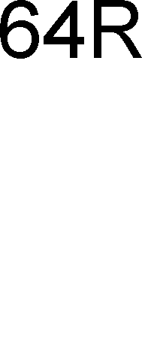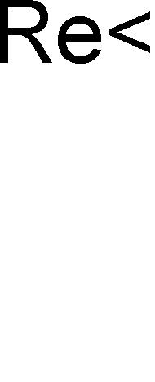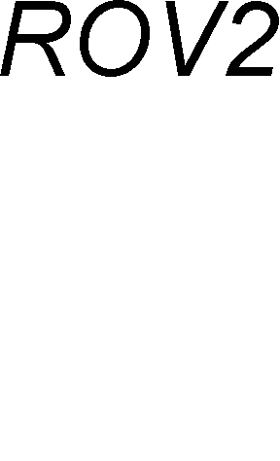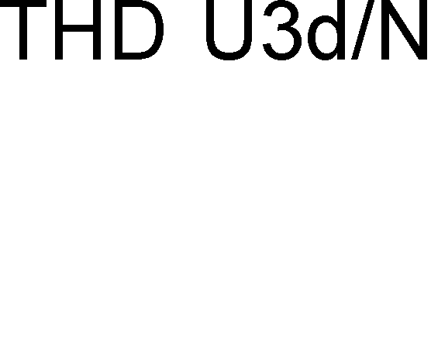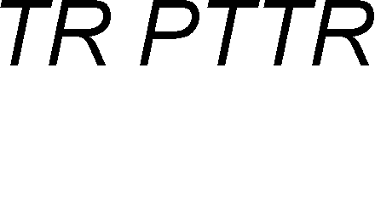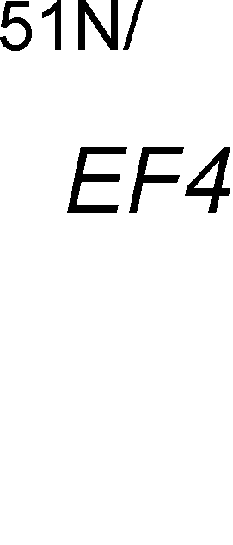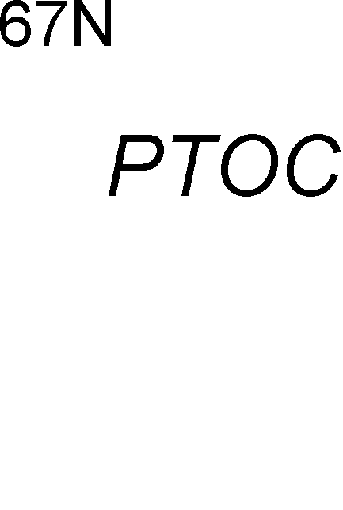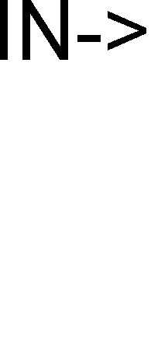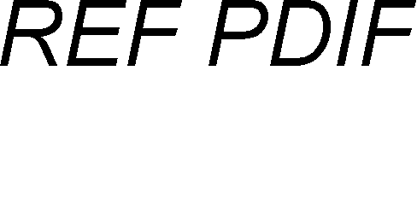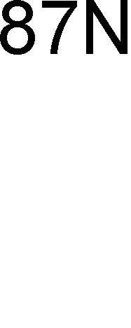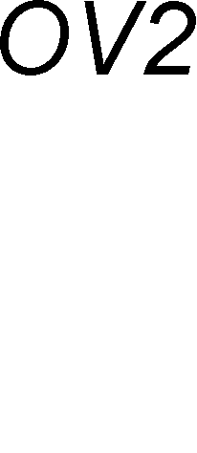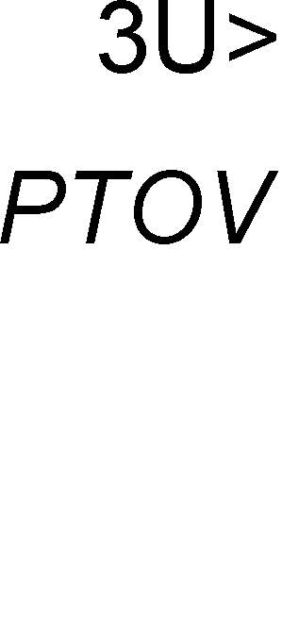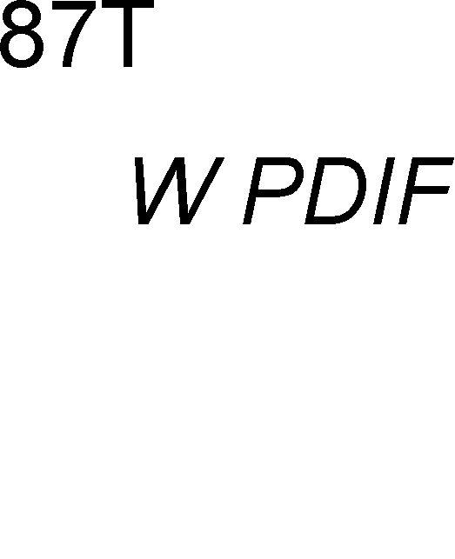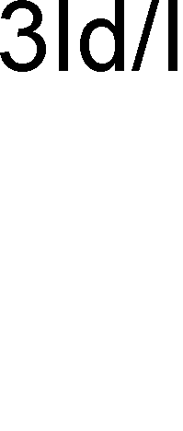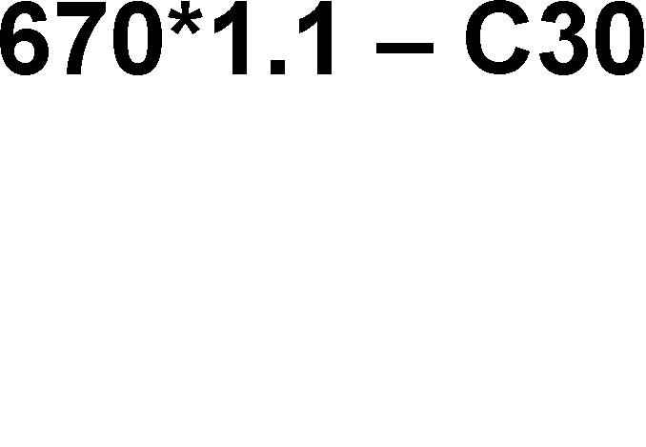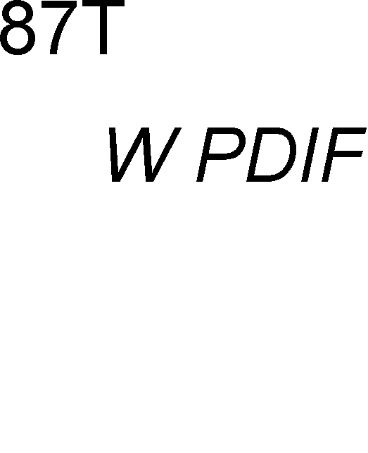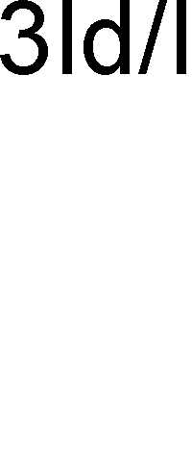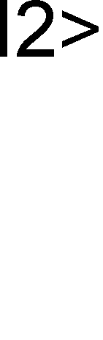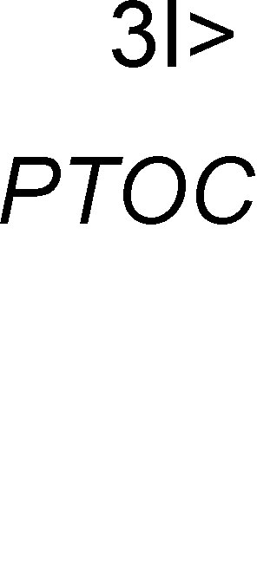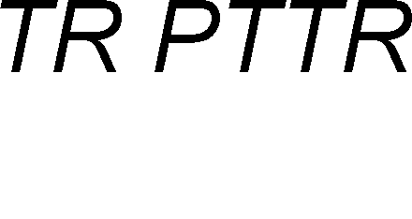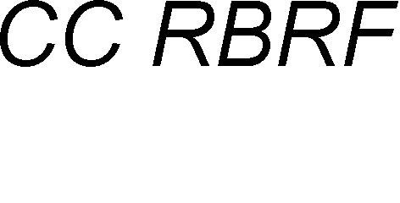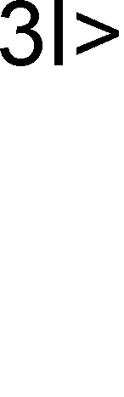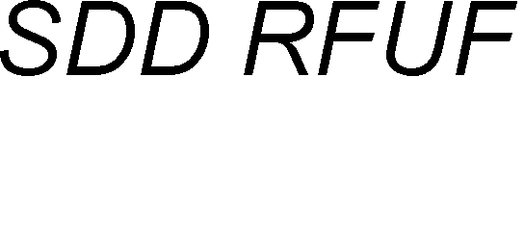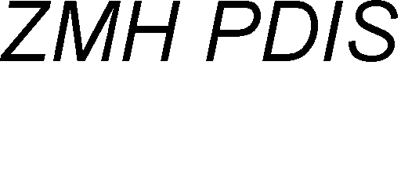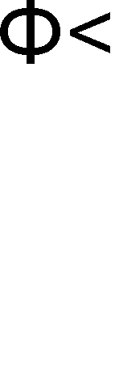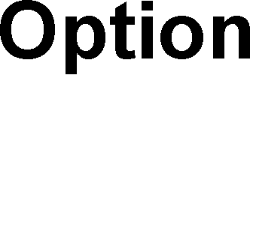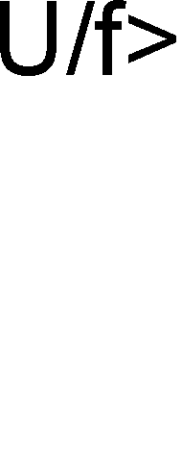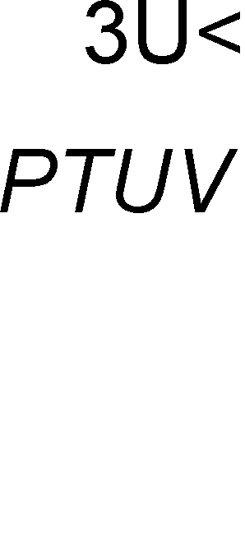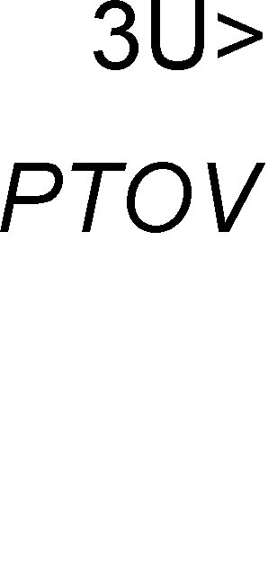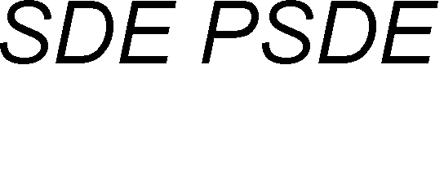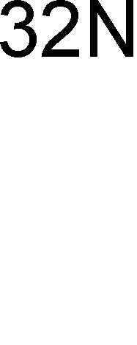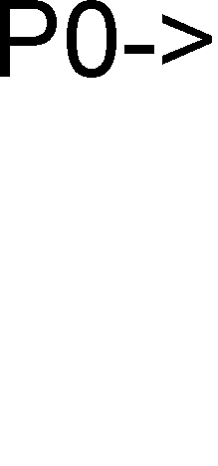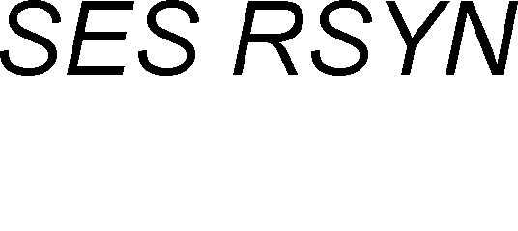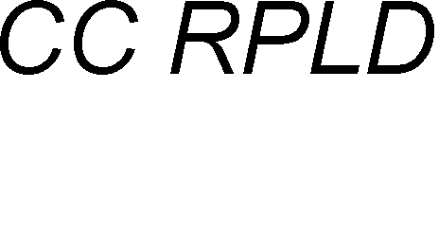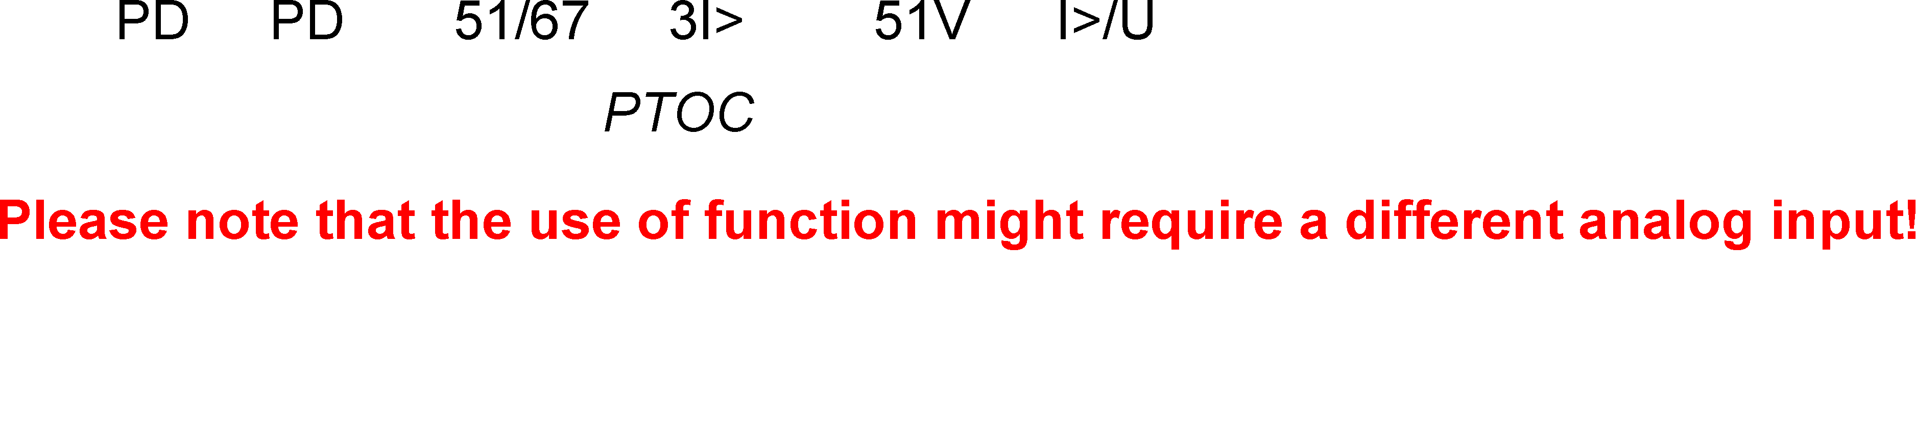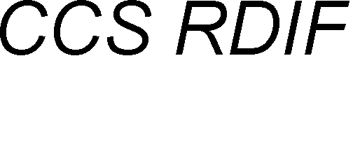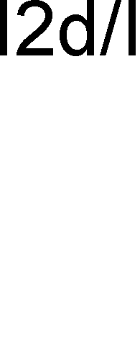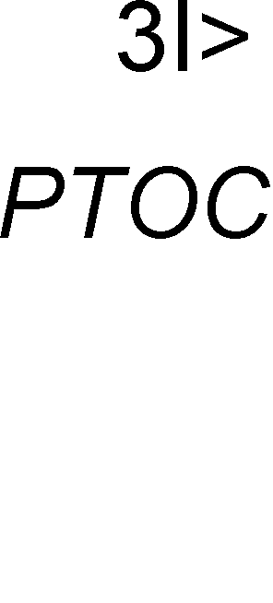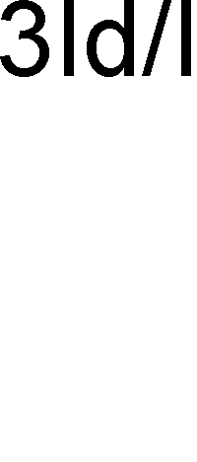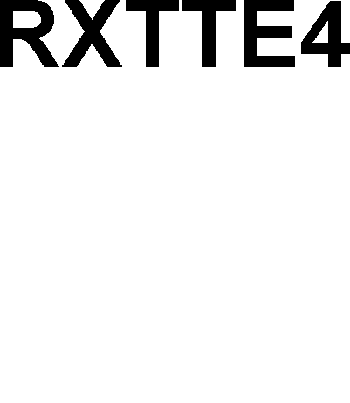

Figure 12 shows the integration of the unit protection to System 800xA. The protection systems consist of two autonomous channels. Ethernet-based IEC 61850 links connect the IEDs to the 800xA control network and the System 800xA server. A routing device separates the System 800xA control network and the IEC 61850 station bus for save operation.

Generator circuit breakerr

Figure 12 RET 670 and REG 670 integration to ABB's System 800xA

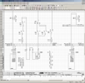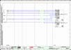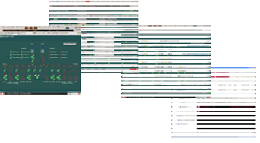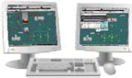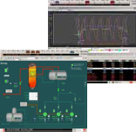

**Operation Monitoring Optimization Trending Reporting**

**Office Workplace Network Control Center Remote Access**

**CMMS SAP**

WLAN

Enterprise LAN

Workplaces

**Diagnosis**

**Asset Management Engineering**

WLAN

Plant Network

800xA System Server

Control Network

Turbine control / protection

**Status signals**

**Manual commands,**

**Status signals + SOE / alarms / expert tool, disturbance logs**

**IEC 61850**

8-wire-cable

110kV

Unit transformer

20kV

Transformer protection RET 670

* Unit transformer
* Auxiliary power transformer

Auxiliary power transformer

Protection on Unit protection REG 670

-Generator protection

Current Voltage Frequency Fault

Status circuit breaker Status earthing switch

...

Generator

**G**

The consistent vertical integration from the IED up to the enterpise-system level allows the implementation of cost efficient maintenance strategies. Maintenance relevant information generated by the RET 670 / REG 670 self-diagnosis can be automatically transformed to a maintenance message and transferred to the CMMS (maintenance management system).

# SUMMARY / CONCLUSION

With the integration of process control and electrical control in power plants, cost savings can be achieved in engineering, operation and maintenance. Control system concepts have to consider that today and in near future, there are and will be no common communication standards for the overall power plant. The new standard IEC 61850 is broadly accepted by the substation automation market and can also be applied for the auxiliary power system of power plants. The portfolio of the leading suppliers of electrical equipment covers the whole range of applications. Some limitations have to be considered for those applications, which are not (yet) defined in IEC 61850, e.g. excitation is an example. Extensions of the standard are already released or are in preparation for hydro power plants (IEC 61850-7-420 / IEC 62344), for wind energy plants and for distributed renewables. These extensions will add new functions to IEC 61850 which can be used in thermal power plants as well.

The future is talking IEC 61850 providing solutions for seamless integration concepts for new and refurbishment projects.

ABB’s System 800xA is the first system on the market to support the described integration concepts, based on IEC 61850.

# REFERENCES

* 1. IEC 61850 „Communication networks and systems in substations”
  2. Substation Automation Handbook, 2003, ISBN 3-85758-951-5
  3. ABB Review 3/2003: IEC 61850 meets Industrial IT
  4. ABB IED 670 Selection Guide, 1MRK 500 078-SEN
  5. Generator protection IED REG 670, 1MRK 502 018-SEN
  6. PRAXIS Profiline – Juli 2005: Maximizing the user benefits of IEC 61850 in

substation automation systems

* 1. [www.abb.com](http://www.abb.com/) / collection of IEC 61850 articles:<http://www.abb.com/cawp/seitp202/5a2f05a756741714c1256e5c00429c4e.aspx>