### **A REPORT**

**ON**

**POWER PLANT THERMAL EFFICIENCY IMPROVEMENT**

**BY**

**NAME: ID:**

MUDIT SRIVASTAVA 2018A3PS0430G

SIDDHARTHA JEJURKAR 2018A3PS0617G

**AT**

**VIKRAM CEMENT WORKS, NEEMUCH**

**A Practice School-I station of**



**BIRLA INSTITUTE OF TECHNOLOGY & SCIENCE, PILANI**

### **A REPORT ON**

**POWER PLANT THERMAL EFFICIENCY IMPROVEMENT BY**

**NAME: ID: DISCIPLINE:**

MUDIT SRIVASTAVA SIDDHARTHA JEJURKAR

2018A3PS0430G B.E.(Hons) E.E.E.

2018A3PS0617G B.E.(Hons) E.E.E.

**Prepared in partial fulfilment of the Practice School-I Course Nos.**

**BITS C221/BITS C231/BITS241**

**AT**

**VIKRAM CEMENT WORKS, NEEMUCH**

A Practice School-I station of



**BIRLA INSTITUTE OF TECHNOLOGY & SCIENCE, PILANI**

# Acknowledgement

We would like to use this opportunity to express our gratitude to everyone who has been supporting us through the course of the project. Firstly, we are extremely grateful to our institute, BITS Pilani for offering us the course, Practice School – I during these testing times and giving us an opportunity to get an industry- based experience. Secondly, we would like to thank our instructor in-charge, Prof. Ankur Bhattacharjee to guide us and help us to get the utmost of this experience. Also, the mentors of our PS station, Vikram Cement Works Mr. Praveen Vijayvargiya to regularly guide us in our project. We would also like to thank everyone else who was directly or indirectly involved to provide us with this opportunity.

**BIRLA INSTITUTE OF TECHNOLOGY AND SCIENCE PILANI (RAJASTHAN)**

**Practice School Division**

**Station**: Vikram Cement Works

**Centre**: Neemuch

**Duration**: 6 weeks **Date of Start:** May 18, 2020 **Date of Submission**: June 26, 2020

**Title of the Project**: Power Plant Thermal Efficiency Improvement

**NAME: ID: DISCIPLINE:**

Mudit Srivastava 2018A3PS0430G E.E.E.

Siddhartha Jejurkar 2018A3PS0617G E.E.E.

**Expert Details :**

**Name :** Mr. Praveen Vijayvargiya

**Designation:** Vikram Cement Works , Neemuch

**Name of the PS Faculty**: Dr. Ankur Bhattacharje

**Abstract:**

A thermal power station may be a power plant during which the first cause is steam driven. Water is heated, turns into steam and spins a turbine which drives an electrical generator. After it passes through the turbine, the steam is condensed during a condenser and recycled to where it had been heated; this is often referred to as a Rankine cycle. The greatest variation within the design of thermal power stations is thanks to the various fuel sources. Some like better to use the term energy center because such facilities convert sorts of heat into electricity. Some thermal power plants also deliver heat for industrial purposes, for district heating, or for desalination of water also as delivering electric power. A large a part of human CO2 emissions comes from fossil fueled thermal power plants; efforts to scale back these outputs are various and widespread. At present 54.09% or 93918.38 MW (Data Source CEA, as on 31/03/2011) of total electricity production in India is from Coal Based Thermal power plant. A coal based thermal power station converts the energy of the coal into electricity. This is achieved by raising the steam within the boilers, expanding it through the turbine and coupling the turbines to the generators which converts energy into electricity.

**Signature(s) of Student(s): Signature of PS Faculty:**

**Date: Date:**

**Introduction**

Almost all coal, nuclear, geothermal, solar thermal electric, and waste incineration plants, also as many gas power plants are thermal. The initially developed reciprocating external-combustion engine has been wont to produce mechanical power since the 18th Century, with notable improvements being made by Watt. When the first commercially developed central electrical power, stations were established in 1882 at Pearl Street Station in Ny and Holborn Viaduct power station in London, reciprocating steam engines were used.

The development of the turbine in 1884 provided larger and more efficient machine designs for central generating stations. By 1892 the turbine was considered a much better alternative to reciprocating engines; turbines offered higher speeds, more compact machinery, and stable speed regulation allowing simultaneous operation of generators on a common bus. After about 1905, turbines entirely replaced reciprocating engines in large central power stations.

THERMAL POWER GENERATION IN INDIA:

Thermal power plants convert energy rich fuel into electricity and heat. Possible fuels include coal, gas, petroleum products, agricultural waste and domestic trash / waste. Coal and lignite

accounted for about 70% of India's installed capacity. India's electricity sector consumes about 80% of the coal produced within the country. A large a part of Indian coal reserve is analogous to Gondwana coal. The installed capacity of Thermal Power in India, as of June 30, 2011, was 115649.48 MW which is 65.34% of total installed capacity. The state of Maharashtra is that the largest producer of thermal power within the country.

**Index**

1. **Project Overview**
2. **Thermal Power Generation Plan0074**

**Project Overview**

The project is Power Plant Thermal Efficiency Improvement. The project objectives are as follows, understanding the concepts behind the power generation of a thermal power plant, exploring new technologies that are being implemented in big scale industries around the world, getting an awareness about how the current technology can be digitalized.

This project demanded some requirements like having basic knowledge about thermodynamics and Automation technology coupled with few Electronics and Instrumentation basics.

The workplan of the project is simple and straightforward. The initial weeks were prescribed to understand TPP and Automatic Process Controller (APC) technology. Later weeks focused on Auxiliary Power Consumption techniques and Variable frequency drives.

Overall, the project milestone is accomplished which is Understanding thermal power plant technology and improvement initiatives for thermal power plant efficiency

**Thermal Power Generation Plant**

Thermal power generation plant or thermal station is that the most conventional

source of electrical power. Thermal station is additionally referred as coal

thermal station and turbine station.

As a matter of fact, Thermal Power Plants constitute 75.43% of the entire

installed captive and non-captive power generation in

India. Before going into detail of this subject, allow us to understand how does an

influence plant work.

*“Thermal power plant* ***”*** *as the title infers is the place of mechanism which converts*

*heat energy into electric power.*

Thermal Power Plants also called Thermal Power Generation Plant or Thermal

Power Station **.**

**How does Thermal Power Plant work?**

In thermal power plants, the warmth energy obtained from combustion of solid

fuel (mostly coal) is employed to convert water into steam, this steam is at air

mass and temperature.

This steam is employed to rotate the turbine blade turbine shaft is connected to

the generator. The generator converts the kinetic energy of the turbine

impeller into electric energy.

**Theory of Thermal Power Plant**

The theory of thermal power plant or working of thermal power plant is

extremely simple. an influence generation plant mainly consists of alternator runs

with help of turbine. The steam is obtained from high pressure boilers. Generally,

in India, soft coal, coal and peat are used as fuel of boiler. The soft coal is

employed as boiler fuel has volatile matter from 8 to 33% and ash content 5 to

16%. to extend the thermal efficiency, the coal is employed within the boiler in

powder form.

In coal thermal powerhouse, the steam is produced in air mass within

the boiler thanks to burning of fuel (pulverized coal) in boiler furnaces. This steam

is further supper heated during a superheater. This superheated steam then

enters into the turbine and rotates the turbine blades. The turbine is

mechanically so including alternator that its rotor will rotate with the rotation of

turbine blades. After entering in turbine, the steam pressure suddenly falls and

corresponding volume of the steam increases.

After imparting energy to the turbine rotor, the steam passes out of the turbine

blades into the condenser. within the condenser, the cold water is circulated

with the assistance of a pump which condenses the low-pressure wet steam. This

condensed water is further supplied to a low-pressure storage tank which acts as

water heater where the low-pressure steam increases the temperature of this

feed water; it's again heated in high pressure.

For better understanding we furnish every step of function of a thermal power

station as follows,

1. First the pulverized coal is burnt into the furnace of steam boiler.

2. High pressure steam is produced in the boiler.

3. This steam is then passed through the super heater, where it further

heated up.

4. This supper heated steam is then entered into a turbine at high speed.

5. In turbine this steam force rotates the turbine blades that means here

in the turbine the stored potential energy of the high-pressured steam

is converted into mechanical energy.

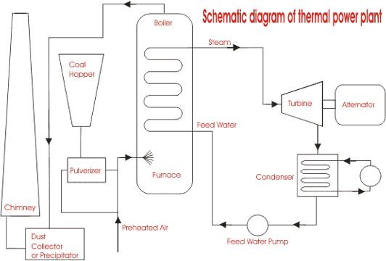

1. After rotating the turbine blades, the steam has lost its high pressure, passes out of turbine blades and enters into a condenser.
2. In the condenser the cold water is circulated with help of pump which condenses the low-pressure wet steam.
3. This condensed water is then further supplied to low pressure water heater where the low-pressure steam increases the temperature of this feed water, it is then again heated in a high-pressure heater where the high pressure of steam is used for heating.
4. The turbine in thermal power station acts as a prime mover of the alternator.

## **Advantages and Disadvantages of Thermal Power Plant**

Advantages:

1. Economical for low initial cost other than any generating plant.
2. Land required less than hydro power plant.
3. Since coal is main fuel and its cost is quite cheap than petrol/diesel so generation cost is economical.
4. Maintenance is easier.
5. Thermal power plant can be installed in any location where transportation and bulk of water are available.

Disadvantages:

1. The running cost for a thermal power station is comparatively high due to fuel, maintenance etc.
2. Large amount of smoke causes air pollution. The thermal power station is responsible for Global warming.
3. The heated water that comes from thermal power plant has an adverse effect on the aquatic lives in the water and disturbs the ecology.
4. Overall efficiency of thermal power plant is low like less 30%.

## **POWER PLANT CYCLES**

A thermal power plant works on the principle that heat is released by burning fuel which produces (working fluid) (steam) from water. The steam so produced runs the turbine coupled to generator which produces electricity.

A working fluid goes through a repetitive cycle change and this cyclic change involving heat and work is understood as thermodynamic cycle. Thus, a thermodynamic cycle may be a series of operations, involving a heat source, a heat receiver, a machine and dealing substance.

#### **Types of Power Plant Cycles**

Thermal power plants, in general, may work on Vapour and Gas Power cycles

Vapour Power cycles can be classified as:

* 1. Rankine cycle
  2. Reheat cycle
  3. Regenerative cycle
  4. Binary vapour cycle

Gas Power Cycle can be classified as follows:

1. Otto cycle
2. Diesel cycle
3. Dual combustion cycle
4. Gas turbine cycle

#### **Rankine Cycle**

Rankine cycle is the notional cycle on which steam power station works. Rankine cycle is a vapour-liquid cycle, it is most convenient to draw it on both the P-V and T-s diagrams with respect to the saturated-liquid and vapour lines of the working fluid, which usually but not always is water.

Figure shows a simplified flow diagram of a Rankine cycle.

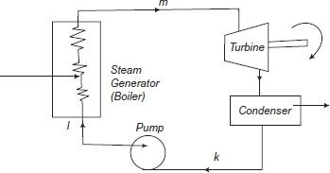

#### **Typical Ideal Rankine Cycle**

In a vapor cycle if the working fluid during a vapor cycle passes through various components of the facility plant without irreversibility and frictional pressure drop, then the cycle is called as Ideal Rankine Cycle.

**Reheat cycle**:

A further improvement in cycle efficiency with gaseous primary fluids as in fuel and gas-cooled power plants is achieved.

The improvement in thermal efficiency thanks to reheat greatly depends on the reheat pressure with reference to the first pressure of steam.

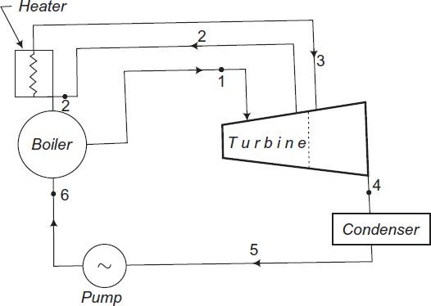

**Advantages of Reheating**

1. there's an increased output of the turbine.
2. The thermal efficiency of the turbines increases.
3. Efficiencies of nozzle and blade increase.
4. Corrosion problems are minimized in steam turbines.
5. Dryness factor of steam improved.

**Disadvantages of Reheating**

1. Reheating requires maintenance.
2. Reheating increases the expenditure.

### **Regenerative Cycle:**

In the Rankine cycle it's observed that the condensate which is fairly at coldness has an irreversible mixing with hot boiler water and this leads to the decrease of cycle efficiency. Methods are, therefore, adopted to heat the feed water from the recent well of condenser irreversibly by interchange of warmth within the system and thus improving the cycle efficiency. This heating method is named regenerative feed heat and therefore the cycle is named regenerative cycle.

The principle of generation is often practically utilised by extracting steam from the turbine at several locations and supplying it to the regenerative heaters. The resulting cycle is understood as regenerative or bleeding cycle.

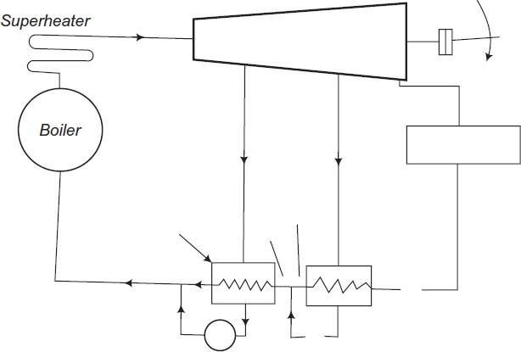

**Advantages of Regenerative Cycle Over Simple Rankine Cycle**

1. The heating process within the boiler tends to become reversible.
2. The thermal stresses found out within the boiler are minimised. This is thanks to the very fact that temperature ranges within the boiler are reduced.
3. The thermal efficiency is improved because the typical temperature of warmth addition to the cycle is increased.
4. Heat rate is reduced.
5. The blade height is a smaller amount thanks to the reduced amount of steam skilled the low stages.
6. thanks to many extractions there's an improvement within the turbine drainage and it reduces erosion thanks to moisture.
7. A small size condenser is required.

**Disadvantages of Regenerative Cycle Over Simple Rankine Cycle**

1. The plant becomes more complicated.
2. Maintenance cost is more.
3. an outsized capacity boiler is required for a given power rating.
4. the warmers are costly and therefore the gain in thermal efficiency isn't much as compared to the prices.

# EFFICIENCY OF THERMAL POWER PLANTS

Overall efficiency of a thermal power plant is calculated as the ratio of heat equivalent of electric power and heat produced due to fuel combustion in the furnace.

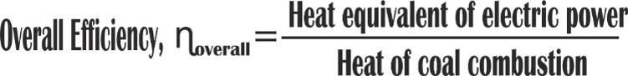

Although many factors affect the heat transfer cycle and efficiency, the major ones are :

###### **Boiler Efficiency :**

Depends on the heat content of the outlet steam and the heat provided by combustion of fuel. Incomplete combustion can lead to excess impurities and decreased efficiency. A typical steam boiler has an efficiency of 85%

###### **Cycle Efficiency :**

The overall thermodynamic cycle also affects the efficiency. Since the thermal power plants use a Rankine cycle with steam/water as the working fluid, loss of heat content which is expelled from the steam turbine affects the efficiency significantly.

###### **Turbine Efficiency :**

This is the efficiency of a turbine to convert heat energy carried by steam from boiler into useful mechanical energy.

###### **Generator Efficiency :**

Generator efficiency is calculated using the mechanical energy input from the steam turbine and the actual energy output generated. A typical generator has an efficiency of 96-99%.

A typical Thermal Power Plant efficiency is quite low. Generally, it ranges between 25 to 30%, and in extremely rare cases it is 40%.

**Present Scenario**

The generation scenario for highest demand day of August 2018, sourced from POSOCO, is given in the

table and chart below. The current installed capacity of renewables is 70 GW out of which maximum power during the day produced by RES is around 23.5 GW, which reduces to around 11.7 GW at night. As online generation data is not received from all RE plant, the actual generation figure may be higher than what is recorded at the NLDC. The percentage variation gives an idea as to how much flexing is currently being done by each fuel source. Even though quantum of total ramp up done by coal is more it is still running at a much stable load, in comparison to hydro, due to its larger installed base. Compared to coal, hydro is a major contributor here due to its ability of quick start-stop and quick ramping.

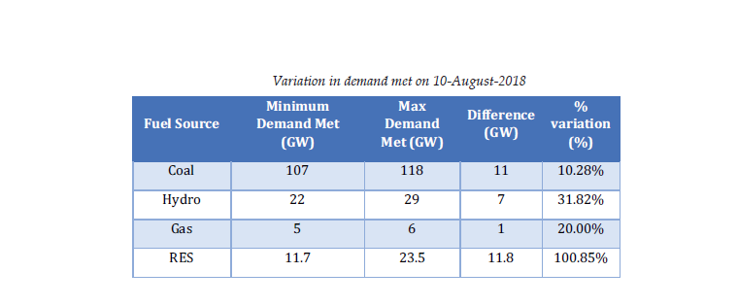

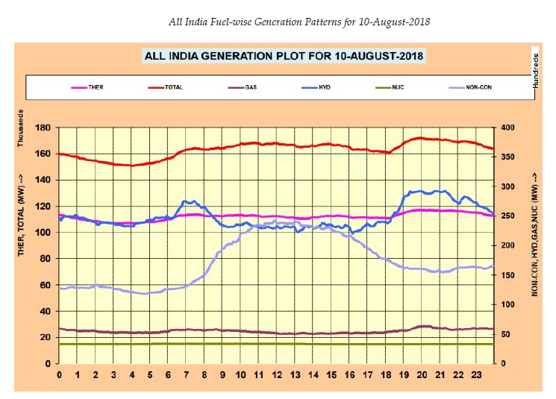

**Flexibility Measures at Plant Level**

Preparation of a coal fired unit for flexible operation would require measures to be implemented at all levels

of operation, maintenance and administration. Some of the measures required are listed below.

**1. Raise the awareness for flexible operation:** Provide background information about the need for flexible operation of coal-fired units. Similarly explain the impact of flexible operation on O&M of the plant and initiate training programs accordingly. The commercial impacts must also be sensitized.

**2. Check the status of the plant** and identify bottlenecks and limitations with respect to flexible operation:

• Consult with OEMs to assess the influences of low load operation and temperature & pressure gradients on main components/ equipment.

• Ensure smooth operation of all control loops at base load.

**3. Plan and execute test runs** to evaluate the plant flexibility potential

• Create transparency about the plant performance with respect to normal load, start-up and cycling behaviour in the current setup.

• Identify constraints and process limitations as well as improvement potential.

**4. Optimize I&C system:** This is the most cost-effective way to enhance the flexibility of the plant. A certain level of automation is a prerequisite for tapping this potential.

• Implementation of smooth control system in major power plant processes strengthen flexible operation; e.g. precise steam temperature control.

• Optimization of underlying control loops, i.e. coal supply, drum level and air control, is a basic requirement and plant operators need to consider interlocks coming from logics.

**5. Implement mitigation measures** to manage the consequences of flexible / cycling operation. This includes a reassessment of all O&M procedures, with a special focus on water and steam quality, preservation and layup procedures as well as on maintenance strategies. The use of appropriate condition monitoring systems is essential.

**6. Optimize combustion:** Stable combustion is the key aspect to ensure minimum load operation. The following aspects are important.

• Reliable flame detection for each individual burner

• Transparency about the coal quality and composition

• Optimization of air flow management

• Operation with a reduced number of mills

• Adaptation of the boiler protection system at low load operation.

**7. Optimize start-up procedures:** In order to ensure a fast and efficient start-up, plant operators should check start-up related temperature measurements and consider replacement of measuring equipments, if required. Besides automated start-up procedures, this is a prerequisite to assess admissible temperature limits and to operate with less conservative set points.

**8. Improve the plant efficiency at part load and dynamic behavior of the plant:** This refers to the measures like use of the potential of the water-steam cycle – such as frequency support by condensate stop and HP heater optimization – as well as measures to enhance the performance of important equipment and components, e.g. ID, FD and PA fans or feed water pumps.

**9. Improve the coal quality:** Better quality of coal improves the combustion process. Therefore, implement measures, such as blending & washing and online coal analysis to improve and monitor coal quality.

**10. Automate Control Procedures:** Automated operation always has advantage over manual operation. Some of the options that can be explored are:

• Automated Start of Fans and Pumps

• Automated Mill Operation

• Steam Temperature Control

• Flue Gas Temperature Control

Since each unit has a separate plant layout, equipment design, efficiency in operation practices and general condition of the machinery the interventions specific to a plant may be enumerated only after conducting a test run. A pilot test for flexible operation was conducted at unit 6 (500 MW) of Dadri TPS of NTPC. The test has successfully demonstrated operation of the unit at 40% minimum load and ramp rates of upto 3%/min. The test procedure of the pilot test is attached at annexure-IV for reference of the generating utilities.

# ONE SYSTEM FOR PROCESS & ELECTRICAL CONTROL

Traditional power plant control systems focus on controlling the process operation of the power plant. The power plant control system controls the different processes to achieve maximum power output at lowest operational cost. Today’s state-of-art control systems are highly automated, and in many installations, allow one operator in a central control room to manage the entire production. In the past, electrical systems were already coupled to the process control system using parallel copper cable hardwired interfaces. Due to cabling and engineering costs, the bandwidth of this kind of interface is very limited; e.g., enabling the display of a single line diagram (SLD) overview in the central control room. For additional signals, the number of I/O boards and the number of DCS marshalling racks increases.

With the introduction of intelligent electronic devices (IEDs) in the auxiliary power system and the 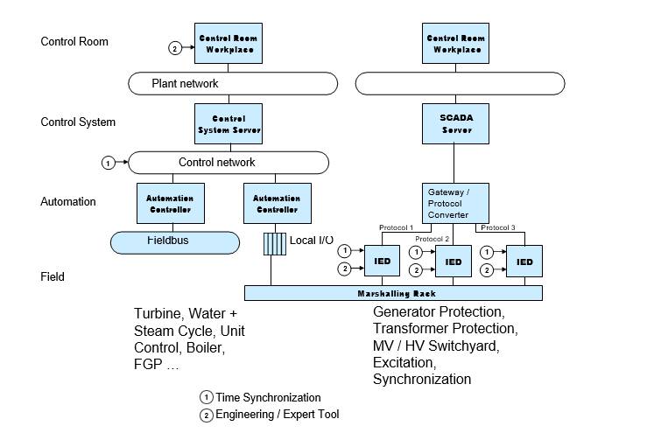

Today’s state-of-the-art technology-based power plant control systems allow integrating both process and electrical control into one consistent system. This makes a separate HSI system for the electrical part unnecessary, providing a couple of benefits to generation companies:

* One user interface

Having one system environment makes it possible to implement a consistent operating philosophy. Process operators and electricians / electrical engineers work with same system and can use the same graphic displays. Consistency of data presentation and operating procedures mean a significant improvement of operation quality

* Access to all data from all screens

Electrical systems can be operated from every system work station according to user access rights. That means that information is available when and where it is needed. Electrical systems information is not limited to dedicated screens.

* Data recording and archiving

Collecting all data from process and the electrical systems in one database means data is recorded uniformly and based on that, analysis and reporting are also.

Having one system means also having a plant-wide sequence of events.

* Lower training cost

Training for control room operators, plant maintenance personnel and system administrators is reduced since there is only one instead of two system environments.

* System administration

Having one system simplifies system administration tasks like user management, backup procedures and, for example, maintenance of signal data and graphic display

* System security

To maintain high security, system-specific concepts and procedures have to be implemented by the system owner. Having one system allows a comprehensive IT security concept to be set up.

* Engineering and documentation

The number of engineering tools is reduced, avoiding multiple entry of the same data and providing consistent documentation.

* Spare parts

Even though today's systems are based on standard PC hardware and operating systems, there are always specific parts necessary. Combining process control and electrical control in one system reduces the number of required spare parts.

* Interfaces to enterprise level systems

To make a power plant competitive nowadays, the automation systems have to be connected to higher level systems and enterprise level networks. Applications to be supported on that level are

* + access to plant data from office PCs (e.g., for environmental reporting)
  + automatic transfer of real-time data to computerized maintenance management systems (CMMS)
  + access to CMMS data (e.g., spare part availability) from control system workplaces
  + remote connection to central dispatch centers
  + remote access for system support purposes
  + automatic transfer of process data to central PIMS (plant information management systems)

A constraint when process control and electrical control systems are separate is that all these interfaces must be implemented twice. Reducing to one control system saves significant implementation and maintenance efforts for interfaces.

It is obvious that all these arguments in favor of having one integrated system lead to lower cost of ownership.

Looking at the control system market, one notices that completely different standards are established in the process automation and the substation automation domains. The fieldbus standards Fieldbus Foundation and Profibus are established on the process-automation-diven side.

State-of-the-art process control systems provide consistent integration of field bus technology. E.g. control system users can directly perform diagnosis or configure devices connected to the system. In the area of electrical systems, driven by substation automation, several serial protocols were introduced in the last decade: IEC 60870-5-10x, DNP3.0, LON, ModbusRTU plus vendor-specific protocols like SPA (ABB).

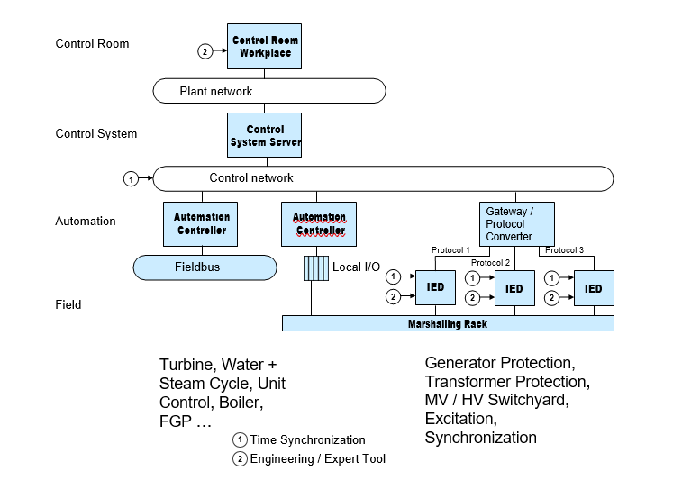

The challenge for integration of process control and electrical control is to support all these standards. Incompatibilities mean interfaces must be implemented and maintained on a project-by-project or even device-by-device basis. Integration becomes expensive due to the diversity of the individual standards. Gateways or protocol converters lead to additional hardware, maintenance and increasing engineering cost as such devices have to be configured, tested, documented, etc.

Issues with today's solution

* Engineering requires specific tools from the supplier of the particular device.

Even for different devices from the same supplier, the engineering and maintenance

tools are device specific. This applies also for different generations of a device product family.

* Standardized documentation for the devices' engineering data is not available. Exchanging data between the different tools is complicated.
* Maintenance and service need specialists who understand different tools and communications protocols
* Devices cannot communicate with each other. For horizontal communication, hardwiring or a substation control system is required.
* It is very expensive to integrate the many protocols on the power plant control systems side
* Lacking capabilities of interfaces and protocols; e.g., not all protocols support time stamping, provide measuring values in engineering units or fulfill data transfer time requirements.
* Time synchronization requires device specific solutions

A big step forward in simplifying the integration of electrical systems is the introduction of the substation automation standard IEC 61850. IEC 61850 does not replace the field busses for process automation, but it is capable of replacing all of the diverse protocols in the substation automation domain. With IEC 61850, future power plant control systems can be based on two pillars: field bus standards on the process automation side and IEC 61850 on the electrical side.

# ELECTRICAL CONTROL SYSTEM REQUIREMENTS

For the integration of the electrical systems as described in the chapter above the control system has to be designed to fulfill some important requirements:

* Monitoring

Monitoring of the electrical system has to be possible at workplaces of the control room, workplaces dedicated to control of the electrical system and workplaces for maintenance planning. Graphic displays have to be available presenting the status of the overall or parts of the electrical system.

To be able to take immediate action in case of disturbances, it is also important to be aware of all alarms and have a quick overview in which part / area alarms are active.

* Manual (remote) operation

The manual (remote) operations of electrical devices have to be supported by consistent means; e.g., faceplates in the control room or locally at the device cubicle using push-buttons or control panels. Switching between remote and local operation has to be secured by locking and release mechanisms.

* Automatic operation

From a power plant control system point-of-view, automatic operation means that electrical devices are part of automatic control sequences executed in an automation controller. This requirement applies only for those devices that interact with process control. For this interaction, the automation controller and those electrical devices have to communicate using a common interface.

* Recording

For purposes of disturbance analysis, documentation, reporting and optimization, the plant control system has to be capable of recording electrical system status signals, alarms, events and measured values.

* Plant-wide sequence-of-events (SOE)

Fatal failures of the electrical system have an impact on the overall plant operation; e.g., may lead to a plant trip. For analysis of such failures a plant-wide chronological sequence-of-events is needed. To cover every type of failure, a time stamp accuracy with 1 ms time accuracy is needed.

* Events have to be recorded in chronological order. For analysis of faults, a time resolution and an accuracy of 1 ms is required. As state-of-art electronic devices do provide time stamped events, it is obvious that these time stamps created at the source of data have to be used throughout the entire communication path.
* Besides the communication part, this requirement imposes accurate time synchronization with a plant-wide master clock on the electronic devices.
* Analysis of disturbance logs by experts from remote workplaces

Fast transient data cannot be transferred through a network or the automation system due to performance reasons. Disturbance logs are stored as files in the IED. The user can upload disturbance logs to the control system workplace. From there the logs can be evaluated and archived.

* Calculation of performance characteristics

For various purposes (performance parameters for condition assessment, summation of parameters for reporting, etc.) the control system has to be capable of performing calculations based on values coming from electrical devices.

* Asset management

Collection of maintenance-relevant data and automated diagnosis for preventive maintenance.

* Engineering

The communication engineering of the electrical system should automatically generate all necessary configuration data in the power plant control system, so that the electrical system data can used in the same way as data from the process field bus etc. No duplicate data entry should be necessary.

**What is Automated Process Control?**

Use of machines and equipment for performing physical and mental operations in a production process in place of human being

Automation has been used since the time of ancient Egypt and Greece (more than 2000 years ago). For instance, automation was used to open the doors of temples. In order to achieve this, a sacrificial fire was lit, increasing the temperature of the air in a vessel below and displacing water from this storage vessel via a pipe to a container connected by a chain drive to the doors. When the fire was extinguished, the water was drawn back into the storage vessel and the counterweights closed the doors.

It is a system of doing work where material handling, production process and product designs are integrated through mechanism of thoughts and efforts to achieve a set regulating & controlling system.

It is the result of Industrialization to increase productivity & to achieve consistent quality products

It can be done at various levels of manufacturing system

* Handling of raw materials, semi-finished goods or finished goods.
* During production process (efficient machines are used).
* In Inspection and Quality control operations.

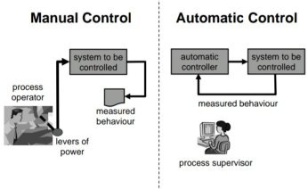

**Basic purpose of AUTOMATION in industry is:**

* To increase Productivity.
* Improve quality of products & to reduce waste.
* To reduce the costs.
* For safe handling of Hazardous substances.
* To take heavy work from workers.

Regulation is a major consideration for Automation as it ensures compliance with safety considerations and guidelines.

ADVANTAGES:

* 2 people clipped this slide
* It provides better quality of goods and service.
* It causes reduction in direct labor costs.
* There is effective control on operation.
* There is greater accuracy, more output and greater speed.
* Presentation Courses
* The production planning and control is to be done in the beginning only
* The working conditions can be improved
* Safety of workers is improved.
* Minimization of wastage
* The service to the consumer is enhanced.
* The quality of product improves as human input is minimized.

DISADVANTAGES:

* Huge capital investment is required.
* The maintenance cost is very high because maintenance labor of high caliber is required.
* It can create unemployment.
* Continuous power supply is required.
* Large inventories are required.
* Any breakdown, anywhere would lead to complete shutdown.
* Requires highly skilled manpower.
* There are restrictions in designing and construction of the building.

**Classification of industrial and laboratory automation:**

*PROCESS AUTOMATION* deals mainly with handling of raw materials in forms such as liquids or powders. Egg in oil refinery, oil & gas and chemical industries.

*DISCRETE AUTOMATION* essentially deals with assembly of parts requiring high levels of mechanical motion to produce consumer electronic products and products for the automotive industries.

**GENERAL AUTOMATIC CONTROL SYSTEM**

* In this process, the in flowing liquid is to be heated to the required temperature by the steam flowing through heating coils.
* The temperature of exit flow is affected by the processes variable such as-temperature and flow rate of the flowing liquid, temperature and flow rate of the steam, heat capacity of the fluids, and heat loss from the vessel and mixer speed.
* Liquid to be heated Mixer, Temperature to be controlled, Liquid flow out Valve, Steam Condensate Simple heat exchange process.

**Type of system in heat exchange process**

* Open loop system
* Closed loop control system
  + Feedback control system
  + Feed forward control system

***Open loop system*** is those in which information about the controlled variable (like temperature) is not used to adjust any of the system inputs to compensate for variation in the process variables.

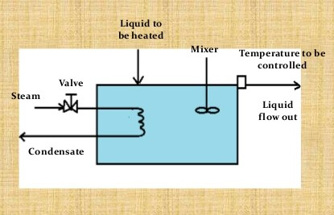

***Closed loop control system*** Is one where control variable is measure and the result of this measurement is used to manipulate one of the processes variables, such as steam flow

* **Closed loop feedback system**
* In this system, information about the controlled variables is feedback as the basis for control of a process variable by a human operator (manual control) or by use of Instruments (automatic control).
* In *manual control system* an operator periodically measures the temperature of liquid. If for example, the temperature is below the desired value, he increases the steam flow by opening the valve slightly.
* For *automatically controlled system* a temperature sensitive device is used to produce a signal proportional to the measured temperature. This signal is feed to controller which compare it with a preset desired valve (set point). If differences exist, the controller changes the opening of the steam control valve to correct the temperature

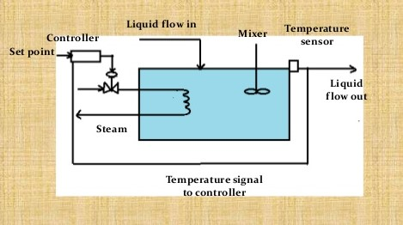

* **Closed loop feed forward control**
* In this process disturbances are measured and compensated without waiting for a change in the controlled variable to indicate that a disturbance has occurred.
* This type of control is useful when the final controlled variable cannot be used.

**PROCESS MEASUREMENTS**

INSTRUMENTS FOR MEASURING VACUUM

* Simple manometers
* Compression gauges
* Thermal gauges
* Ionization gauges
* Diaphragm gauges

INSTRUMENTS FOR TEMPERATURE

* Thermo Couples
* Resistances Thermometers
* Filled-In Thermometers
* Bimetal Thermometer
* Liquid-in-glass Thermometer
* Pyrometer

**Latest Technologies in the field of Thermal Power Plant**

Thermal power plants contribute the highest level of emissions among the power generation sources, causing air quality and other environmental concerns.

Also, these plants have the highest age with an average approaching 40 years.  These older coal and gas plants contain older designs and technologies designed for fixed baseload operation.  Operating at partial loads exacerbates many issues.

To overcome these issues and increase the efficiency of the plant we need new equipment with upgraded components and new technologies. Some of the latest technologies around the world that are being implemented are,

**AdvX™** **Heat Recovery Technology**

* AdvX™Auxiliary Heat technology is built to recover and utilize additional heat from flue gas, maximizing efficiency and saving cost significantly in both the short and long-term.
* AdvX™ Stack Gas Reheat is the most efficient way to clean and dry stack. The AdvX™ Stack Gas Reheat system will capture and utilize excess heat from flue gas, enhancing the operational efficiency and add to cost saving significantly.
* AdvX™ Upgrade solutions are the easiest way to improve thermal plant’s efficiency. The technology has been purposefully designed and built to enable the most efficient operation of thermal plants. With advanced configurations that increase efficiency with a low draft loss, AdvX™Upgrade Solutions push boundaries so that thermal plants can reach their goals.

**Digitalization Technology**

* Continuous combustion tuning with artificial intelligence
* Turbine operational optimization in real time using a combination of first principle analytics and machine learning
* Predictive maintenance to avoid unplanned downtime using machine learning
* Reducing stresses during variation on load to avoid failures and reduce maintenance needs
* Remote monitoring for visibility and analysis

**Ultra super critical (USC) conditioning**

* For conventional thermal power plants, each unit capacity has been increased and high-temperature and high-pressure steam conditions have been promoted to improve the thermal efficiency.
* The Hirono No. 5 Thermal Power Station of Tokyo Electric Power Company is a coal-fired thermal power plant adopting the ultra super critical (USC) conditions of 24.5 MPa × 600/600°C, the highest level in the world, and has continued highly reliable operation since it started commercial operation in July, 2004.
* This most sophisticated coal-fired thermal power plant has the efficiency of 43% at generator terminal (HHV base), and reduces CO2 emissions intensity by 3% of conventional plants.

**AUXILIARY POWER CONSUMPTION :**

Power generation capacity of a Thermal Power Plant also depends on the power consumed by its machinery and equipment. To keep the plant operational, certain source of electric power is needed to drive equipment and their auxiliaries. This power requirement is fulfilled by the plant itself. Out of the total power generated by the turbines, some part of it is lost as the power consumed by the plant equipment. This is known as auxiliary power consumption, that is the power consumed by plant equipment and its auxiliaries.

Auxiliary power consumption of a plant typically lies within the range of 8 to 10%, with variations occurring overtime due to aging equipment.

Major equipments consuming auxiliary power are :

1. Boiler Feed pumps
2. ID fans
3. PA fans
4. SA fans
5. ACC fans
6. Pulverizers
7. CWF pumps
8. Electrostatics precipitators

Percentage wise distribution of auxiliary power consumption of Vikram Cement Works Power Plant for the year 2018-19 is given below :

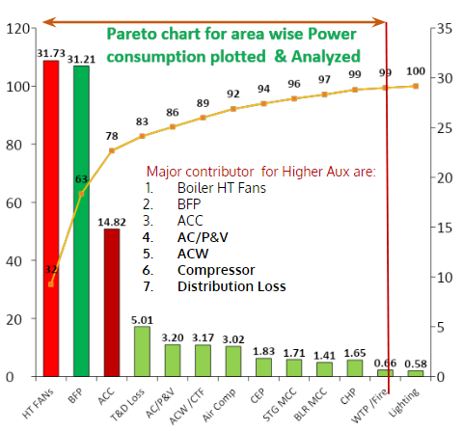

**CHANGES IN AUXILIARY POWER CONSUMPTION :**

Auxiliary power consumption varies over a limited range but deviations are observed over a long period of time. It affects the overall efficiency of the plant considering an average 8% consumption value, but it also indicates degrading machine cycles or faults in the pipeline due to increasing age of equipment and machinery.

Power consumption increases with the passing lifespan of equipment due to increased thermal stress or deterioration due to disturbances in the operation cycles. Major factors that can increase power consumption are :

1. Air leakage into the boiler gas enclosure can decrease the temperature within the boiler combustion chamber and can create an unsuitable combustion environment for the fuel.
2. Deterioration of boiler heating surface. This decreases heat rate and causes higher dry gas loss.
3. Higher draft loss due to air ingress and ash deposition.
4. Deterioration of generator stator windings due to increased stress and age
5. Deterioration of Turbine Steam Path Condition.
6. Condenser pressure/ condenser cleanliness affected due to air ingress and extent of tube pluggage. Contamination of feed water can cause changes in heat capacity, that indirectly affects boiler efficiency
7. Steam and water leaks from drains and vents.

The factors listed all point towards increasing thermal stress that leads to increased load on equipment and its auxiliaries. This causes an increase in power consumption with the goal of maintaining optimal operational conditions.

**PLANT LOAD FACTOR :**

Auxiliary power consumption can be quantified for analysis and comparison with the use of plant load factor. Many of the Indian power stations are operating at sub-optimal plant load factor that cause higher auxiliary power and decreased efficiency and performance.

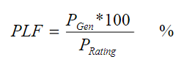

Instantaneous plant load factor is given by :

Whereas auxiliary power consumption of individual components can be calculated using 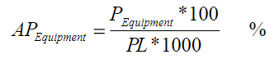

:

Since auxiliary power is essential to keep the plant operational, there is no scope of nullifying power consumption of equipment and machinery. Instead any deviation in power consumption can be used as a control parameter to identify areas with increasing power demand and help in optimizing the overall power consumption. The formula for deviation of AP of individual components is :

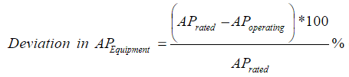

A few areas that can improve the plant load factor include :

1. Quality of coal used - higher calorific value and low ash content coal reduces the flue gas flow, which decreases stress on ID fans.
2. Boiler efficiency - increased boiler efficiency reduces stress on BFP, PA fans and SA fans.
3. Turbine efficiency - increasing turbine efficiency ensures reduced stress on CWF pumps and alternator windings.
4. Regular maintenance of BFPs and heating valves to ensure corrosion and other deterioration parameters are within acceptable ranges.

**REDUCING AUXILIARY POWER CONSUMPTION :**

Few steps to reduce auxiliary power consumption are listed below :

1. Consider Variable frequency drives for Boiler feed pumps, fans and other major Auxiliaries. Manual operation of BFP control requires a wide tolerance range, which leads to excess power consumption than required.
2. Choose optimum margins on head and flow for Boiler feed pumps and fans, to attain best efficiency under actual operating conditions.
3. Boilers with best possible efficiency should be used that allow optimal combustion environment along with automated control loops to keep power consumption within specified tolerance range
4. Leak proof duct design to avoid air ingress in order to reduce load on induced draft fan.
5. Ensure complete combustion in furnace, so that required steam generation can be achieved with optimum fuel quantity.
6. Minimise system drop (flue gas side , steam and water side) without affecting the Boiler performance.

**Auxiliary Energy Consumption–Coal fired stations**

**1.** In the CEA Report on operation norms for 2009-14, the reduction in AEC on account of turbine driven BFP was increased from 1.5% to 2.5% thus lowering the AEC for 500 MW units with TBFP to **6.0** % from then prevailing **7.0** %. However, no changes were made in the allowable AEC as such; and thus the prevailing norms for AEC have been continuing for the last 20 years. Improvements in equipment/systems design have occurred over the years like

introduction of axial fans having lower power consumption, introduction of variable frequency drives, overall design optimization etc. Further, the auxiliary consumption may not increase proportionately with unit size and higher sized units are expected to have lower auxiliary consumption in terms of percentage of unit size.

**2.** The operational data of AEC for the stations are given in table- 12. The table shows yearly AEC and average AEC for five years. Also shown are the normative AEC (worked out on the basis of unit size and type of CW systems) and difference between normative and average operating AEC. The table also shows share of capacity constituted by 500 and higher sized units in the total station capacity.

**3.** Barring one, all stations show auxiliary energy consumption lower than the normative auxiliary energy consumption, however, stations with 500 MW units have shown much lower auxiliary consumption as compared to their respective normative auxiliary consumption. Barring Indiragandhi TPS, all stations with solely 500 MW units show an AEC of about 1 % lower than the normative AEC. Indiragandhi TPS has several additional systems leading to higher AEC. Sipat and Simhadri TPS show an AEC of 5.5 % - both these stations are new stations and comprise of 500 MW and higher size units only. The slightly higher overall AEC of Sipat appears due to the commissioning of two units in the year 2012-13 leading to higher yearly consumption for 2012- 13.

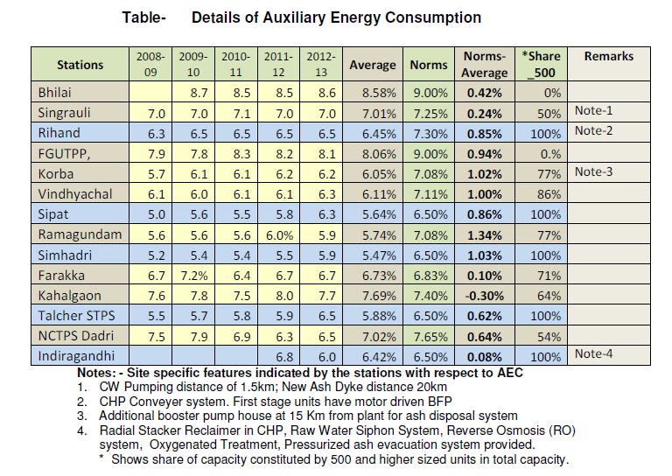

**4.** A review of guaranteed Auxiliary Energy Consumption data of various projects available with CEA shows that the guaranteed AEC for boiler for 500 MW units is about 0.6 % points lower than the boilers’ AEC for 200/210 MW units. Besides, higher unit size also leads to savings in AEC in BoP systems.

**5.** An attempt has also been made to compute AEC for 500 MW units from the data of stage wise generation furnished by some stations and the details of computed auxiliary energy consumption of 500 MW units worked out are indicated in table

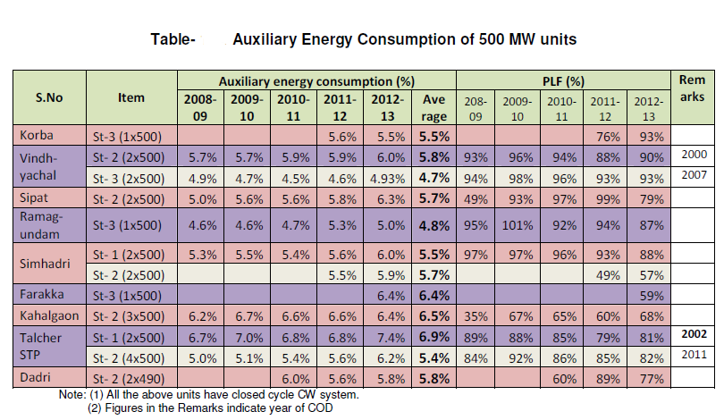

**6.** From the above table it may be seen that AEC of all the 500 MW units is considerably lower than the prevailing norm of 6.5 % (for closed cycle CW system). In fact several stations have achieved AEC of less than 5 %. The only exceptions are Kahalgaon and Farakka where the AEC is higher due to very low PLF. Further, the AEC of new 500 MW units is considerably lower than the older 500 MW units.

**7.** Thus considering the above, there is a case for lowering of AEC by 1 % (one percentage point) for 500 MW and higher size units installed after 1-4-2009. However, with a view to allow some operational flexibility to the stations, it is suggested that normative AEC for 500 MW and higher size units installed after 1-4-2009 may be reduced by 0.75 % ( three fourth percentage points)

**OBSERVATIONS AND PERFORMANCE OVERVIEW OF VIKRAM CEMENT WORKS POWER PLANT**

**Plant Overview : Vikram Cement Works Power Plant**

UTCL, Vikram Cement Works Power plant was commissioned in 2008. It is a part of Ultratech Cement Limited located in Neemuch, Madhya Pradesh. It is a 2x23MW Captive Power Plant with 2 water tube coal fired boilers, each with a 130TPH capacity.

Details of main equipment and DCS are given below :

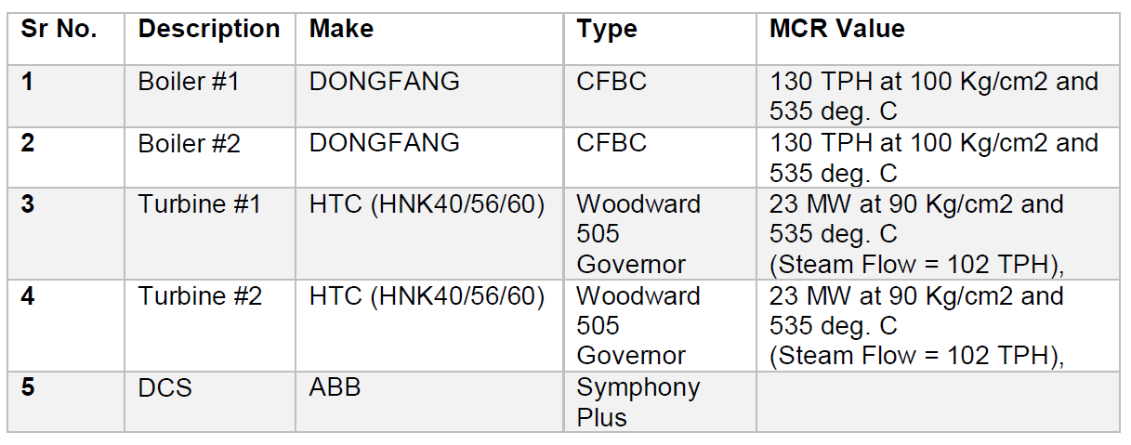

**Fuel used in the plant :**

Main fuel used in the boiler combustion chamber is a combination of Pet coke, Indian coal and Lignite. Here the measurement of coal flow is volumetric type. Composition

and heating value of the fuel is given below :

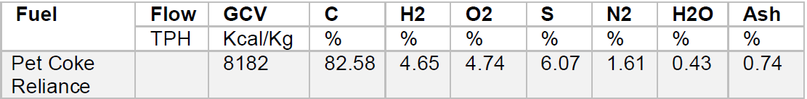

**Boiler overview :**

Each boiler has a 100 kg per sq.cm of working pressure along with a 540 degree Centigrade working temperature.Major Boiler equipment is listed below:

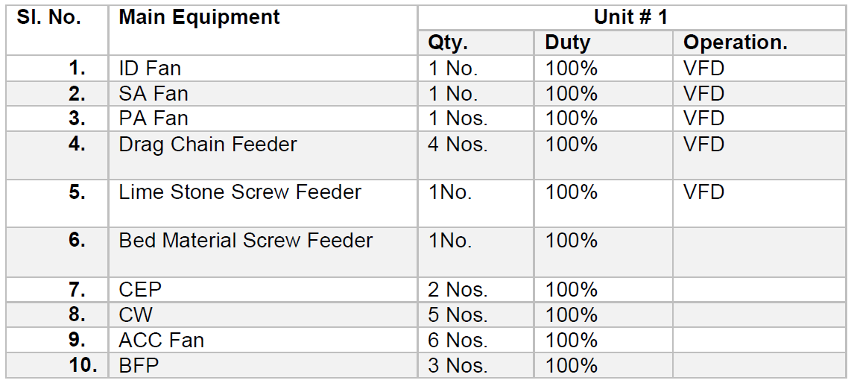

The plant uses CPP Boilers (Condensate Polishing Plants), that prevents steam condensate contaminants and corrosion products from entering the boiler or turbine. CPP Boilers in the plant are connected via a common header, but measurement of Common Header Steam Pressure is missing.

**Control Loops for combustion control :**

Major control loops employed in the plant and their designs are listed below :

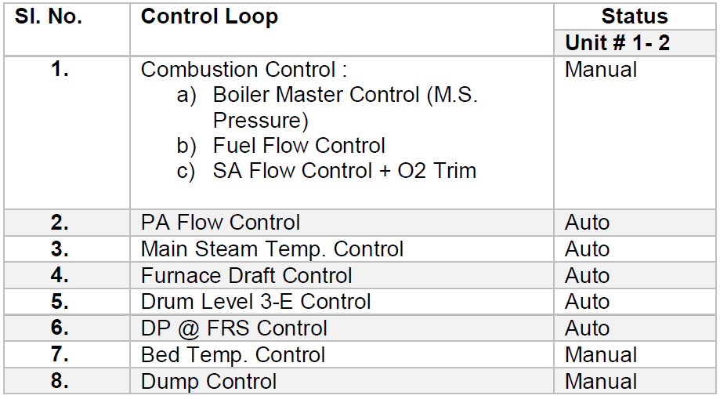

**OVERVIEW OF TPP PERFORMANCE IMPROVEMENT REPORT :**

We were provided an Opportunity Identification Report which detailed the current performance of the UTCL Vikram Cement Works Power Plant and identified opportunities for improvement and increasing efficiency. The report was based on a performance study conducted by ABB where plant performance data was recorded and analysed.

**HOW ABB CONDUCTED THE STUDY**

Before conducting a detailed study, a baseline for current plant performance was established. This was done to compare it against the new performance data that would be recorded after the suggested improvements were implemented. The baseline also helped in finding any deviations in design performance values for plant equipment and machinery.

ABB’s performance calculation software module was used to determine actual plant performance. The software assumes a fuel composition of 100%Pet Coke (with calorific value of 8182 kcal/kg), mixed with 30-40% limestone used as boiler feed. Control logic software was also used to track how present controls were configured.

The actual plant performance was then recorded for 2 different units of the plant to establish a baseline

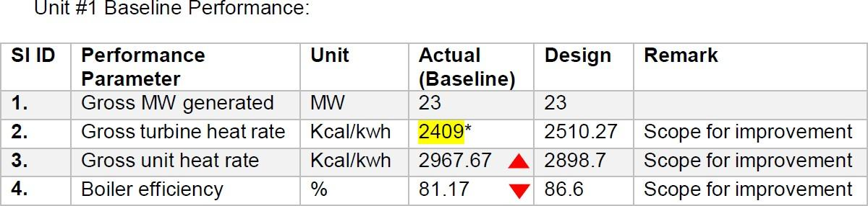

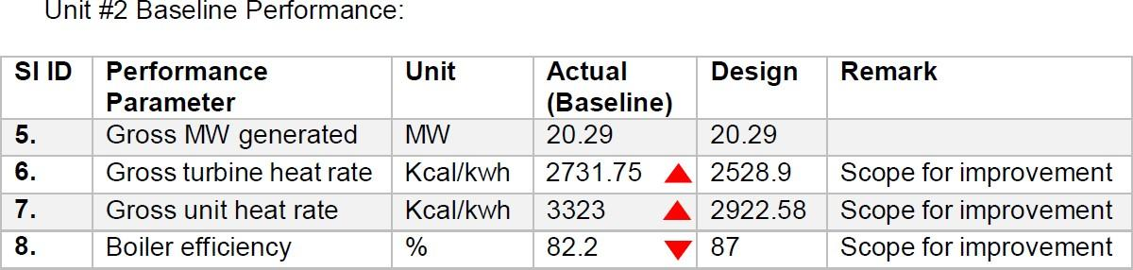

This baseline was first compared with the set design parameters and then with actual data that was collected during site visit.

**CONCLUSIONS THAT WERE DRAWN FROM THE STUDY :**

The performance report suggested over a dozen performance improvement opportunities for UTCL Vikram Cement Works Power Plant. The report also suggested improvements for few control logics along with their prospective benefits.

Estimated improvements of implementing suggested solutions are listed below:

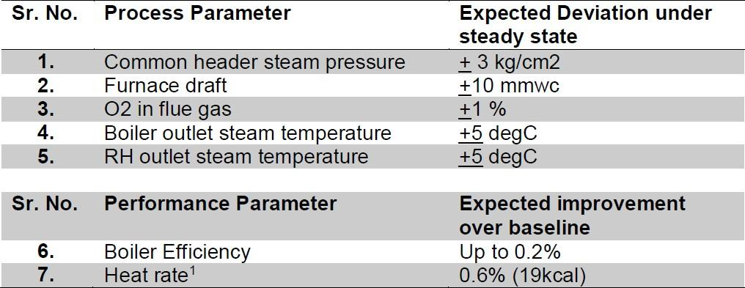

A few benefits of implementing suggested solutions include:

1. Improvement in heat rate due to reduction of fuel consumption per unit of energy
2. Increased Boiler efficiency due to combustion optimization
3. Faster equipment response to load disturbances
4. Reduction in energy consumption by equipment such as ACC fans.
5. Reduction in excess O2 consumption
6. Improved emission and operator efficiency

**FEW OBSERVATIONS :**

After carefully reviewing the industry report, we made a few observations that were in alignment with our study of Thermal Power Plants, APC and Auxiliary Power Consumption.

1. No control loop exists for coordinating boiler and turbine operations. This can cause problems during variations (such as changes in fuel composition or leakages) and disturbances during operation. Lack of a feedback mechanism means boilers and turbines operate independent of each other and any variation in one doesn’t affect the operational parameters of the other. An APC on top of existing control loops can help coordinate operation of both.
2. There is no continuous performance monitoring of the plant. Any deviations in current and design performance like heat rate, efficiency, etc are not recorded and hence the operator remains unaware of any corrections that must be made to current operational modes. A performance monitoring and reporting system can help in fine tuning of machinery and equipment during operation.
3. Furnace pressure control is not optimized which leads to higher auxiliary consumption by PA and SA fans. An Advanced Controller with feedforward for the individual VFDs can help optimize power consumption by PA and SA fans.
4. The current control loops didn’t take into account any changes in fuel quality/composition or variations in combustion conditions. Advanced Controller for fuel feed can improve and provide stable response to air and fuel feed. This model can tune fuel feed parameters so that the combustion cycle adjusts to any changes in fuel type/composition. Also it can fine tune fuel feed based on GCV of fuel composition.

**Abbreviations and Acronyms**

ACE Area Control Error

AGC Automatic Generation Control

APC auxiliary power consumption

CEA Central Electricity Authority (India)

CERC Central Electricity Regulatory Commission (India)

DC direct current

DCS Distributed Control Systems

FR frequency response

FL full load

HP high pressure

ID induced draft

IPP Independent Power Producer

MTL Minimum Thermal Load

OPEX operational expenditure

PA primary air

PC Pulverised coal

RES renewable energy sources

TSO Transmission system operator

VRE variable renewable energy

**Units of Measure**

GW gigawatt

kV kilovolt

kWh kilowatt-hour

Rs/KWH Rupees per Kilowatt hours

MVA megavolt ampere

MWh megawatt hour

MW/min megawatts per minute

**CONCLUSION :**

The project mainly focuses on Thermal power plants efficiency and the factors affecting it. It presents the factors that affect the efficiency, while also presenting areas of improvement along with their prospective benefits. To achieve this an understanding of basics of thermodynamics and power cycles, with specific focus on Rankine cycle is required, which is also presented in this report. Much of the study draws assumptions/hypotheses that are later compared and verified against actual industrial data provided by the PS-1 station (Vikram Cement Works).

The project dives deep into the topics of Advanced Process Control (APC) and latest technologies, while also detailing various factors such as auxiliary power consumption that affect the overall efficiency of a thermal power plant. The data presented is derived from industrial reports and sources online. This availability of industrial data compensates for the lack of an actual industrial visit caused due to the Covid pandemic.

Overall the project aimed at improving the thermal power plant efficiency and performance. The main objectives of this project were to identify areas of improvement, suggest solutions for existing problems and present new technologies that can be utilised by thermal power plants to compete in a market where renewable energy sources are becoming more dominant.