**A REPORT**

**ON**

**POWER PLANT THERMAL EFFICIENCY IMPROVEMENT**

**BY**

**NAME: ID:**

MUDIT SRIVASTAVA 2018A3PS0430G

SIDDHARTHA JEJURKAR 2018A3PS0617G

**AT**

**VIKRAM CEMENT WORKS, NEEMUCH**

**A Practice School-I station of**



**BIRLA INSTITUTE OF TECHNOLOGY & SCIENCE, PILANI**

**A REPORT**

**ON**

**POWER PLANT THERMAL EFFICIENCY IMPROVEMENT**

**BY**

|  |  |  |
| --- | --- | --- |
| **NAME:** | **ID:** | **DISCIPLINE:** |
| MUDIT SRIVASTAVA | 2018A3PS0430G | B.E.(Hons) E.E.E. |
| SIDDHARTHA JEJURKAR | 2018A3PS0617G | B.E.(Hons) E.E.E. |

**Prepared in partial fulfilment of the Practice School-I Course Nos.**

**BITS C221/BITS C231/BITS241**

**AT**

**VIKRAM CEMENT WORKS, NEEMUCH**

A Practice School-I station of



**BIRLA INSTITUTE OF TECHNOLOGY & SCIENCE, PILANI**

**Acknowledgement**

We would like to use this opportunity to express our gratitude to everyone who has been supporting us through the course of the project. Firstly, we are extremely grateful to our institute, BITS Pilani for offering us the course, Practice School – I during these testing times and giving us an opportunity to get an industry- based experience. Secondly, we would like to thank our instructor in-charge, Prof. Ankur Bhattacharjee to guide us and help us to get the utmost of this experience. Also, the mentors of our PS station, Vikram Cement Works Mr. Praveen Vijayvargiya to regularly guide us in our project. We would also like to thank everyone else who was directly or indirectly involved to provide us with this opportunity. The work summarised in this report represents contribution from a group of three students working on the project, Power Plant thermal efficiency improvement.

**BIRLA INSTITUTE OF TECHNOLOGY AND SCIENCE PILANI (RAJASTHAN)**

**Practice School Division**

**Station**: Vikram Cement Works

**Centre**: Neemuch

**Duration**: 6 weeks **Date of Start:** May 18, 2020 **Date of Submission**: June 6, 2020

**Title of the Project**: Power Plant Thermal Efficiency Improvement

|  |  |  |
| --- | --- | --- |
| **NAME:** | **ID:** | **DISCIPLINE:** |
| Mudit Srivastava | 2018A3PS0430G | BE (Hons.) E.E.E. |
| Siddhartha Jejurkar | 2018A3PS0617G | BE (Hons.) E.E.E. |
|  |  |  |

**Expert Details :**

**Name :** Mr. Praveen Vijayvargiya

**Designation:** Vikram Cement Works , Neemuch

**Name of the PS Faculty**: Dr. Ankur Bhattacharjee

**Abstract:**

**Signature(s) of Student(s) : Signature of PS Faculty:**

**Date: Date:**

**INDEX**

1. Introduction
2. Power Plant Cycles
   1. Types of Power Plant Cy cles
3. Rankine Cycle
   1. Typical Ideal Rankine Cycle
   2. Reheat Cycle
      1. Advantages of Reheat Cycle
      2. Disadvantages of Reheat Cycle
   3. Regenerative Cycle
      1. Advantages of Regenerative Cycle
      2. Disadvantages of Regenerative Cycle
4. Conclusion
5. References
6. Glossary

**POWER PLANT CYCLES**

A thermal power plant works on the principle that heat is released by burning fuel which produces (working fluid) (steam) from water. The steam so produced runs the turbine coupled to generator which produces electricity .

A working fluid goes through a repetitive cycle change and this cyclic change involving heat and work is understood as thermodynamic cycle. Thus, a thermodynamic cycle may be a series of operations, involving a heat source, a heat receiver, a machine and dealing substance.

**Types of Power Plant Cycles**

Thermal power plants, in general, may work on

Vapour and Gas Power cycles

Vapour Power cycles can be classified as:

(i) Rankine cycle

(ii) Reheat cycle

(iii) Regenerative cycle

(iv) Binary vapour cycle

Gas Power Cycle can be classified as follows:

(i) Otto cycle

(ii) Diesel cycle

(iii) Dual combustion cycle

(iv) Gas turbine cycle

**Rankine Cycle**

Rankine cycle is the notional cycle on which steam power station works. Rankine cycle is a vapour-liquid cycle, it is most convenient to draw it on both the P-V and T-s diagrams with respect to the saturated-liquid and vapour lines of the working fluid, which usually but not always is water.

Figure shows a simplified flow diagram of a Rankine cycle.

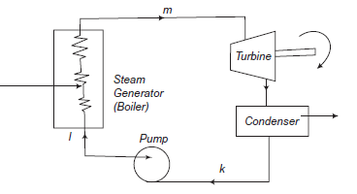

P-V diagram is shown in Figure.

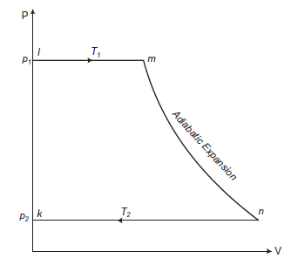

1. Operation (k-l): Condensed steam at pressure p2 and temperature T2 which is pumped into the boiler by means of feed pump at pressure p1 and there it is called temperature T1.

2. Operation (l-m): The hot water at a saturation temperature T1 is evaporated to steam at pressure p1.

3. Operation (m-n): After coming out of the boiler, the steam enters the turbine and expands adiabatically to a pressure p2.

4. Operation (n-k): The steam expands and condenses to water within the condenser at an equivalent temperature and is at pressure p2. Thus, the cycle is completed. This condensed water is again pumped to the boiler and then the next cycle starts.

**Typical Ideal Rankine Cycle**

In a vapor cycle if the working fluid during a vapor cycle passes through various components of the facility plant without irreversibility and frictional pressure drop, then the cycle is called as Ideal Rankine Cycle.

**Reheat cycle**: a further improvement in cycle efficiency with gaseous primary fluids as in fuel and gas-cooled power plants is achieved.

The improvement in thermal efficiency thanks to reheat greatly depends on the reheat pressure with reference to the first pressure of steam.

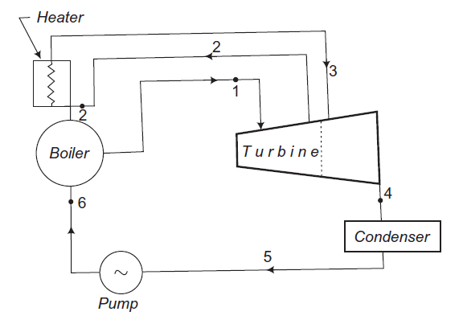

The corresponding representation of ideal reheating process on T-s is shown in the next Figure. It shows the formation of steam in the boiler. The steam at state point 1 (i.e., pressure p1 and temperature T1) enters the turbine an expands isentropically to a certain pressure p2 and temperature T2. From this state point 2 the entire of steam is drawn out of the turbine and is reheated during a reheater to a temperature T3.

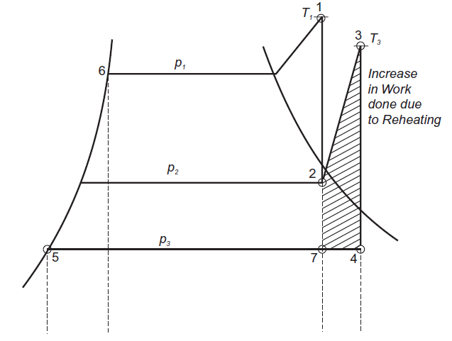

This reheated steam is then readmitted to the turbine where it's expanded to condenser pressure isentropically. Reheat allows heat addition twice. It leads to increasing the typical temperature at which heat is added and keeps the boiler hot, which ends up in improvement in cycle efficiency. Reheating also results in drier steam at turbine exhaust which is beneficial for real cycles.

**Advantages of Reheating**

1. there's an increased output of the turbine.

2. The thermal efficiency of the turbines increases.

3. Efficiencies of nozzle and blade increase.

4. Corrosion problems are minimised in steam turbines.

5. Dryness factor of steam improved.

**Disadvantages of Reheating**

1. Reheating requires maintenance.

2. Reheating increases the expenditure.

**Regenerative Cycle:**

In the Rankine cycle it's observed that the condensate which is fairly at coldness has an irreversible mixing with hot boiler water and this leads to the decrease of cycle efficiency. Methods are, therefore, adopted to heat the feed water from the recent well of condenser irreversibly by interchange of warmth within the system and thus improving the cycle efficiency. This heating method is named regenerative feed heat and therefore the cycle is named regenerative cycle.

The principle of generation are often practically utilised by extracting steam from the turbine at several locations and supplying it to the regenerative heaters. The resulting cycle is understood as regenerative or bleeding cycle.

The heating arrangement comprises:

(i) for medium capacity turbine — less than 3 heaters;

(ii) for top pressure high capacity turbines — less than 5 to 7 heaters; and

(iii) for turbines of supercritical parameters—8 to 9 heaters. The most advantageous condensate heating temperature is chosen counting on the turbine throttle conditions and this determines the amount of heaters to be used.

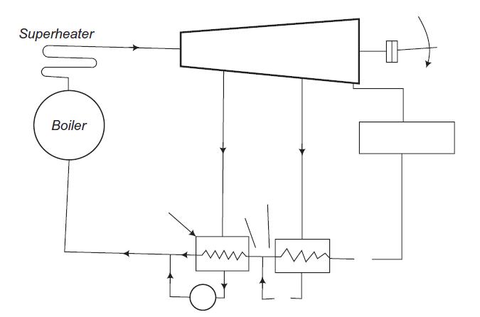

Figure shows a diagrammatic layout of a condensing steam power plant in which a surface condenser is used to condense all the steam that is not extracted by feed water heating. The turbine is double extracting and therefore the boiler is provided with a superheater. This arrangement constitutes a regenerative cycle.

The condensate from the bled steam is then added to feed water.

**Advantages of Regenerative Cycle Over Simple Rankine Cycle**

1. The heating process within the boiler tends to become reversible.

2. The thermal stresses found out within the boiler are minimised. This is thanks to the very fact that temperature ranges within the boiler are reduced.

3. The thermal efficiency is improved because the typical temperature of warmth addition to the cycle is increased.

4. Heat rate is reduced.

5. The blade height is a smaller amount thanks to the reduced amount of steam skilled the low stages.

6. thanks to many extractions there's an improvement within the turbine drainage and it reduces erosion thanks to moisture.

7. A small size condenser is required.

**Disadvantages of Regenerative Cycle Over Simple Rankine Cycle**

1. The plant becomes more complicated.

2. Maintenance cost is more.

3. an outsized capacity boiler is required for a given power rating.

4. the warmers are costly and therefore the gain in thermal efficiency isn't much as compared to the prices .