**Fundamentals of Thermal Power Plant**

The theory of thermal power plant or working of thermal power plant is extremely simple. an influence generation plant mainly consists of alternator runs with help of turbine. The steam is obtained from high pressure boilers. Generally, in India, soft coal, coal and peat are used as fuel of boiler. The soft coal is employed as boiler fuel has volatile matter from 8 to 33% and ash content 5 to 16%. to extend the thermal efficiency, the coal is employed within the boiler in powder form.

In coal thermal powerhouse, the steam is produced in air mass within the boiler thanks to burning of fuel (pulverized coal) in boiler furnaces. This steam is further supper heated during a superheater. This superheated steam then enters into the turbine and rotates the turbine blades. The turbine is mechanically so including alternator that its rotor will rotate with the rotation of turbine blades. After entering in turbine, the steam pressure suddenly falls and corresponding volume of the steam increases.

After imparting energy to the turbine rotor, the steam passes out of the turbine blades into the condenser. within the condenser, the cold water is circulated with the assistance of a pump which condenses the low-pressure wet steam. This condensed water is further supplied to a low-pressure storage tank which acts as water heater where the low-pressure steam increases the temperature of this feed water; it's again heated in high pressure.

**Power Generation Technology**

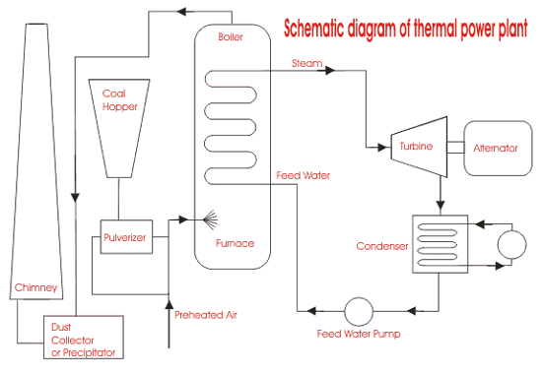

1. After rotating the turbine blades, the steam has lost its high pressure, passes out of turbine blades and enters into a condenser.
2. In the condenser the cold water is circulated with help of pump which condenses the low-pressure wet steam.
3. This condensed water is then further supplied to low pressure water heater where the low-pressure steam increases the temperature of this feed water, it is then again heated in a high-pressure heater where the high pressure of steam is used for heating.
4. The turbine in thermal power station acts as a prime mover of the alternator.

**Latest Technologies in the field of Thermal Power Pant**

Thermal power plants contribute the highest level of emissions among the power generation sources, causing air quality and other environmental concerns.

Also, these plants have the highest age with an average approaching 40 years.  These older coal and gas plants contain older designs and technologies designed for fixed baseload operation.  Operating at partial loads exacerbates many issues.

To overcome these issues and increase the efficiency of the plant we need new equipment with upgraded components and new technologies. Some of the latest technologies around the world that are being implemented are,

**AdvX™** **Heat Recovery Technology**

* AdvX™Auxiliary Heat technology is built to recover and utilize additional heat from flue gas, maximizing efficiency and saving cost significantly in both the short and long-term.
* AdvX™ Stack Gas Reheat is the most efficient way to clean and dry stack. The AdvX™ Stack Gas Reheat system will capture and utilize excess heat from flue gas, enhancing the operational efficiency and add to cost saving significantly.
* AdvX™ Upgrade solutions are the easiest way to improve thermal plant’s efficiency. The technology has been purposefully designed and built to enable the most efficient operation of thermal plants. With advanced configurations that increase efficiency with a low draft loss, AdvX™Upgrade Solutions push boundaries so that thermal plants can reach their goals.

**Digitalization Technology**

* Continuous combustion tuning with artificial intelligence
* Turbine operational optimization in real time using a combination of first principle analytics and machine learning
* Predictive maintenance to avoid unplanned downtime using machine learning
* Reducing stresses during variation on load to avoid failures and reduce maintenance needs
* Remote monitoring for visibility and analysis

**Ultra super critical (USC) conditioning**

* For conventional thermal power plants, each unit capacity has been increased and high-temperature and high-pressure steam conditions have been promoted to improve the thermal efficiency.
* The Hirono No. 5 Thermal Power Station of Tokyo Electric Power Company is a coal-fired thermal power plant adopting the ultra super critical (USC) conditions of 24.5 MPa × 600/600°C, the highest level in the world, and has continued highly reliable operation since it started commercial operation in July, 2004.
* This most sophisticated coal-fired thermal power plant has the efficiency of 43% at generator terminal (HHV base), and reduces CO2 emissions intensity by 3% of conventional plants.

**Automatic Process Control**

Automatic process control in [continuous production processes](https://en.wikipedia.org/wiki/Continuous_production) is a combination of [control engineering](https://en.wikipedia.org/wiki/Control_engineering) and [chemical engineering](https://en.wikipedia.org/wiki/Chemical_engineering) disciplines that uses [industrial control systems](https://en.wikipedia.org/wiki/Industrial_control_system) to achieve a production level of consistency, economy and safety which could not be achieved purely by human manual control. It is implemented widely in industries such as oil refining, pulp and paper manufacturing, chemical processing and power generating plants.

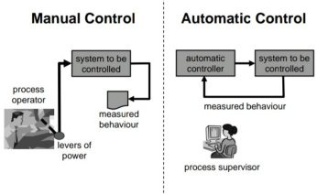

An automatic control system for a thermal power plant comprises a master controller controlling a turbine in response to an externally applied load command signal, and producing a boiler input command signal by correcting the load command signal on the basis of the detected pressure of main steam generated from a boiler, and a water/steam process controller, a fuel process controller, a combustion process controller and a draft process controller to all of which the boiler input command signal is applied from the master controller. The process controllers apply control signals to equipment controlling a water/steam process, a fuel process, a combustion process and a draft process respectively among the terminal actuating equipment of the various parts of the boiler.