Name: Mudrak Patel; ID: 300878960

Lab group members: (Mudrak Patel and Savankumar Patel)

CNET 124-005

Lab 1 (Mapping the internet)

Q1) ping [www.cisco.com](http://www.cisco.com)

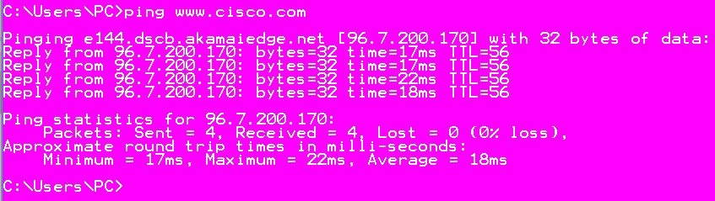

ping -n 100 [www.cisco.com](http://www.cisco.com)





Regional ping list

ping [www.afrinic.net](http://www.afrinic.net)

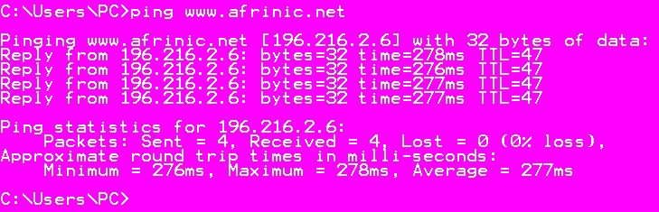

ping [www.apnic.net](http://www.apnic.net)

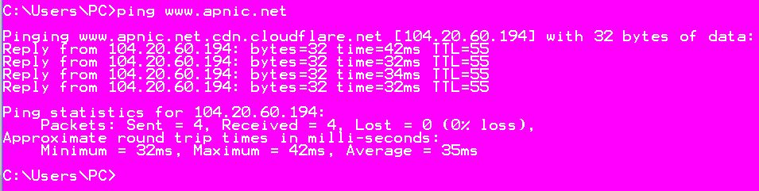

ping [www.ripe.net](http://www.ripe.net)

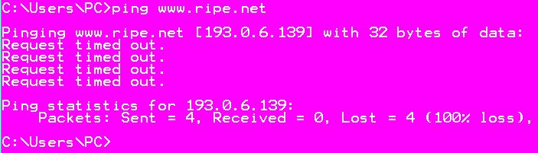

ping [www.lacnic.net](http://www.lacnic.net)

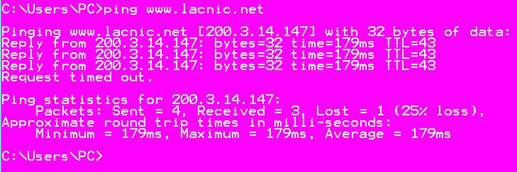

Q2) Trace a route to a remote server using tarcert

tracert [www.cisco.com](http://www.cisco.com)

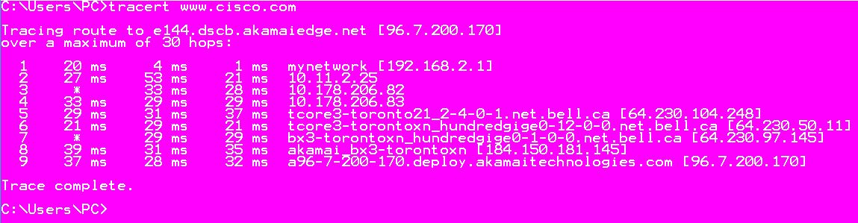

tracert [www.afrinic.net](http://www.afrinic.net)

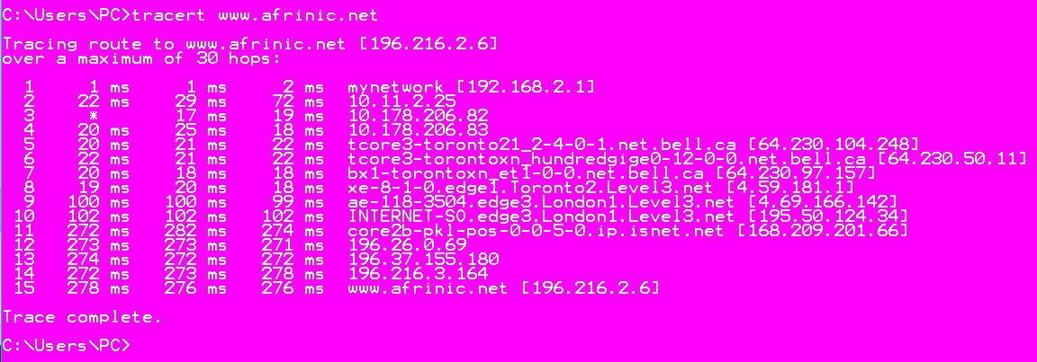

tracert [www.lacnic.net](http://www.lacnic.net)

