Mudrak Patel; 300878960; CNET 124 Lab 3

Step 1

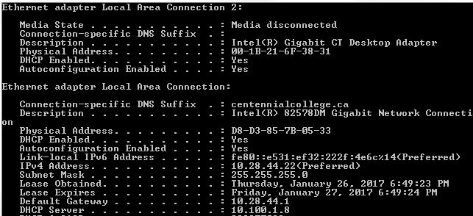

Step 2

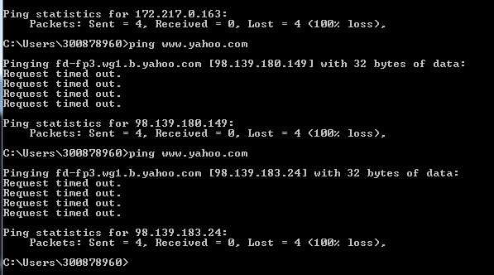

Step 3

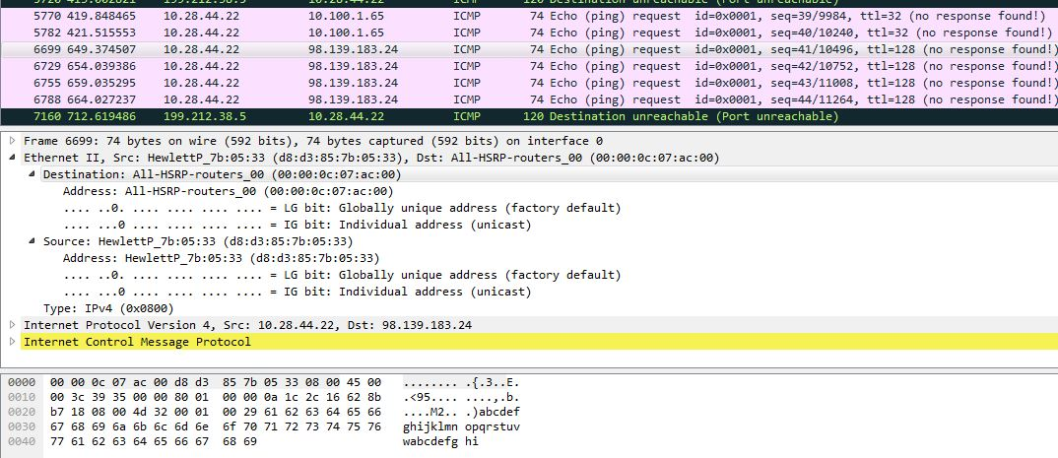

Step 4

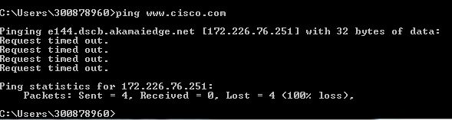

Step 5

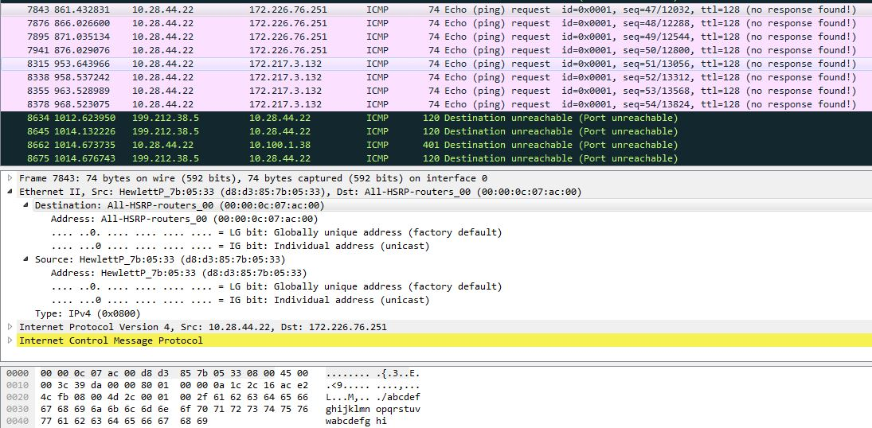

Step 6

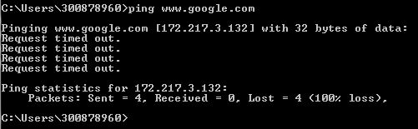

Step 7

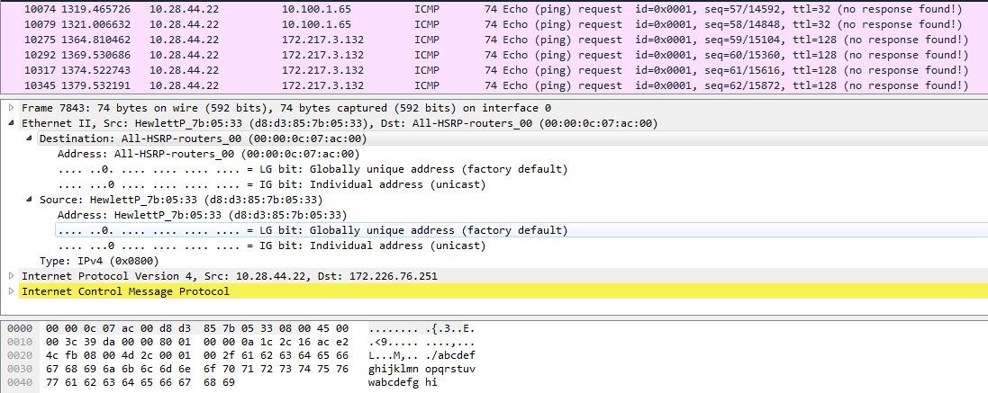

Q1) Does the source MAC Address match your PC’s interface?

* Yes

Q2) How does this information differ from the local ping information you received in the part 2?

* MAC Address of destination was local but for other 3 servers it was same.

Q3)

