# The Time Class

### Code the Time class below:

This class comprise of two fields, a constructor a SetTimeFormat() and a ToString() method. All the fields and properties are private and all the methods are public

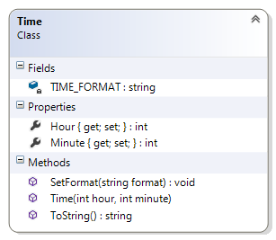

#### Description of class members

##### Fields:

**TIME_FORMAT** – this class variable is a string representing the intended format of the ToString() method. This field has private accessibility.

##### Properties:

**Hour** – this is an integer representing the hour value this object. This field has private accessibility.

**Minute** – this is an integer representing the minute value this object. This field has private accessibility.

##### Methods

**Time(int hours, int minutes)** – This is a public constructor that takes two integer arguments. It checks if the first argument is between 0 and 24 it assigns it to the Hour property otherwise a value of 0 is assign to the hour property. Similarly the second argument is check if it is between 0 and 60 then it is assigned to the Minute property otherwise a value of 0 is assigned to the Minute property.

**SetTimeFormat(string time_format)** – This a class method that is public. It takes a single string argument and assigns it to the static TIME_FORMAT field.

**ToString()** – This public method overrides the ToString of the object class. It does not take any argument and returns a string representation of the object depending on the value of the TIME_FORMAT field.

If you have a Time object with the hours value as 18 and the minutes value as 5 then the print out of the object will be

A **switch** statement is probably the simplest way to implement this functionality

“1805” if TIME_FORMAT is set to “Mil”

“18:05” if TIME_FORMAT is set to “24Hour”

“6:05 PM” if TIME_FORMAT is set to “12Hour” or anything

### Test Harness

Insert the following code statements in your Program.cs file:

Time a = new Time(9, 35);

Console.WriteLine(a);

Time b = new Time(18, 5);

Console.WriteLine(b);

Time c = new Time(28, 500);

Console.WriteLine(c);

//change the format of the output

Time.SetTimeFormat("Mil");

Console.WriteLine("Time format is Mil");

Console.WriteLine(a);

Console.WriteLine(b);

Console.WriteLine(c);

//change the format of the output

Time.SetTimeFormat("24Hour");

Console.WriteLine("Time format is 24Hour ");

Console.WriteLine(a);

Console.WriteLine(b);

Console.WriteLine(c);

//change the format of the output

Time.SetTimeFormat("12Hour");

Console.WriteLine("Time format is 12Hour ");

Console.WriteLine(a);

Console.WriteLine(b);

Console.WriteLine(c);