This exercise you will be building the three interconnected types illustrated below:

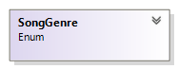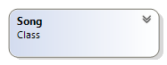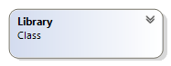

All the above type must decorated with the public keyword

# The SongGenre enum

This enum comprise of seven types of songs

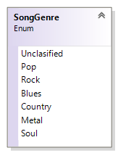To code this add a new item to your project and select the class option. Make the necessary changes to the header to reflect the enum type

# The Song class

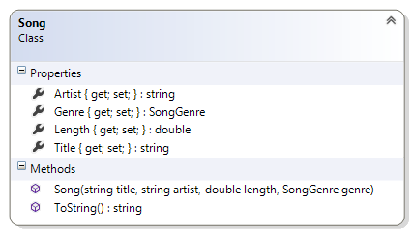This acts like a record for the song.

#### Description of the class members

##### Fields

There are no fields

##### Properties:

This class comprise of four properties with public getters and private setters. See the class diagram for more details

##### Constructor:

**Song(string title, string artist, double length, SongGenre genre)** – This constructor that takes four arguments and assigns them to the appropriate properties

##### Method:

**ToString()** – This public method overrides the **ToString()** method of the object class. It does not take any argument and returns a string representation of the object.

# The Library class

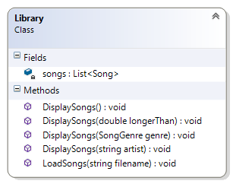This is the front end of the application. All the members are static

#### Description of class members

##### Fields:

**songs** – this private field is a list of song object is a class variable.

##### Properties:

There are no properties

##### Constructor:

There is no constructor for this class.

##### Methods

**DisplaySongs()** – This is a public class method that does not take any argument and displays all the songs in the collection

**DisplaySongs(double longerThan)** – This is a public class method that takes a double argument and displays only songs that are longer than the argument

**DisplaySongs(SongGenre genre)** – This is a public class method that takes a SongGenre argument and displays only songs that are of this genre

**DisplaySongs(string artist)** – This is a public class method that takes a string argument and displays only songs by this artist

**LoadSong(string fileName)** – This a class method that is public. It takes a single string argument that represents a text file containing a collection of songs. You will read all the data and create songs and add it to the songs collection. See the files for a better understanding of how this should be done

### Test Harness

Insert the following code statements in the **Main()** method of your Program.cs file:

// Console.WriteLine(new Song("Baby", "Justin Bebier", 3.35, SongGenre.Pop));

Library.LoadSongs("songs4.txt");

Console.WriteLine("\n\nAll songs");

Library.DisplaySongs();

SongGenre genre = SongGenre.Rock;

Console.WriteLine("\n\n{0} songs", genre);

Library.DisplaySongs(genre);

string artist = "Bob Dylan";

Console.WriteLine("\n\nSongs by {0}", artist);

Library.DisplaySongs(artist);

double length = 5.0;

Console.WriteLine("\n\nSongs more than {0}mins", length);

Library.DisplaySongs(length);