This exercise you will be exploring more usage of the static keyword.

# You must following the specifications exactly

# The Astronaut class

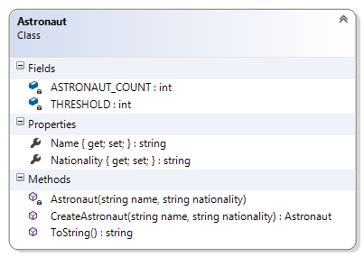We are simulating a biosphere on Mars. The biosphere is only able to sustain five persons. This application will try to mimic this condition.

This class is composed of two fields, two properties, a constructor and two methods

#### Description of the members

##### Fields

**THRESHOLD** – this private field has class persistence. It represents the maximum number of astronauts that the station can safely accommodate. This is initialized to 5. This and **ASTRONAUT_COUNT** is used in the **CreateAstronaut(string name, string nationality)** method to determine if another astronaut can be created.

**ASTRONAUT_COUNT** – this private field has class persistence. It represents the number of astronauts that is currently living in the station. This is initialized to 0. This and **THRESHOLD** is used in the **CreateAstronaut(string name, string nationality)** method to determine if another astronaut can be created.

##### Properties:

**Name –** this string property represent the name of the astronaut. The getter is public and the setter is private.

**Nationality –** this string property represents the Country of origin of the astronaut. The getter is public and the setter is private.

##### Constructor:

**Astronaut(string name, string nationality)** – This private constructor that takes two string arguments and assigns them to the respective properties. The class variable is incremented to reflect the correct count. This method is used by the CreateAstronaut() method.

##### Method:

**CreateAstronaut(string name, string nationality)** – This public class method takes two string arguments. This method compares the **ASTRONAUT_COUNT** and **THRESHOLD** to determine if there is room for another astronaut. If there is room then it instantiates a new astronaut and return it. Otherwise it returns null.

A null is a stand in for ANY type.

**ToString()** – This public method overrides the ToString() method of the object class. It does not take any argument and returns a string representation of the object.

### Test Harness

You will need to write code to test all the features of your class:

You might create a collection and try to insert 10 objects into it. Then print all the objects.

#### Additional functionality

Without changing the existing code, what would you add to be able to change the number of astronauts?

#### Further exploration

What happens if the properties Name and Nationality were decorated with the static keyword?