**Centennial College**

**Comp 301: UNIX/LINUX Operating Systems**

**Assignment 01**

NAME : Mudrak Patel

Student No.: 300878960

**[**Complete the following tasks and answer the questions. Take screenshots to display the output for each task. Follow the question numbers and put all the screenshots and answers to the questions in a single Word document. Submit one Word document in the eCentennial dropbox titled Assignment 01.]

1. Create a file called *month* containing the current month

Cal|cat>month

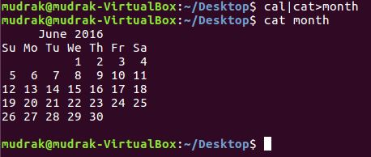

1. View the contents of the month file you created in Exercise 1.

**Note: that is shown in the picture above :)**

1. Create a file called who_info that contains the documentation for the *who* command. Next, use the *less* command to view the who_info file contents and scroll forward and backward through the information. Then use the *tail* command to view the final 12 lines of the who_info file. Finally, use the *head* command to view the first 12 lines of the who_info file.

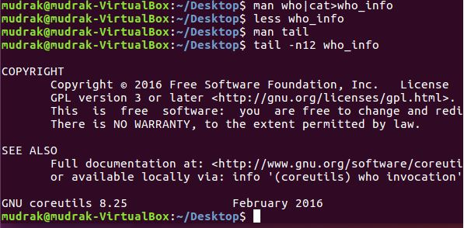

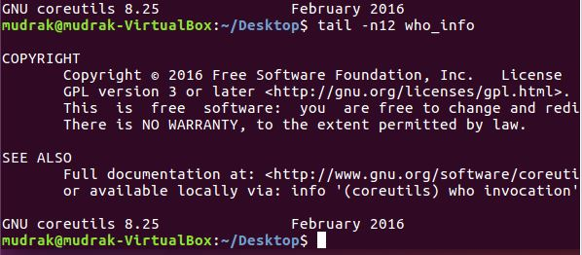

1. Create a file called favorite_foods, and list your favorite foods, entering five or six or more. Press Enter after each favorite food so it appears on its own line (make certain you also press Enter after the final food item). After the file is created, add two more foods you like that are not on the list (press Enter after the final food item). View the list of foods to make certain the two items you added appear at the end of the list.

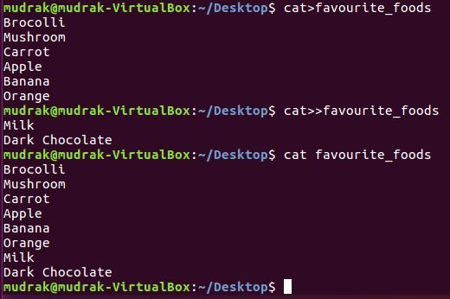

1. Change to the /dev directory. Next, access your home directory using a tilde (~) in the command that you employ

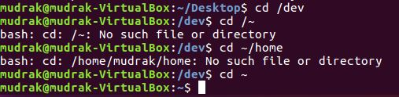

1. Determine whether there are any hidden files in the /home directory.

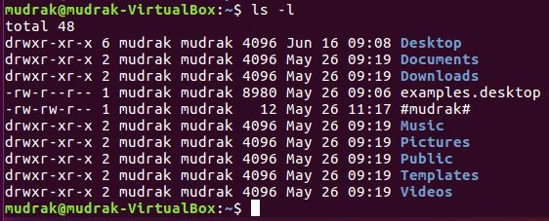

1. Make a directory under your home directory called documents. Next make a directory under the documents directory called spreadsheets. What is the absolute path for the spreadsheets directory?

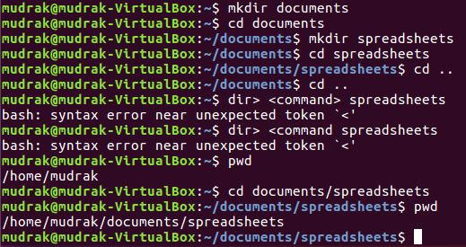

1. With your home directory as your current directory, use the command to remove read, write, and execute permissions from group and others for the spreadsheets directory. Next, verify that your change has taken place.

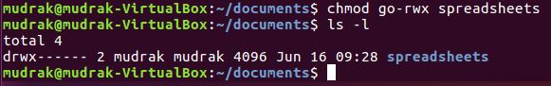

1. Create a directory called secure under your home directory. Next, using the octal permission format, set security on the secure directory so that you have all permissions and no one else has any permissions.

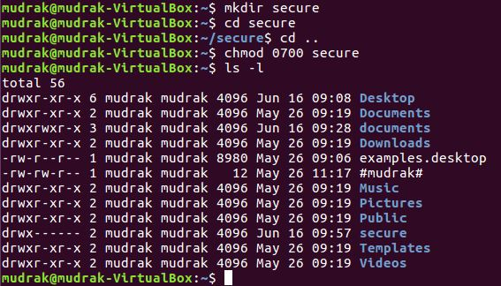

1. Create a document called first_file, and enter a few lines of text in it. Save it.
   * Create a second document called second_file, and enter a few lines of text in it. Save it.
   * Create a third document called third_file by merging the text from the first two files.
   * Save the third file, and exit the editor.
   * Type vi third.file and press Enter to be certain third_file contains the text from both files.

**>>Answers to question 10**

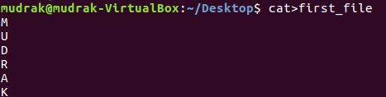

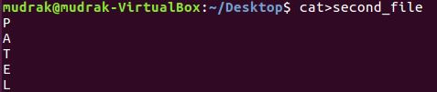



After the above step, type : vi third_file to see the following output ☺

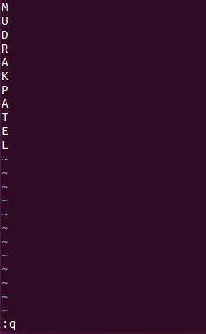

Finished ☺