**Centennial College**

**Comp 301: UNIX/LINUX Operating Systems**

**Assignment 03**

**300878960**

**Mudrak Patel**

Instructions: Please make a shell script to make the main menu of the application. This should call other shell scripts to view, add and search student information. Make a directory to hold all the shell scripts and student info file. Zip and upload the assignment into the dropbox folder named Assignment 03. The deadline for this submission is **13 Jul 2016**). Help for this assignment: Please lookup the hands on projects 6-15 to 6-20.

Objective : Create an interactive student information system.

First, store some student information consisting of the studentid, name, gender (M or F), department, date of enrolment in a file in the following format in a file called studentinfo.

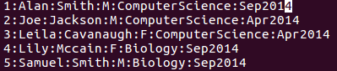

My file:

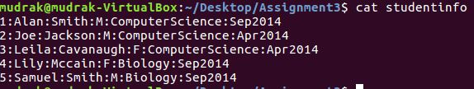

Then create a menu based application as shown in the picture below.

As soon as the user runs the application, he should be presented with the menu to view student list, add new student info, search student information or quit as shown in the pic below.

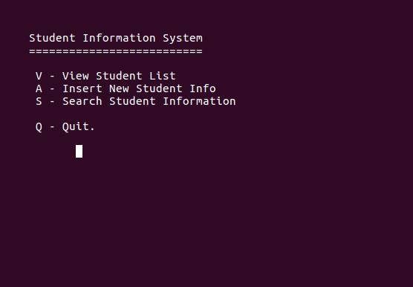

My file:

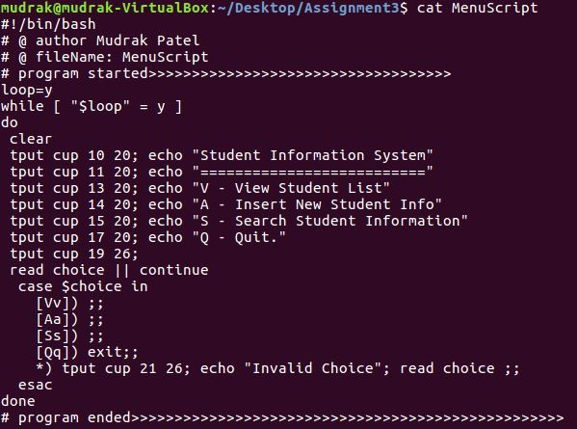

MenuScript execution:

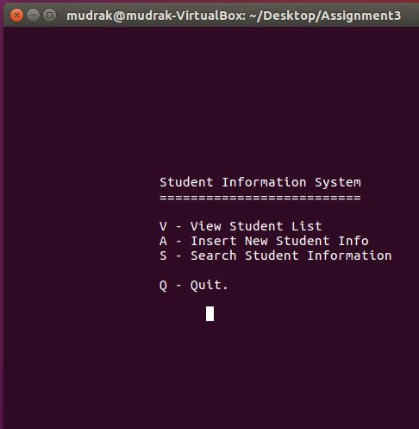

If the user types V or v, the application should execute a script to show all the student information in the following format

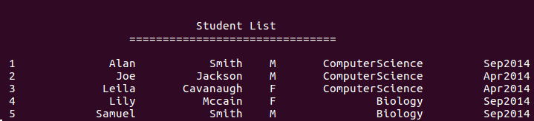

StudentList code:

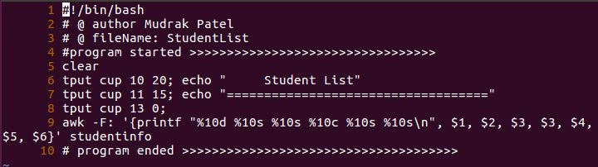

StudentList execution:

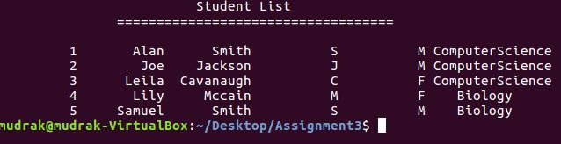

If the user types A or a, the application should prompt the user as shown in the screen shot below and add the entered information in the studentinfo file. It should give the user ability to add a new record after completing this one or quit and be shown the main menu again.

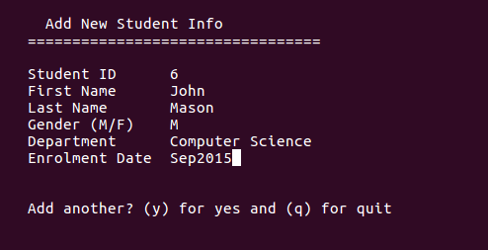

If the user types S or s, the application should let the user search for the user by student name and display matching records or “No matching record found” message.

If the user types Q or q, the application should clear the screen and quit.