**Centennial College**

**Mudrak Patel; 300878960**

**Comp 301: UNIX/LINUX Operating Systems**

**Assignment 04**

**Instructions:** Please share screen shots of the C or C++ programs as well as the output generated by running the program. The screen shots should be placed after each question. Write comments at the beginning of each program that states your name, date and purpose of the program. Failure to include this information may lead to deduction of marks.

1. Write a C program to read an integer from a user and print the square of the number. **(2 marks)**

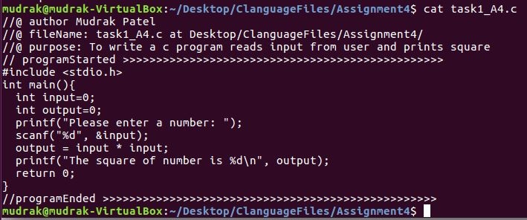



1. Write a C program to calculate the area of a rectangle. Input to the program should be the length and breadth of the rectangle.

(Area= length * breadth). **(2 marks) >>Snips on Next Page:**

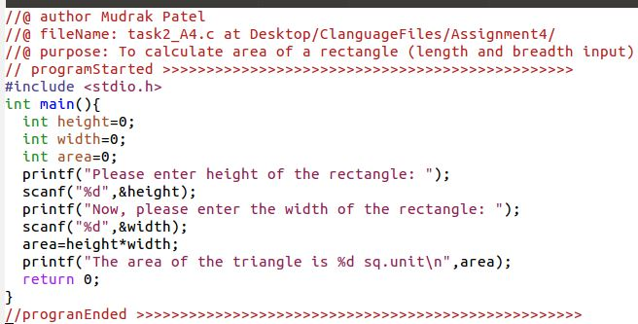

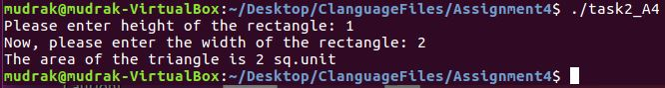

1. Write a C program to open an existing file in write mode. Add the string “Added content “ at the end of the existing content of the file. Show evidence that the content has been added to the file.**(2 marks)**

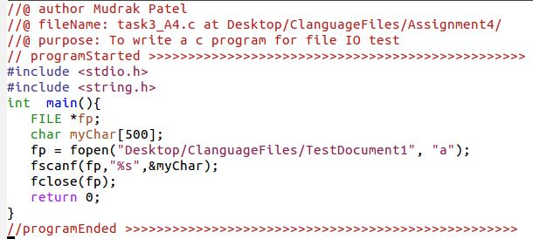

1. Repeat the tasks listed in 1 and 2 in C++. **(4 marks)**

**Task1 in c++ language**

**Code (on next page) :**

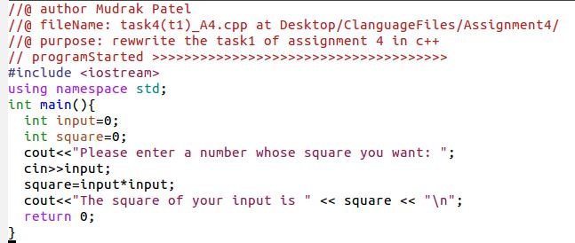

**Output:**

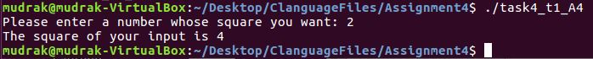

**Task2 in c++ language**

**Code:**

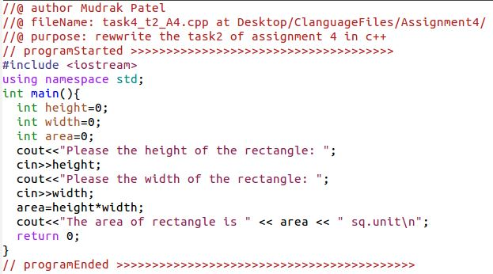

**Output:**

