

Car Information System

Unix/linux operating systems

**Mudrak Patel**| **300878960** | **August 18, 2016**

# Introduction

This project is for COMP 301 (UNIX/LINUX OPERATING SYSTEMS). It is a server side scripted web based (using php as a backend server side scripting language). This project has four web pages plus a css stylesheet (To style the Index page) and three of them are coded with the functionality to add, view and search for a particular car.

**Please Note**: The source code files have already been submitted to ecentennial.

**Reason**: As the source code for all pages are too big to display.

# Index page

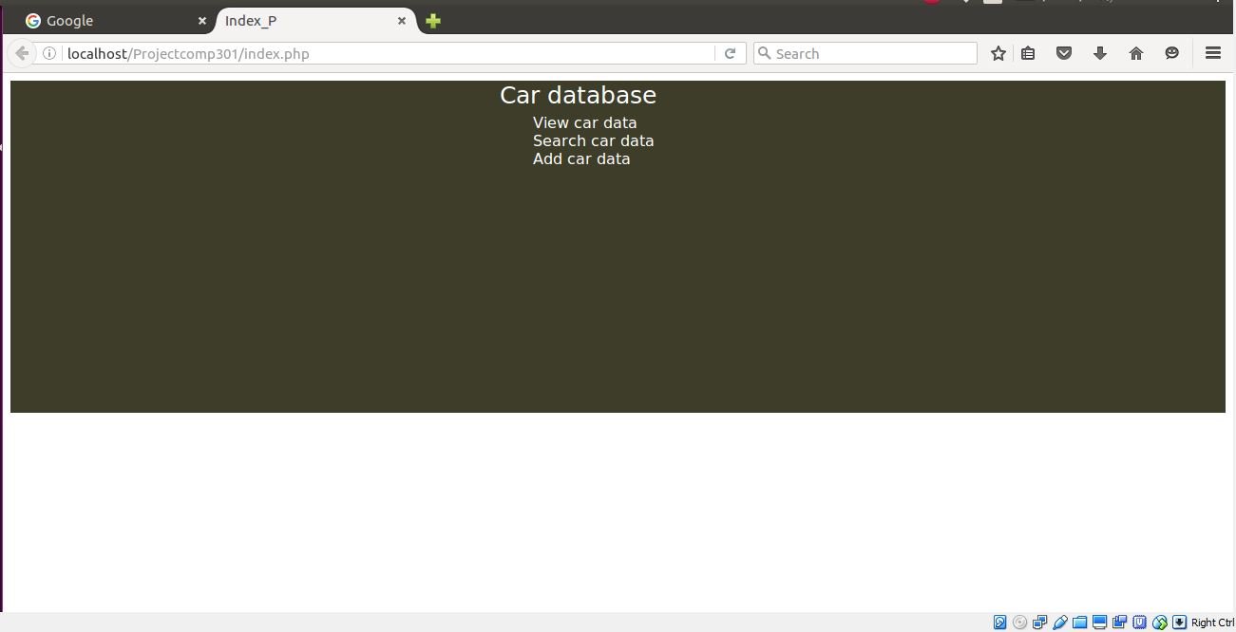

# View page for users to see the data about cars

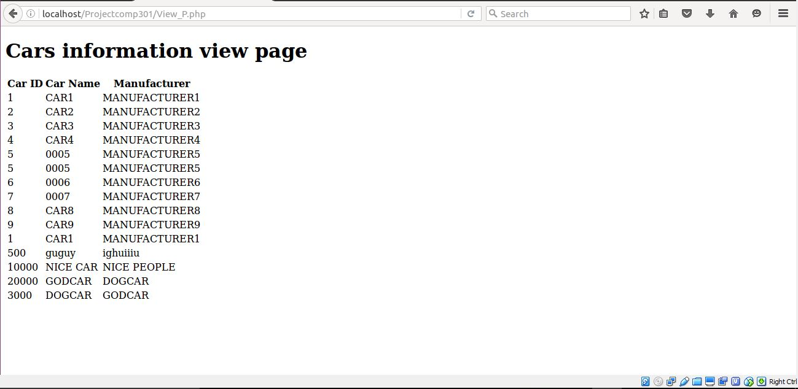

# Search page for users to search about a particular car

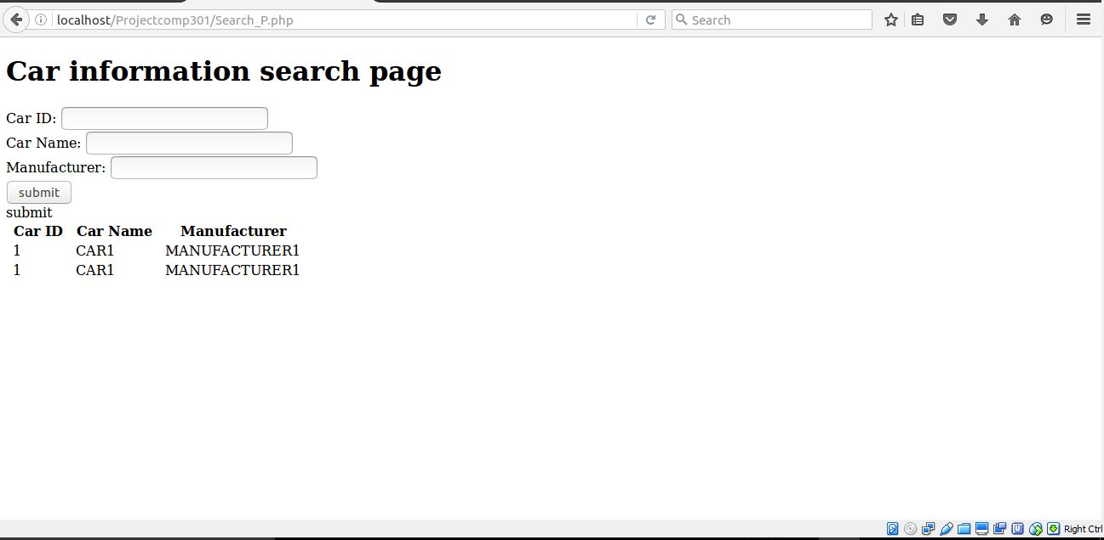

# Add page for admin to add the data about new car in collection

