Unix/Linux Week 3 Work

Task 1,2 and 3

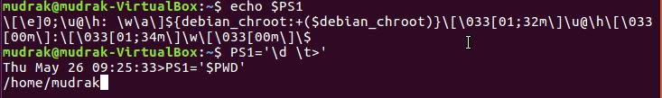

Task 4



Task 5

