Command Summary:

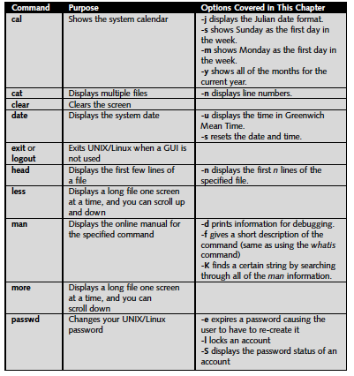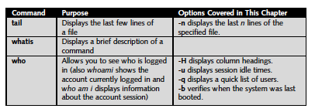

Lab Exercises:

1. Display the current date in UTC format

Date -u

1. Display the current date in this format ‘mm-dd-yyyy’ (hint: Use the date +FORMAT)

date +%d%m%y

1. Display the current time in this format “HH:MM:SS”

date +%r Or date +%X

1. Clear the screen using *clear*

clear

1. Create two files using *cat* command named ‘sample1’ and ‘sample2’. Enter some text in each of the files

cd Desktop

cat>sample1

Some text in it…

ctrl+d //To exit command

cd Desktop

cat>sample2

Some text in it…

ctrl+d //To exit command

1. Merge these two files and create a third file named ‘sample3’ using *cat* command.

cat sample1 sample2>>sample3

1. Change your password to a new password.
2. Install telnet server on your computer using the command:

sudo apt-get install telnetd

Ask your neighbour to connect to your computer using telnet. Reset your password to something you don't mind sharing with your friend. Ask your friend to install telnet server too and access their system. Use *telnet <*ip address*>* toconnect to their computer.

1. Install ssh server on your computer using the command:

sudo apt install openssh-server

Repeat the same steps as in previous task. What is the difference between ssh and telnet?

1. Try the following command-line editing options:

