**Lab Exercises**

**Mastering Editors and Unix/Linux File Processing**

Download and rename this file containing your Firstname_Lastname. For each task take a screen shot of your work and place it under each question. Upload the completed work into the dropbox folder named “Week_5_Bonus_Marks”

1. Create a new file using vi editor called ‘vi_info’. Write down the following line in the editor:

vi editor is a modal editor





1. Using the period command(.). Repeat the same sentence 2 more times.

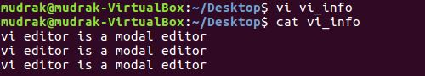

1. Use the *nG,* where n specifies the number of the line, to move to the beginning of the second line.

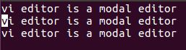

1. Use the cursor movement key *l* to move to theright until you move to the beginning of the word modal.



1. Delete the word modal using a vi editor’s delete word command. Insert the word screen before the word ‘editor’.



1. Using the command :2,$s/<pattern_search>/<pattern_replace>/g , replace the word “modal” with “text”.

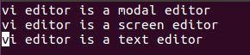



1. Using the vi editor’s cursor movement keys, move to the upper left corner of the screen. Then, move to the end of each line using the appropriate cursor movement key and insert a period (.) at the end of each sentence.



1. Save the file. Show the command used to save the file and exit vi editor in the screen shot.

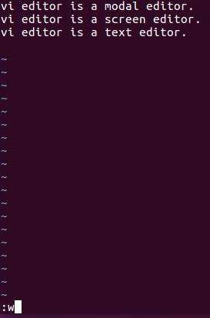



1. Use the Emacs editor to open the same file. Add the line “vi editor is available in most Unix/Linux distributions” as the last sentence.

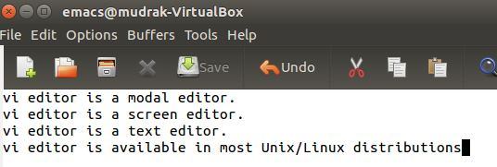

10) Save and close the file.

**Unix/Linux File Processing**

1. Create two empty files on your Desktop using the *touch* command with the names test01, test02. Check the accessed time, modified time using the *stat* command. Now, update the modified time of the file without actually modifying the file.

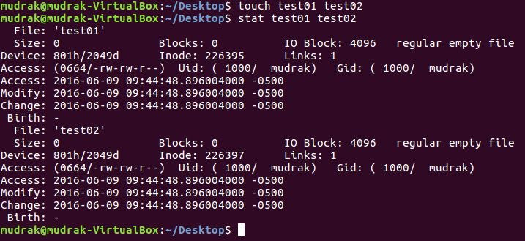

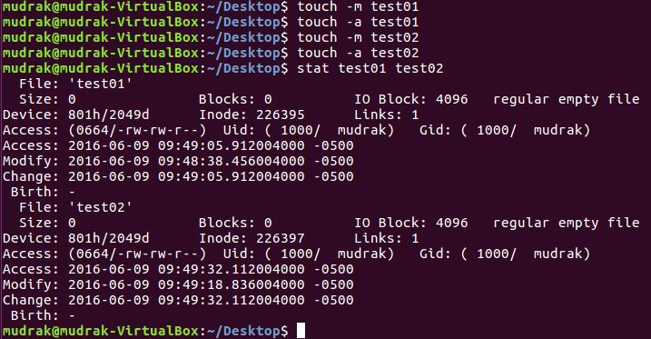

1. Use the *find* command to locate all the files starting with the name ‘test’. Check if the files you created are listed in the result.

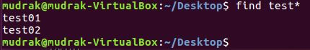

1. Create a directory named ‘testdir’ using the *mkdir* command.



1. Copy test01 from your Desktop to testdir directory.



1. Now open the file test01 in your testdir. Add the following lines of text into the file.

Carol 01

Michael 02

John 03

Lily 04

1. Now use the command cp –u ~/Desktop/test01 testdir/test01. Does the empty file from the Desktop overwrite the file in the testdir directory? Why?



1. Try to delete test02 on your Desktop . What option should you use if you want to get a warning before you delete a file?



1. Rename the file test01 on your desktop to test02 using the *mv* command and enter the following text in test02

Carol COMP301

Michael COMP229

John COMP123

Lily COMP301

1. Move the test02 to testdir using the *mv* command.
2. Write a shell script to join the content of the two files into a single file named test03 and use the *awk* to show only the students enrolled in COMP301 in the output. Run the shell script and see if the new file test03 and the correct output is being shown.

For more help on the *awk* command look at the following link:

http://www.tutorialspoint.com/awk/awk_built_in_variables.htm