Lab – Week 7

Learning Outcomes:

Introduction to shell script programming

Note: Throughout the assignment anything enclosed in [ ] is a placeholder. Substitute what is required as indicated by the word inside the [ ]. Do not use the [ ] in the final command.

At the beginning of every shell script specify which shell you will be using to run the program (!#/bin/bash). Add comments to specify the Author Name, Date, Brief overview of the shell script.

1. Write a shell script to print the list of all environment variables. (Use the *printenv* command).

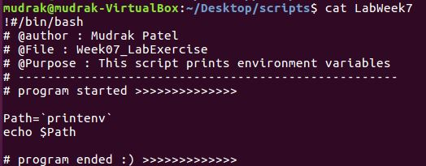

1. Create a shell script that reads your name from the command line and echoes “Hello [your name]”. Use read [variable name] to read input from user and store it into a variable)

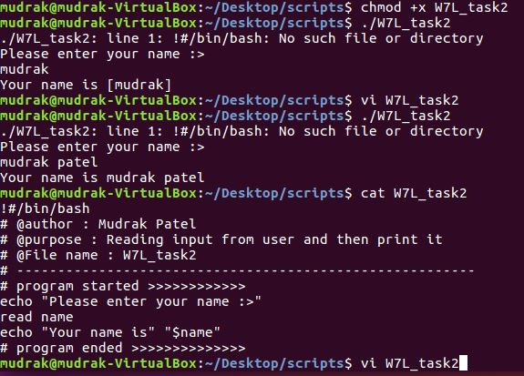

1. Write a shell script that reads two numbers from the command line and shows the sum of the two numbers
2. Make a directory called ‘shell_scripts’. Move all your scripts to this folder. Add this folder to the PATH environment variable.
3. Write a shell script that read the day of the week from the command line. If the day is Sunday or Saturday, echo “Holiday!” else echo “Workday” ( Use or operator ( || ) to check two conditions in the if statement).
4. Change the script you wrote in exercise 5 to echo “Holiday!” only for Sunday and “Half day!” for Saturday. For all other weekdays, echo “Workday!” (Use nested if …else statement)
5. Work on the Hands on projects 6-8 to 6-12 given in the text book : Palmer M. Guide to Unix using Linux.