

Foundations of Programming
Assignment No. : 9

PROBLEM STATEMENT:
Write a program in C to check whether the given number is an Armstrong number or not.
An Armstrong number is an integer with three digits such that the sum of the cubes of its digits is equal to the number itself.
Example: 371

OBJECTIVE:
• To understand the concept of Armstrong numbers.
• To practice arithmetic operations in C.
• To develop logical thinking using loops and conditional statements.

THEORY:
An Armstrong number (also called a narcissistic number) is a number that is equal to the sum of the cubes of its digits. For a three-digit number abc, it is an Armstrong number if:
a³ + b³ + c³ = abc
For example, 371 is an Armstrong number because:
3³ + 7³ + 1³ = 27 + 343 + 1 = 371.

PLATFORM:
Linux

C PROGRAM:
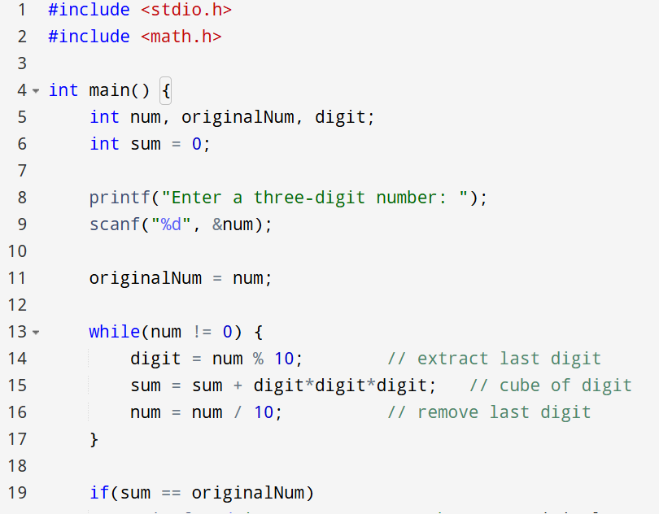
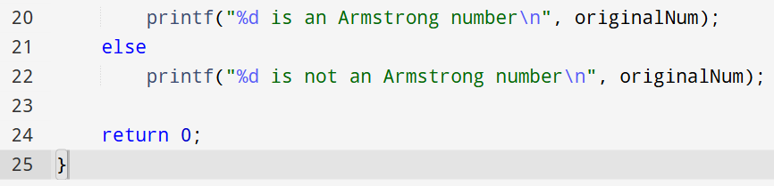

ALGORITHM:
1.Start
2.Input a three-digit number num.
3.Store the original number in originalNum.
4.Initialize sum = 0.
5.Repeat while num is not 0:
a. Extract the last digit: digit = num % 10
b. Add cube of digit to sum: sum = sum + (digit * digit * digit)
c. Remove last digit: num = num / 10
6.Compare sum with originalNum:
If equal → print "Armstrong number"
Else → print "Not an Armstrong number"
7.Stop

INPUT:
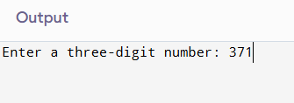

OUTPUT:
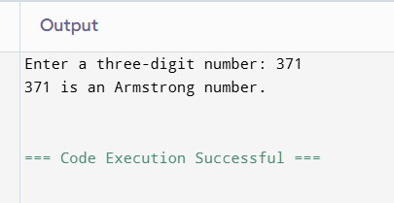

CONCLUSION:
Thus, we have successfully written a C program to check whether a given number is an Armstrong number using loops and arithmetic operations.

FAQs:
- What is an Armstrong number?
2. Why is the Armstrong number concept important in programming?
3. How does this program work step by step?

