

Foundations of Programming
Assignment No. : 12

PROBLEM STATEMENT:
Write a program in C to accept two numbers from the user and compute:
- The smallest common divisor of the two numbers (other than 1, if any)
- The Greatest Common Divisor (GCD) of the two numbers

OBJECTIVE:
• To understand the use of mathematical operations in C.
• To implement loops and conditional statements
. • To perform number-based computations.
• To enhance logical thinking using menu-driven programs.

THEORY:
Divisors and the Greatest Common Divisor (GCD) are fundamental concepts in number theory. The smallest common divisor of two numbers is the smallest positive integer greater than 1 that divides both numbers. The GCD of two numbers is the largest positive integer that divides both numbers without leaving a remainder. In C programming, these operations can be efficiently implemented using loops and the Euclidean algorithm, which repeatedly applies the modulo operation until the remainder becomes zero.

PLATFORM:
Linux

ALGORITHM:
Step 1: Start
Step 2: Declare variables: num1, num2, i, gcd, smallest_divisor
Step 3: Accept two integers from the user
Step 4: Initialize smallest_divisor = -1
Step 5:
Loop from i = 2 to minimum of (num1, num2)
- If both numbers are divisible by i
  - Set smallest_divisor = i
  - Break the loop
Step 6:
To find GCD using Euclidean Algorithm:
- While num2 != 0
  - temp = num2
  - num2 = num1 % num2
  - num1 = temp
Step 7: Store num1 as GCD
Step 8: Display smallest common divisor
- If no divisor found → print "No common divisor other than 1"
Step 9: Display GCD
Step 10: Stop

FLOWCHART:
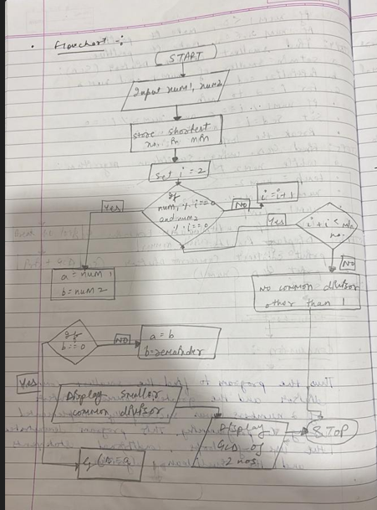

C PROGRAM:
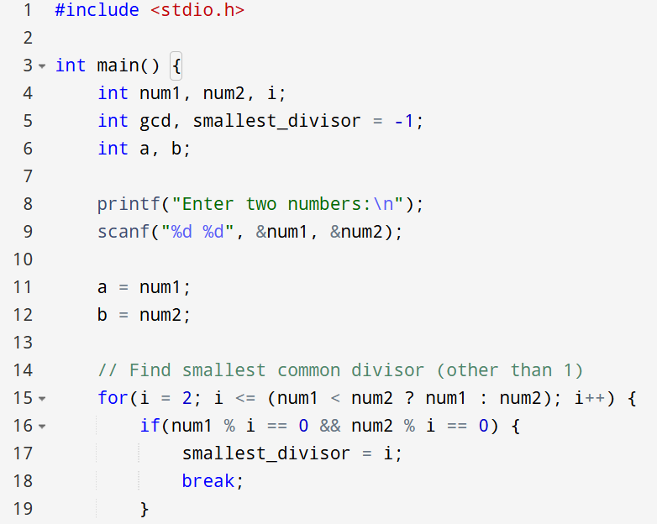
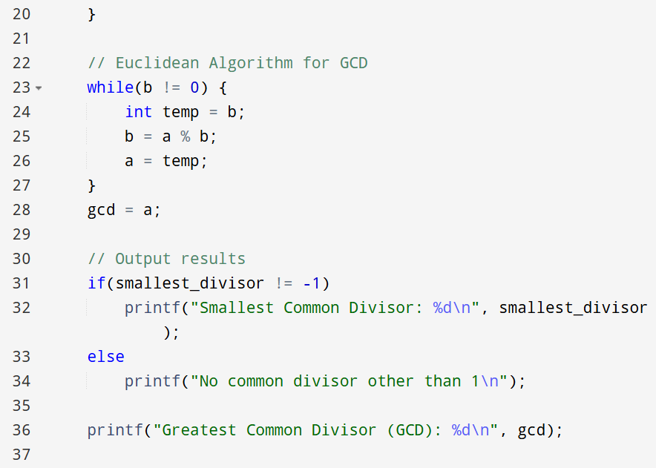
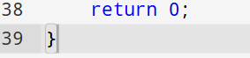

INPUT:
INPUT:
The user enters two integer numbers.
Example Input: Number 1: 24 Number 2: 36

Paste Screen Shot of Input
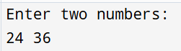

OUTPUT:
The program displays the smallest common divisor and the GCD of the two numbers.
Example Output: Smallest Common Divisor: 2 Greatest Common Divisor (GCD): 12

Paste Screen Shot of Output
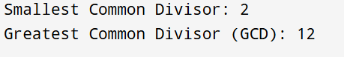

CONCLUSION:
Thus, the program to find the smallest common divisor and the Greatest Common Divisor of two numbers was successfully implemented using C programming. This program demonstrates the use of loops, conditional statements, and the Euclidean algorithm.

FAQs:
- What is meant by the Greatest Common Divisor (GCD)?
- Why does the Euclidean algorithm efficiently compute the GCD?
- How can this program be modified to handle negative numbers?
- What changes are required to compute the Least Common Multiple (LCM) using the GCD?
- How can this program be extended to find the LCM of two numbers?

