

Foundations of Programming
Assignment No. : 13

PROBLEM STATEMENT:
Write a program in C to accept a number from the user and print the digits of the number in reverse order.

OBJECTIVE:
• To understand number manipulation using loops
. • To learn the use of modulo (%) and division (/) operators.
• To implement logic for reversing digits of a number.
• To improve problem-solving skills using iterative structures.

THEORY:
• To understand number manipulation using loops. • To learn the use of modulo (%) and division (/) operators. • To implement logic for reversing digits of a number. • To improve problem-solving skills using iterative structures.

PLATFORM:
Linux

ALGORITHM:
Step 1: Start
Step 2: Declare variable num and digit
Step 3: Accept an integer from the user
Step 4:
If num == 0
- Print 0
Step 5:
If number is negative
- Convert it to positive using num = -num
Step 6:
While num > 0
- Find last digit using digit = num % 10
- Print the digit
- Update number using num = num / 10
Step 7: Stop

FLOWCHART:
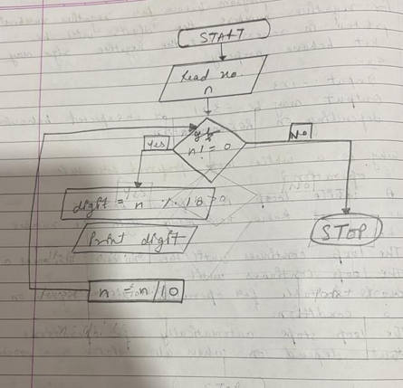

C PROGRAM:
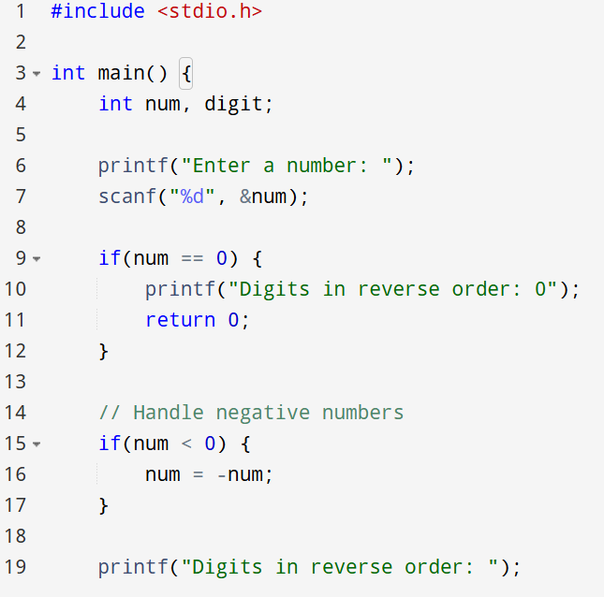
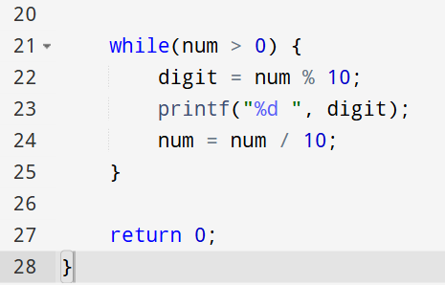

INPUT:
INPUT:
The user enters an integer number.
Example Input: Number: 4567

Paste Screen Shot of Input
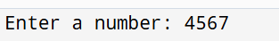

OUTPUT:
The program prints the digits of the number in reverse order.
Example Output: Digits in reverse order: 7 6 5 4

Paste Screen Shot of Output

CONCLUSION:
Thus, the program to print the digits of a number in reverse order was successfully implemented using C programming. The program demonstrates the effective use of loops, modulo operator, and division operator.

FAQs:
- Why is the modulo operator (%) used in this program?
- Why is division by 10 used after extracting each digit?
- What happens if the input number is zero?
- How will the program behave for negative numbers?
- Why is a while loop preferred for this operation?

