
;l

Foundations of Programming

Assignment No. : 01
PROBLEM STATEMENT:
Write a program in C to check whether a given year is a Leap Year

OBJECTIVE:

- To understand the use of conditional statements in C programming.
- To implement logical conditions for solving real-world problems.
- To develop problem-solving skills using decision control structures.

THEORY:
1.Theory for conditional statements with syntax (if , if-else, if-else ladder) are used in C programming.
Sol-1]*if statements:The if statement is the simplest decision making statement .it is used to decide whether a certain statement or block of statements will be executed or not.
*if-else statements:The if-else statements allow a program to execute one block of code if the condition is true and a different block if the condition is false.
*if-else ladder statements:This is used when you need to check multiple conditions sequentially. Once a condition is met, its corresponding code block is executed,and the rest of the ladder is skipped.
2.Theory for a Leap Year - year that contains 366 days instead of the usual 365 days.
Sol-2]Rules:
• A year is a leap year if it is divisible by 400, OR
• A year is a leap year if it is divisible by 4 but not divisible by 100.

3.Algorithm:
Sol-3]
STEP-1)START.
STEP-2)Read leap year as an integer a.
STEP-3)if ((a%4==0&&a%100!=0)||a%400==0) generate result and store it as,b.
STEP-4)Display result as “The given year is a leap year.”
STEP-5)Else
STEP-6)Display result as “The given year is not a leap year.”
STEP-7)STOP.

PLATFORM: Linux

CODE:
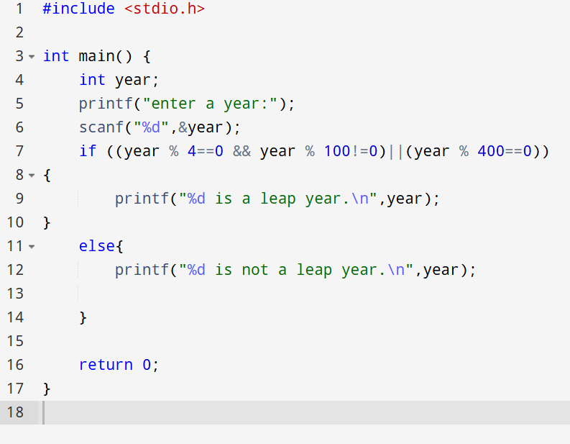

INPUT:
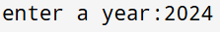
OUTPUT: Displays whether the entered year is a Leap Year or Not a Leap Year.
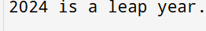
Sample Input
2024
Sample Output
2024 is a Leap Year
CONCLUSION: Thus, the program successfully checks whether a given year is a Leap Year using conditional statements in C.

