**TABLE OF CONTENTS**

1 Introduction 6

1.1 Physiology of PHEO’s 6

1.1.1 Prevalence in population: 6

1.1.2 Tumour 6

1.1.3 Surgery: 7

1.1.4 Catecholamines and PPGL Diagnoses 7

1.1.5 Genetic 8

1.2 Study design and research questions 9

1.2.1 Challenge: 10

1.3 Database and data 10

1.3.1 Data format 10

1.3.2 Variables descriptions 11

1.3.3 Variables criteria and Data Cleaning 11

1.4 Covariates and Outcomes 12

1.4.1 Patient 12

1.4.2 Age 13

1.4.3 Gender 14

1.4.4 Genes 14

1.4.5 Biomarkers 16

1.4.6 Interactions 18

1.4.7 Missing data 19

1.4.8 Censoring 20

2 Longitudinal data in Linear Mixed Models 21

2.1 Introduction 21

2.1.1 A special case Random coefficient models: RI/RIAS (Laird & Ware, 1982) 22

2.2 MLE vs RMLE 23

2.3 Prediction and EBLUP in mixed models 24

2.3.1 Shrinkage 25

2.3.2 Residuals diagnostics 25

2.3.3 Random effects diagnostics 25

2.4 Inference testing and model selection. 26

2.4.1 Wald (Z test) 26

2.4.2 Likelihood Ratio Test, LRT 26

2.4.3 Testing Hypotheses About the Variance-Covariance Parameters: 27

2.4.4 AIC 27

2.4.5 Pseudo R2 27

2.5 Defining Time Predictors and terminology 27

2.5.1 Time varying predictors: 28

2.6 Time model for post-surgery biomarker decay 30

3 Modelling LMM 32

3.1 Need of random slopes and intercept 32

3.1.1 Linearity assumptions 33

3.1.2 Parametrizations: 34

3.1.3 MLE vs RMLE 34

3.1.4 Algorithms testing: 35

3.2 Case-Control with logistic regression 35

3.2.1 Parametrization concept: 36

3.2.2 The marginal logistic model: 36

3.2.3 Age as a factor classes 36

3.2.4 Intercations: 37

3.2.5 Conclusions on outcome surgery 37

3.3 Model structure 1 : Post Surgery models 38

3.3.1 Random effects 41

3.3.2 Residuals analysis 41

3.3.3 Predictions 42

3.3.4 Censoring 44

3.4 Model structure 2 : An Overall model (revised) 44

3.4.1 Model structure 44

3.4.2 Results 46

4 Discussion 46

4.1.1 Robust estimators 48

5 Conclusions 49

5.1 Recommendations 49

6 Annexes 49

6.1 R Data 49

6.2 R code 49

7 Bibliographie 50

8 APPENDIX 53

8.1 Material: 53

8.2 Profile plot 54

8.3 Logistic regression 54

8.4 Model 54

8.4.1 Diagnostic plot 54

8.4.2 55

8.4.3 Table of pre-model test: 55

8.4.4 Effect plot 57

8.4.5 Covariance Matrix for ID: V Matrix 59

8.4.6 Prediction by ID 59

8.5 Robust and Censoring models 60

8.6 R data 60

**ABBREVIATION**:

ACF: Auto correlation function

AIC: Akaike Information Criteria

BVN: Bivariate Normal

CPS: Compound symmetry

Df: Degrees of freedom

FIXEF: Fixed effects

GAM: Generalized Additive models

GLMM : Generalized Linear Mixed models

EBLUP: Empirical best linear unbiased predictors

EDA: Exploratory data analysis

ICC: Intraclass correlation

ICP-MS: Induced plasma Mass Spectrometer

LMM: Linear Mixed Models

Log10: Logarithmes base 10

Ln: Logarithmes baseexp (Népérien)

LRT: likelihood ratio Test Statistic

MNL(T): Free (total) Metanephrines

NMNL (T): Free (total) Normetanephrines

MTL(T): Free (total) 3-Methoxityramine

MLE: Maximum Likelihood estimator

MVN: Multivariate Normal

OLS: Ordinary least square estimator

PPGL: Pheocytochroma and Paraganglioma

RI: Random Intercept

RIAS: Random intercept and slope

RANEF: Random effect

REML: Restricted (“Residuals”) Maximum Likelihood estimator

RTM: Regression to the Mean

SE: Standard Error

s.l. Sensus lato (definition)

s.s Sensus stricto (definition)

:: R packages

| Given that

LISTE OF TABLES

Table 1 Metanephrines Maximum Values for PHEO diagnostics [URL] 8

Table 2 Variables descriptions (1st dataset with 1591 raw lines) 11

Table 3 Counts ID per Gene classes [N=220] 14

Table 4 Missing value for all biomarkers 21

Table 5 Comparison at ID levels of a LMM RIAS model fixed effect estimates 36

Table 6 Algorithm’s test for nlme and lme4 packages on Fixed effects | ID 36

Table 7 samples 39

Table 8 Anova type III : Log10 MNL ~ . 41

Table 9 Surgeries ID 45

Table 10 Censored models and bias coefficient comparison 45

LIST OF FIGURES

Figure 1 Barplot patient ID vs numbers of measures 12

Figure 2 Boxplot of 30 random ID | Log 10 MNL Biomarker 13

Figure 3 Histogram of Patient Age [Range 7-96 Years] 13

Figure 4 Barplot Age vs total count of measures 14

Figure 5 Boxplot of log10 Biomarkers | Genes 15

Figure 6 Boxplot log10MNL~Gender | Genes 16

Figure 7 Log10 Biomarkers distributions 17

Figure 8 Scatter-Correlation plot : Log 10 value Biomarkers, method “Pearson” 18

Figure 9 Regression line for log10 NMNL biomarkers vs Age 18

Figure 10 Two-ways factors interactions plot | mean log 10 (MNL) 20

Figure 11 Profile plot (ID trajectories) of 30 random patients | Time of arrival 29

Figure 12 Profile plot or Patient biomarker trajectories 30

Figure 13: Simulation of 50 pre and post test value based on MVN distribution: 31

Figure 14 Simulation of Yi: Xt β=function log(time) + [ log(time)]2 32

Figure 15 Landing Phase of 30 random patients. Right: Data remove from 0-3 months 32

Figure 16 Patients trajectories after 3 months post surgery (1st) based on linear regression 33

Figure 17 Linear regression on ID (top) and Genes (bottom) using LmList function:: nlme 34

Figure 18 Scatter plot of OLS regression line for 10 random sample ID 35

# Introduction

## Physiology of PHEO’s

Adrenal-medulla pheochromocytomas “PHEO” and extra-adrenal sympathetic paragangliomas PGL, known as “PPGLs” are rare neuroendocrine chromaffin tumours, characterised by production of catecholamines: noradrenaline, adrenaline and dopamine. Tumoral secretion of catecholamines determines their clinical presentation which is highly variable among patients. Clinical presentation of patients reports paroxysmal episodes of headache, sweating and palpitations. In addition, pallor, feelings of panic or anxiety, nausea, fever, flushing and constipation may occur although up to 10–15% of patients present entirely asymptomatic. (N.Kaplan, 1994). Hypertensive episodes are paroxysmal with either normal blood pressure between paroxysms or sustained hypertension. Pheochromocytomas are usually benign and curable if properly identified and removed but can be fatal if undiagnosed or mistreated. Autopsy series, however, suggest that many pheochromocytomas are not suspected clinically and, in these patients, lead to a tragic outcome. (McClellan M.Walther, 2003)

In the presenting study we will not differentiate PHEO from PGL, although partial information about sustained status is available in the database.

### Prevalence in population:

PPGL prevalence in Switzerland is about 0,1- 0,6% on hypertensives patients (A.Meyer, 2009).

Kaplan report incidence of 0.95 cases / 100’000 hab. / years in USA and about 6 PHEO can be found in 100’000 hypertensive patients.

Solitary adrenal pheochromocytomas occur in about 72–82 per cent of affected patients, bilateral adrenal pheochromocytoma in 3–11 per cent, and extra-adrenal tumours in 9–19 per cent (Sutton et al. 1981)

Women and men are similarly affected with pheochromocytoma. Sporadic pheochromocytomas most commonly present in the fourth through sixth decades of life. (L.Bammater, 2016)

30 à 40% of PPGL are originated from genes mutation and encountered in patients aged below 40. Conversely uncorrelated[1] genes PPGL are usually detected on older patients (ref: Swiss Medical Forum).

### Tumour

Most tumours are benign but 10–15% are defined as malignant based on the development of metastases in nonchromaffin tissues such as lymph nodes, liver, and bone. Therefore, prompt diagnosis of PPGL remains a challenge for every clinician. Early consideration of the presence of a PPGL is of upmost importance, because missing the diagnosis can be devastating due to potential lethal issue.

The size of tumour is related to productions of catecholamines in an exponential relationship from a 10% rise abnormal rate with masses less than <1 cm up to 64% in masses greater than 2 cm. Mass of 8 cm are reported. (Pacak, 2019)

Reported Median tumour growth rate was 0.1cm / year and for tumour< 2cm and 0.32 cm/year > 2cm. (A van Berkel, 2014)

Recurrence (“relapse”) of tumour in follow-up studies is about 7.9 Years for PPGL (Contralateral PHEO 8.0 Years). This is consistent of what was found in present study but time recurrence seems strongly related genes class[2].

Partial information about tumour size [cm] is available in the database. It is common practice in oncology statistic to transform tumour volume by it x-1/3 for linearity.

### Surgery:

Imaging and surgery are not covered by the present study, but some data are available. The main issue with surgery that wrong incision may lead to an uncontained burst of catecholamines in the blood therefore patient will sustained lowering medications before interventions (Grouzmann pers. comm.).

### Catecholamines and PPGL Diagnoses

First step in diagnosis is proper biochemical analysis (blood &/or urines ) to confirm or refute the presence of excess production of catecholamines or their metabolites[3] through complex enzymatic[4] processes (Berkel, 2014). What must be underlined that during metabolic processes plasma free metanephrines are then conjugate with sulphates by the gut wall enzymes giving a measured “Total metanephrines”. Repeated follow-up measurements of metanephrines in plasma or urine offer the best diagnostic. (Lenders JWM, 2002) .

In the present study only plasma measurement is considered.

It is not unanimity admitted but free metanephrines resident time is about 3-7 days as total metanephrines are about 2 Months blood persistent. (Grouzamnn , pers.comm ,2021).

This has had shortfall on modelisation post- surgery because metanephrines production are not in steady state.

Table 1 presents the normal Maximum limit values for Metanephrines. These values are also applied as benchmark in European countries. Beyond these Upper Reference Limit (URL), PPGL is diagnosed, and further investigation is rapidly proposed[5] (CT-MRI imagery). What we have to take into account is that, in this prospective[6] study some patients are addressed to the CHUV laboratory in emergency measurement while symptomatic. Therefore, we frequently record 1st biomarkers measurement value well above URL (up to 4-10 fold). This limits the use of a baseline covariate for controlling any regression to the mean , hence gaining statistical precision. (Senn,1999).

Paying attention to sampling conditions, patient preparation, food[7] diet intake and use of interfering medications[8] is important, as these factors can largely influence test results .For a complete descriptions see (N.Kaplan, 1994) Therefore measuring exact values of biomarkers without bias is a real challenge and is covered by to a strict protocol. (Grouzmann E., 2010)

Table Metanephrines Maximum Values for PHEO diagnostics [URL]

|  |  |  |  |
| --- | --- | --- | --- |
| Biomarker | Name | URL in[ nMol] | Log[ e ] |
| MNL [9] | Free Metanephrine | 0.85 | - 0.163 |
| NMNL | Free Normetanephrine | 1.39 | 0.330 |
| MTL | Free Methoxytyramine | 0.06 | - 2.813 |
| MNT | Total Metanephrine | 13.45 | 2.599 |
| NMNT | Total Normetanephrine | 36.65 | 3.601 |
| MTT | Total Methoxytyramine | 4.19 | 1.433 |

### Genetic

A key feature of PPGLs is their genetic diversity and susceptibility. The majority of hereditary PPGLs are caused by mutations affecting NF1, MEN2 (Multiple Endocrine Neoplasia A/B form) , VHL (Von Hippel-Lindau syndrome), SDH.x (Syndromes des paragangliomes héréditaires SDH-B, SDH-D, SDH-C, SDH-A). Genetic testing of these genes in PPGL patients is not commonly laboratory routine as an expensive analysis; moreover, some patients don’t want to be tested for personal reason. This information is crucial for stratifying the risk of synchronous or metachronous tumour development an is a main factor to control in prospective study. (Pacak, 2019). Interactions between class genes as not been really tempted in research and literature. So familial follow-up is highly recommended frequently when gene is identified.

Genetic test result can also be used for estimation of tumour size / tumour location and chance of relapse[10]. (Berkel, 2014) (Grouzmann E., 2010) (L.Bammater, 2016) .

## Study design and research questions

Pharmaco-epidemiology observational studies are of prime interest because they are costless and no time consuming. Some observational studies are prospective like cohort study some are retrospective like case-control. But sometimes it is not possible to define the exact relationship as in the present case as:

-To be qualified as cohort recruiting subject are not outcome holder: In the present, some patient enters the process with the expressed outcome resulting in a mixing population.

-To be qualified as case control study patient must be randomized to allocation group: No randomization occurred and more informally no baseline measure was possible or envisioned.

We therefore we do not prefer to strictly classified our study to a published framework but keep advise clinician and researchers that bias can easily occurred and inference might be valid only for the profile population set in the data. But some basic biostatistics concepts can be kept in mind and possibly applied to reach lower bias and cofounding. (Senn S., 1994)

As in all EDA perspective lot of questions arises when data are processed and possibly were revised during the process due to both complexity and workload. Some research questions are presented below.

* Make EDA descriptive statistics.
* Proposed the best methodology modelling for these kinds of data.
* If feasible, model data into a Multivariate Analysis GLMM with dichotomous outcomes using operated yes/no or ratio (Grouzmann E., 2010) using the 6 Biomarkers and draw conclusion. (Objectives Revised[11])
* Proposed a model EBM based[12], able to monitor patient biomarker trajectories.
* Predict patient evolution with enough precision (“low variance”) but controlling for risk factor.
* Predict future potential relapse (2nd surgery) for patient.
* Evaluated the possible linearity relations ship between the biomarkers and dynamic time predictor: If not proposed a nonlinear (i.e GAM models)
* Advised if a random slope is needed and analyse the correlation structure.
* Incorporated a complex function to accommodate the non-steady state of biomarker kinetics behaviour after 1st surgery. (Revised)
* Based on preceding, evaluate the best revisit time for measurement (Variogram).
* Stay simple as possible.

### Challenge:

Beside statistical issues like unbalanced follow- up,missing data, censoring and correlation between measures majors difficulties arised also in:

1. Continuous database update was fed during the entire period of analysis. Therefore it was decided to work in a 2 steps modelling: a first pre-dataset (from August 20 onwards) and final one (November 2020 to December 2020) , when all missing information’s from Multi-centres will be gathered.
2. As the study was an exploratory case approach, research questions evolve on a weekly basis (see report meeting in annexes).
3. The knowledge of Generalized Mixed Models and Joint Models was not covered by ECTS credit and knowledges have to be acquired (UNIGE).
4. Get a common and uniform census opinion amongst clinicians.

## Database and data

In 2008 it was decided in CHUV, Laboratoire des catecholamines, to rise a new database based on observational follows up of 2000 Hypertnensive Swiss citizen patient on metanephrines measurements. CHUV is the place of collection of multi-centric hospitals data.

In Avril 2014 the CHUV was equipped with high precision Mass Spectrometers for plasma measurements, hence reducing considerably the measurement error (residuals variance). To account for such, we applied in longitudinal recording a linea coefficient correction for Total metanephrines (only) from the ID record 1 to 18029.This factor is linear and has a coefficient of 1.4. (Abid pers.comm.).

The database is maintained on an exportable Access format, but main data input is made by hand either from laboratory staff under supervision of an IT engineer via an Excel link.

The present study also aims to recommend best procedure for data recording in the prospective study. But retrospective data acquisitions were recommended too and performed during these 6 months period as some major missing static covariate like gender was missing. Extracted values with matching research criteria was delivered for the analysis (mid-August-mid December).

### Data format

Longitudinal data requires special format where repeated measurements (Yij) for each patient is made by rows (said as long). Therefore, the dimension of matrix was Ni x J lines and variables as columns (Matrix of 1405 x 21). With unbalanced times there is no practical version of wide format as most software only accommodate long format with equally time balanced data. (Weiss, 2005). But with Reshape:: packages allows such adaptation without loss hard working. Tremendous effort was done for correctness of data reshaping by cross checking from *.xls* to R back (“random check lines”).

For sake of reproducibility and as 3000 lines of R codes has been produced and given in Appendix R code.

### Variables descriptions

It was although thought for sake of reproducibility not to change names form the original 1st delivered dataset (*qry_FEV_pour_stats_jmm.xls*) but instead create new variables.

Table 2 describes the variables available for the study. Highlighted in grey those used for modelling according to research questions.

Table Variables descriptions (1st dataset with 1591 raw lines)

|  |  |  |  |
| --- | --- | --- | --- |
| **Variables Name**  **orginal dataset** | **Descriptions** | **Type of variables in R** | |
| **IDPatient** | Patient identification Number in database ACCESS,CHUV | Factor ID Ni sized |
| **DNPatient** | Date of Birth | Date |
| **Sexe** | Gender "M"/"F" | Factor 2 levels |
| **MaladieGent** | Type of Genes If unknown category labelled R as "sporadi" | Factors 5 Levels |
| **Malignite** | Malignant orBegnin | Factor 2 levels |
| **Anamnese** | Follow up and diagnoses | Texte |
| **IDDemande** | Attributed serial number based on arrival in study | Integer |
| **DateArr** | Date of Arrival in the database | Date |
| **MNL** | Untransformed value of Biomarker: Free Metanephrine | Continous |
| **NMNL** | Untransformed value of Biomarker: Free NormMetanephrine | Continous |
| **MTL** | Untransformed value of Biomarker: Free Methoxytyramine | Continous |
| **MNT** | Untransformed value of Biomarker: Total Metanephrine | Continous |
| **NMNT** | Untransformed value of Biomarker: Total NormMetanephrine | Continous |
| **MTT** | Untransformed value of Biomarker: Total Methoxythyramine | Continous |
| **operation y/n** | 1 st operation Yes/no | Factor 2 levels |
| **Op_prec** | Date of 1 st surgery (unmabigous) | Date |
| **SurgeryType** | Type of surgery | Texte |
| **TumorSizeWcm** | Width tumour size in cm | Continuous |
| **TumorSizeHcm** | Height tumour size in cm | Continuous |
| **Op_suiv** | Date of > 1 st operation up to 4 (ambiguous) | Date |
| **SurgeryType** | Type of surgery | Texte |
| **TumorSizeWcm** | Width tumour size in cm | Continuous |
| **TumorSizeHcm** | Height tumour size in cm | Continuous |
| **> 3 mois ?** | Mesasurment 3 months after surgery | Factor 3 levels |

### Variables criteria and Data Cleaning

It was a major duty to recode form original data xls into R with compatibility format issues (i.e. Date,UTF8). “Best practice of coding” was addressed to IT maintenance during the study.

It was decided for model predictions to avoid as much observational bias sampling and get homogenous population criteria for comparisons. We therefore excluded variables:

* Malignant PPGL.[13]
* Patient with at least one surgery (only for modelling)[14].

## Covariates and Outcomes

### Patient

Under criteria N=220 patients [Gender:118 “Men” ; 102 “Women] was initially selected for descriptive statistics, with 1405 lines of record in each biomarker. Some patient range from J=1 measurement up to J=19 . Figure 1 show clearly an unbalanced follow-up study but also a decrease in numbers of measurements as patient enter lately.

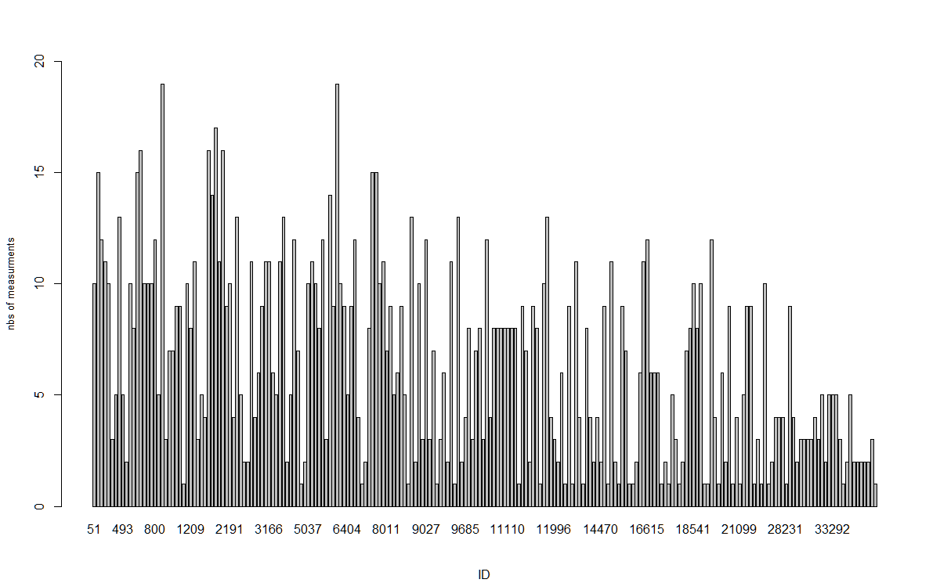

Figure Barplot patient ID vs numbers of measures

To estimate how much variance occurs between patients’ measurements given a biomarker, boxplot of 30 random ID is presented in figure 2. Bearing in mind that data is pre & post-surgery cofounded here, large variation around the mean occurred, large variance is clearly identifiable. When such pattern is detected, Linear mixed models will be able to capture such variation.

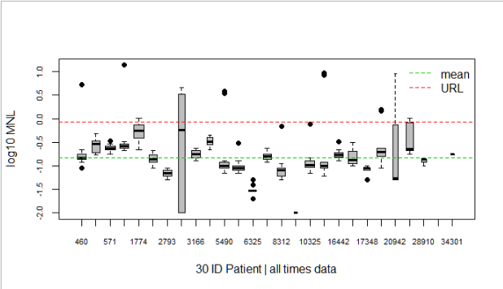

Figure Boxplot of 30 random ID | Log 10 MNL Biomarker

### Age

Age repartition is presented in figure 3.

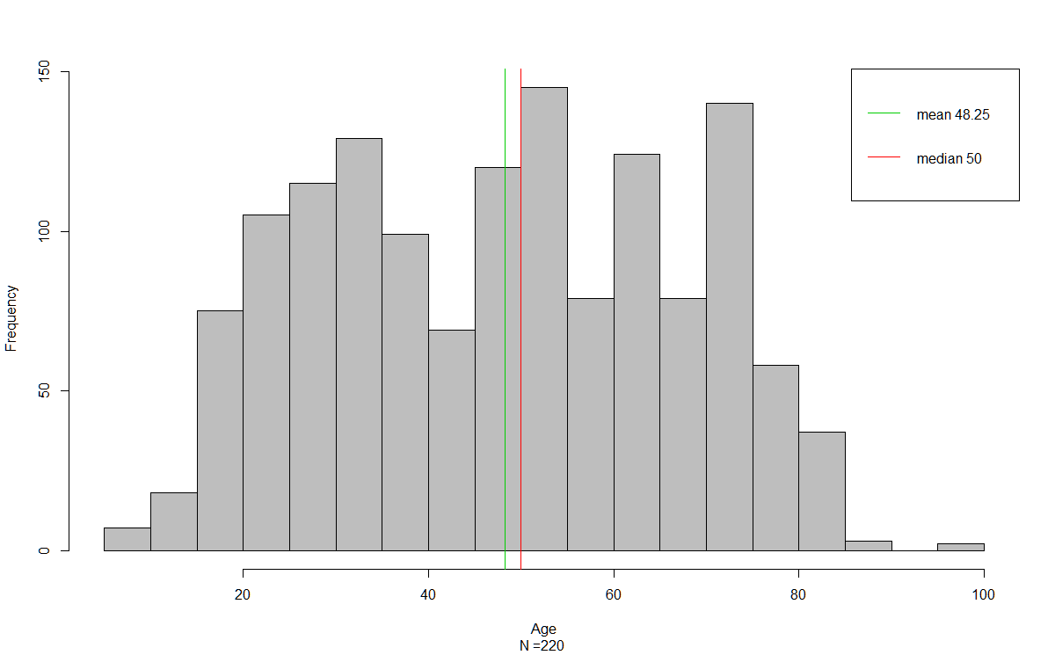

Figure Histogram of Patient Age [Range 7-96 Years]

Although looking bimodal age distribution is considered as Normal (N;48,2).

### Gender

In literature it seems equally likely that gender encounters PHEO (Pacak, 2019). In the present study women are far more screened than men (Figure 4) this result in unbalanced data for gender. This fact stays not well explained amongst clinicians.

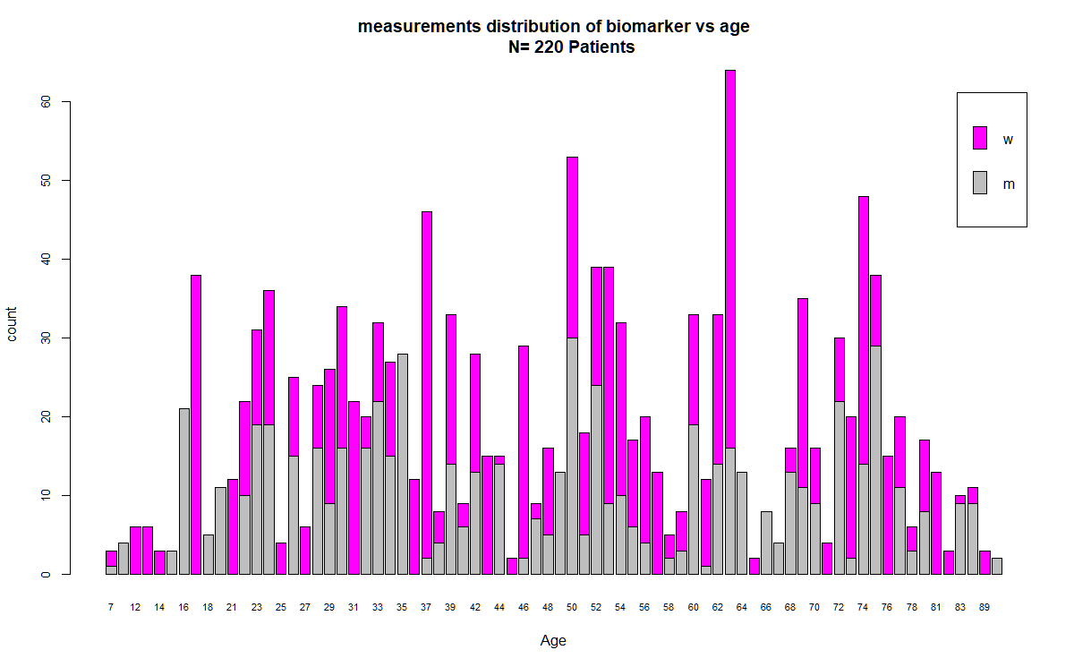

Figure Barplot Age vs total count of measures

### Genes

Genes was recoded as a 5 factors levels. Clinicians insist on the need to possibly maintain SDH VHL and NF1 has own group in the modelling[15] despite the limiting number of data available. In a consensual way it was proposed to split class as Table 3:

Table Counts ID per Gene classes [N=220]

|  |  |  |  |  |
| --- | --- | --- | --- | --- |
| Men | NF1 | SDH | sporadi | VHL |
| 108 | 10 | 11 | 86 | 5 |

The second dataset delivered by mid- December should raised low count.

Figure 5 present you boxplot of biomarkers in respect to genes. Generally speaking, Total metanephrines quote higher than free and each biomarkers class show same behaviour from their mean apart. “Sporadic” then MEN genes show the greatest variability. Some threshold censoring can been noticed in MTL.

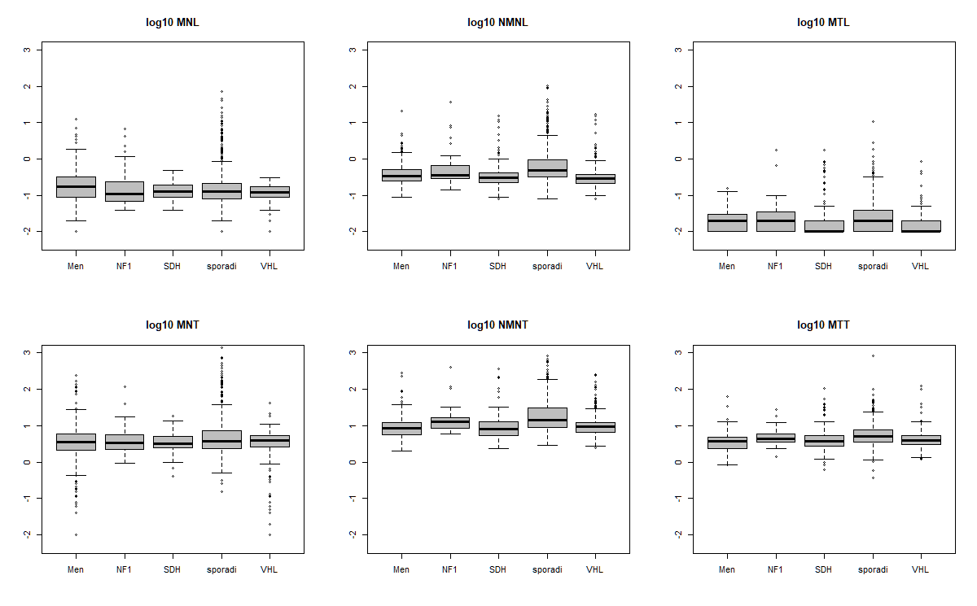

Figure Boxplot of log10 Biomarkers | Genes

Figure 6 present the boxplot of MNL biomarker[16] given gender, controlling for genes. As expected there is no much difference across gender, thus we expect this interaction as non-significant in the model (verified p=0.38). Please take cautious conclusion about NF1 , when interpreting (low sample group).

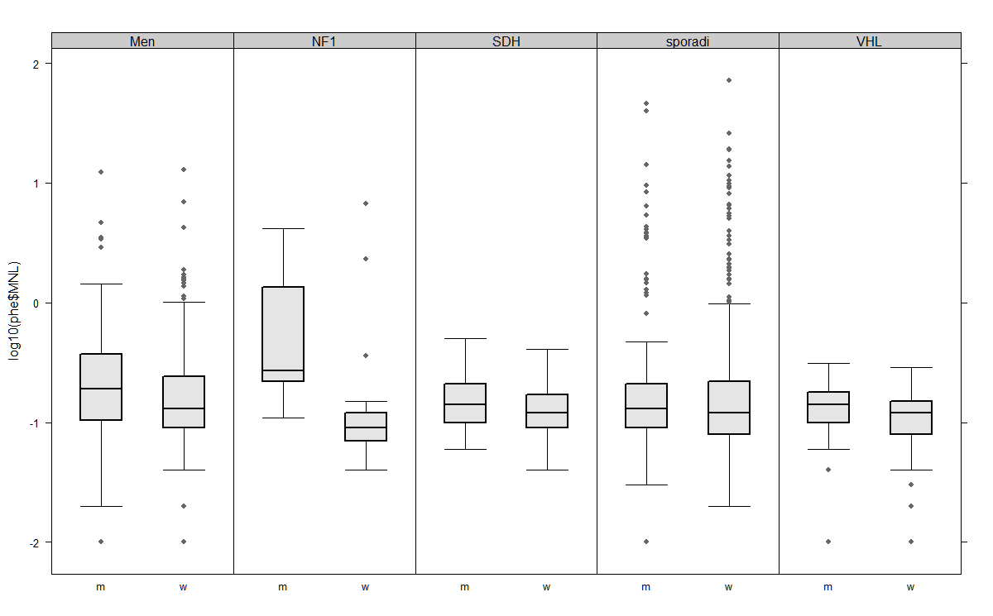

Figure Boxplot log10MNL~Gender | Genes

### Biomarkers

After few simulation, Multivariate analyses in form of Multivariate distributions between outcomes variable was dismissed for a Master. Thesis and GLMM too. The research question was orientated in a simpler univariate model LMM with continuous outcome.

It was decided therefore to model the 6 Biomarkers (Yij, i patient, j measurement ), on an univariate analysis. Only one univariate model will be presented this publication du too voluminous data but are available in R codes.

As biomarkers are positive data’s they show obvious skewness and overdispersion. To handle this issue, it was decided to log transform outcomes to get an acceptable Normal distribution (Figure 7). Although the log transformation did not rigorously correct for Normality[17] (“ uncured residual skewness”), it was found acceptable for two reasons:

* Log10 / Ln have nice Mathematical properties and eased interpretation.
* The common use of log10 / ln amongst pharmacokinetics practicians and laboratory.

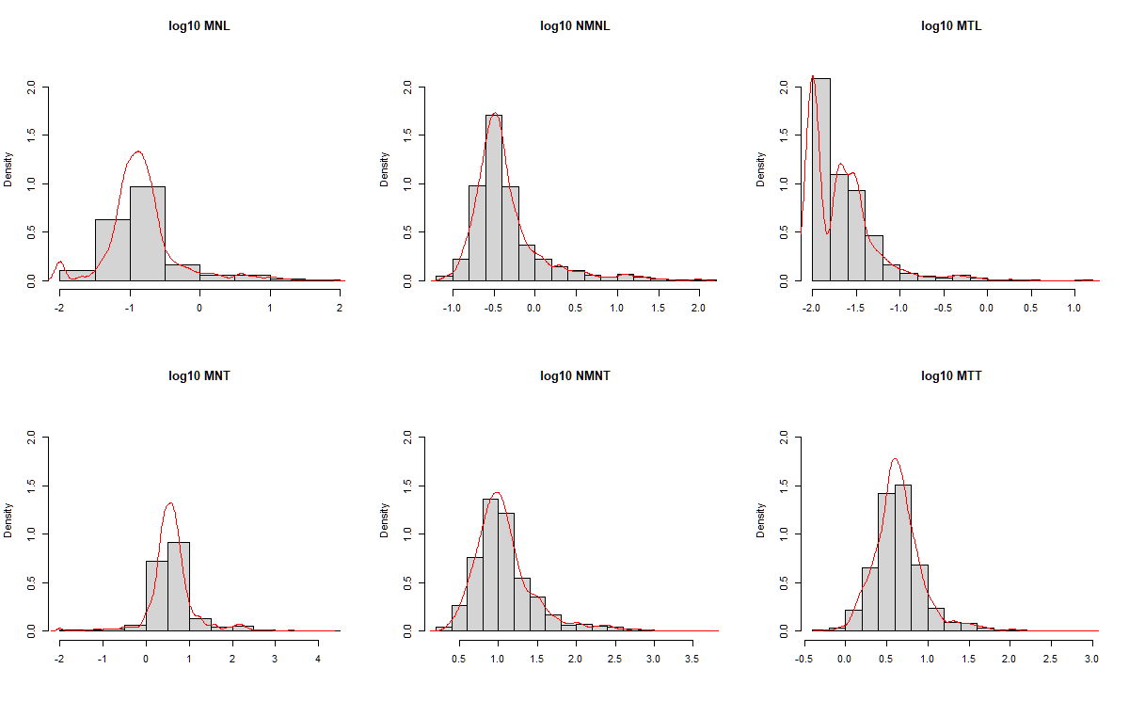

Figure Log10 Biomarkers distributions:

NA by markers:1st row 58/23/27 2nd row 231/201/215 over 1405 lines  
Skewness 1st row: 1.28/ 2.05/ 2.00 2nd row 0.55/ 1.68 / 1.24

Although correlation was not the focus point, we present the Pearson correlation matrix in figure 8. Note that the smoother gives about a linear relationship but some groups divergence is clearly visible in the scatter plot (i.e. log10 MTL-MNL). This can be an hint for Biomarkers ratio modelisation (Grouzmann E., 2010). PCA highlight this fact too (not presented). Even strong correlation occurring some incipient tumour induce only a rise in one of the biomarker but the other wont. This non- concomitant rise is due probably to physiological control of gene /age but need to be demonstrated (Grouzmann pers.comm.).

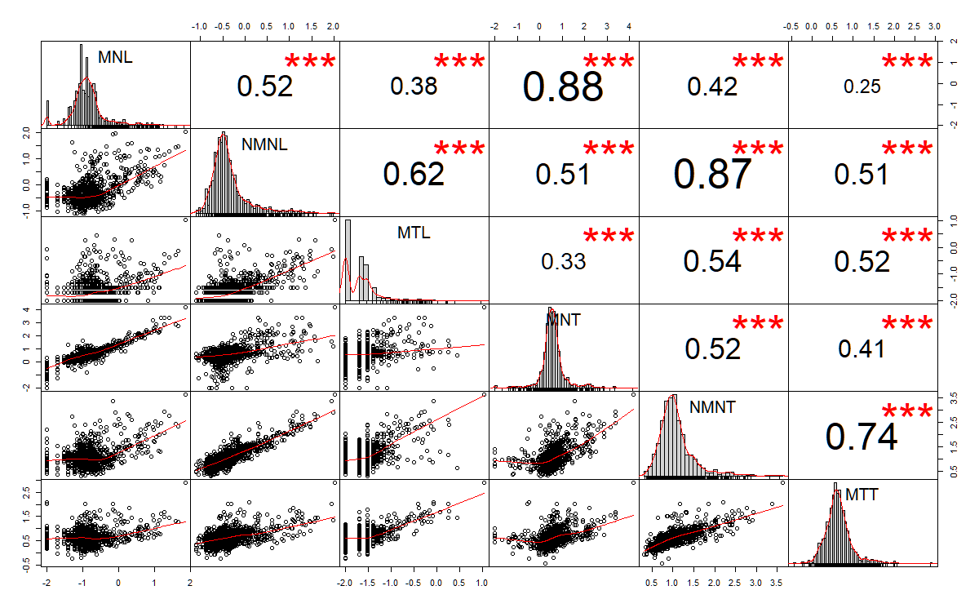

Figure Scatter-Correlation plot : Log 10 value Biomarkers, method “Pearson”

According to (G. Eisenhofer, 2012) and (Sawka AM, 2005) biomarker production increase with age at a mean rate of 1.047 nmol/L / year for NMNL. We found that, our samples lie within worldwide published mean rate (slope of regression line); it is presented in figure 9.

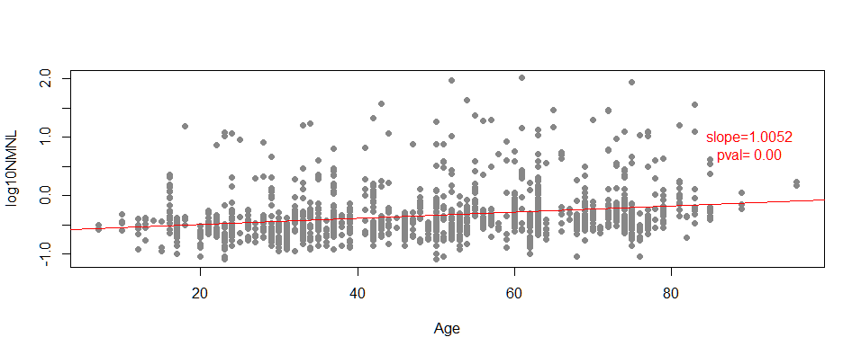

Figure Regression line for log10 NMNL biomarkers vs Age

N=220ID ,1405 points of measures. Note: Slope is given in raw value of NMNL .

### Interactions

We say that Interaction occur when the effect of one variable on the outcome depends on the value of another variable, that is the value of the response variable is modified by the two-way factors interactions. In some case like the Ancova model s.s. the interactions between a factor and a continuous variable is interpreted as the change in slope between the levels of that factor given contrasts matrix is “treatment” (J.Fox, 2002). Increasing interactions numbers[18] between static predictors complexify model interpretations. The easiest way to suspect interaction is to plot a mean response through levels E(Y| Factor levels). Figure 10 present you these interactions knowing that 90o crossing lines is a sign of strong interactions and parallel one none:

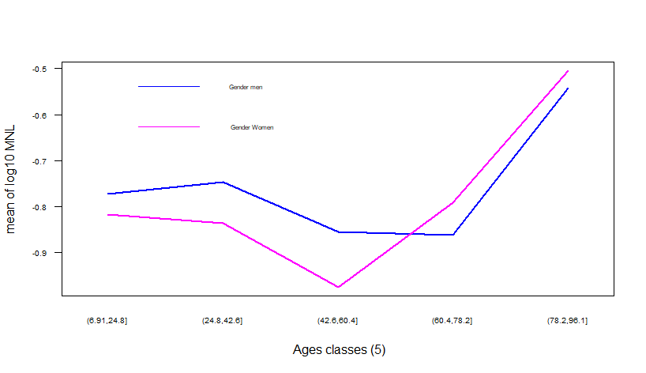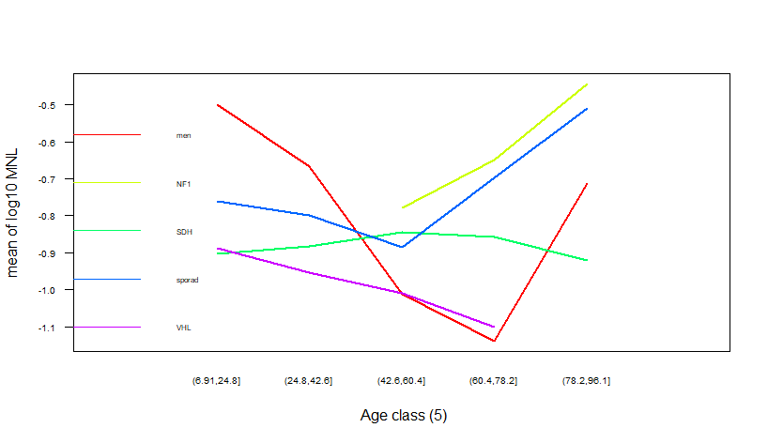

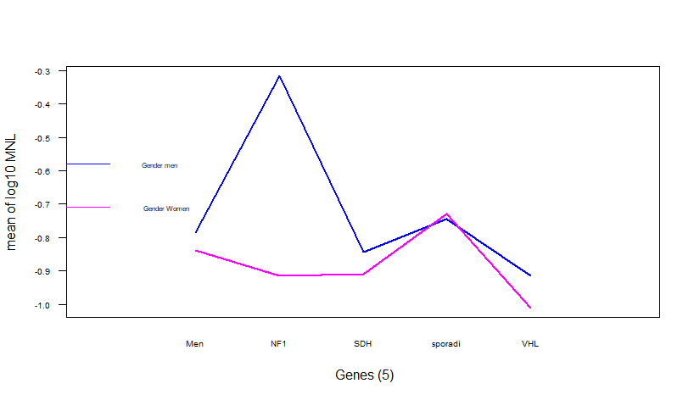

Figure Two-ways factors interactions plot | mean log 10 (MNL)

As suspected in the data processing and from literature review age-gender response for PHEO won’t presents many differences. Note that top figure shows that women possibly increase their value post-menopause. This has not been investigated further. Middle shows that moderate interactions occur between genes and age (model will confirm it’s is significant). Bottom interactions between genes and sex don’t show many differences in their mean (NF1 unreliable as Nwomen=2). Interactions will be reviewed in chapter 3 and marginal principles will apply for their models’ inclusions. (J.Fox, 2002).

### Missing data[19]

Missing data can take different forms and is reviewed by (Little, 2002). To summarize, there is 3 types of missingness:

* Missing Completely At Random (MCAR)

The probability or cause of missingness neither depends on Xis nor on Yij.

Example: Some responses were accidentally deleted.

* Missing At Random (MAR)

The probability or cause of missingness depends on Xis but not on Yij. Example: Some Patients don’t want to be tested for genes categories.

* Non Missing At Random (NMAR)

The probability of missing depends on Y (and possibly on X). Example: Participants get early in surgery due to reaching URL limits.

All the forms of missing data are common in longitudinal data sets due to complexity, size of data collection and task involved; but also the fact that human beings are involved neither infallible nor perfectly compliant with research protocols result in NA values. Moreover this kind of patterns occur naturally in observational studies where we do not have control on subjects to be measured. (Weiss, 2005)

In the present study, the repeated measurements are unequally spaced in time (“lag”) and unbalanced in numbers on J measures (Yij), on I subjects.

Table Missing value for all biomarkers

[based on initial matrix dimension all data 43555 Points where 4899 data].

|  |  |  |  |  |  |  |
| --- | --- | --- | --- | --- | --- | --- |
| **NA** | **Men** | **NF1** | **SDH** | **sporadi** | **VHL** |  |
| **m** | 130 | 3 | 60 | 72 | 54 |  |
| **w** | 138 | 24 | 67 | 133 | 80 |  |

Presented in table 4 the overall outcome missingness is 9% but it is higher for Total metanephrines (16%). This has to be taken into account when interpreting Total outcome but as the sample size is sufficiently large it was not decided to go forward with imputing technique (i.e KNN, Mean). Moreover, with multicentre back-feeding inquiry, some missing value will be available on the 2nd dataset. Very few[20] missing data occur for static predictors (Gender,Genes,Age).

Proceeding with NA omit function will result in a distorted data.frame (list) and is clearly not optimal for data analyse. So we kept the original data with NA values and adjust function for that missingness.

### Censoring

The rate of pathology progression (slope) is not only different from patient to patient but also dynamically changes in time for the same patient. Thus, the true potential of a biomarker in describing disease progression and its association with survival can only be revealed when repeated evaluations of the marker are considered in the analysis. To address research questions involving the association structure between repeated measures and event times, a class of statistical models has been developed known as joint models for longitudinal and time-to-event data. (Rizopoulos, 2012).

In short, to have a valid inferences, estimators must be based on the joint distribution of the measurement (Longitudinal sub-model) and missing processes (survivals sub- model), both jointed with Likelihood factorization from (J.Heckmann, 1976).

Censoring can be viewed as a sub part of NMAR missingness process by patient drop out.

In the present study we are facing to type of censoring:

1. Informative censoring:

In our study a patient who experienced a sharp rise in biomarker (slope) will be prone to reach the URL in a shorter time hence few measurements can be made (Fast Progressors). This result in bias of possible measurement and affect probabilities of early drop-out (due to surgery or other causes). We will report in the data modelling (“joint models”) the theoretical application and explain how possibly it could be applied to our sample.

1. Threshold censoring:

In the present study the lower resolution measurement of ICP-MS in the laboratory for MNL[21] is 0.03 nmol/L; No value lower than this threshold can be given. This gives a truncation of the sample distribution and his known as left censoring s.l. In fact and to summarize one can replace the probability function of a “ thresholded ” measure by the empirical cumulative one. This has been accommodate with the package::JM in R specially design for joint censored distributions. The list of patients belonging to this pattern is given in Appendix 8.5.

# Longitudinal data in Linear Mixed Models

## Introduction

Because the nomenclature of LMM[22] are quite complex and extensive we adopted here for the sake of clarity, the extensions given by (Pinheiro J. C., 2000) (Douglas Bates, 2014) (West, 2003)

Some dataset in medical research present a hierarchical structure or cluster like multicentric trials and special analysis must account for it. Longitudinal data is a special care where they are repeated measure through time on an experimental unit sometimes called a panel study. As biomarker are measured repeatedly over time and for each subjects (= patients), we defined our grouping factor patients themselves according to definition of Mixed Models (Bates D. B., 2014).

As we expect positive correlation between longitudinal data, and closer measurements are presumably more correlated than distant one, this must be modelled in the analysis to properly assess the information in the dataset about the population mean response. (Weiss, 2005). If we erroneously treat observations as independent (OLS) we will over-under-estimate the strength of our conclusions. As suggested by previous research questions, we want to use repeated measures design to answer the questions about variability in biomarker as well as average of biomarkers evolution. The Linear Mixed Moedl allows us to model both of them by accurately depicting the within - subject correlation inherently associated with repeated measures, hence making better inferences and predictions on the means of subjects. Variance’s components (random effects) will be therefore structured and partitioned in a between and within patients’ components and characterized by an Intra-class coefficient. Moreover the problem caused by missing data when fitting a fixed effect model do not arise in LMM, providing the missing pattern is MAR.

With LMM we can predict Yij form the fixed components Xβ and random components Zui and errors terms too eij. The model ca be written as;

Yi j = X+ Zi + eij

[23]Yi N (Xβ, ZDZT + σ2I)

- Y a N x1 vector of response variables scores for subject i at time j.,

-X is a N x q design matrix analogous to linear model, βis aq x1 vector of unknow population parameters. β ‘s are fixed effects parameters for predicting subjects response at population level E(Yi| Xi) = X (referred as ” population or groups level”).

-Z is the random component matrix of random effects. Usually the Z matrix is a sub part of the design matrix X and is blocked-diagonal (allowing *Kroenecker-product*). The Z matrix allows us to define different relationship amongst subjects. The r x1 vectors of unknows ui are random subject-specific effects. Vectors ui[24]are stacked in columns. Finally, the random effects component e is a N x1 vector containing the within-subjects’ random errors.

The distributional assumptions require that:

* Error terms are Normally distributed N (0,σ2 I) andE (e) = 0 as common with linear models. This conditions must be relaxed further as eij follows a N (0, Rσ2) when serial correlation occurred and it certainly does in longitudinal studies (Bates D. B., 2014). That is, residuals ei must be independent but the errors in group (i) are assumed multivariate normal distributed (Fox J., 2015).
* Random effects ui follow a Multivariate Normal distribution MVN (0, D) [25], and with null mean ; although questionable (Douglas Bates, 2014).
* The error must be independent of the random effects.

### A special case Random coefficient models: RI/RIAS (Laird & Ware, 1982)

In RIAS models allows that individuals rate of change (slope) and initial value (Intercept) to vary randomly between patients.

As you see the mixed models are flexible in modelling either covariance structure of the D matrix and the covariance structure of the R matrix (i.e ARMA/AR correlation). Some author model a unique matrix V as a unique random error known as “marginal models”[26] (Zeger, 1988). Both approaches are equivalent although it is not recommended to mix them (West, 2003).

The random effects are not model parameters but random variables and often not of interests because they are specific to subject. But they can be predicted (see. EBLUP).

Co-Variances Matrix of random parts can be easily derived:

**VAR (Yij)** = ZDZT + σ2I = Vi

That is, the covariance function in RI model is given in:

**Cov (Yj ; Yj+1)** = (1) D (1)T + σ2 I= d11 + σ2

This variance function is then constant and the ICC is given by d11 /d11 + σ2 known as a compound symmetry structure (CPS) of the correlation matrix. This kind of structure seldom accommodate longitudinal data (Longford, 1193).TheICC (“within cluster correlation”) is an important indicator of how much variance is partitioned from the within subject correlation into a between component (Everitt B. , 2011). Moreover, if the ICC > 0 this clearly indicate that the grouping factor account for the variability in the outcome.

That is, the covariances function in RIAS model is given in:

**Cov (Yj ; Yj+1)** = (1; tj) D (1; tj+1)T + σ2 = d12(tj + tj+1 ) + d22 (tj tj+1 ) + d11 + σ2

Now the model implies the variance function of the response to be quadratic over time, with positive curvature d22. With squared random effects the variance become a power 4th of time. Correlation matrix structure might take a form close to AR/ARMA model. Semi-variogram are helpful to understand the shape of correlation pattern, replacing ACF in unequal lag time design (Peter Diggle P. J.-Y., 2002) . An example of this covariance matrix is given in appendix 8.

Of course more complex rooted correlation structure would be possibly modelled in a future study with either nested/crossed random effects: As such we might consider adrenal tumour (either side) as a random component nested within each patient (not covered).

In RIAS statistician may model no correlation between random intercept and slope if he believes so. In RIAS the ICC is more tricky to calculate.

With zero expectation the co-variance matrix for the random effects in RIAS is give as:

COV (u0, u1) =

The , if non zeroed, might have a possible physiological significance too. That is, if a negative correlation occur in ui it means that a deflation of variance occur in time and instead of fanout the line measures regress to their mean. As belief, we think that is a key feature of the majority of bio and physiological process acting under normal law.

Clearly, the random effects provide us a model for the correlated observations that characterized longitudinal data (Long, 2012).

## MLE vs RMLE

Likelihood-based methods yield distinct estimating equations for the fixed effects and variance components, with FIXEF estimating equations need the variances parts and conversely. Consequently the overall estimation required an iteration algorithms (IRWLS: Newton-Raphson or the EM algorithm.) to reach final solution. Because MLE is bias downward, two main methods was developed for likelihood estimates; the standard MLE and the restricted (“residuals”) one. Standard GLS maximization procedure can be used to derived non-linear variance component. Because these estimates involved β, an alternative method was addressed. The RLME relies on modifying the MLE via factorization of the likelihood. It involves partitioning the data into two orthogonal components: The errors space and the column space of X. For a deeper formulation see (Harville D.A, 1977).

In summary both likelihood differ in a matrix form by a factor of log (XTV-1X)-1 and the nuisance parameters can be formulated as such (Brown & Prescott, 2006) :

$σ_{MLE =}^{2} \frac{\sum_{i}^{N}{e_{i}^{2}}}{N}$; ${ σ}_{RMLE =}^{2} \frac{\sum_{i}^{N}{e_{i}^{2}}}{N-p-1}$

Finally, fixed effect parameters can be estimated via following formula similar to WLS MLE:

= (∑ XT V-1 X)(-1)T-1

VAR () = (∑ XT V-1 X)-1

When parameters estimate are close to the boundary space (i.e. when variance is close to zero) convergence will not occurs as the matrix is not positive-definite and improper estimates will be reported. A good diagnose for this either when ICC or correlation between random coefficients are close to 1. This can be due either that the model is mis specified, poorly fitted with covariates or they are too few data are available for correct estimations (Couturier, pers.comm.). They are no common healing strategy but (West B., 2007) summarize the possibilities. But it can also happen that the captured variance is null and therefore the need of random effect might be hence excluded.

On summary it is mandatory for unbiased parameters estimates to use a REML estimator. Moreover for model comparison the use of MLE is recommended when the design matrix is changing.

Note that MLE s.l. estimates are invariant in regards of the contrast matrix used. (Rizopoulos, 2012)

## Prediction and EBLUP in mixed models

As the value of the random effects ui are not fixed and act as RV, they should follow a MVN distribution. We rather “predict” these value rather than estimating them. In our study the predictions at the patients levels of these random components is of primary interest for patient trajectories. In this perspective we are not interested to estimate the mean of these set ui because they are a vector of zero under MVN assumption but on the conditional expectations of the random effects, given the observed response value. In the Bayesian framework the EBLUP can be summarized as the following equations (Brown & Prescott, 2006):

**ûi** = E ( ûi | Yi = yi ) = Likelihood (yi | ûi) x ƒ(ûi) = D ZT V-1 (yi- Xβ)

These are the expected values of the random effects associated with the (i) level of a random factor given the observed data. These conditional expectations[27] are known as EBLUP and are known as “posterior mean” estimates. EBLUP are linear as they are a linear function of observed yi . Finally, they are the best unbiased predictions of the random effects based on observed data. It is frequently encountered the term of “corrected” EBLUP and are the predicted value at a zero mean (= at random effect level) and “uncorrected” EBLUP gives the exact predicted value at the patient level, accounting for the fixed group effect (Ranef::nlme function in R).Variance of ui are much more complex and can be found in (Galecki, 2013). As previously stated it is irrelevant to hope for confidence bands around random effects.

### Shrinkage

EBLUP are also known as shrinkage[28] estimators because they tend to be smaller than the estimated effects would be if they were treated as fixed factors. As a result, a patient with too few measures or/and high variance estimate (i.e. curvature) will “shrink” towards his/her group mean; hence, the fixed effect. Information’s is weighted more towards the groups; Therefore, it is said that it is “borrowing the strength” from the group level. That is really the power of this type of model.

### Residuals diagnostics

Usually common techniques applied as in the linear models but we must specially defined two type of residuals:

* The conditional residuals (defined as level 1 res.) are defined as:

ei = yi - X - Z ${\hat{u}}_{i}$

These are not well suited for verifying model assumptions and detecting outliers. These residuals tend to be correlated and their variance might change form sub-group. To resolve this, we can consider scaling these raw residuals by their estimated standard deviation; they become then “Pearson” residuals that can be further externalized, if desired.

For example, if we plot the Pearson residuals and any correlation pattern is still visible, the R matrix can be re-design with a special correlation pattern. (i.e.CorAR). But even more, if the correlation/or variance pattern is dependant of a factor it can also be modelled as such (i.e CorAR | Xi).This can only be done in the ::nlme of R. But it become computably extensive and resulting often in non- convergent estimators. To much control on the structure of residuals would lead in high complexity models. Therefore, parsimony principle is a foreword. For deeper understanding, see (Douglas Bates, 2014).

Finally for a full variance capture check, the semi-variogram must show close to a flat line his.

* The marginals residuals are at groups level are defined as:

ei = yi - X

There are principally used to assess the linearity relationship of covariates and the outcome variable. Of course, we might expect light departure from this , just as the profile plot are not perfectly linear (fig. 12).

In all case it is of good practice to plot residuals against fitted value and observed either variance change or any non linear missed pattern.

### Random effects diagnostics

The natural choice for diagnose is to consider the empirical bayes estimates predictors defined in preceding sections (EBLUP). Check-in Normality of the observed ui is of limiting value because they might not reflect their true distribution (West, 2003). It is of common practice for each random effect to accept even moderate asymmetry normality in histogram but no “rough” bivariate pattern must be tolerated (Bates D. M.). The most useful assessment is to ensure that they are no pattern/trend in random effects plotted against covariates. Note that some theory exists where the normality assumptions of random effects are ruled out but they are not of routine analysis (Yucel & Demitras, 2010).

## Inference testing and model selection.

The inference for the classical LMM, focuses on the fixed-effect parameters β and/or the variance-covariance parameters of the random effects.

In all case it is suitable to use REML for parameters estimates (Bates D. B., 2014)

### Wald (Z test)

For each parameters ${\hat{} }_{j REML}$ an approximation is done by an univariate Normal distribution. In general and derived from the F statistics (partial F), any contrast matrix L a test hypothesis can be constructed as follow:

*H*0 : Lβ = 0 vs *H*a : Lβ ≠ 0

It follows that:

( XT 1) XT) -1 -1

will follow a Chi square distribution with rank(L) degrees of freedom. Dividing by the rank (L) and you end ups with an approximated F-Test.

Although this Linear assumption underestimate the true variability of due to the REML estimation process the need of correction appears evident. Therefore the use of t-distributed test with modified degree of freedom can be an acceptable compromise in case of simple hypotheses. Like Satterhwait correction proposed in GLM, Kenward & Rodger proposed an adaptation of it, based on the data. (Kenward, (1987) ) It is not universally applied, and it is a long debate on their conclusions and usefulness (Pinheiro J. C., 2000).

### Likelihood Ratio Test, LRT

As an alternative to the Wald statistics the use ML-based, LR tests are preferred for their higher reliability and approximation (Bates D. B., 2014).

Suppose we have a statistical model with parameter space θD. The null hypotheses is stated by saying that the parameter θ is in a specified subset θo of θD . The alternative hypotheses is thus that is in the complement of θo.

The LRT test statistics for the null hypotheses H0 : θ ∈ θD is given, with little algebra as:

LRT λ = - 2 ( $l ($ θo) - ( $l (\hat{}$) )

The (-2 ) ensure that the asymptotic behaviour , under the null, of a Chi Square distribution with degree of freedom as the difference in tested parameters.

Obviously, tested parameters and models must be nested within otherwise the test not valid. LRT is useful to evaluate either one parameters significance or either model selection. LRT test in R is implemented in Anova function with “Chisq” as specific distribution.

Note: As data are unbalanced E(SSSQ) cells might differs (orthogonality loss).That is, ANOVA type III is highly recommended for such test, for more see (Fox, 2003)

### Testing Hypotheses About the Variance-Covariance Parameters:

Similarly, LRT and information criteria AIC are used for this purpose. The comments related to the need of the use of the REML based tests apply to the LMMs as well. However, for the latter models, an additional issue needs to be mentioned: When the values of the variance-covariance parameters, compatible with the null hypothesis, do lie at the boundary of the parameter space, such as;

*H*0 : θD = 0 *(D ref. to the D matrix)*

In such situations, the null distribution of the LR test is not a χ2 distribution. In certain cases it is possible to show that the null distribution is a mixture of several χ2 distributions . However the mixture is actually a conservative approximation to the finite-sample distribution of the LR test, which they derive (Geert Verbeke, 2000).

Finally note that, instead of using a χ2 distribution for an LR test, one could use an empirical distribution of the test statistic, obtained by fitting the alternative and null models to multiple bootstrapped datasets simulated under the null model and will be presented in the model (Pinheiro and Bates 2000)

### AIC

AIC is defined as: - 2 ( |y) + 2npar

Strictly speaking, using AIC for model selection is not a formal statistical testing approach, but commonly used by statisticians. As long as AIC is coupled with other test, we found this approach valuable.

### Pseudo R2

In the MuMin:: pseud R2 for GLMM is available and his described in (Nakagawa, 2013).

As recently developed, they are useful for quantifying how much variance is accounted in either the fixed part or the random part of the model.

Note on Fixed-effects:

Very large correlations between fixed effects, however, are indicative of an ill-conditioned model with high unresolved collinearity. (Fox J., 2015)

## Defining Time Predictors and terminology

There are two type of predictors or covariates.

-Dynamic predictors (Time varying, Weiss 2005) are one which change value over time. (Long, 2012). Not all dynamic predictors need to be time (i.e. math score in school). It is important that dynamic predictor not to be redundant with time-meaning predictor.

-Conversely static predictor (Time-fixed, Weiss 2005) don’t change value over time. (Long, 2012).

In our study gene, gender, age are considered as static but time is dynamic. It is of upmost importance to identify them clearly as they convey mainly variability across measures and slope information’s.

### Time varying predictors:

In observational study researcher try to identify bias and possibly control for regression to the mean. As said no baseline values can be included due to the unrandomized design and uncontrolled value at first measurement. Moreover as longitudinal data model deals with a common Time-event analysis, this has to be clearly, uniquely defined for the model (Zero point Time from Weiss 2005).What could be the initial time t0 in our study? Some patient enter thestudy and get measured in emergency then proceed with surgery , some are just familial follow-up. Figure 11 highlight this problematic when “cohort” study entry time is taken as the reference.

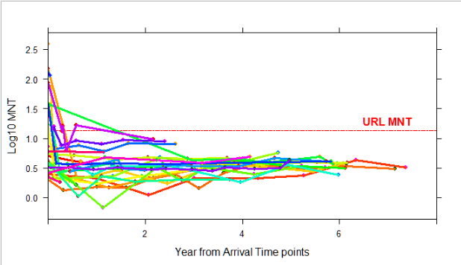

Figure Profile plot (ID trajectories) of 30 random patients | Time of arrival

After some lively debate, it becomes clear that the common event for groups is the first surgery time-event (dichotomous factor). But this has a shortfall too: We have to remove patient without surgery reducing the data patient N=220 to N=114. [ Gender 59 Men / 55 Women with equally numbers on factor measurement]. Setting this null point some data were attributed a negative times called “pre ops” time and other to a “post ops” time with positive value (Dirchlet function coding in R). This has an importance in the model structure and interpretation explain under chap 3. Figure 12 give you a profile plot for one biomarker with this defined time event to= “1st surgery”.

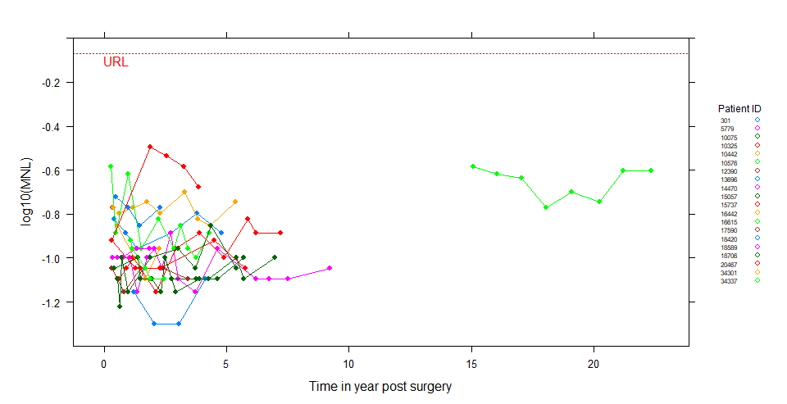

Figure Profile plot[29] or Patient biomarker trajectories

30 Random ID | log10 MNL

-Note: Some patient even having define time event are measured only years after (this is an exception),

-Note: Changing the scale of time won’t change the interpretation of model: i.e. changing from months to years increase coefficient by a linear factor of 12.

-ote: Very Few patient relapse (<10%) a second time for another surgery.

It is not easy by visual inspection to get a feeling about changed in mean nor correlation. To help us in this task we simulate from a Multivariate normal distribution a pre/post test value changing the mean and variance/correlation parameters.Fig.13 present the results:

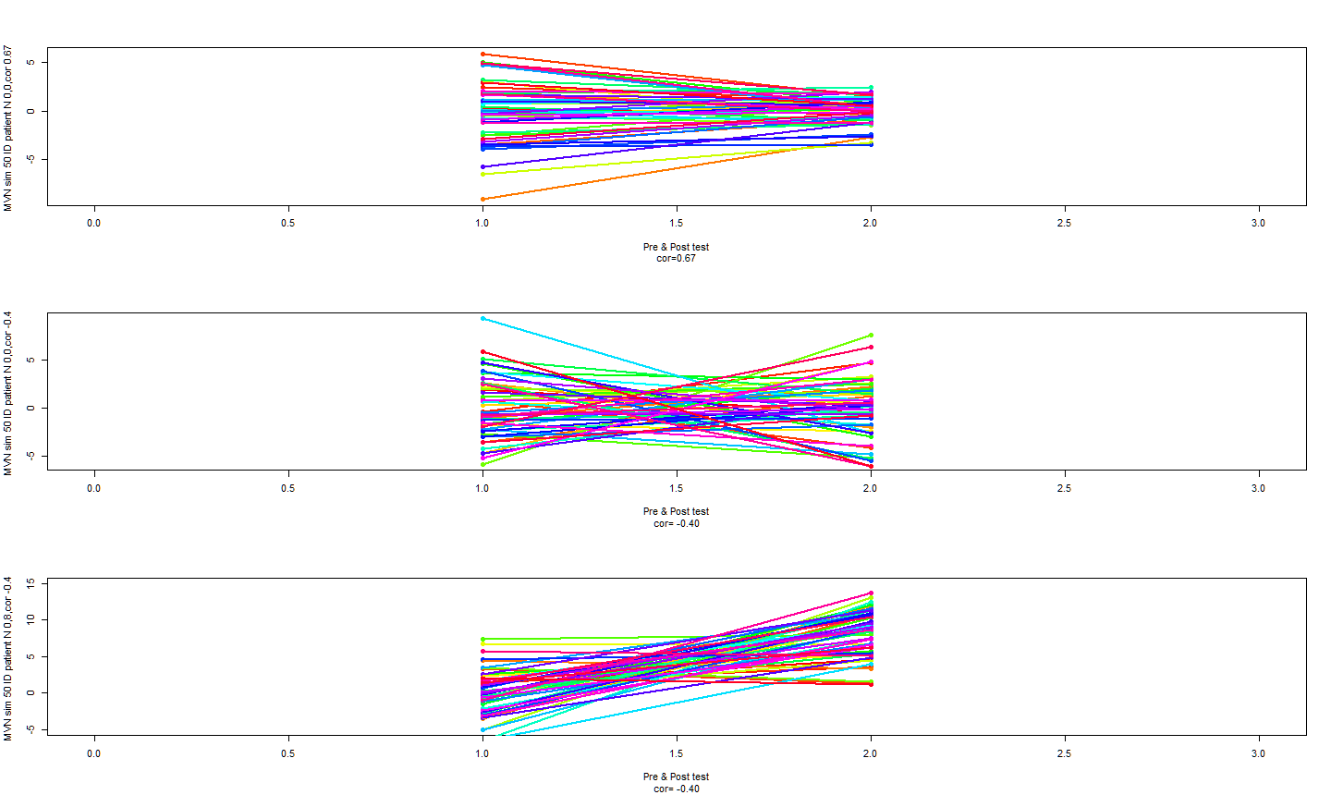

Figure : Simulation of 50 pre and post test value based on MVN distribution:

Top; Means (0,0), cor +0.64, Middle; Means (0,0), cor -0.4 Bottom; Means(0,8) cor -0.4

Therefore based on profile plots and this simulation we might anticipate a model between Top-Middle, with possibly mild correlation but no much change in mean.

## Time model for post-surgery biomarker decay

Another problem arises in the data when biomarker is measured during the first 3 months post-surgery; A surgery induced-shock occurs in adrenals glands with erratic boost/drop of catecholamines production bringing behaviour as a nonlinear pattern. We christened this phase “the landing” phase (Buclin, Mudry). It can be physiologically explained by the catch-up phase of opposite adrenal gland to produced baselevel catecholamines. (Abid pers.comm.)

We try to simulate such kinetics behaviour of biomarkers: A complex function has been found and simulation given in figure 14 try to reproduce this behaviour:

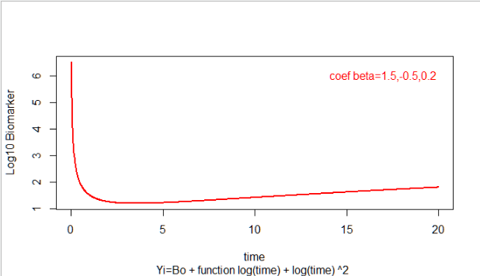

Figure 14 Simulation of Yi: Xt β=function log(time) + [ log(time)]2

Unfortunately, the complexity of this extension into the LMM model was a too high workload but worth to be re-reviewed in future studies. We decide thereof to remove value from time=0 to time < 3 months onwards in the dataset.

Figure 15 presents the behaviour of the log10 MNL during the landing phase. On the left with all value on the right with value [0-3 Months] removed. Note the smoothing effect of removal. The drop will be captured by the random intercepts of patients in the model .

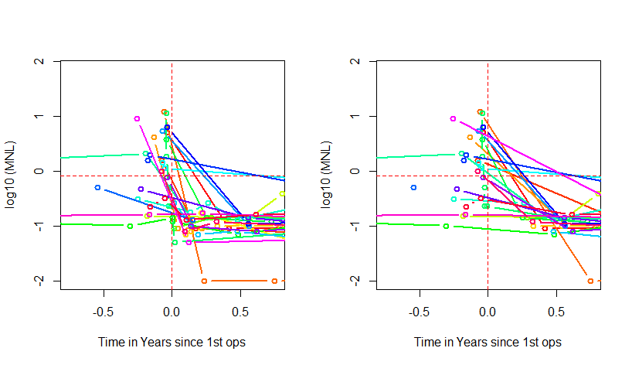

Figure Landing Phase of 30 random patients. Right: Data remove from 0-3 months

We present in figure 16 the OLS estimates of all patients after 3 months post 1st surgery.

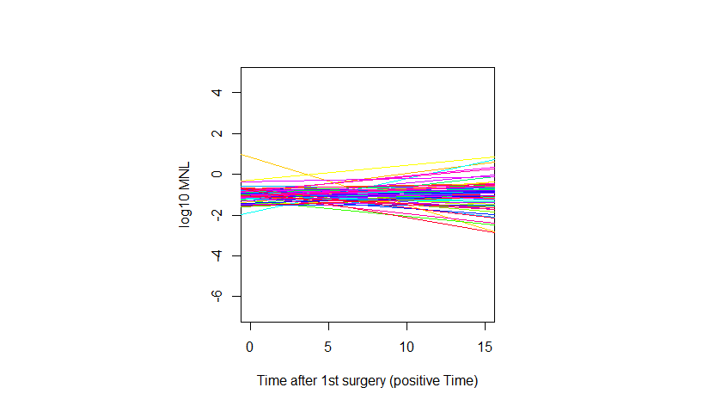

Figure Patient’s trajectories after 3 months post- surgery (1st) based on linear regression

Neg. cor. 0-57

The plot suggest a negative corelation: Although difficult to link with physiology, a patient who start with a low value have a higher slope and conversely (negative correlation). Therefore, it can be synonymous of regression to the mean effect (L.Wassermann, 2004).

# Modelling LMM

## Need of random slopes and intercept

In order to assess the need of RI/RIAS model structure we runed for each ID patients and gene factor a linear regression on log10MNL ~ Time to appreciate the variation in either, intercept or slope for the population (of course no inference can be made due to correlated data). Using sum contrasts on positive time[30], figure 12 shows that non overlapping intervals calls for variability occurring either in Intercept and slope. The difference in confidence intervals is attributed to unbalanced measures[31]. It is advisable to mean-centre the predictors in case of too high correlation in intercept and slope ( > +- 0.80) (Pinheiro J. &., 2001). A negative corelation of -0.39 was found which are usual in physiological data. After centering time predictor correlation was found to be positive (+0.18).

The reader notes that the scale is 10 folds across coefficients as on different scale. The magnitude difference is expected also to occur in the variance estimates. Of course, less overlap occurs in slope but the random coefficient will inform us on his magnitude effect.

According to Bates a factor with more than 6 levels will be adequately fits by a random effect, therefore we will be considered gene as fixed effect.

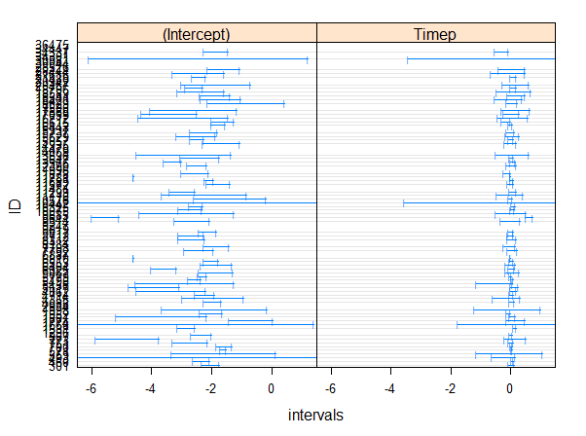

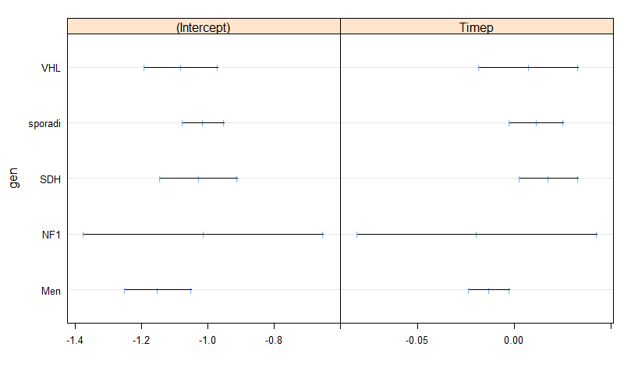

Figure Linear regression on ID (top) and Genes (bottom) using LmList function:: nlme

Patients 1499 has to be removed as outlying observation-

### Linearity assumptions

In order to visualize if a linear relationship is sufficient for modelling we plot individually 10 ID random sample with their respective OLS. Of course, not all panels ID fit perfectly with either tow few points or nonlinear patterns but in general there is a good agreement between a linear relationship and trend between outcome and Time. LMM Shrinkage effect would probably correct for it. We also investigate the GAM[32] smoother and confirm that orthogonal polynomials could accommodate curvature if needed.

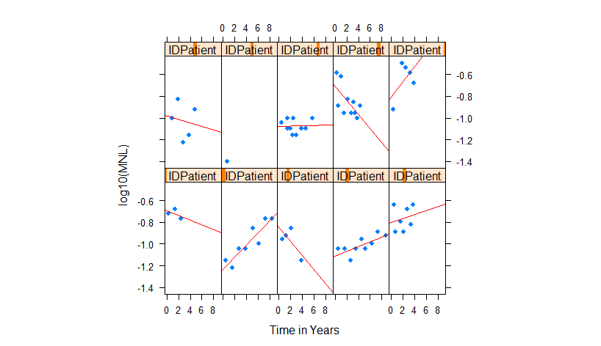

Figure Scatter plot of OLS regression line for 10 random sample ID

### Parametrizations:

In order to compare groups we used “treatment” contrasts[33] matrix for fixed effects. So any interactions of a factor and time tij represents the difference in rate of change (slope) for that group, compared to the reference group (i.e. men for factor gene). To ensure that slope is different from zero in a Wald test, it must be compared to the reference group too.

Proposed models are linear on their parameters meaning that to accommodate curvature some orthogonal polynomials can be fitted. When tij range is large it has been reported that 2nd polynomials might be unsuccessful. (Weiss, 2005). 3rd order polynomial might accommodate growth rate pattern.

As inference is made in the transformed scale (log) the need to back transform the data and calculate SE errors was not needed (Delta-Method).

### MLE vs RMLE

To check efficiency in parameters estimates and ensure that no major bias between MLE and RMLE technique, we runed two basic null[34] model RIAS (lmm0 and lmm0ml) to check the behaviour of these two estimators. Table 5 report the first five patient fixed effect estimates:

Table Comparison at ID levels of a LMM RIAS model fixed effect estimates

|  |  |  |
| --- | --- | --- |
| ID | RMLE Intercept | MLE Intercept |
|  |  |  |
| 301 | 0.1194 | 0.1194 |
| 460 | 0.6732 | 0.6726 |
| 493 | 0.4453 | 0.4452 |
| 559 | -0.3551 | -0.3549 |
| 571 | -0.1384 | -0.1386 |
| 700 | -0.1451 | -0.1452 |

Statistician need to confirm that no major difference occurs in these estimates which is a sign of un-ill conditioning of model. Adding more static predictors will degrade this asymptotic behaviour because the design matrix X is changing therefore REML too, and final model need to be re-checked. That is, MLE must be used for model comparison when design matrix X of fixed effect is changing (Peter Diggle P. J.-Y., 2002).

### Algorithms testing:

R is a freeware and despite the high reliability of the package nlme (> 20 years old) it is of paramount importance to test optimization algorithm (for detailed see (Douglas Bates, 2014) (Pinheiro J. B., 2014). Depending on the starting point the derivatives functions of MLE can be trapped in a local minima[35] and results in convergence issues. For such comparison we choose another popular package for LMM , the lme4::.Based on the preceding simulation we compared in table 6 the coefficients estimates which are very similar.

Table Algorithm’s test for nlme and lme4 packages on Fixed effects | ID

|  |  |  |  |  |
| --- | --- | --- | --- | --- |
|  | **nlme::** |  |  |  |
| ID | Intercept | Time | Time0 | Timep |
| 301 | 0.1194 | 0.0362 | -1.0192 | -0.0289 |
| 460 | 0.6732 | 0.0362 | -1.5805 | -0.0289 |
| 493 | 0.4453 | 0.0362 | -2.4244 | -0.0289 |
| 559 | -0.3551 | 0.0362 | -0.4067 | -0.0289 |
| 571 | -0.1384 | 0.0362 | -0.5307 | -0.0289 |
|  |  |  |  |  |
|  | **lme4::** |  |  |  |
| ID | Intercept | Time | Time0 | Timep |
| 301 | 0.2533 | 0.0973 | -1.1519 | -0.0912 |
| 460 | 0.7018 | 0.1444 | -1.7208 | -0.1194 |
| 493 | -0.1156 | 0.0706 | -0.8303 | -0.1040 |
| 559 | -0.3879 | 0.0280 | -0.3421 | -0.0341 |
| 571 | -0.1144 | 0.0499 | -0.5955 | -0.0350 |
|  |  |  |  |  |

## Case-Control with logistic regression

Before presenting the retained models it might be worth to get more insight on the event which defined initial time set t0: Surgery. As our observational study as a strong bias of selection (recall a lot patient comes in on measurement on paroxysmal event hence surgered few day/weeks after, then included in the follow up) we tried to understand more on this event. Other patient never had surgery and can be viewed as part of a pure cohort study. We assign these patients to a case group although no randomization was performed. We then evaluate OR by the way of logistic regression, try to get any probabilities information according to patients profile (age, genes,gender) and draw some possible interaction on the outcome Y=1/0 Surgery /no surgery from covariates. Nevertheless as we have no control on the experiment the use of logistic regression is of limited use for inference but such analysis don’t assume longitudinal event. We present[36] some of the relevant points of this analysis:

### Parametrization concept:

Sum contrast was not considered as no one know exactly what is the Overall mean Model would be better contrasted with treatment as Gene: MEN Gender Men and age is centered at mean around 48 Years Old.

### The marginal logistic model[37]:

|  |  |  |  |  |
| --- | --- | --- | --- | --- |
| *Logistic : Step R function ( -age)* | | | *Ops~gender* | *+ genes* |
|  | Coefficients: | SE | Z value | Pr(>|z|) |
| (Intercept) | 0.268 | 0.121 | 2.206 | 0.027 |
| Sexiw | -0.521 | 0.133 | -3.908 | 0.000 |
| genNF1 | 1.903 | 0.555 | 3.431 | 0.001 |
| genSDH | -0.224 | 0.172 | -1.302 | 0.193 |
| gensporadi | 3.468 | 0.284 | 12.227 | 0.000 |
| genVHL | 0.057 | 0.160 | 0.358 | 0.720 |

Age is not significative, hence removed but could be easily explain by the fact that Gene have the greatest strength for controlling patient surgery (MEN gene ar younger and familial follow-up, sporadic patient go on surgery easily after 60 years). For Women the odds is 41% less that odds for men. Although not well understood we can assume that:

* Women are far more monitored in this pathology (Grouzamnn pers. comm.),
* Women might possibly be protected by oestrogen systems up to the age of 60 (?).

### Age as a factor classes

To investigate deeper into the relation of age and surgery (in our study group!) we decide to transform age form a continuous predictor as a 5 levels factors. We run a simple univariate logistic regression and check for non-constant OR in the age classes.As parametrization the younger level is taken as reference. Result is presented in the table in logit scale:

|  |  |  |  |  |  |
| --- | --- | --- | --- | --- | --- |
|  | | Coefficients | SE | z value | Pr (>|z|) |
| (Intercept) |  | -0.693 | 0.433 | -1.601 | 0.109 |
| agecut(24.8 | 42.6] | 0.773 | 0.517 | 1.495 | 0.135 |
| agecut(42.6 | 60.4] | 1.358 | 0.521 | 2.606 | 0.009 |
| agecut(60.4 | 78.2] | 1.792 | 0.539 | 3.327 | 0.001 |
| agecut(78.2 | 96.1] | 1.792 | 0.924 | 1.939 | 0.053 |

Then it show at the 5% level of significance that the majority of patient who will probably go on surgery range from 42 to78. But also it is envisioned that surgery will occurs also past this age for life saving despite the risk.

### Intercations:

After searching for and removing outliers, an all interactions model provides multi-colinearity problems[38] and df use-up we decided to apply the technique reported in (Hilbe, 2009): When running two marginal model coefficients won’t change much if another covariates is added to the model ,meaning no interaction or these covariate. If it does any interaction might be expected.

Gender-Genes : Possibly, as coefficients (logit) are changing (-0.30 to -0.59 Women).But we choose not included them in the prime model as it used up 10 df.

|  |  |  |
| --- | --- | --- |
| *Logistic regression:* | | *ops~gender* |
|  | 2.50% | 97.50% |
| (Intercept) | 0.168 | 1.091 |
| Sexiw | -0.903 | 0.297 |
|  |  |  |
| *Logistic regression: ops ~ gender+gene* | | |
|  | 2.50% | 97.50% |
| (Intercept) | -0.712 | 0.641 |
| Sexiw | -1.288 | 0.082 |
| geneNF1 | -0.709 | 3.098 |
| geneSDH | -0.577 | 1.288 |
| genesporadi | 1.871 | 4.098 |
| geneVHL | -0.796 | 0.931 |

For the other interactions we proceed with such methodology avoiding binary and multi-levels interactions (Hilbe, 2009). As result, we discover that a possible mild-interaction between the gene and age exist but easily explained as sporadic patients are non- follow-up patients and typically are related to a late age pathology (Abid pers.comm.). MEN gene as the opposite behaviour.

### Conclusions on outcome surgery

As the experiment was not controlled (1) and no common longitudinal event between these groups can be found (2), and logistic regression coefficients are unstable (3), such case control comparison will lead possibly to biased conclusions and flaws in models: We therefore decided to remove from our models the 73 ID patients without surgery (follows-up).

## Model structure 1 : Post Surgery models

Here it was decided to simplify model and get parameters estimates based on a common event to use only data of post 3 months 1st surgery. (73 measurements of landing phase removed)-

Table present the 89 ID patient by gene group:

Table samples post surgery

|  |  |
| --- | --- |
| Gene | N |
| MEN | 18 |
| NF1 | 2 |
| SDH | 8 |
| Sporaidc | 49 |
| VHL | 12 |

Running simple linear regression by ID a correlation between time and slope is 0.57 (R code ligne 62 md2 df,codemd1NMLR script).(if centred man cor. -037).Fig in chapter present you visually this correlation

Two patient (ID=1499 & ID 9644) present abnormal normal variance behaviour (plot annexe ..) and mean’s groups have changed: MEN has the lowest mean post- surgery, SDH the highest (plot design Annexe…).

Note: No t-test has been mage on the mean changes.

Again we can note a RTM behaviour : Some patient get away from the mean trend some lowered. There is at least no major effect on the population and we might assume that pattern occur under Normal law processes.

To get consistent with proceeding model syntax, we present you some of the retained step and final models[39]:

Table present you the need of a random slope models in an empty model by a LR Test :

|  |  |  |  |  |  |  |  |
| --- | --- | --- | --- | --- | --- | --- | --- |
| Log10MNL names | model | df | AIC | Loglik | Test | LRT | p-value |
| mix00RI | 1 | 3 | -391.5 | 198.75 |  |  |  |
| mix00RIAS | 2 | 5 | -437.15 | 22357 | 1 vs 2 | 49.65 | <0.0001 |

Note that in RI empty model the ICC is reported as 0.82 which indicate still a great variability post-surgery (Intercept). Correlation in RIAS between random slope/intercept is -0.36. However, this test is subject to the limitation of parameters space a correction would be needed for accounting it. As stated by (Geert Verbeke, 2000) the non-corrected p.value is more stringent hence conservative.

Table present you that polynomial order 2 in a RIAS empty model is not needed:

|  |  |  |  |  |  |  |  |
| --- | --- | --- | --- | --- | --- | --- | --- |
| Log10MNL names | model | df | AIC | Loglik | Test | LRT | p-value |
| mix00RIAS | 1 | 5 | -437.15 | 223.57 |  |  |  |
| mix00RIASsq | 2 | 10 | -416.9 | 218.45 | 1 vs 2 | 10.25 | 0.0685 |

Note that given the Nedler principle the polynomial term should be included in the random effect. But in this case if the 2nd polynomial is significant it should be included whatever is the 1st order polynomial (Harrell, 2001).Here the term is significant (p=0.04) but AIC /BIC are contradictory in model selection.We decided for simplicity not to account for a second degree polynomial.

The need of uncorrelated ui in this model has no justification and therefore not tested.

The test as gene as a random factor, nested within patient is unconclusive and not retained because the complexity of interpretation.

Summary of coefficient are given in Appendix 8.4.2 pre-model test.

In proceeding as such (step selection) the final model retained:

To be sure of our model’s interpretation, contrasts change have been tested[40] to get a better grasp on coefficients relationship (relevel “sporadic”). It can be shown that for a log10MNL outcome.

In forehand of interpretation, we recall the reader that:

* The overall effect of a factor should be assessed with Anova function.
* The interpretation of parameters for a Fixef depends on the contrast used.
* There is no major difference in MLE/REML estimates for all model tested (<1% all fixef).

|  |  |  |  |  |  |  |
| --- | --- | --- | --- | --- | --- | --- |
|  | | | | | | |
| **Fixed Effects** | Value | Std.Error | DF | t-value | p-value | |
|  | | | | | | |
| (Intercept) | -0.114 | 0.209 | 413 | -0.547 | 0.585 | |
| Timep | 0.010 | 0.004 | 413 | 2.338 | 0.020 | |
| genNF1 | -1.869 | 1.090 | 79 | -1.715 | 0.090 | |
| genSDH | -1.212 | 0.395 | 79 | -3.064 | 0.003 | |
| gensporadi | -1.046 | 0.267 | 79 | -3.917 | 0.0002 | |
| genVHL | -1.193 | 0.320 | 79 | -3.725 | 0.0004 | |
| age | -0.022 | 0.005 | 79 | -4.852 | 0.00001 | |
| genNF1:age | 0.039 | 0.021 | 79 | 1.830 | 0.071 | |
| genSDH:age | 0.033 | 0.010 | 79 | 3.294 | 0.001 | |
| gensporadi:age | 0.024 | 0.005 | 79 | 4.620 | 0.00001 | |
| genVHL:age | 0.029 | 0.009 | 79 | 3.166 | 0.002 | |
|  |  |  |  |  |  | |
| **Random Effects** |  |  |  |  |  | |
| Intercept | 0.280 | Cor |  |  |  | |
| Timep | 0.025 | -0.60 |  |  |  | |
| Residuals | 0.109 |  |  |  |  | |
|  | | | | | |

Table Anova type III : Log10 MNL ~ .

|  |  |  |  |  |
| --- | --- | --- | --- | --- |
| ANOVA III[41] finalmod | numDF | denDF | F-value | p-value |
| (Intercept) | 1 | 413 | 27.9 | 0.001 |
| Timep | 1 | 413 | 5.92 | 0.02 |
| gen | 4 | 79 | 6.20 | 0.0001 |
| age | 1 | 79 | 0.39 | 0.53 |
| gen:age | 4 | 79 | 7.38 | 0.0001 |

Confint are give in Appendix 8.

Gender doesn’t account for difference post surgery.

Reference group is sporadic and noting can be deduced from it. But MEN has a higher intercept coefficient compare to all other groups with a value= -1.16 + 1.046 and his significant. The design plot don’t acknowledge this interpretation: However what can be said about MEN is they are the group most susceptible of drop ou (see censoring 3.2.). What is confirmed is that the experienced a high intercept but with time (age) their log10MNL value on average is decreasing. Effect plot (Fox, 2003) in Appendix 8 support this interpretation.

Time is significant as well meaning a natural increase of log10 MNL with ongoing time.

Age is not significant (for sporadic) but in overall Anova table it is ( Df corrected)

Age (static predictors) is significant and seems not to be colinear with Time (dynamic predictor) and their correlation is reported as -0.10. However we had indices that age: Gene might have a light interaction which is confirmed in Anova table. We proposed to keep interactions age:gene and interpret them as a slope for each gene category like an ANCOVA models (Rutherford, 2001) ; age in FIXEF correspond to the reference group MEN which as a negative coefficient of -0.022 (decrease in age).

Definitely effects plots (Fox, 2003) are of considerable help in these interpretations.

### Random effects

Confidence Interval are given below:

|  |  |  |  |
| --- | --- | --- | --- |
| **Random Effects** | lower | est. | upper |
| sd Intercept | 0.231 | 0.28 | 0.35 |
| sd slope | 0.018 | 0.025 | 0.03 |
| cor | -0.81 | -0.6 | -0.27 |

Regarding the random effect we can see that there is no major variability in the slope Timep, therefore the fixed coefficient can be trusted as very precise estimated. The variability comes from mainly the individuals’ intercepts (ICC 0.45).

As one can noticed there is a lot of residuals variance (~1/3) not explained by the model.

Plotting the random effect conditionally on gene show that MEN show the greater variability in the intercept (captured by the model) ,the VHL and sporadic. This had important implication if personal patient follow-up for relapse. Given slope (Time), MEN still show greater variability in their ui1 in (+/-) range.

Plotting the random effect conditionally on age classes (5) the greatest variability in intercept and slope is given in the range from 7 to 43 Years. Elderly people show a variability in the drop of biomarker post-surgery but are prone to pronounced variability in their slope (higher than population level). This should be accounted in the patient monitoring.

Note adding some fixed effects slightly decrease the random part.

### Residuals analysis

Plot for residuals “Pearson” are given in Appendix 8 under. They don’t show major linear trend , few abnormal value >2 .However the semi-variogram capture some residuals correlation at a range of 2.8 Years. This might has a bio physical explanation or the expression of a latent variable. We wont correct for such variation in the final model but a correlation of AR1 type has been tested on the Ri Matrix and found significant [LRT 8.172; p.value =0.0043; AIC=-456.359].

Outliers observations:

Out of boxplot we found ID = [967,1499,1807,1952,4862.8712,9644,11572,14935] have abnormal residuals.

What is striking that outliers doesn’t correspond to those of patients operated more than one (censoring). For the latter random effect had capture the variation.

A robust estimator (Hubbert weighted { 1 ; c/dj } from robustlmm::) has been tested. No major deviation from model parameters are of concern,

### Predictions

Prediction for the 89 ID patients are given in Appendix .

There are preidctions at the population level (groups or fixef level) and the EBLUP predictions (at ID levels of grouping factor).

We choose 4 plot to highlight the performance and the behaviour of Mixed effects models:

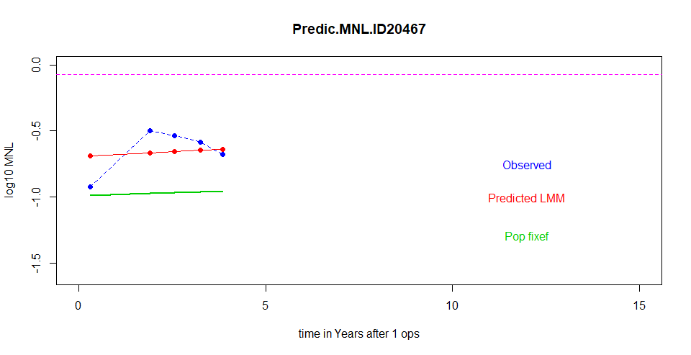**ID:20467** Presents a Shrinkage effect towards the population level (Fixef) as the linear estimates has a high variance (ui)

**ID 9644** presents a little shrinkage effect towards population: The variance is moderate, that is enough point are available for a precise estimate of parameters.

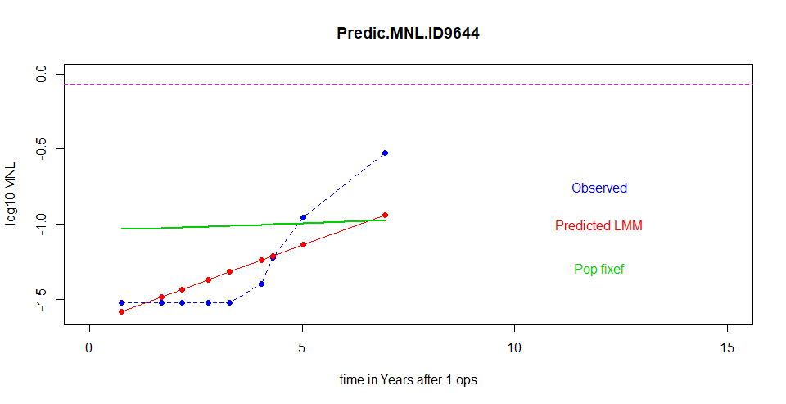

**ID 20942** present a high shrinkage because only two measures are available.

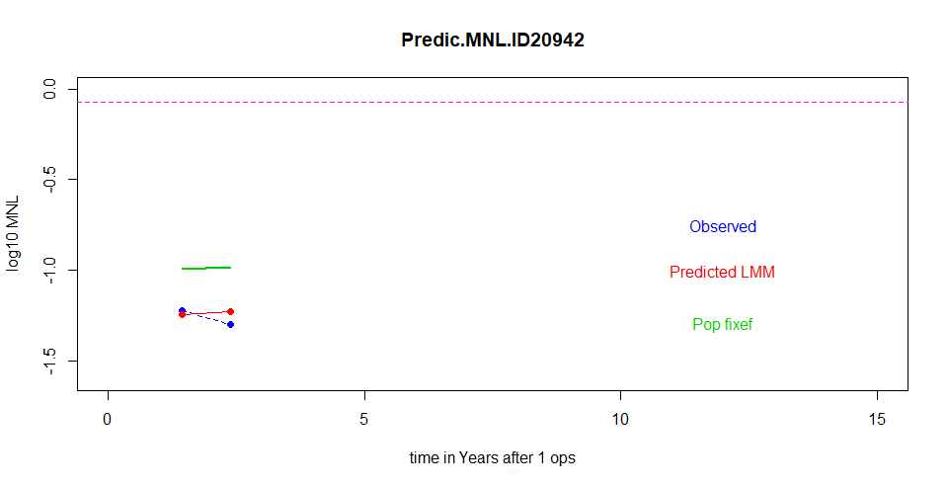

**ID 21480** present no shrinkage , low variance (ui) and precise estimate.

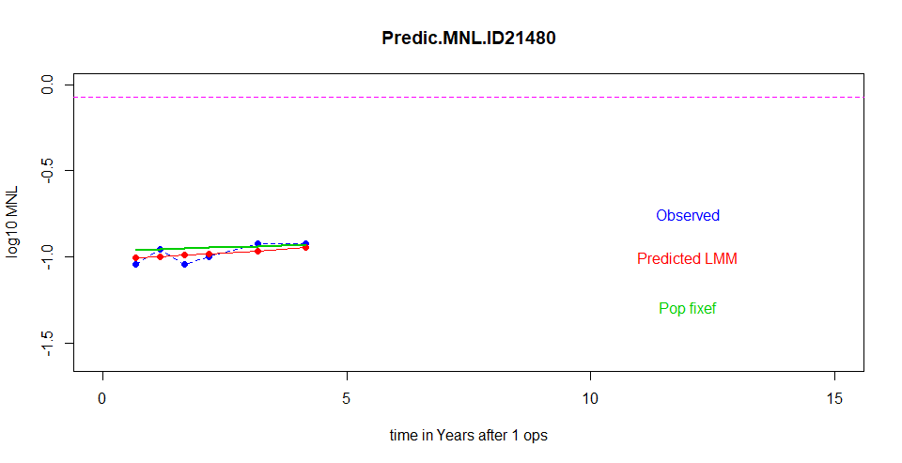

In summary patients with high random effect (hight positive values), few points and high intercept must be major concern a close follow-up.

### Censoring

Of course and again informative censoring still occurs (drop-out) as some of these patients will go on a second surgery. The table gives you the ID of more than 1 surgery:

Table Surgeries ID

|  |  |  |
| --- | --- | --- |
| ID | Nbrs surgeries | Gene |
| 773 | 2 | MEN |
| 1668 | 2 | MEN |
| 1998 | 4 | SDH-B |
| 5456 | 2 | MEN |
| 11781 | 2 | MEN |

Strikingly MEN are prone to relapse, but to few samples enable robust conclusions.

The drop out represent about 6% of the data (post surgery). Censored model was not run due to the heavy demanding task and time available. However we presumably that bias could be neglected/or has a low impact in the coefficient and their SE in the present study.

Threshold censoring occurs in 32 out of 503 measurements in MNL Biomarker: Given that left censoring occur only in MNL biomarker ,We decided to run the censored model on a simple form of predictors: Time. As the process is of memory consuming, we report on table coefficients and SE. Based on model comparison we can assumed that the bias induced by few values is neglectable in this study.

Table Censored models and bias coefficient comparison

|  |  |  |  |
| --- | --- | --- | --- |
|  |  |  |  |
| Model: Log10 MNL ~Time +(Time|ID)[42] | Fixef Coefficient | SE | P value |
| MLE |  |  |  |
| Censoring lmec:: | -1.0501 | 0.008 | p=0.31 |
| Censoring with Time center lmec:: | -1.0482 | 0.008 | p=0.30 |
| Linear Mixed Models nlme:: | -1.0635 | 0.007 | p=0.16 |

## Model structure 2 : An Overall model (revised[43])

We decided to present you the model process for the outcome MNL Biomarker only.

### Model structure[44]

Having lost information by removing follows-up patient we tried to find a clever way to keep as much information’s from the data into the model. The following sketch presents you this model:

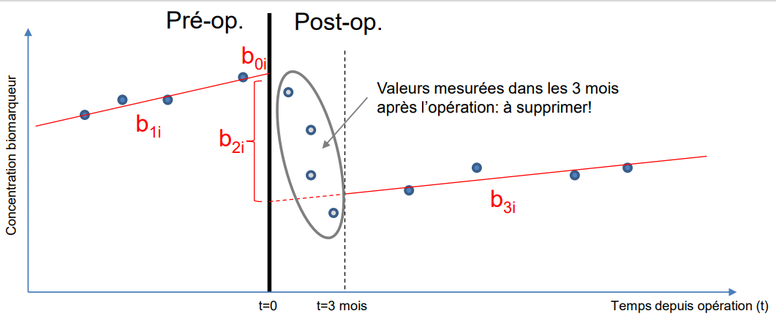

Model can be written in the following form:

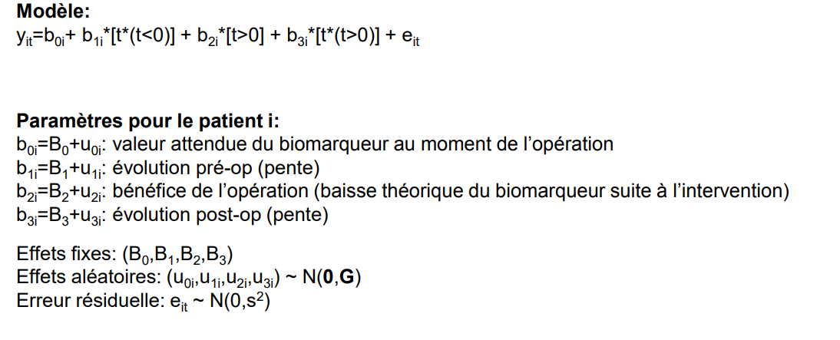

In fact, what is genius with this model that is:

* It has two intercepts (left and right), and slopes (left and right) ,this done by coding a as “piecewise” linear regression. That is, each patient can accommodate his own intercept by a random component uoi and b2i can be interpreted has the drop of the biomarkers after surgery and therefore can be used pre- surgery profiling. Of course the landing phase period as been removed (Chap.2.3.2).
* It will use all information form the data (positive time but also negative time 153 data points,73 ID).

Figure presents you the distribution of the biomarker MNL pre and post-surgery:

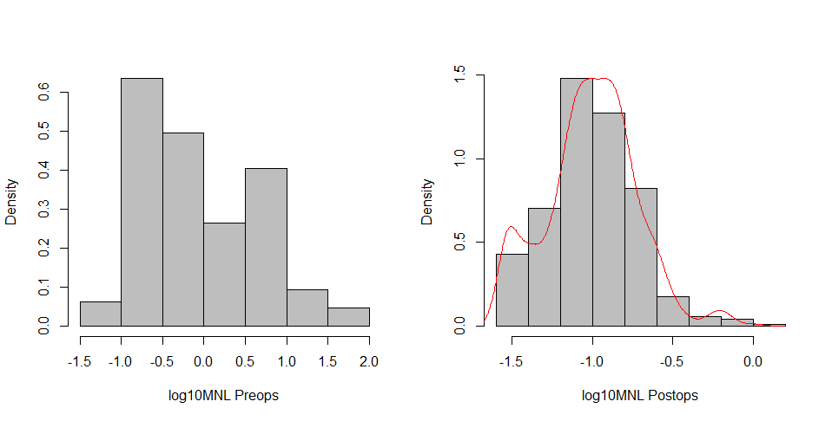

Based on design plot in appendix we can assume that: MEN gene mean value post surgery decrease over Time. As opposite sporadic gene patient tend to increase their mean value over time SDH show a moderate rise, and VHL a slope.

### Results

We wont present result of residuals, random effect plot diagnostic (but no major concern in their pattern) but prediction for each ID patient can be found in Appendicx.

We give you as an exemple of plot of prediction;

Censoring:

Drop out and threshold censoring as not been evaluated in this model due to high complexity to implement and time available.

# Discussion

What is determinant in patient evolution it is his/her age and gene characterization that drive trajectory:recall with negative correlation in intercept/slope the lower the intercept the highr the slope.Therefor and a prior young patient with low value are particularly of great concern in follow-up.(high variability in age, random effect and gen:age categories.)

Correct inference in LMM is a long debate and nothing is clear cut.

What conclusions is valid for one biomarker might be different form the others are their kinematics and bio-physiology seems to response to different end purpose.

The evaluation of the relation ship between begin/malgin tumour and the size of tumour might improved the knowledge and the power of the model.

Suffering that no baseline definition was estimable clearly decrease the control on bias of selection.

There is still of random variability not captured by the model.

According to 3.4 MEN patient must be follow in a shorter time post 1st because:

* They are more prone to relapse
* According to model (neg.coefficient age: MEN) their value decrease on a long term profile conversely to the general time coefficient that increase the value of biomarker with age/time.

Foundings different conclusions from different Biomarker classes probably repsent different kinetaic and biophysiological property of these ones.

Residuals

Outlier

We shall follow the common practice of labelling points as outliers in small to moderate size data sets if the standardized residual for the point falls outside the interval from -2 to 2 . In very large data sets, we shall change this rule to -4 to 4 . (Otherwise, many points will be flagged as potential outliers.) (Peter Diggle P. J.-Y., 2002)

One interesting points in this model is that in all cases tested the relationship of intercept and slope of RANEF stay negatively correlated (so that fixed effect).One conclusion that each patient will tend in time to “regress to his mean”-like instead of “getting” out of the trend

# Bibliographie

Namdar M, Koepfli P, Grathwohl R, Siegrist P.T,. (2006). Caffeine decreases excercices-induced myocardial flow reserve. *Journal of American college of cardiology*, 405-410.

A van Berkel, L. &. (2014). Biochemical diagnosis of phaeochromocytoma Paraganglioma:DIAGNOSIS OF ENDOCRINE DISEASE. *European Journal of Endocrinology*, Vol 170.

A.Meyer. (2009). Dépistage du phéochromocytome,. *Revue medical suisse RMS*, 5-15.

Andrinopoulos R.E, R. D. (2015). An Introduction to Mixed Models and Joint Modeling: Analysis of Valve Function Over Time. *Annales of Thoracic Surgery*.

Bates, D. B. ( 2014). *fitting linear mixed effects models using lme 4 arxiv.*

Bates, D. M. (s.d.). *lme4: Linear mixed-effects models.* R package version 1.1-7.

Berkel, V. (2014). Biochemical diagnosis of phaeochromocytoma. *Journal of endocrinolyE*, 170.

Besag, J. a. ( (1993) ). Spatial statistics and Bayesian computation. *J. R. Statist. Soc. B,*.

Blogger, R. (2015/8). https://www.r-bloggers.com/2015/08/analysing-longitudinal-data-multilevel-growth-models-i/. *www.r-bloggesr.com*. Récupéré sur https://www.r-bloggers.com/2015/08/analysing-longitudinal-data-multilevel-growth-models-i/

Brown, H., & Prescott, D. (2006). *Applied Mixed Models in Medicine* (éd. 2nd). New-York: Wiley and Son.

Cowpertwait, P. (2008). *Introduction Time Series with R.* Springer Verlag series.

Dahia, P.-L. (2013). *Endocrine Tumor Syndromes and Their Genetics.* Stratakis CA.

Deepayan. (2008). *Lattice:Multivariate Data vissualization with R.* NYC: Springer.

Douglas Bates, M. M. (2014). Fitting Linear Mixed-Effects Models Using lme4. *Journal of statistics software*.

Dunn, K. (1996). Randomized Quantile Residuals. Australia conference for applied statistics.

Everitt, B. (2011). *An Introduction to Applied Multivariate Analysis with R.* Springer Verlag.

Everitt, B. S. (2010). *A handobook of Statistica Analyiss using R .* CRX Press Chapmann Hall.

Faraway, J. ( 2005). *Extending the Linear Model with R: Generalized Linear, Mixed Effects and Nonparametric Regression Models.*

Fox J., W. S. (2015). *Mixed-Effects Models in R:An Appendix to An R Companion to Applied Regression, Second Edition.* Web pdf.

Fox, J. (2003). Effect Displays in R for Generalised Linear Models. *Journal of Statistical Software, 8*(15).

G. Eisenhofer, P. L. (2012). Reference intervals for plasma free metanephrines with an age adjustment for normetanephrine for optimized laboratory testing of phaeochromocytoma. *Ann.linics of Biochemistry*, 62-69. doi:10.1258/acb.2012.012066

Galecki, A. &. (2013). *Linear Mixed-Effects Models Using R: A Step-by-Step Approach.*

Geert Verbeke, G. M. (2000). *Linear Mixed Models for Longitudinal Data.* Springer-Verlag New York.

Grouzmann E., D.-T. L. (2010). Diagnostic accuracy of free and total metanephrines in plasma and fractionated metanephrines in urine of patients with Pheochromocytoma. *European Journal of Endocrinology 162*, 951–960.

Harrell, F. (2001). *Regression modeling strategies.* Springer, Berlin.

Harville D.A. (1977). Maximum likelihood approachs to variance component estimation and to related problems. *American Journal of Statistics*.

Hilbe, J. (2009). *Logistic Regression Models.* Chapmann Hall CRC.

Holzhausen, J. (1999). Textprobleme in den phoinizierinnen des Euripides. *Hermes, 127*(4), 410-421. Consulté le 10 17, 2020, sur http://cat.inist.fr/?amodele=affichen&cpsidt=1542161

J., S. (1981). *Prevalence of clinically unsuspected phaeochromocytoma. In Mayo Clin Proc*.

J.Fox. (2002). *An R and S-PLUS companion to applied regression .* . Sage , California .

J.Heckmann. (1976). *The Common Structure of Statistical Models of Truncation, Sample Selection and Limited Dependent Variables and a Simple Estimator for Such Models.* Annals of Economic and Social Measurement, 5, 475-492.

J.K., U. (2012). *Repeated measures, part 2, advanced Method: A different view on the random effects approach.* eNote 12.

Jaccard, J. (2003). *Interactions in Multiple linear regression.* SAGE London.

Jacques W.M. Lenders, G. E. (2004). *Normetanephrine and Metanephrine.* Encyclopedia of Endocrine Diseases, 2004.

Kamala, L. (2009). *Modern Regression Techniques Using R A Practical Guide.* Sage Publications UK.

Kenward, M. G. ((1987) ). A method for comparing profiles of repeated measurements. . *Appl. Statist.,36*.

Kudva YC, S. A. ( 2003). Laboratory Diagnosis of adrenal pheochromocytoma: The Mayo Clinic study. *J Clin Endocrinol Metab*, Vol ;88.

L.Bammater. (2016). *Monitoring metanephrines to follow-up patients with predisposition to pheochromocytoma.* Lausanne: Mémoire de Maîtrise en Médecine Code N3439,CHUV .

L.Wassermann. (2004). *All of Statistics: A Concise Course in Statistical Inference.* Springer Verlag NYC.

Laird, N. M., & Ware, J. H. (1982). Random-Effects Models for Longitudinal Data. *Biometrics*, pp. 963–974.

Langsrud, O. (2003). ANOVA for unbalanced data: Use Type II instead of Type III sums of squares”, Statistics and Computing, Volume 13, Number 2, pp. 163-167, 2003. *Statistics and Computing, Volume 13, Number 2, pp. 163-167,*.

Lenders JWM, P. K. (2002). Biochemical diagnosis of pheochromocytoma:Which is the best? *JAMA*, 427-34.

Little, R. J. (2002). *Statistical Analysis with Missing Data.* Wiley-Blackwell.

Long, J. D. (2012). *Longitudinal Data Analysis for The behavioral Sciences using R.* California: SAGE Publications.

Longford, N. (1193). *Random Coefficients models.* Oxford Sciences UK.

McClellan M.Walther, G. E. (2003). Pheochromocytoma. *Renal and adrenal Tumors : biology and Managment*, Oxford University press.

Meyer, P. (2009). Endocrinologie Dépistage du phéochromocytome. *Revue médicale Suisse*, 5.

Michael R. Clarkson, C. N. (2011). *Pocket Companion to Brenner and Rector's The Kidney* (éd. 2nd). Michael R. Clarkson, Ciara N. Magee and Barry M. Brenner. Récupéré sur https://www.sciencedirect.com/book/9781416066408/pocket-companion-to-brenner-and-rectors-the-kidney

N.Kaplan. (1994). *Clinical Hypertension.* Willimas & Wilkins 7th ed-.

N.M.Salib. (1985). *The effect of caffeine on respiratory exchange ratio of submaximal arms and legs exercises of middle distance runners.* Purdue University.

Nakagawa, S. (2013). A general and simple method for obtaining R² from Generalized Linear Mixed-effects Models. *Methods in Ecology and Evolution*, 133-142.

Pacak, K. (2019). *Pheochromocytoma and PGL.* 4052 Basel, Switzerland: MDPI cancers.

Pang, Y. (2019). Pheochromocytomas and Paragangliomas: From Genetic Diversity to Targeted Therapies. *cancers*.

Patalauskaite, R. (2015). *On the need for stratification of HbA1c.* UNINE Msc.

Peter Diggle, M. G. (1994, 3). Informative drop‐out in longitudinal data analysis. *Journal of the Royal Statistical Society: Series C (Applied Statistics)*.

Peter Diggle, P. J.-Y. (2002). *Analysis of longitudinal data.* Oxford University Press.

Pinheiro, J. &. (2001). Mixed-Effects Models in S and S-PLUS. *Technometrics*, 43, 113 - 114.

Pinheiro, J. B. (2014). *nlme: Linear and Nonlinear Mixed Effects Models.* R package version 3.1-117.

Pinheiro, J. C. (2000). *). Mixed-effects models in S and S-PLUS. .* New-York: Springer.

Rizopoulos, D. (2012). *Joint Models for Longitudinal and Time-to-Event Data: With Applications in R (Chapman & Hall/CRC Biostatistics Series) .* Chapman & Hall/CRC Biostatistics Series .

Rutherford, A. (2001). *Introducing Anova and Ancova : A GLM Approach.* SAGE Publications London.

Sawka AM, T. L. (2005). Measurement of fractionated plasma metanephrines for exclusion of pheochromocytoma: Can specificity be improved by adjustment for age? *BMC Endocr Disord.*

Senn S. (1994). *Testing for baseline balance in clinical trials.* Medical Section of the Royal Statistical Society,London.

Taïeb, K. P. (2019). *Pheochromocytoma & Paraganglioma.* MDPI Basel.

Vineeta Singh, R. K. (s.d.). Analysis of repeated measurement data in the. *Journal of Ayurveda & Integrative Medicine | April-June 2013 | Vol 4 | Issue 2*.

Weisberg, F. J. (2015). *Mixed-Effects Models in R:An Appendix to An R Companion to Applied Regression, Second Edition.*

Weiss, R. (2005). *Modelling Longitudinal Data.* Springer Verlag.

West B., W. K. (2007). *Linear Mixed models : Apractical guie using sas statistical software.* Chapmann and Hall.

West, T. (2003). *Lienar Mixed models A parctical guide suing Statistical Software.* Chapmann Hall.NYC.

Wilhelmina H. A. de Jong, G. E. (2009). Tumors, Dietary Influences on Plasma and Urinary Metanephrines: Implications for Diagnosis of Catecholamine-Producing. *The Journal of Clinical Endocrinology & Metabolism, Volume 94, Issue 8, 1 August 2009, Pages 2841–2849*.

Zeger, S. L.-Y. (1988). Models for longitudinal data: a generalized estimating equation approach. *Biometrics, 44*, pp. p-1049-1060; correction, 45 (1989), 347.

Zimmerman, N. &. (2018). *Data Visualization Using R and ggplot.*

# APPENDIX

## Material:

Meetings reports and materials (3000 lines of R codes) are available in the USB keys under folder Master_JMM.For any inquiry please do contact the author [mudryjm@bluewin.ch](mailto:mudryjm@bluewin.ch)

## Profile plot

Post surgery plots of 30 random ID is given in : profile_plot_30ID.pdf

## Logistic regression

Effects plots

Diagnostics: Base on Randomized quantiles residuals (Dunn, 1996)

Probability plot

## Model

### Diagnostic plot

Variance post surgery:

Design plot | Gene pre and post surgery.

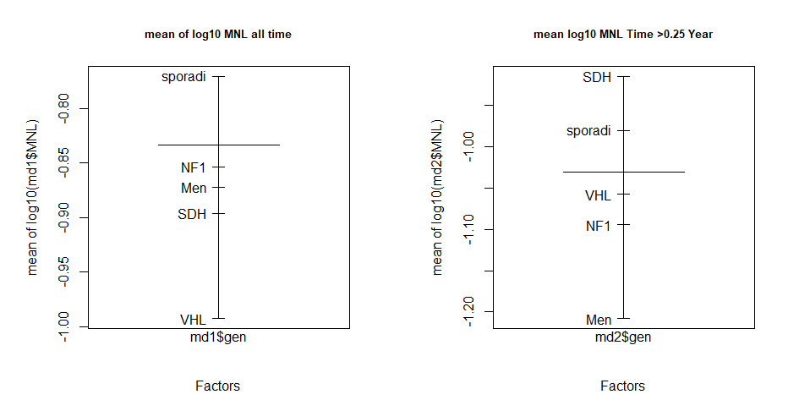

### 

### Table of pre-model test:

|  |  |  |  |  |  |
| --- | --- | --- | --- | --- | --- |
|  | | | | | |
|  | Dependent variable: | | | | |
|  |  | | | | |
|  | log10(MNL) | | | | |
| MLE estimates | (1) | (2) | (3) | (4) | (5) |
|  | | | | | |
| Timep |  | -0.01 | 0.13*** | 0.13*** | 0.13*** |
|  |  | (0.01) | (0.03) | (0.03) | (0.03) |
|  |  |  |  |  |  |
| I(Timep2) |  | 0.002** |  |  |  |
|  |  | (0.001) |  |  |  |
|  |  |  |  |  |  |
| genNF1 |  |  | -0.89 | -0.89 | -0.89 |
|  |  |  | (1.35) | (1.35) | (1.38) |
|  |  |  |  |  |  |
| genSDH |  |  | -0.50 | -0.50 | -0.50 |
|  |  |  | (0.46) | (0.46) | (0.53) |
|  |  |  |  |  |  |
| gensporadi |  |  | -0.29 | -0.29 | -0.29 |
|  |  |  | (0.32) | (0.32) | (0.42) |
|  |  |  |  |  |  |
| genVHL |  |  | -0.52 | -0.52 | -0.52 |
|  |  |  | (0.38) | (0.38) | (0.47) |
|  |  |  |  |  |  |
| age |  |  | -0.01** | -0.01** | -0.01** |
|  |  |  | (0.01) | (0.01) | (0.01) |
|  |  |  |  |  |  |
| Timep:genNF1 |  |  | -0.22 | -0.22 | -0.22 |
|  |  |  | (0.15) | (0.15) | (0.15) |
|  |  |  |  |  |  |
| Timep:genSDH |  |  | -0.17*** | -0.17*** | -0.17*** |
|  |  |  | (0.06) | (0.06) | (0.06) |
|  |  |  |  |  |  |
| Timep:gensporadi |  |  | -0.18*** | -0.18*** | -0.18*** |
|  |  |  | (0.04) | (0.04) | (0.04) |
|  |  |  |  |  |  |
| Timep:genVHL |  |  | -0.16*** | -0.16*** | -0.16*** |
|  |  |  | (0.05) | (0.05) | (0.05) |
|  |  |  |  |  |  |
| Timep:age |  |  | -0.002*** | -0.002*** | -0.002*** |
|  |  |  | (0.001) | (0.001) | (0.001) |
|  |  |  |  |  |  |
| genNF1:age |  |  | 0.02 | 0.02 | 0.02 |
|  |  |  | (0.03) | (0.03) | (0.03) |
|  |  |  |  |  |  |
| genSDH:age |  |  | 0.02 | 0.02 | 0.02 |
|  |  |  | (0.01) | (0.01) | (0.01) |
|  |  |  |  |  |  |
| gensporadi:age |  |  | 0.01 | 0.01 | 0.01 |
|  |  |  | (0.01) | (0.01) | (0.01) |
|  |  |  |  |  |  |
| genVHL:age |  |  | 0.01 | 0.01 | 0.01 |
|  |  |  | (0.01) | (0.01) | (0.01) |
|  |  |  |  |  |  |
| Timep:genNF1:age |  |  | 0.004 | 0.004 | 0.004 |
|  |  |  | (0.003) | (0.003) | (0.003) |
|  |  |  |  |  |  |
| Timep:genSDH:age |  |  | 0.003** | 0.003** | 0.003** |
|  |  |  | (0.001) | (0.001) | (0.001) |
|  |  |  |  |  |  |
| Timep:gensporadi:age |  |  | 0.003*** | 0.003*** | 0.003*** |
|  |  |  | (0.001) | (0.001) | (0.001) |
|  |  |  |  |  |  |
| Timep:genVHL:age |  |  | 0.003*** | 0.003*** | 0.003*** |
|  |  |  | (0.001) | (0.001) | (0.001) |
|  |  |  |  |  |  |
| Constant | -1.02*** | -1.01*** | -0.63** | -0.63** | -0.63** |
|  | (0.03) | (0.03) | (0.26) | (0.26) | (0.32) |
|  |  |  |  |  |  |
|  | | | | | |
| Observations | 503 | 503 | 503 | 503 | 503 |
| Log Likelihood | 223.58 | 218.45 | 174.33 | 174.33 | 174.33 |
| Akaike Inf. Crit. | -437.15 | -416.90 | -300.65 | -294.65 | -298.65 |
| Bayesian Inf. Crit. | -416.06 | -374.76 | -200.33 | -181.79 | -193.14 |
|  | | | | | |
| Note: | *p<0.1; >**p<0.05; >***p<0.01 | | | | |

Model 1) RIAS 2) RIAS Squared polynomial 3) RIAS all interactions Time: age: gene 4 5) Gene as random within patients RIAS

Anova LRT for above selection:

Model Nbrs Df AIC BIC Loglik Test LRT Pvalue

|  |  |  |  |  |  |  |  |  |  |  |
| --- | --- | --- | --- | --- | --- | --- | --- | --- | --- | --- |
| mixRIASsq | 1 | 10 | 443.1546 | 400.9487 | 231.5773 |  |  |  | |  |
| mix00RIAS | 2 | 5 | 442.4186 | 421.3156 | 226.2093 | 1 | vs | 2 | 10.73606 | 0.0569 |
| mixxgenage | 3 | 24 | 456.9113 | 355.6171 | 252.4556 | 2 | vs | 3 | 52.49271 | 0.0001 |
| mixxgenagerandomgen | 4 | 27 | 450.9113 | 336.9553 | 252.4556 | 3 | vs | 4 | NA | NA |

Anova LRT for final model with /without intercations for MNL:

|  |  |  |  |  |  |  |  |  |  |
| --- | --- | --- | --- | --- | --- | --- | --- | --- | --- |
| Gen :age inter vs none | Model | df | AIC | BIC | logLik | Test |  | LRT | P.value |
| mixgenagenointer3and2 | 1 | 15 | 380.44 | 317.14 | 205.22 |  |  |  |  |
| finalmod | 2 | 11 | 383.11 | 336.69 | 202.55 | 1vs2 |  | 5.33 | 0.25 |

Anova LRT for final model with /without intercations for NMNL:

|  |  |  |  |  |  |  |  |  |  |
| --- | --- | --- | --- | --- | --- | --- | --- | --- | --- |
| Gen :age inter vs none | Model | df | AIC | BIC | logLik | Test |  | LRT | P.value |
| mixgenagenointer3and2 | 1 | 15 | 380.44 | 317.14 | 205.22 |  |  |  |  |
| finalmod | 2 | 11 | 383.11 | 336.69 | 202.55 | 1vs2 |  | 5.33 | 0.25 |

Confidence intervals for final model using REML estimates:

|  |  |  |  |
| --- | --- | --- | --- |
| *Finalmodel* |  | *confint* |  |
|  | **Fixed effect** |  |  |
|  | *lower* | *est.* | *upper* |
| (Intercept) | -0.490 | -0.105 | 0.280 |
| Timep | 0.002 | 0.010 | 0.018 |
| genNF1 | -3.911 | -1.885 | 0.140 |
| genSDH | -1.965 | -1.224 | -0.484 |
| gensporadi | -1.562 | -1.062 | -0.563 |
| genVHL | -1.801 | -1.201 | -0.602 |
| age | -0.031 | -0.022 | -0.014 |
| genNF1:age | 0.000 | 0.040 | 0.080 |
| genSDH:age | 0.014 | 0.033 | 0.052 |
| gensporadi:age | 0.015 | 0.024 | 0.034 |
| genVHL:age | 0.012 | 0.029 | 0.046 |
| Contarst trt: *MEN* |  |  |  |
|  | **Random** | Effects: |  |
|  | *lower* | *est.* | *upper* |
| sd((Intercept)) | 0.220 | 0.267 | 0.323 |
| sd(Timep) | 0.017 | 0.024 | 0.034 |
| cor((Intercept) | -0.826 | -0.631 | -0.303 |
|  | **Within-group** | standard | error: |
|  | *lower* | *est.* | *upper* |
|  | 0.101 | 0.109 | 0.118 |

Correlation of Fixef coefficient Finalmodel:

|  |  |  |  |  |  |  |  |  |  |
| --- | --- | --- | --- | --- | --- | --- | --- | --- | --- |
|  |  | Timep | MEN | NF1 | SDH | VHL | age |  |  |
| Timep | -0.10 |  |  |  |  |  |  |  |  |
| gennewMen | -0.62 | 0.06 |  |  |  |  |  |  |  |
| gennewNF1 | -0.15 | -0.04 | 0.09 |  |  |  |  |  |  |
| gennewSDH | -0.44 | -0.02 | 0.27 | 0.07 |  |  |  |  |  |
| gennewVHL | -0.57 | 0.05 | 0.35 | 0.08 | 0.25 |  |  |  |  |
| age | -0.97 | 0.00 | 0.61 | 0.15 | 0.43 | 0.55 |  |  |  |

### Effect plot (Fox, 2003)

Effect plots based on model : finalmodreml on log10MNL[45]

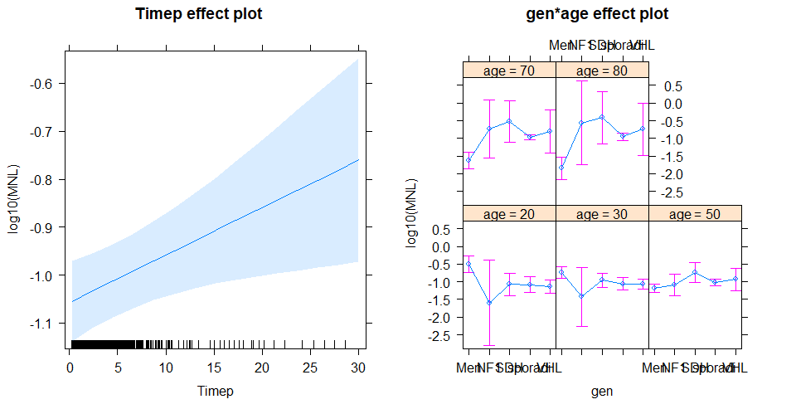

Residuals plot (finalmod):

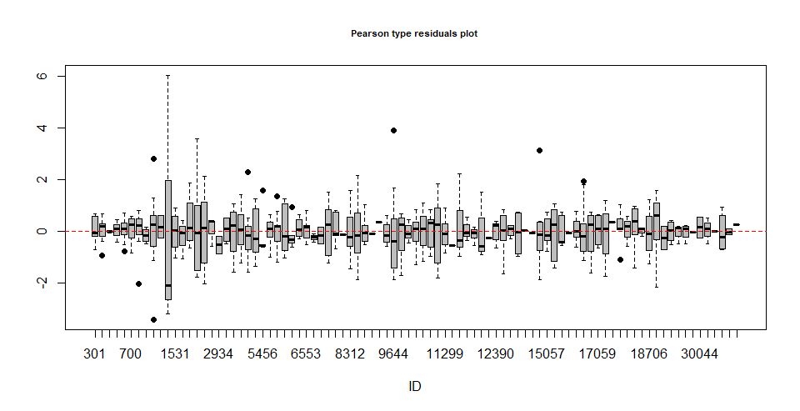 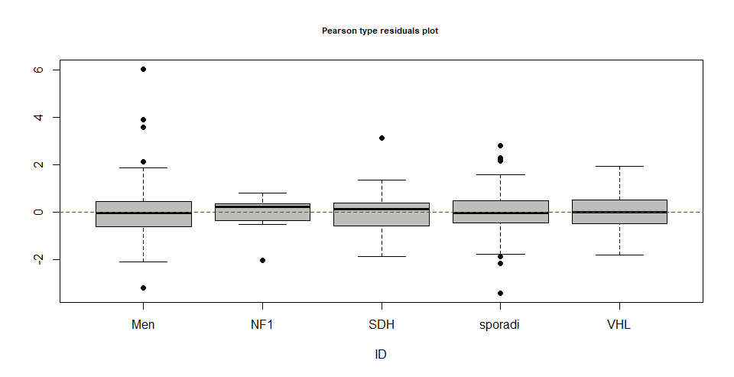 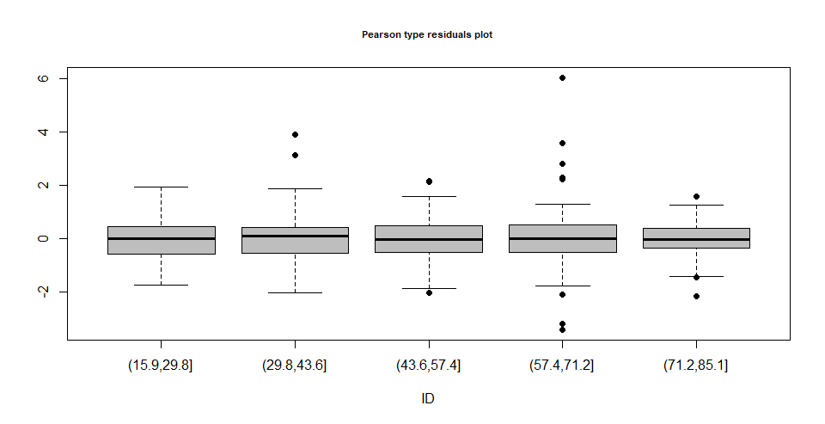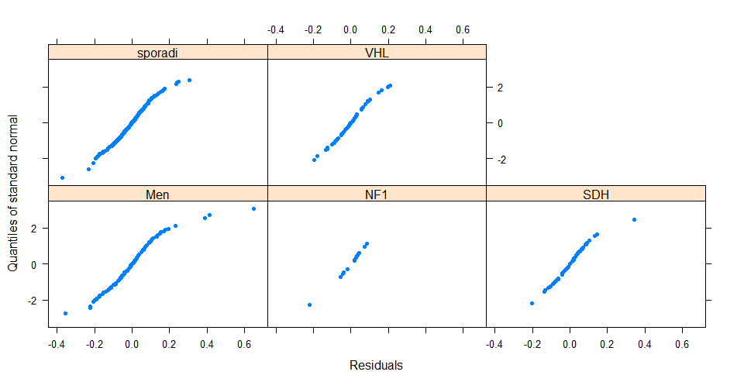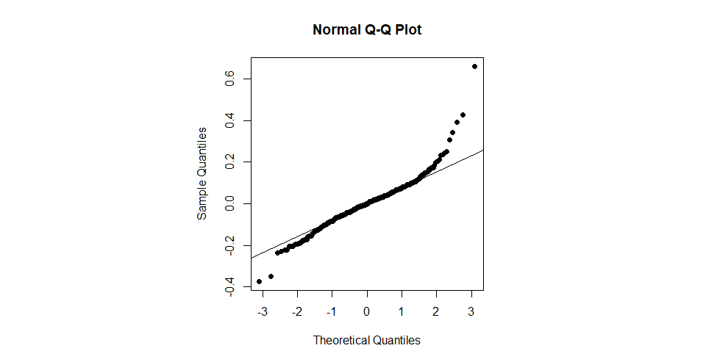

### Covariance Matrix for ID: V Matrix

### Prediction by ID

Vi Covariance Matrix (Cor) for ID 773 with 4 measures

|  |  |  |  |  |
| --- | --- | --- | --- | --- |
|  | 1 | 2 | 3 | 4 |
| 1 | 1 | 0.84 | 0.81 | 0.76 |
| 2 | 0.84 | 1 | 0.81 | 0.78 |
| 3 | 0.81 | 0.81 | 1 | 0.79 |
| 4 | 0.76 | 0.78 | 0.79 | 1 |

## Robust and Censoring models

The ID list of threshold MNL <=0.03 (log10):

[493;773;1499;1807;2934;5117;5456;6325;6810;9644;11781;13376;17059]

Lmec:: was using for left censoring.

## R data

Each Lattice plot is constructed by using the default plot method for grouped-data objects. Grouped-data objects, provided by the nlme package, are enhanced data frames, incorporating a model formula that gives information about the structure of the data. (Weisberg, 2015) (Pinheiro J. B., 2014).

Important note:  
It has been discovered that improper coding will result in wrong connected line in profile plot and hence wrong visual perception of data. Solution :selects random sample ID and cross-checked plot-data.

1. Referenced as “sporadique” class in our database,
2. Although no formal analyses was demanded the author recommend a Survival Analysis. Base on descriptive statistic sand graphs readings average relapse time event seems to be in range of 4-7 years.
3. Metanéphrines/Normétanéphrines/Metatoxytyramine (free or Sulfato-conjugate).
4. Mainly MAO and COMT enzyme
5. Rapidly if measured level are 2 fold UCL
6. Not to be confounded with cohort
7. i.e. Bananas
8. Beta Blocker , Tricyclic antidepressant usually prescribe with associated PPGL risk factor) .
9. During the analysis we checked that only MNL was threshold censored due to limitation detection in mass spectrometry [0.14]. This has been accounted in model for left censoring
10. Although present study highlights the dependence of genes and relapse it was not the main research question.
11. Refer to meeting report from 3.7.2020
12. EBM :Evidence based medicine.
13. For *qry_FEV_pour_stats_jmm.xls 176”malignant” out of 1581 lines per biomarkers removed (long format)*
14. It was thought that non-operated patient will be act as a control group. Unfortunately, this group doesn’t share a common Time event for future modelling hence will result in bias estimates/unmatched model assumptions.
15. Problems occurs in modelling as ill-conditioned matrix and unreliable coefficient and their associated SE due to low sample class factor.
16. others have same pattern.
17. In Linear Model s.l. only the errors follow a normal distribution, which implies the conditional probability of Y given X is normal too. Here the plot are not conditioned on Xi’s.
18. Accounting for 3 statics predictors they are n(n-1) 2ways,1 3ways interactions: 3 ways will not be considered.
19. “NA”
20. < 3/1000
21. MTL present also a lower threshold of censoring limit but it was disregarded as this biomarker is seldom used for diagnostic on upper limit
22. Random coefficient model from Longford and Diggle (1993) or Multilevels models.
23. A nice demo based on conditional Expectation can be found in (Galecki, 2013)
24. Usually, we named uio for random intercept & ui1 for random slope: They are the individual deviation from the population level.
25. This covariance matrix is also named the ∑ matrix by some literature.
26. Further extend of it lead to t GEE models based on a quasi-likelihood (moment-based estimates) of nuisance parameters (Φ,α),α be the working correlation matrix.
27. In copula theory a joint distribution which is gaussian has also a gaussian conditional distribution.
28. Usually this term is poorly used and misunderstood amongst statisticians.
29. All biomarkers profile plot can be consulted in:”profileplot_30ID.pdf” / ANNEXES 5
30. Negative time is given in R code line 127-133 code_md1presentation.R
31. Of course, a large confidence interval SE for gene NF1 occurs due to low sample size in that group.
32. GAM was not retained by clinicians claiming the overfitting capability of GAM.
33. Sum or Helmert can be used too.
34. without static predictors
35. This occurs usually when global trend is against trends of individuals.
36. For such data has to be reformatted in wide format and could be cumbersome in unbalanced data.
37. Anova , model diagnostics and effect plots are given in the appendix 3.
38. Although suspected it might also be an overdispersion, although doubtful of or to low signal to noise ratio in the data.Any way the diagnose is high SE estimates for parameters. Further investigations should be envisioned.
39. For detailed selection report to R code.
40. (relevel “sporadic”, contr sum;R code)
41. We underline the need to run typIII anova in unbalanced design : I.e. with a type I nor gene/Time would be signif.Df with Kenward Rodgers approximation has been evaluated too, leading to same conclusions. Type III Anova only with contr.sum
42. In parentheses is coded as the Random part: Here model is RIAS.
43. It has been proposed to clinicians but found more too complex for interpretations. Present author does not share this point of view.
44. For coefficient estimate: REML estimators for model comparison: MLE
45. We recall the readers that these effects might be different on different outcome log10 Biomarkers.