**National University Of Modern Languages Islamabad**

**Group Members:**

**Mueez Ahmad**

**Faizan Ahmer**

**Muhammad Zubair Khan**

**Muhammad Ali Hassan Khan**

**Date: 4/4/2025**

**Usecase Diagram:**

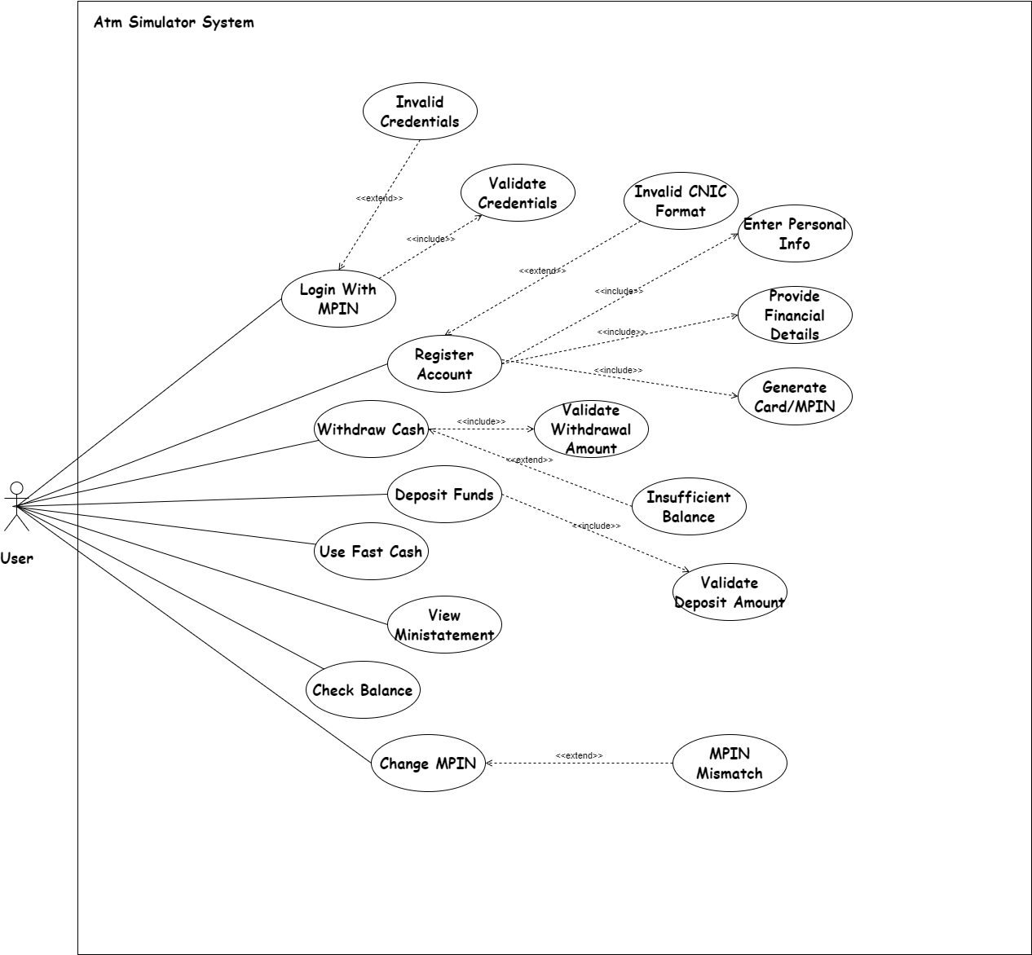

Class Diagram:

Object Diagram:

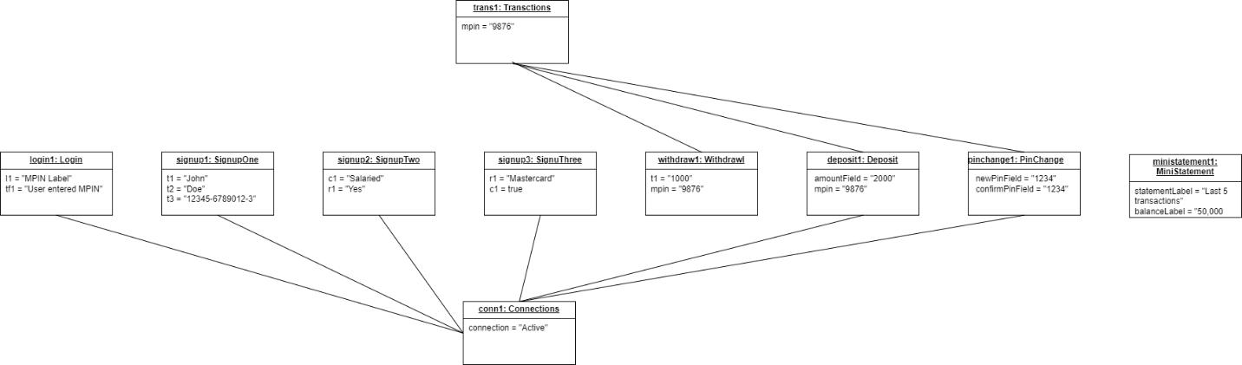

Sequence Diagram:

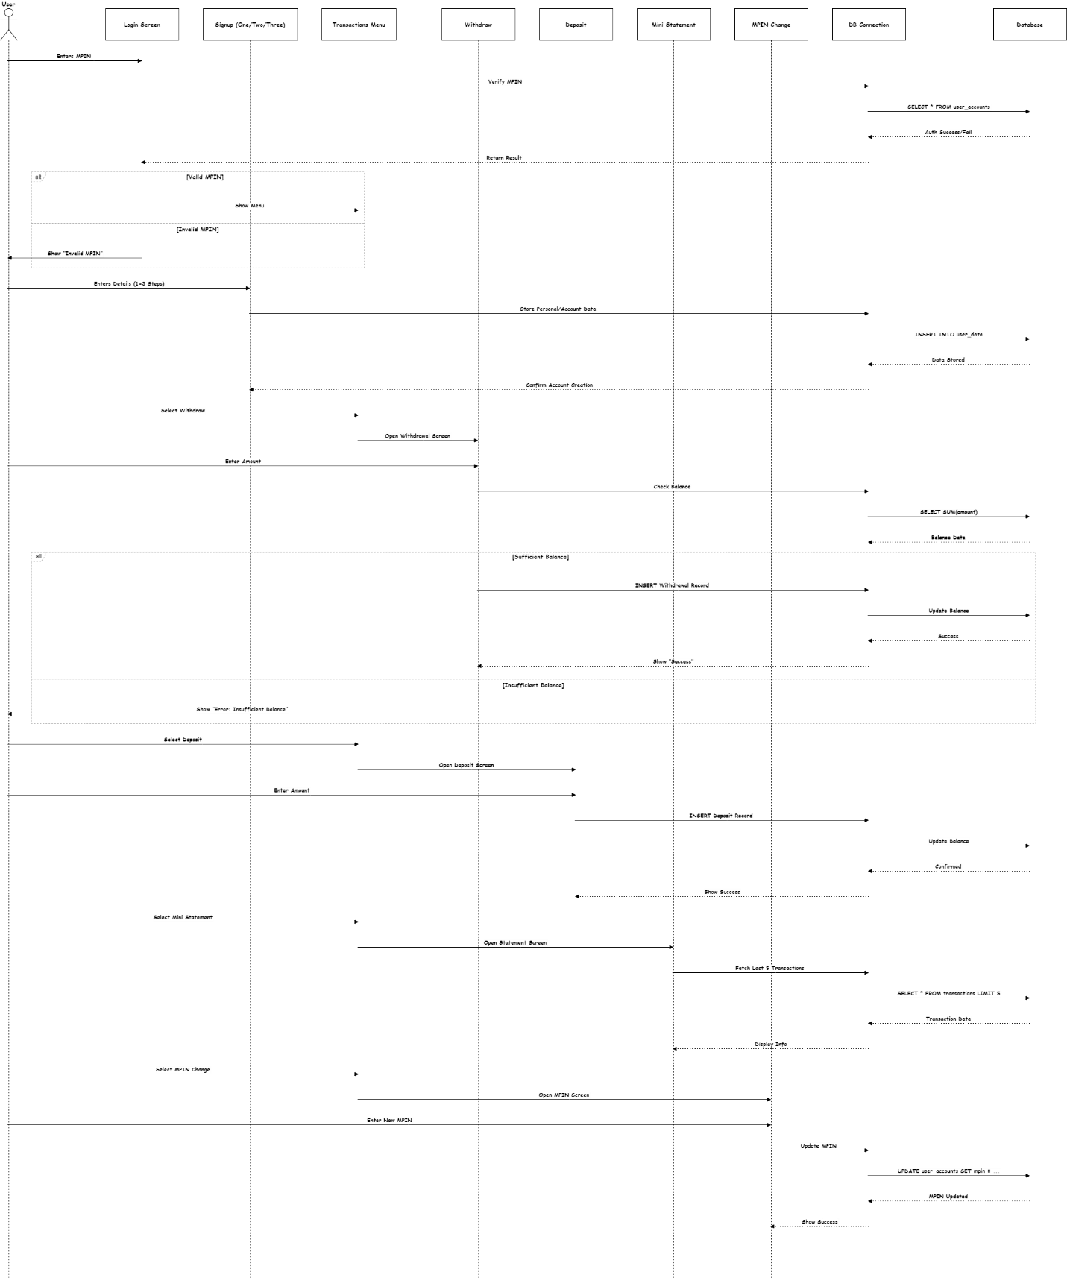

Communication Diagram:

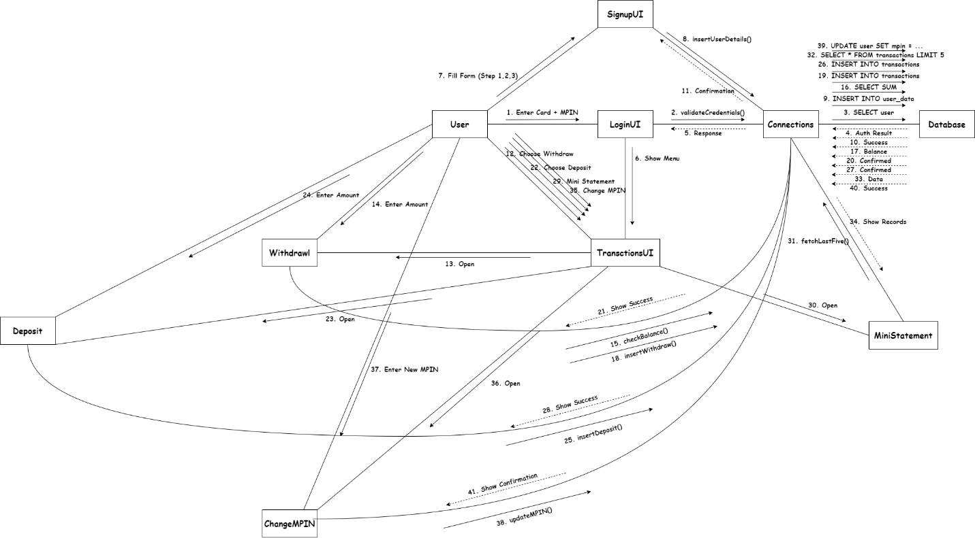

Petri Net Diagram:

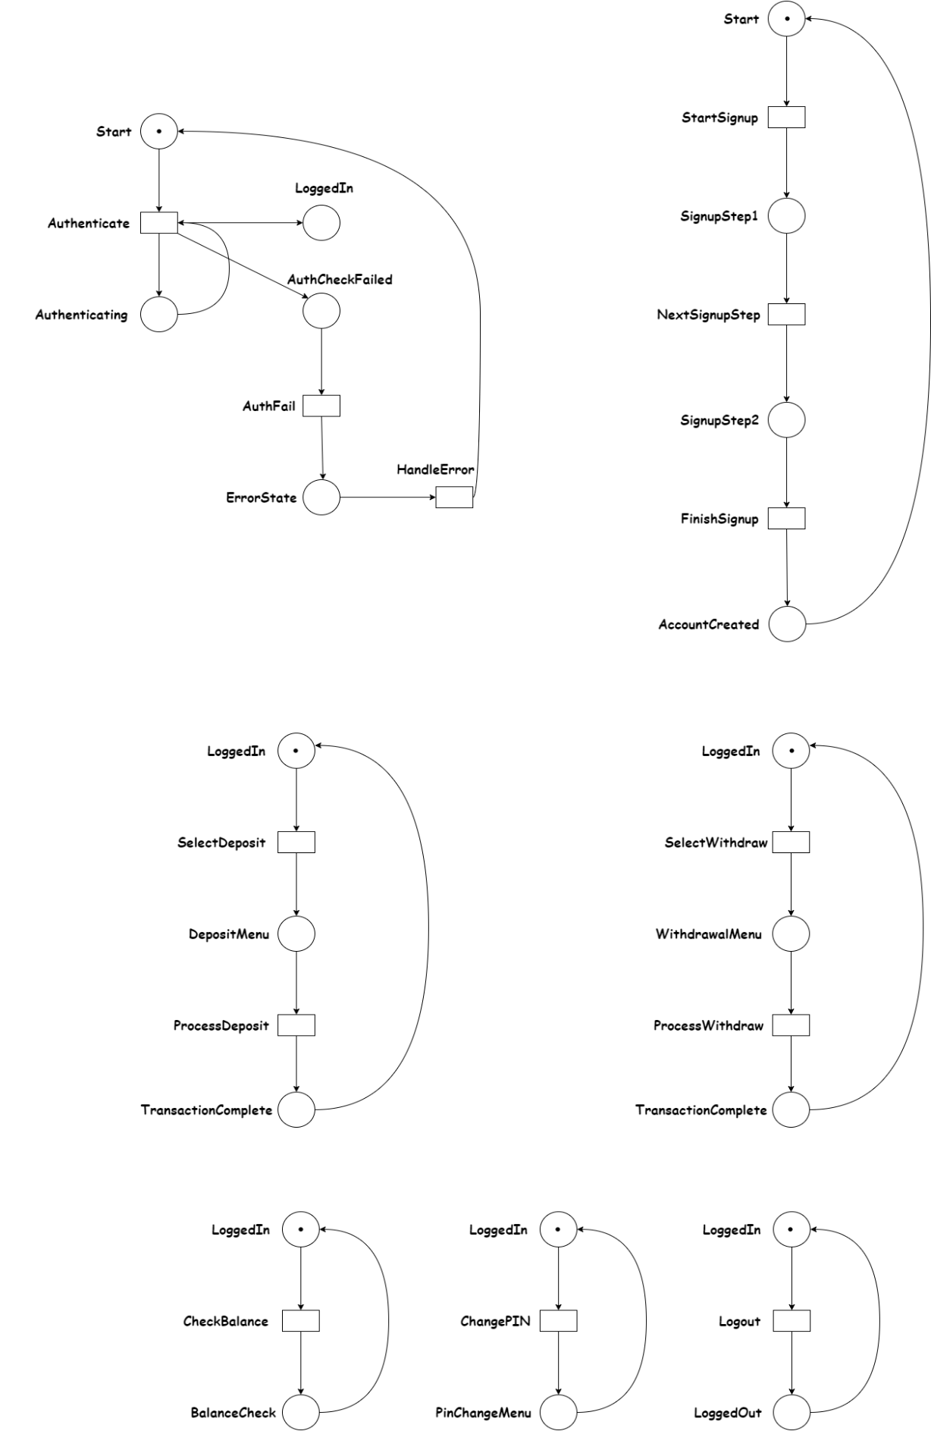

Timing Diagram:

