Prompt 1: Initial Setup :

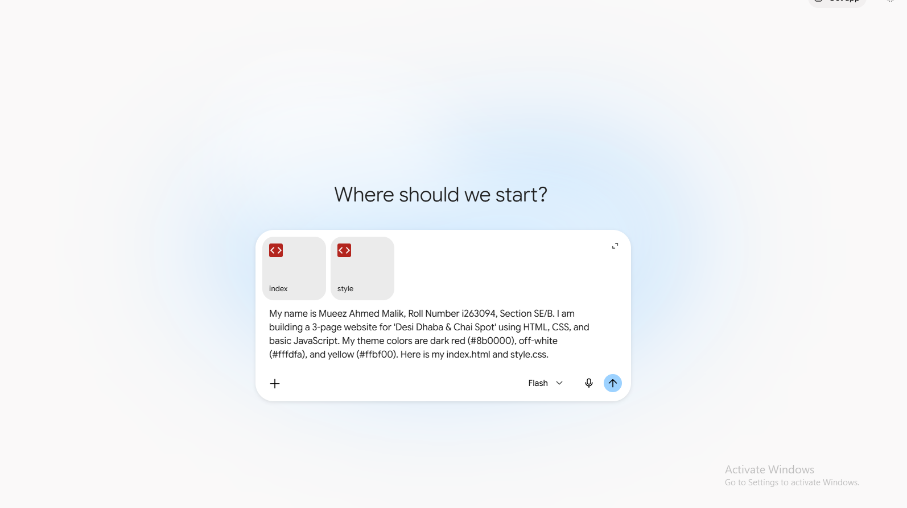
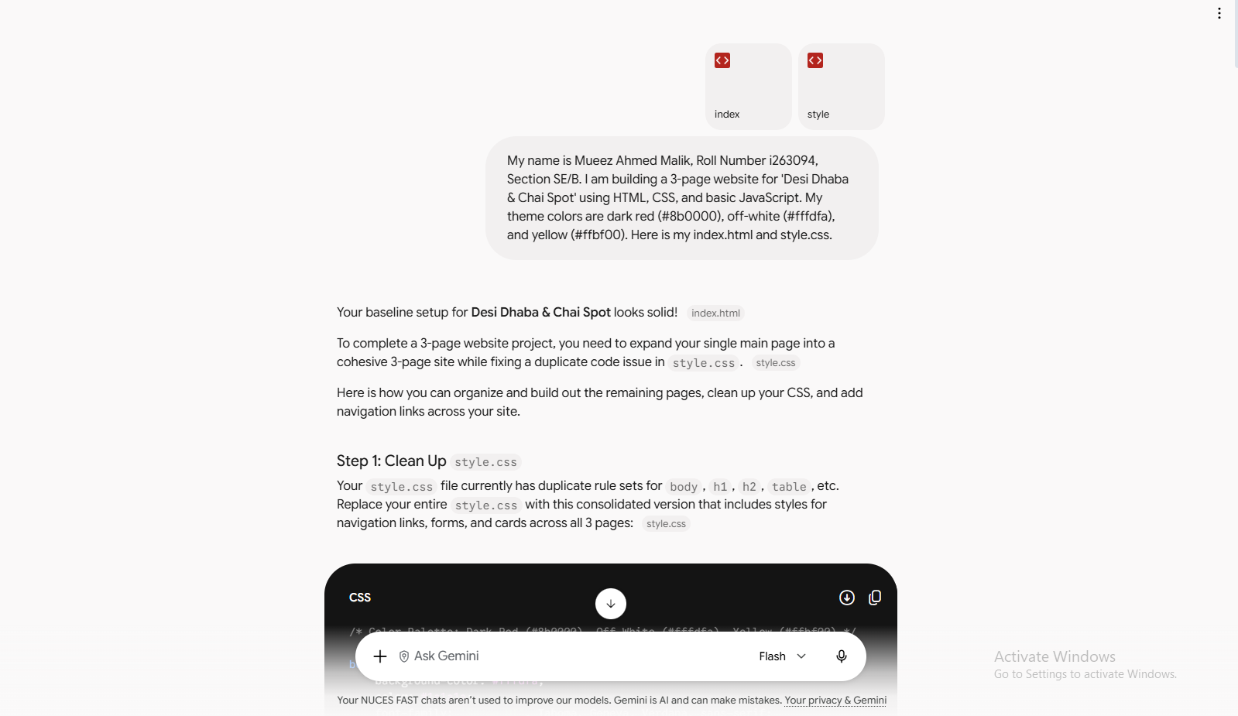

Prompt 2: Detailed Menu Page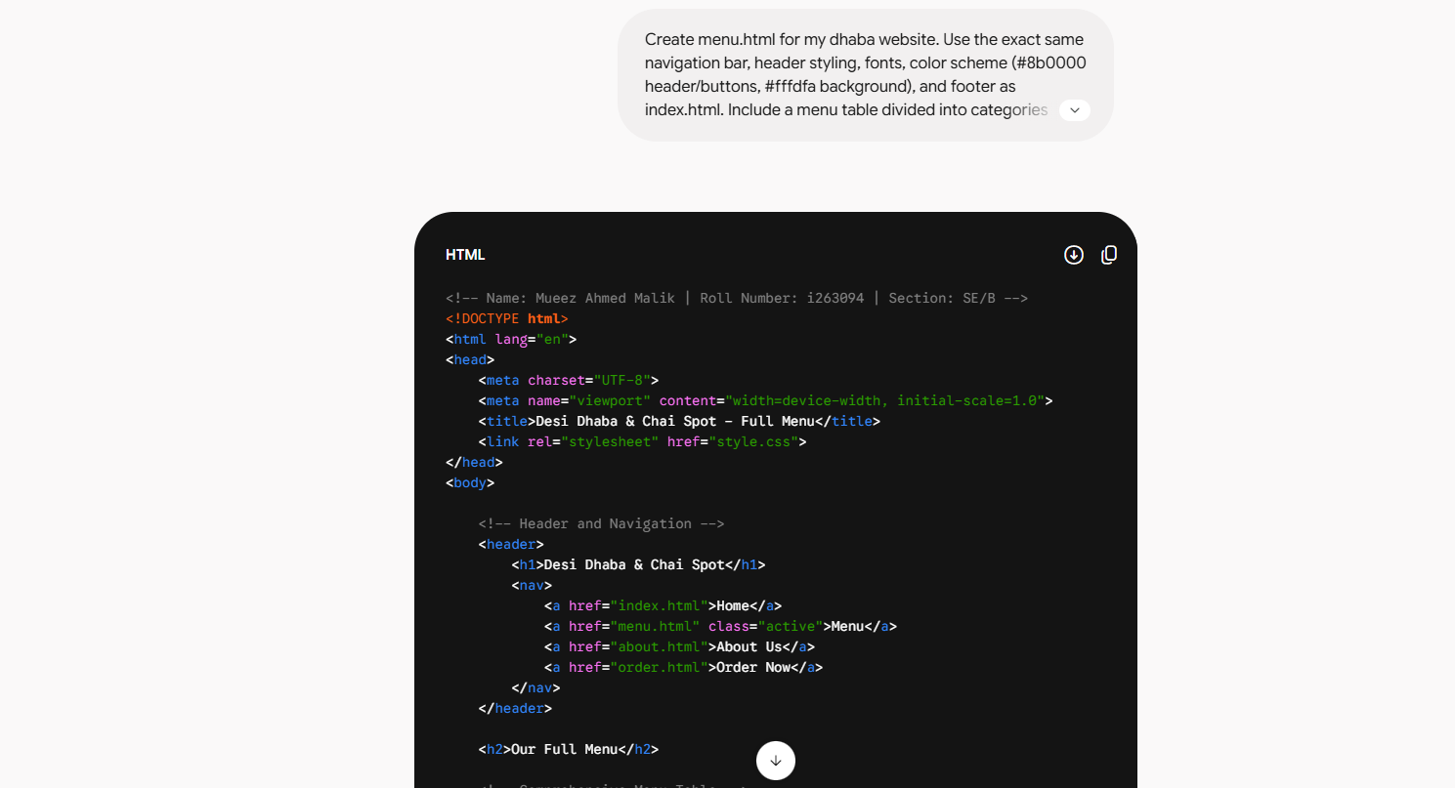
Result: Created menu.html with structured categories, prices, and interactive order button.

Prompt 3: Gallery Page on Feature Branch
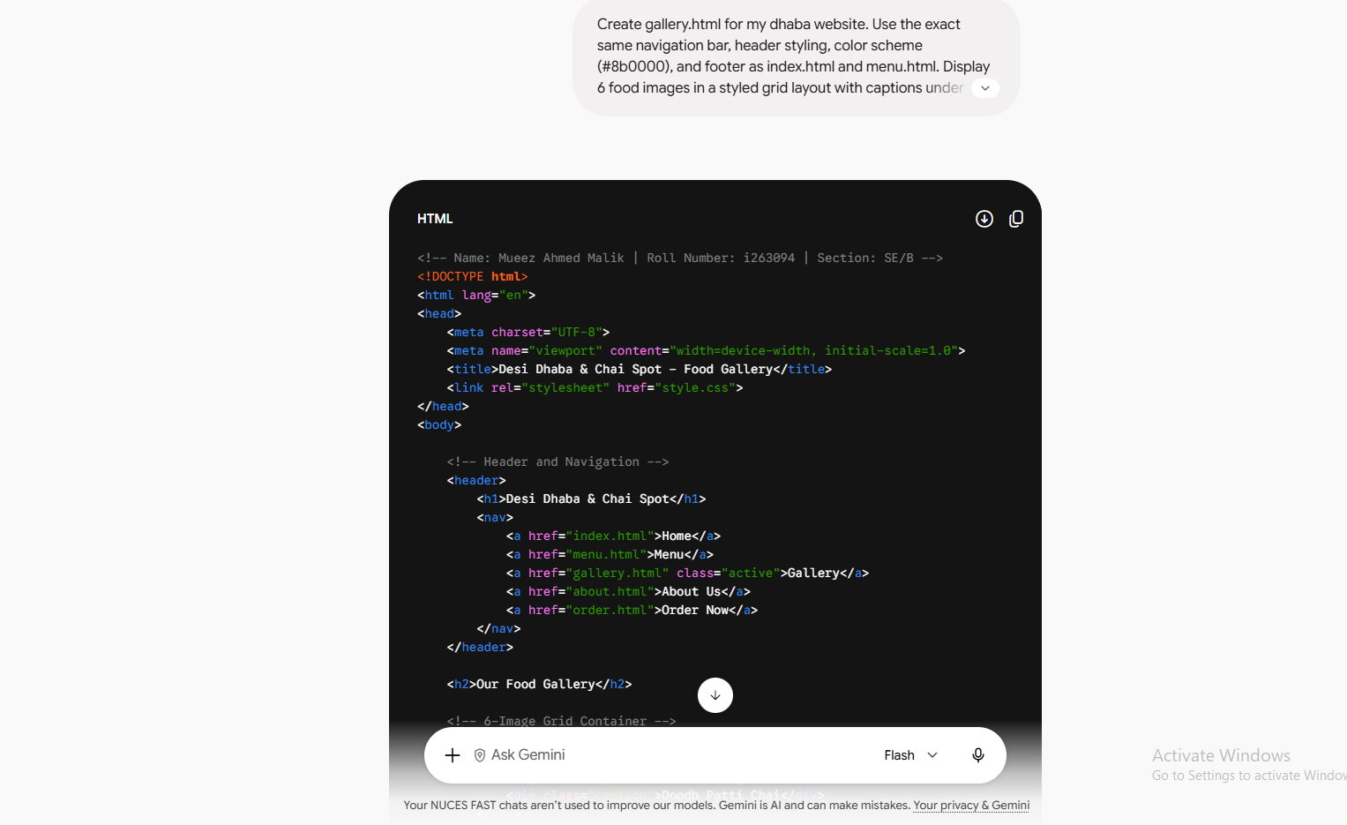
Result: Created gallery.html with a 6-item image grid and updated prompts.

