SKILLBRIDGE: DIGITAL SKILLS DEVELOPMENT PLATFORM
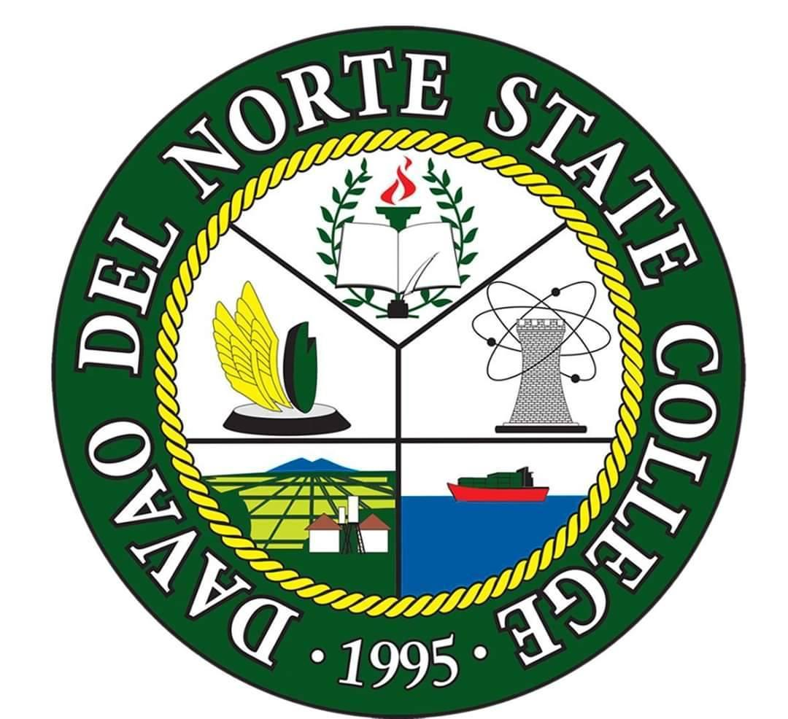

IT223 – ADVANCE DATABASE SYSTEM
PRESENTED TO

Mr. Eduardo Jr. Catoc
Faculty, Institute of Computing
Davao Del Norte State College

Shane Jaybe Cojetia
Trish Charlotte Muega
Sofia Azriel Alameda

April 14, 2026
BACKGROUND OF THE STUDY
Education plays a vital role in shaping individuals and preparing them for the demands of the modern world. In line with SDG 4: Quality Education, there is a growing need to ensure inclusive and equitable access to quality education, especially in the area of digital skills. As technology continues to advance, students are expected to possess not only academic knowledge but also practical digital competencies that are essential in various fields and industries.
However, many students still face challenges in acquiring these skills due to limited access to learning resources, a lack of structured training, and insufficient opportunities for hands-on practice. Traditional classroom settings may not always provide enough time or tools to fully develop digital literacy and technical abilities. This creates a gap between what students learn in school and the skills required in real-world environments.
To address these challenges, there is a need for an accessible and efficient platform that can support students in developing their digital skills. A system that offers interactive learning, self-paced modules, and real-time progress tracking can significantly enhance the learning experience. This study proposes the development of SkillBridge: Digital Skills Development Platform, a web-based system designed to help learners improve their digital competencies through structured and engaging content.

General Objective:
To develop a web-based platform that enhances students’ digital skills through accessible and interactive learning tools.
Specific Objectives:
- To design a system that provides structured digital learning modules
- To implement interactive features such as quizzes and exercises
- To create a progress tracking system for monitoring performance
- To develop a user-friendly interface for better accessibility
- To provide certification upon course completion

SYSTEM FUNCTIONALITIES

System Functional Requirements:

User Registration and Authentication
- The system shall allow users to create an account and log in securely.
User Profile Management
- The system shall allow users to update personal information and view their profiles.
Course Management
- The system shall provide a list of available digital skill courses.
- The system shall allow users to enroll in courses.
Learning Module Access
- The system shall display lessons, tutorials, and learning materials.
- The system shall support multimedia content (text, videos, images).
Interactive Assessments
- The system shall provide quizzes, exercises, and mini-projects.
- The system shall automatically check and display results.
Progress Tracking
- The system shall track completed lessons and scores.
- The system shall display progress through dashboards or indicators.
Certification Generation
- The system shall generate certificates after course completion.
Search and Filter Functionality
- The system shall allow users to search and filter courses by category or level.
Admin Management System
- The admin shall be able to add, update, and delete courses.
- The admin shall manage users and monitor system activity.
Notifications System
- The system shall notify users about course updates, deadlines, or achievements.

System Non-Functional Requirements:

Performance
- The system should load pages within 3–5 seconds.
- It should handle multiple users simultaneously without lag.
Usability
- The system should have a user-friendly and intuitive interface.
- It should be easy to navigate for beginners.
Reliability
- The system should operate consistently with minimal downtime.
- Data should be saved accurately without loss.
Security
- The system should protect user data through encryption and secure login.
- It should prevent unauthorized access.
Scalability
- The system should be able to handle an increasing number of users and courses.
Compatibility
- The system should work across different devices (desktop, tablet, mobile).
- It should support major browsers (Chrome, Edge, Firefox).
Maintainability
- The system should be easy to update, fix, and improve by developers.
Accessibility
- The system should be usable by individuals with different levels of digital literacy.
Availability
- The system should be accessible 24/7 with minimal interruptions.
Data Integrity
- The system should ensure that stored data remains accurate and consistent.

Scope and Limitations

Scope:
The system focuses on providing digital skills training through an online platform. It includes user registration, course modules, interactive assessments, progress tracking, and certification. The system is intended for students, particularly those in college and senior high school, who want to enhance their digital competencies.

Limitations:
- The system requires internet access to function
- It is limited to selected digital skill courses only
- Advanced features such as live mentoring or real-time tutoring may not be included
- The system does not guarantee employment but aims to improve skills

