Kurt Mueller

November 21st, 2019

IT FDN 100 A -- Foundations of Programming (Python)

Assignment 06

# Creating a To-Do-List Program

Note to Reviewer: I had difficulty using the provided code to complete this assignment. I therefore reverted to a simpler script that was used for Assignment 04. I realize this may not be what you are looking for but using the simpler code for this helped me to better understand functions and using lists and dictionaries.

Introduction

This paper will describe how to create a program that displays a menu of options to the user and, depending on the choice the user makes, either adds items to a list, displays what items are currently on the list, and saves the data to a text file. Functions are added to organize the code.

Work Instructions

Create a dictionary, list, and file object using a relative file path at the beginning of the script to store the data.

myList = [ ]

dicRow = { }

strFile = ‘ToDoList.txt’

Create four functions to display and handle the data as it input is received from the user. The first should display a menu of choices to the user.

def OutputMenuItems():

print()

print("Menu of Options")

print("-" * 40)

print("1) Add Item To List")

print("2) Display Current List")

print("3) Save To File And Exit The Program")

print("-" * 40)

The second allows the user to add an item to the list along with the priority and then appends the entries to the dictionary created at the beginning of the script. The entries are also displayed to the user separated by an ‘=’ sign.

def AddItems():

strTask = input("Enter a task or household chore: ")

strPriority = input("Enter the priority [low, medium, high] of the task: ")

dicRow = {"Task":strTask, "Priority":strPriority}

myList.append(dicRow)

print("You entered.... ")

for strTask, strPriority in dicRow.items():

print(strTask, " = ", strPriority)

The third function will show all entries in the list of dictionary rows.

def DispItems():

for objRow in myList:

print(objRow["Task"] + ' = ' + objRow["Priority"])

The fourth will write all entries to a text file using the write method.

def ExpItems():

strFile = open('ToDoList.txt', "w")

for objRow in myList:

strFile.write(objRow["Task"] + ' = ' + objRow["Priority"] + "\n")

strFile.close()

The main body of the script uses a while loop and a series of if/elif statements. Depending on the choice the user makes, the functions defined above will be called and the appropriate code will be run as shown below:

if add=="1":

AddItems() # Add entries to the list

print("Your entries have been saved to the list.... ")

elif add =="2":

print("Your current inventory is: ")

DispItems() # Display the current list

elif add =="3":

ExpItems() # Write list to text file

print("Data saved to file. You have exited the program.")

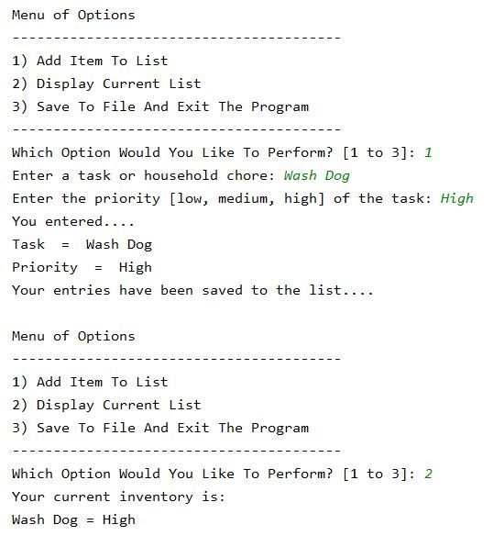

Figure 1: Output in PyCharm for user entries 1 and 2.

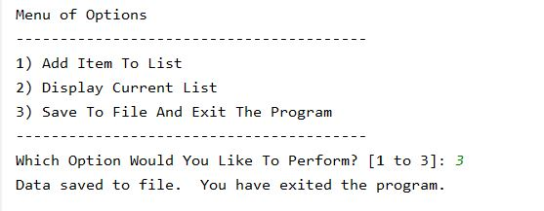

Figure 2: PyCharm output for user entry 3

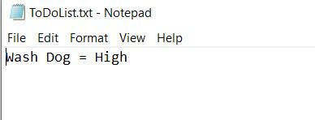

Figure 3: The data written to text file

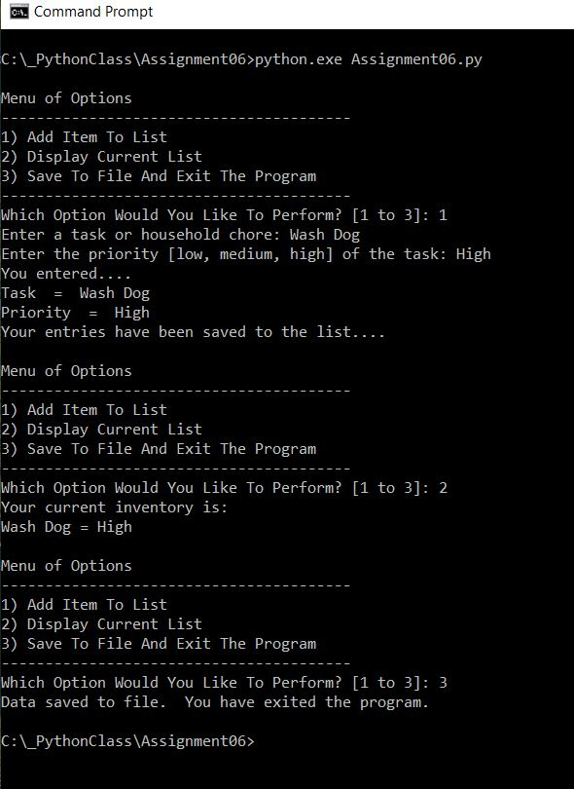

Figure 4: Command line output for Assignment06.py

Summary

This paper has described how to utilized functions to create a list and store it in a dictionary, accept user entries to add items to the list, and save these data into a text file.