Kurt Mueller

November 10th, 2019

IT FDN 100 A -- Foundations of Programming (Python)

Assignment 05

# Creating a To-Do-List Program

Introduction

This paper will describe how to create a program that displays a menu of options to the user and, depending on the choice the user makes, either adds items to a list, displays what items are currently on the list, allows the user to remove items from the list, and saves the data to a text file.

Work Instructions

Create a text file called “ToDoList.txt” using a relative file path. The text file will therefore reside in the same directory as the python script.

Use a for statement to load any data in a text file called “ToDoList.txt”. In my case, I had to have text pre-populated in the file, otherwise I would get an error that the list index was out of range. Perhaps error handling might solve this in the future, but I ran out of time despite my best efforts to fix this error.

For Step #1, the data will be loaded into a Python dictionary using the split and append method:

objFile = open(“ToDoList.txt”, “r”)

for row in objFile:

lstRow = row.split(“,”)

dicRow = {“Task”: listRow[0], “Priority”: lstRow[1].strip()}

lstTable.append(dicRow)

print(dicRow)

Making sure that the text file is pre-populated with an entry, i.e., “Wash Car, High”, use a for statement to print out the information contained in the list for Menu Option #1:

for objRow in lstTable:

print(objRow)

The list will be displayed to the user as follows:

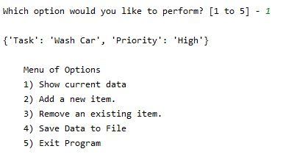

Menu Option #2 allows the user to add an item to the list along with the priority and then appends the entries to the dictionary created at the beginning of the script.

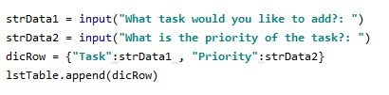

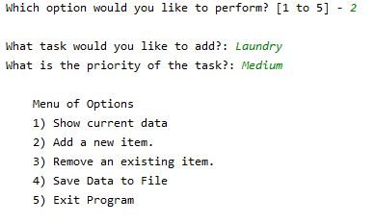

Menu Option #3 allows the user to remove the last item from the list using its index value.

del lstTable[len(lstTable)-1]

Menu Option #4 writes the data stored in the dictionary/list using a for loop and the write method.

objFile = open(‘ToDoList.txt’, “w”)

for objRow in lstTable:

objFile.write(objRow[“Task”] + ‘,’ + objRow[“Priority”] + “\n”

objFile.close()

print(“Data saved to file.”)

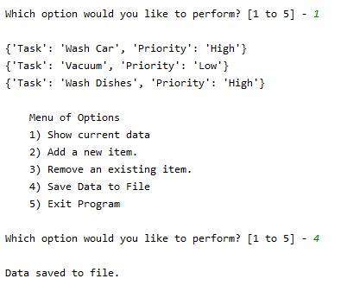

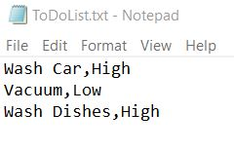

Menu Option #5 breaks the loop and prints a message to the user that they have exited the program.

print(“You have exited the Program.”)

break

Summary

This paper has described how to create a list and store it in a dictionary, accept user entries to add items to the list, remove the last item from the list, and save these data into a text file. This code does not have complete functionality, and additional code needs to be added to improve it regarding the need to have a text file pre-populated.

Figures 1 - 3 below show the code as run in the Windows Command Prompt as well as in PyCharm.

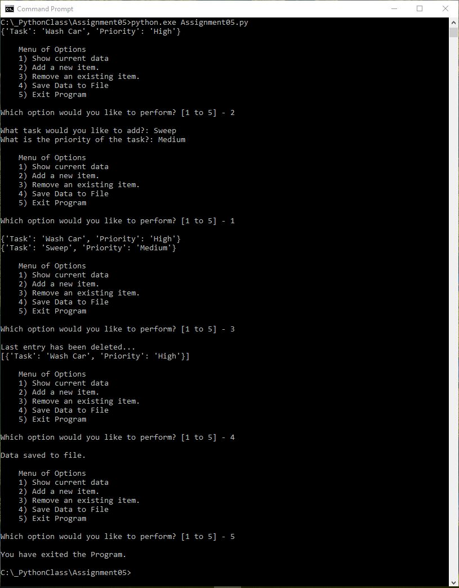

Figure 1: Windows Command Line Output

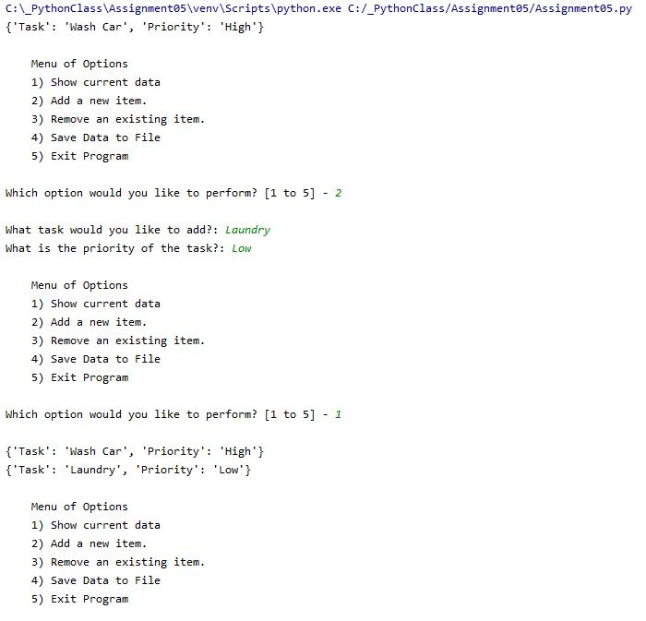

Figure 2: PyCharm output

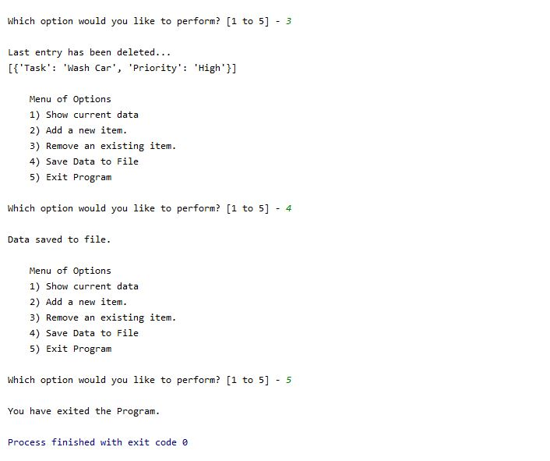

Figure 3: PyCharm output, cont’d