SDK Primitive Layer

R&D Group

Software Design Description

Written by LabTest

Approved by

Created 31 October 2010

Modified 31 October 2010

CONFIDENTIAL

Change Control Information
Version No. | Date | Changed by | Scope of Change
1.00 | 20-Sep-2010 | Meital Levy | Initial version
1.1 | 11-Oct-2010 | Meital Levy | Added the required interfaces.
1.2 | 26-Oct-2010 | Meital Levy | Added key manipulation.
1.21 | 10-Nov-2010 | Meital Levy | New format. Added DLOG and KDF
1.2 | 15-Nov-2010 | Meital Levy | Added the translation tool.

Table of Contents
1. Scope 5
1.1 Introduction 5
1.2 Goals 5
2. Definitions Acronyms and Abbreviations 5
3. References 6
4. Wide Design Decisions 6
Background: 9
4.1 The provider architecture: 9
4.2 JNI (Java Native Interface ) technology 10
5. Architectural design 12
5.1 General 12
5.1.1 Researcher view 13
5.1.2 Programmer view 14
5.1.2.1 Hash 15
5.1.2.1.1 Function : Update 15
5.1.2.1.2 Function : hashFinal 15
5.1.2.2 Pseudorandom Function and Permutation 16
5.1.2.2.1 Function : computetBlock 16
5.1.2.2.2 Function : invertBlock 16
5.1.2.3 Pseudorandom Generator 17
5.1.2.3.1 Function : streamBytes 17
5.1.2.4 Trapdoor Permutation 17
5.1.2.4.1 Function : invert 18
5.1.2.4.2 Function : compute 18
5.1.2.4.3 Function : setKeyPair 18
5.1.3 Additional Cryptographic classes: 19
5.1.3.1 Pseudorandom Permutation with Arbitrary Input-Output Lengths 19
5.1.3.1.1 computeBlock 19
5.1.3.1.2 invertBlock 19
5.1.3.1 Pseudorandom function with Arbitrary Input-Output Lengths 19
5.1.3.1.1 computeBlock 19
5.2 Dlog group 20
5.2.1 Function : simultaneosMultipeExponentiation (GroupElement[] groupElements ,BigInteger [] exponentiations ) 21
5.2.2 Function : GroupElement multExponentiationsWithSameBase (GroupElement groupElement , BigInteger exponent) 22
5.3 KeyDerivationFunction 22
5.3.1 Class HKDF 22
5.3.2 Class KDF_ISO18033 23
5.4 Key manipulating 23
5.4.1 Key representations: 23
The KeySpec Interface: This interface contains no methods or constants. Its only purpose is to group and provide type safety for all key specifications. All key specifications must implement this interface. 23
5.4.2 Key translation 23
5.4.3 Key creation 24
The KeyGenerator Class: A key generator is used to generate secret keys for symmetric algorithms. 25
5.4.4 Key management 25
5.5 Wrapping 26
5.5.1 PRP - BC 26
5.5.2 Hash - BC 27
5.5.3 PRG - BC 28
5.5.4 TrapdoorPermutation - BC 29
5.5.5 TrapdoorPermutation (Rabin) – Crypto++ 29
5.6 Translation from string to concrete classes 30
5.7 SDK Provider 32
5.8 JNI technology 32
6. Performance 33
7. Multi-Platform Issues 33
8. Backward-Compatibility 34
9. Benchmarking 34
Open Issues 34
9.1 From crypto++ to Java using JNI. 37

Scope
The Crypto SDK exists as a service for high-level multi-party computation protocols as well as a standalone product. High-level protocols will be built upon the low-level primitives in the SDK. The Crypto SDK is composed of the following three layers.
- Low-level crypto functions.
- Non-interactive mid-level crypto functions.
- Interactive mid-level crypto functions.
The purpose of this SDD is to design the low level crypto functions based on existing packages.

Introduction
The Crypto SDK is a wide set of cryptographic tools that is the basis to higher-level cryptographic protocols as well as a standalone tool.
As mentioned above it can be divided into three logical layers. From the first layer including cryptographic primitives to the last layer that includes mid-level cryptographic protocols.
Functions in the first level are independent of other functions. They are the building blocks of functions of other layers as well as independent applications and as such should supply an easy to use API.

Goals
The purpose is to provide a reliable, efficient, flexible cryptographic low level layer as the basis of the development of the two higher cryptographic layers.
We aim to provide a rich layer and thus import functionality of good existing packages in parallel. The first layer provides the user ability to choose which source of a specific cryptographic function to use in run time, e.g. the version provided by Bouncy Castle, crypto++ and so on.

Definitions Acronyms and Abbreviations

MPC | Multi Party Computation
JCA | Java Cryptography Architecture
JNI | Java Native Interface
BC | Bouncy Castle

References
[1] Crypto SDK Software Requirements Specifications (SRS)
[2] SDK_interface.xlsx
[3] primitives_for_implementationV2.2.docx

Wide Design Decisions
- Our implementation will be written in Java. We use the provider architecture of the JCA to supply our own provider as well as a detailed API containing interfaces for abstract concepts such as:
  - Pseudorandom generator
  - Pseudorandom permutation
  - Pseudorandom function
  - Hash function
  - Trapdoor permutations
  - Get random
  - Discrete log Library
New interfaces may be added as needed in newer versions of the SDK.
The required functionality that the SDK should provide can be found in the following table that is part of the file [3] primitives_for_implementationV2.2.docx

Layer 1 – Low-Level Primitives
Libraries to use: Bouncy Castle, CACE, Crypto++
General
1. GetRandom: use cryptographic call, if possible from OS
2. Randomness extraction HKDF: http://eprint.iacr.org/2010/264
Pseudorandom generator
1. RC4 (throw out first 1024 bytes)
2. SHA-based PRG
Pseudorandom permutations
1. AES_128
2. AES_256
3. 3DES
4. PRP for arbitrary input/output length
Pseudorandom functions
1. All of the pseudorandom permutations
2. HMAC_SHA-1
3. HMAC_SHA-256
4. HMAC_SHA-512
5.
PRFs with arbitrary input and output length

a. Arbitrary input length: using any of the HMAC-SHA constructions
b. Arbitrary output length:
i. If shorter than basic, truncate
ii. If longer than basic: apply multiple times with CTR index
(if do this, then the concrete instance with a given key must ALWAYS use this mode)
Hash functions
1. SHA-1
2. SHA-256
3. SHA-224 (this is truncated SHA-256)
4. SHA-512
5. SHA-384 (this is truncated SHA-512)
6. Universal one-way/target collision-resistant hashing: http://webee.technion.ac.il/~hugo/rhash/rhash.pdf
7. Perfect universal hash functions (use package giving GF[2^{k}] computations)
a. GF[2k] operations: http://www.shoup.net/ntl/doc/tour-modules.html
b. http://www.cosic.esat.kuleuven.be/publications/article-73.ps
Trapdoor permutations
1. RSA_1024
2. RSA_2048
3. RSA_4096
4. Rabin_1024
5. Rabin_2048
Discrete log
1. Z_{p}* for p of length 1024, with p=2q+1 and q prime (group of order q); fine also with general q
2. Z_{p}* for p of length 2048, with p=2q+1 and q prime (group of order q)
3. Elliptic curve groups: as given by NIST and implemented in bouncy castle, CACE or whatever you find
Minimal operations:
a. Get generator
b. Get random element
c. Multiply group elements
d. Add and multiply mod q
e. Compute inverse of a group element
f. Exponentiate
g. Multiple exponentiations with same base
h. g^{r}h^{s} computations
i. Bilinear operations
Quadratic residuosity (QR)
1. Modulus of length 1024
2. Modulus of length 2048
Lattice constructions

The infrastructure will be built upon several cryptographic packages.
  - Java JDK(Java)
  - Sun Provider (Java)
  - Crypto++ (C++)
  - OpenSSL (C)
  - CACE – salt (C)
  - Bouncy castle (Java)
  - Any other cryptographic low level implementation we will find suitable including possibly our own.
- An interface dll translating from crypto++ and CACE-salt to Java will be provided by using JNI. JNI is a programming platform that allows Java code running in a JVM to call and to be called by native applications and libraries written in other languages, such as C and C++.
On top of these interfaces, a wrapping will be written to match our java interfaces mentioned above.
Also, in a later stage we may provide engines and providers for each package.
We will write JNI interface, wrappings and provider/engines only for the functionality we intend to use. However, in the future, as the code progresses the cryptographic community may use our provider and JNI interface to add more functionality from native crypto++ and CACE-salt.
- Bouncy castle is written in Java and uses the provider architecture of the security package of Java and thus will be easy to integrate into this layer. In order to use the BC code we will write wrappings for written classes to match our first layer API interfaces.
- The crypto SDK provider chooses one default implementation for each cryptographic primitive, if a specific implementation is needed by the user it can be easily retrieved by a specific call to the required provider (if provided).
- The performance of calling many functions on the way to the specific native function should be taken into account. If a good java implementation can be found it will be preferred on a native implementation. It is recommended that only functionality that has clear superiority over other java implementations should be called/implemented. Note that the java interface that converts a function from a native language is both complicated and prone to error. Since C/C++ may be more efficient in some cases using JNI which only adds a negligible time is unavoided.

Background:
The functionality of this layer is taken from different well already written and tested known packages. An easy to use API via interfaces as well as a provider will be supplied in this layer. The concrete implementation of these interfaces will be either our own implementations or wrappings from other packages. Also, for each cryptographic package we would like to write a java provider at a later stage if one is not already provided.

Below one can find the main ideas of the provider architecture and a link for further information.

The provider architecture:
The following text is taken from chapter 8 of the book Java™ Security by Scott Oaks. For further information, follow this link: http://docstore.mik.ua/orelly/java-ent/security/ch08_01.htm

"The security provider abstracts two ideas: engines and algorithms. In this context, "engine" is just another word for operation; there are certain operations the security provider knows about, and in Java, these operations are known as engines. An algorithm defines how a particular operation should be executed. An algorithm can be thought of as an implementation of an engine, but that can lead to confusion, because there may be several implementations of an algorithm.
As a simple example, the Java security package knows about message digests. A message digest is an engine: it is an operation a programmer can perform. The idea behind a message digest is independent of how any particular message digest may be calculated. All message digests share certain features, and the class that abstracts these common features into a single interface is termed an engine. Engines are generally abstract, and are always independent of any particular algorithm.
A message digest may be implemented by a particular algorithm, such as MD5 or SHA. An algorithm is generally provided as a concrete class that extends an abstract engine class, completing the definition of the class. However, there may be many classes that provide a particular algorithm; you may have an SHA class that came with your Java platform, and you may also have obtained an SHA class from a third party. Both classes should provide the same results, but their internal implementations may be vastly different.
Security providers are the glue that manages the mapping between the engines used by the rest of the security package (such as a message digest), the specific algorithms that are valid for those engines (such as an SHA digest), and the specific implementations of that algorithm/engine pair that might be available to any particular Java virtual machine. The goal of the security provider interface is to allow an easy mechanism where the specific algorithms and their implementations can be easily changed or substituted. The security provider allows us to change the implementation of the SHA digest algorithm that is in use, and to introduce a new algorithm to generate a digest.
Hence, a typical programmer only uses the engine classes to perform particular operations. You don't need to worry about the classes that actually perform the computation. The engine classes provide the primary interface to the security package."

The crypto SDK primitive layer will be written also using the provider architecture and thus will supply the SDK provider. This will give the user a simple and known way to call functionalities.
Part of this layer is to write providers for other known packages and java interface if required.

JNI (Java Native Interface ) technology

The following text is taken from chapter 5 of Sun Developer Network. For further information follow the following links: http://java.sun.com/developer/onlineTraining/Programming/JDCBook/jni.html
http://java.sun.com/docs/books/jni/html/jniTOC.html

" The Java platform is relatively new, which means there could be times when you will need to integrate programs written with the Java language with existing non-Java language services, API toolkits, and programs. The Java platform provides the Java Native Interface (JNI) to help ease this type of integration.
The JNI defines a standard naming and calling convention so the Java¹ virtual machine can locate and invoke native methods. In fact, JNI is built into the Java virtual machine so the Java virtual machine can invoke local system calls to perform input and output, graphics, networking, and threading operations on the host operating system.
This chapter explains how to use JNI in programs written in the Java language to call any libraries on the local machine, call Java language methods from inside native code, and how to create and run a Java VM instance."
An interface translating from crypto++ and CACE-salt to Java will be provided by using JNI. Since we do not intend to change the provided libraries of crypto++ and CACE we will provide an independent dll's for each library including the functionality we choose.

Architectural design

General
The following class diagram presents the main cryptographic primitives interfaces and their main functionalities. This layer is built on these interfaces and provides concrete classes either written from scratch or wrapped from existing packages. The user of the SDK will not call these interfaces concrete implementation classes directly, rather it will pass the string name of the algorithms and by the translation tool will be translated to concrete classes.

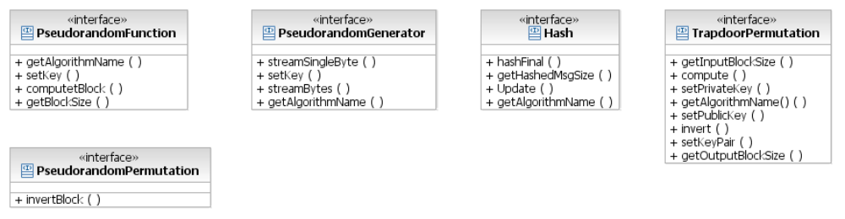

This layer also have two interfaces that provide mathematical services that may also be used by the above realized classes.

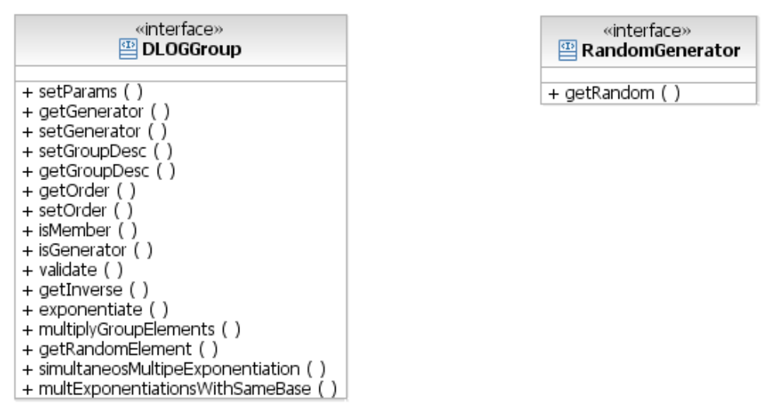

The abstract primitive concepts will be implemented via abstract classes that implement interfaces. Using java interfaces has the advantage that many of them can be implemented for each derived class. Also existing classes that already inherit from other existing classes can implement the interface and be used. In interfaces there is no inherited methods functionality or attributes, rather an interface of methods to be implemented in the derived implementing class. Thus we intend to implement the interfaces via abstract classes since the concrete classes may share some attributes as well as some common functionality. To avoid code duplication the use of abstract classes is essential.
In the following class diagram we present the relationship between the interfaces and the abstract classes. In later diagrams we will not present the interfaces to keep the diagram simpler.

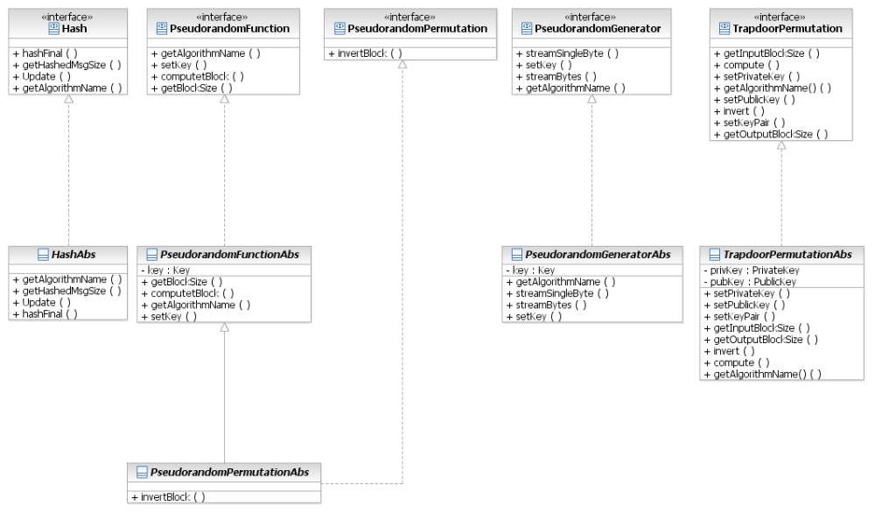

Researcher view
Below is a class diagram of the abstract interfaces (in italic) this layer supports and the derived concrete functionality requested by the researcher. These are taken from the table in reference [3] (there are some concrete classes missing). Note that the derived elements are not classes in code, rather the demanded functionality. In the implementation some concepts will be merged to form a single class. For example RSA_1024, RSA_2048, RSA_4096 are all supplied in a single class.

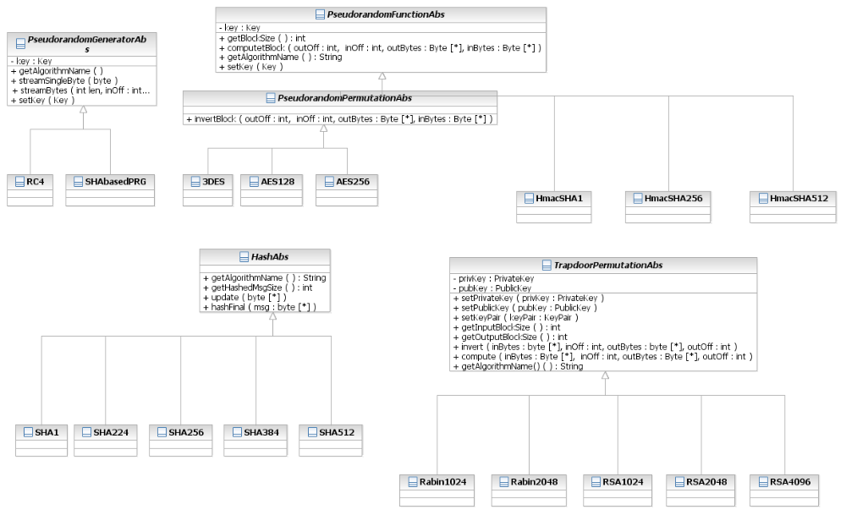

Programmer view
The following diagram presents the view of the programmer. There is no need for a Rabin and RSA classes for different key sizes. On the other hand, the different SHA implementations are too different to be included in the same class.

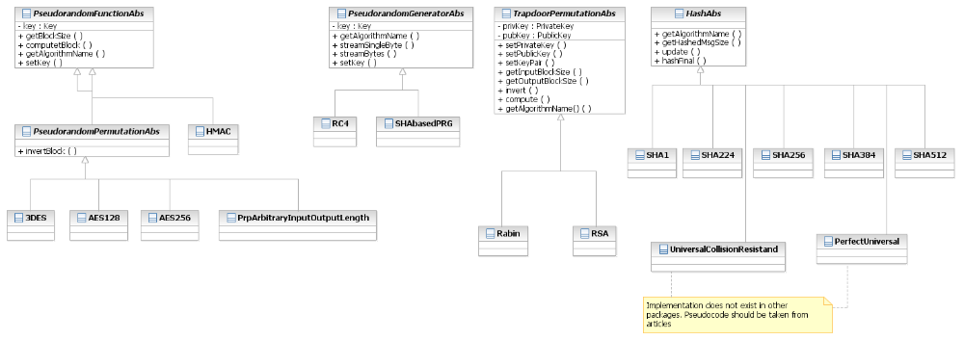

We now get into more details for each interface/abstract class.

Hash
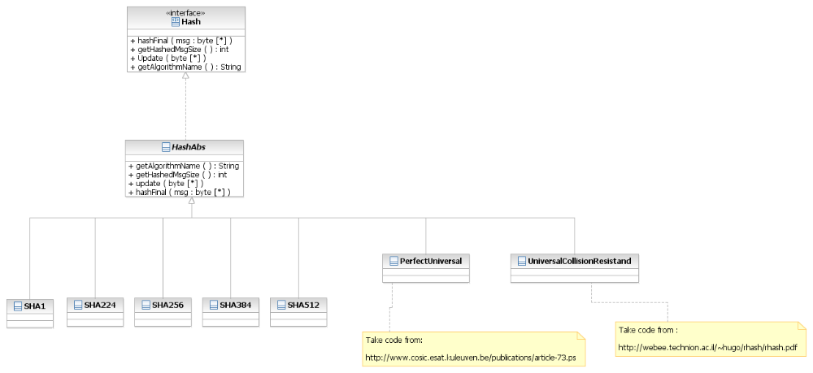

Function : Update
Adds the byte array to the existing msg to hash.

Function : hashFinal
Completes the hash computation.

Pseudorandom Function and Permutation
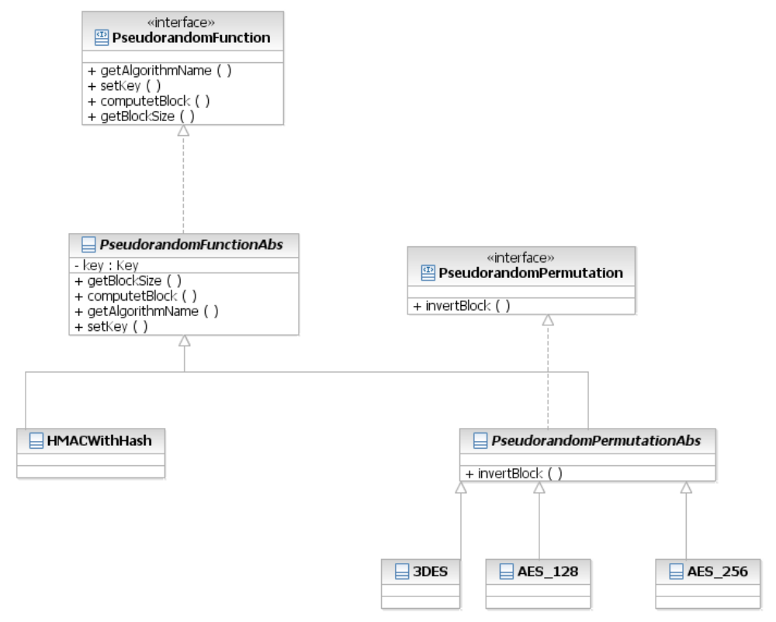

Function : computetBlock
Computes the function using the set key.

Function : invertBlock
Inverts the permutation using the set key. This function is not part of the pseudorandom function class.

Pseudorandom Generator
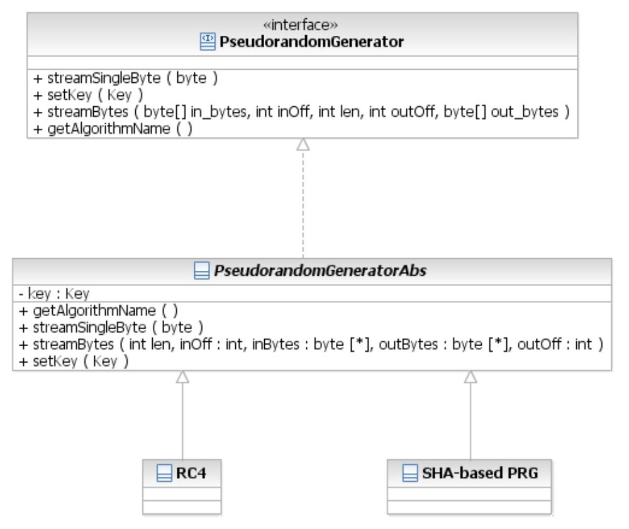

Function : streamBytes
Invoke the stream cipher on the incoming bytes

Trapdoor Permutation

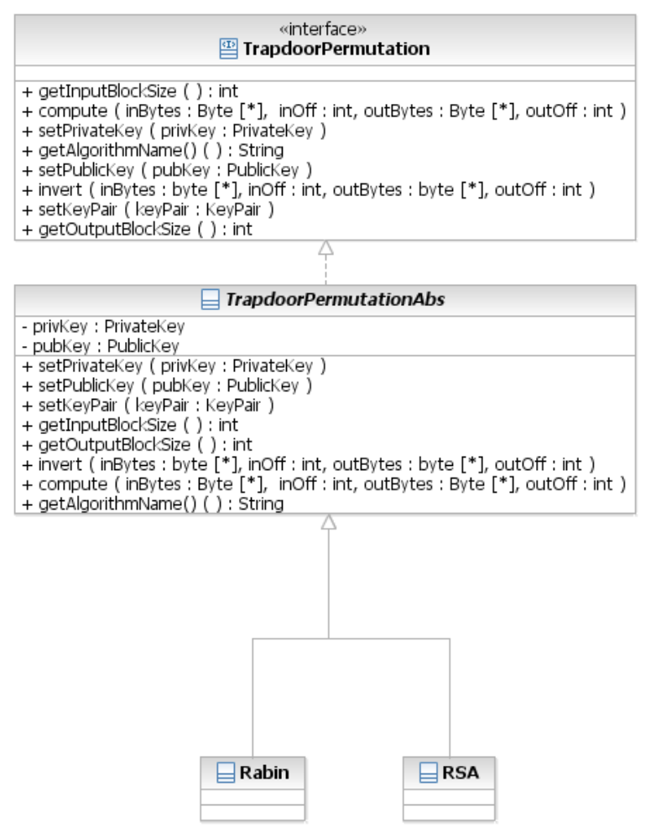

Function : invert
Inverts the function using the private key

Function : compute
Computes the function using the public key

Function : setKeyPair
Sets both public and private keys.

Additional Cryptographic classes:

Pseudorandom Permutation with Arbitrary Input-Output Lengths

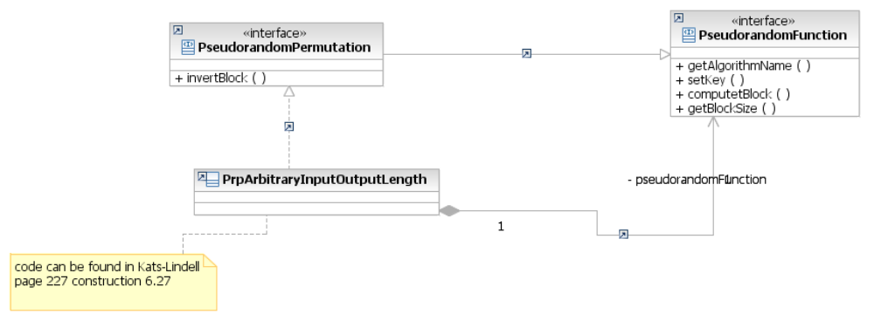

The construction uses Feistel and thus using PRF can be invertible.

computeBlock
Pseudocode in Katz-Lindell, Section 6.6.

invertBlock
Use the Feistel construction to invert the block.

Pseudorandom function with Arbitrary Input-Output Lengths

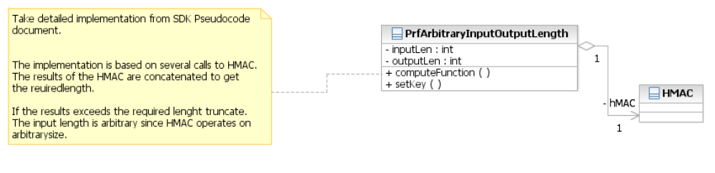

The construction uses Feistel and thus using PRF can be invertable.

computeBlock
Define y = F_{K}(x,outlen) = HMAC_{K}(x,outlen,1),…,HMAC_{K}(x,outlen,m) where m is the smallest integer for which L⋅m > outlen, where L is the output length of HMAC. Then, output y truncated to length outlen. Observe that in terms of input length this is fine because HMAC works for any input length already.

Dlog group
We supply a Discrete log group that can be Zp* or other elliptic curve implementation. The user may request a DlogGroup interface and instantiate totally different groups such as Zp* and EC.

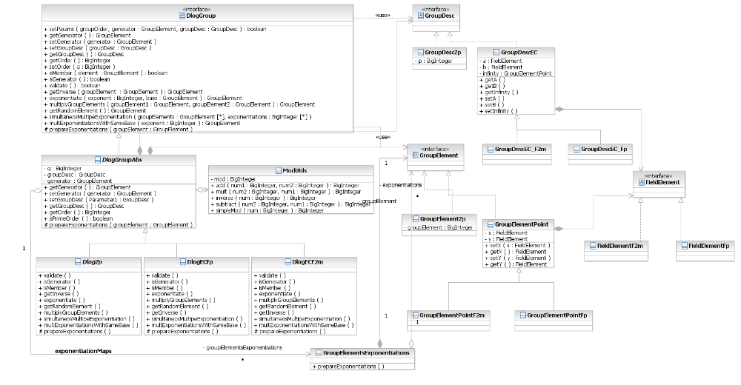

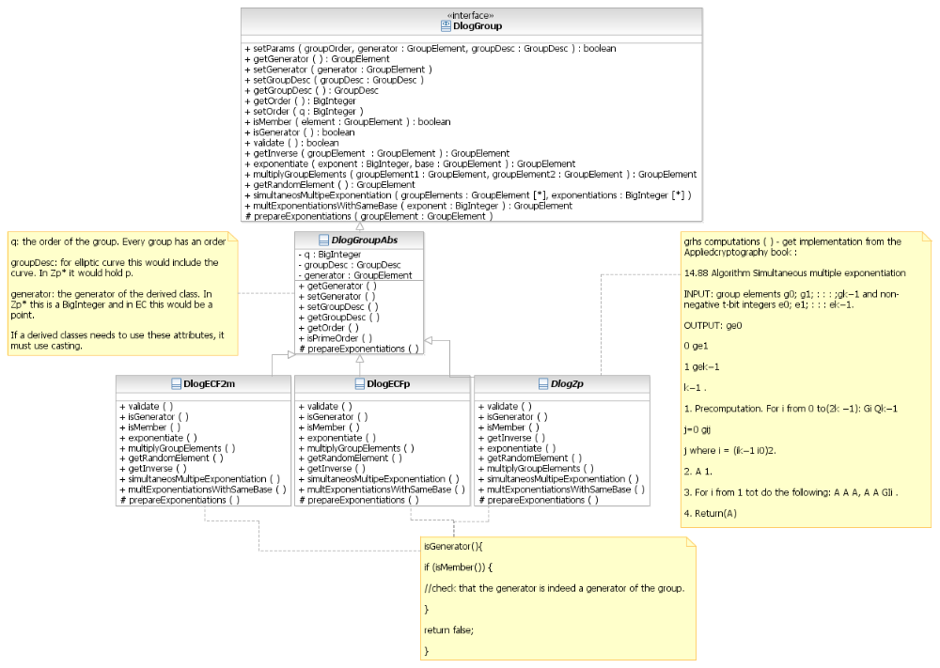

Function : simultaneosMultipeExponentiation (GroupElement[] groupElements ,BigInteger [] exponentiations )
Code taken from the book applied cryptography page 618 , 14.88 Algorithm Simultaneous multiple exponentiation

Let e0; e1; : : : ; ek−1 be positive integers each of bitlength t; some of the high-order bits
of some of the exponents might be 0, but there is at least one ei whose high-order bit is 1.
Forma k_t arrayEA (called the exponent array)whose rows are the binary representations
of the exponents ei, 0 _ i _ k − 1. Let Ij be the non-negative integer whose binary
representation is the jth column, 1 _ j _ t, of EA, where low-order bits are at the top of the column.

14.88 Algorithm Simultaneous multiple exponentiation
INPUT: group elements g0; g1; : : : ; gk−1 and non-negative t-bit integers e0; e1; : : : ek−1.
OUTPUT: ge0
0 ge1
1 _ _ _ gek−1
k−1 .
1. Precomputation. For i from 0 to (2k −1): Gi Qk−1
j=0 gij
j where i = (ik−1 _ _ _ i0)2.
2. A 1.
3. For i from 1 to t do the following: A A _ A, A A _ GIi .
4. Return(A).

Function : GroupElement multExponentiationsWithSameBase (GroupElement groupElement , BigInteger exponent)
Optimization of exponentiations given that the same element is called a number of times. This function calls the private function prepareExponentiations() in order to prepare a vector in the GroupElementsExponentiations class that contains all the exponentiations needed for the optimization. If a GroupElementsExponentiations object already exists (was called with the same GroupElement once before) than the optimization uses the vector possibly adding more exponentiations to it.

KeyDerivationFunction
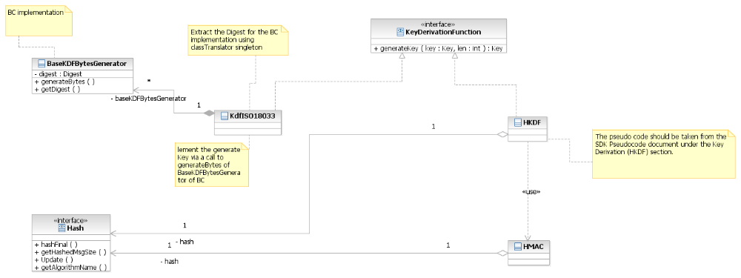

Class HKDF
The implementation of generating a new key is taken from the document SDK pseudocode.

COMPUTE PRK = HMAC(kdfKey, key) [key= kdfKey, data= key (input key)]
Let t be the smallest number so that t⋅|H|>len where |H| is the HMAC output length
K(1) = HMAC(PRK,(CTXinfo,0)) [key=PRF, data=(CTXinfo,0)]
FOR i = 2 TO t
K(i) = HMAC(PRK,(K(i-1),CTXinfo,i)) [key=PRF, data=(K(i-1),CTXinfo,i)]
OUTPUT the first len bits from K(1),…,K(t)

Class KdfISO18033
This implementation follows the IEEE P1363a/ISO 18033. This implementation exists in BC and may be taken from there. If we use BC implementation we may only use BC's digest and not our own hash. The way to get the Digest is done using the classTranslator. For more information go to the section on translation from string to concrete classes.

Key manipulating
The java architecture provides a rich key functionality. It provides an interface to create keys, translate between different key representations and load/store keys to/from database. Since the infrastructure provides all of the required utilities additional interfaces will not be provided unlike the interfaces from previous sections. We may take key implementations from Bouncy Castle and if we would like to supply more we would implement/wrap to conform to the interfaces/classes of the JCA/JCE.
The functionally of the keys is taken from http://download.oracle.com/javase/6/docs/technotes/guides/security/crypto/CryptoSpec.html#Key (for more information follow the link)

Key representations:
Key Interface: An opaque key representation is one in which you have no direct access to the key material that constitutes a key. In other words: "opaque" gives you limited access to the key--just the three methods defined by the Key interface (see below): getAlgorithm, getFormat, and getEncoded.
KeyPair Class: The KeyPair class is a simple holder for a key pair (a public key and a private key). It has two public methods, one for returning the private key, and the other for returning the public key:
PrivateKey getPrivate()
PublicKey getPublic()

The KeySpec Interface: This interface contains no methods or constants. Its only purpose is to group and provide type safety for all key specifications. All key specifications must implement this interface.

Key translation
The KeyFactory class: The KeyFactory class is an engine class designed to perform conversions between opaque cryptographic Keys and key specifications (transparent representations of the underlying key material). 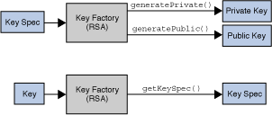
Key factories are bi-directional. They allow you to build an opaque key object from a given key specification (key material), or to retrieve the underlying key material of a key object in a suitable format.
The SecretKeyFactory Class: This class represents a factory for secret keys. Unlike KeyFactory, a javax.crypto.SecretKeyFactory object operates only on secret (symmetric) keys, whereas a java.security.KeyFactory object processes the public and private key components of a key pair.
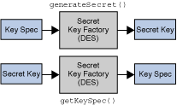
Key factories are used to convert Keys (opaque cryptographic keys of type java.security.Key) into key specifications (transparent representations of the underlying key material in a suitable format), and vice versa.

Key creation
The KeyPairGenerator Class: The KeyPairGenerator class is an engine class used to generate pairs of public and private keys.
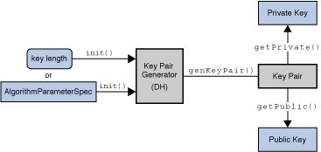
There are two ways to generate a key pair: in an algorithm-independent manner, and in an algorithm-specific manner. The only difference between the two is the initialization of the object.

The KeyGenerator Class: A key generator is used to generate secret keys for symmetric algorithms.
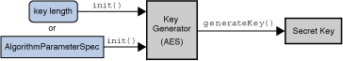

Key management

The KeyStore Class: The KeyStore class is an engine class that supplies well-defined interfaces to access and modify the information in a keystore. 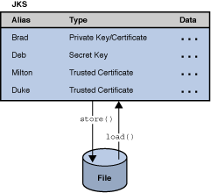
Note that we do not have to write our own KeyStore. We can use Sun or BC implementations that are suitable for all the elements of this layer. Unlike other classes there should not be one for each algorithm rather, each KeyStore is suitable for all algorithms.

To use all of the above classes of the security architecture we will implement the relevant key abstract classs/interfaces with respect to each primitive. I.e., for RSA, Elgammal, AES, DES and so on. This will be done by extending from the relevant engines and implementing the relevant interfaces. For example for RSA we should have RSAPublicKey, RSAPrivateKey, RSAKeySpec, RSAKeyFactory, RSAKeyPairGenerator and the general KeyStore.

Wrapping
If a good given implementation is given we will wrap this implementation using the adapter design pattern. Below are some examples wrappings of Bouncy castle implementations.
In general if the wrapped package has a general interface/abstract class similar to our primitive we would prefer a general class with a reference to that interface/abstract class. An example of such general classes can be found in the examples of PRP and Hash using the interfaces of Bouncy Castle. If there is no such interface/abstract class we would have to wrap each concrete primitive one by one.

Our wrappings are done using the adapter design pattern.
The adapter design pattern class diagram:

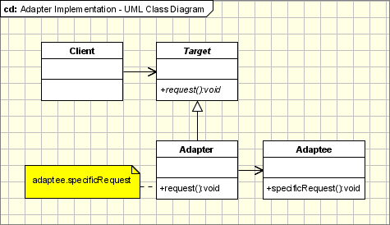

PRP - BC

The pseudorandom permutation class represents the target class in the adapter design pattern, the adapter is the class BC_PRP and the adaptee is the implementation of BC of DES in the class DESEngine. The BC_ PRP (adapter) implements the pseudorandom permutation interface (for example the functions decrypt, getAlgorithmName and so on) and calls functions implemented in the DESEngine such as processBlock().

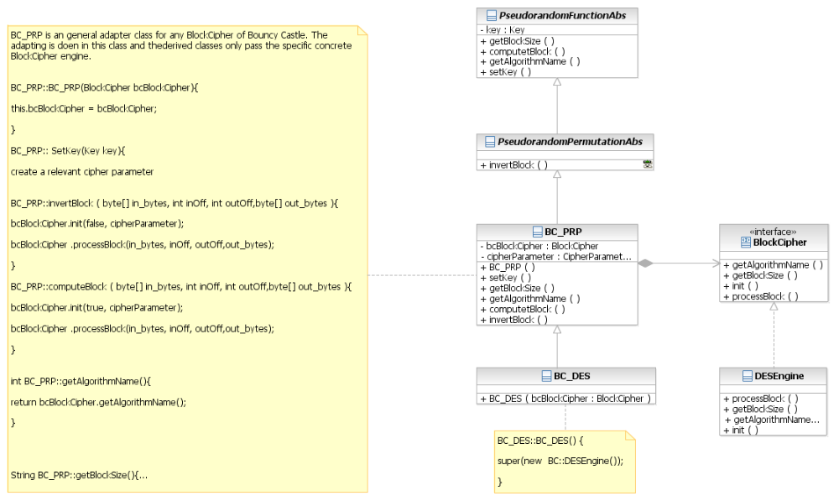

Hash - BC
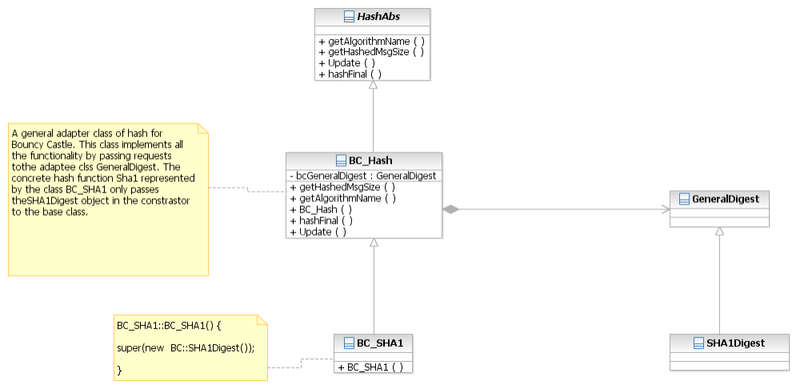

PRG - BC
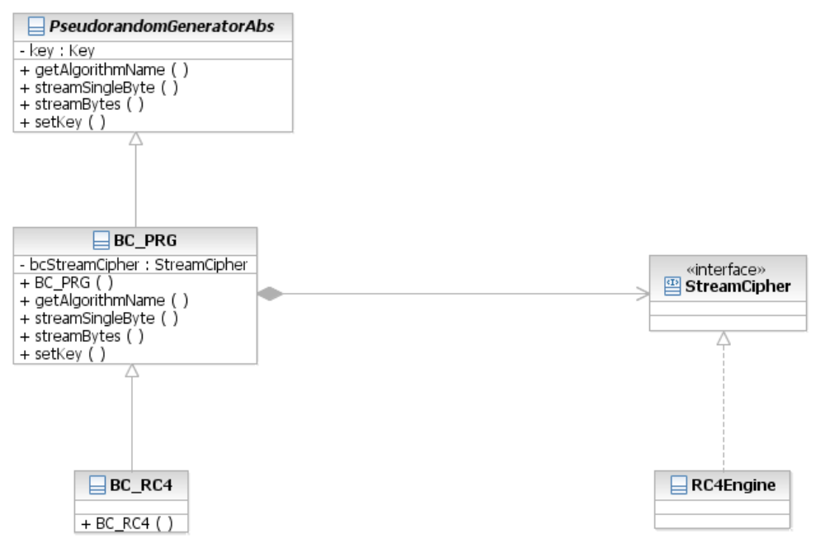

TrapdoorPermutation - BC
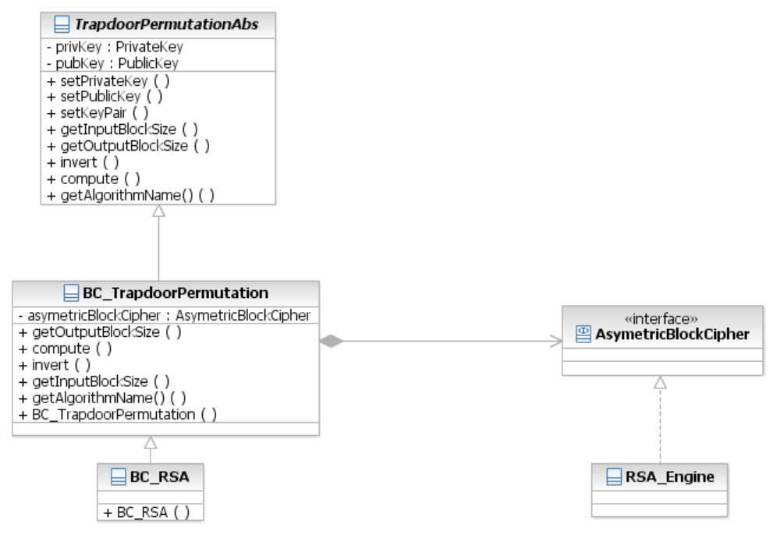

TrapdoorPermutation (Rabin) – Crypto++
Wrapping for crypto++ is different since we use the JNI tool. The JNI tool provides functions and not classes and thus to generate a class from C++ we will have a related class that calls the relevant functions.
The Class Rabin is not implemented in BC and would be imported from a different package.

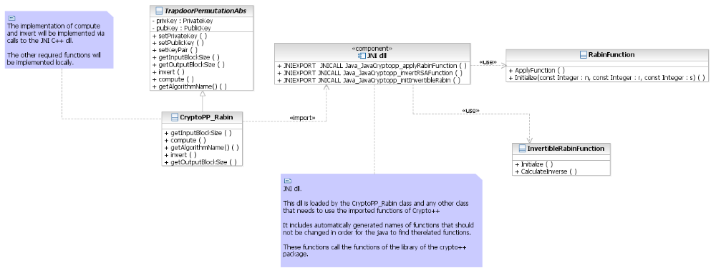

Translation from string to concrete classes
Our aim is to provide the primitive functionality to the user of the package without requiring any knowledge of the supplied classes. Meaning, the user needs to specify the known cryptographic name of the primitive algorithm and the infrastructure will provide the right class. E.g., "DES" for the pseudorandom permutation DES.
This requirement eases the use as well as the readability of a client application.
There is another advantage. Suppose we wish to wrap a higher level cryptographic element that uses a primitive interface in its inner implementation. For example, HMAC of BC holds a Digest interface but requires a specific digest to invoke it's main functions. However the users of our tool are not familiar with the classes of BC. Yet if we wish to wrap this class we will need to pass a Digest (specified by the user) to the wrapped BC HMAC.

The user request an algorithm by it's string name. For example:
PseudorandomPermutation prpDes = classTranslator.getInstance().getPRP("DES");
prpDes.computeBlock();

Another option is to add a static method to each of our abstract classes (that implement the main interfaces) and call the translator from there. For example

PseudorandomPermutation prpDes = PseudorandomPermutation.getPRP ("DES");
prpDes.computeBlock();

In this case the static function getPRP will be as follows

PseudorandomPermutation getPRP(String name){
return classTranslator.getInstance().getPRP (name);
}

The translator gets an algorithm name and returns an instance of the requested algorithm class. In order to load a class from a string name we will use the ClassLoader of java to create an instance of class Class (java) and use its newInstance method to create an instance of the related class.
The getPRP(string name) method will find the related name of the class and pass it to the class loader in order to load the class. The returned value of the method will be a PseudorandomPermutation instance of the required algorithm.

The related getBCBlockCipher will be called directly by wrapper classes. Since the user of the SDK uses only our classes/interfaces such a call will not be in the client application. Look at the following example
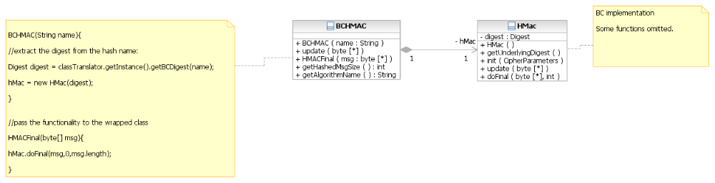

The classTranslator is a singleton since there is no need to create more than one instance. The class contains Properties which is basically a hash that is also very easy to load from a file. We intend to load the name of the classes from a file and thus using Properties here is a natural solution. The design of this class is as follows:

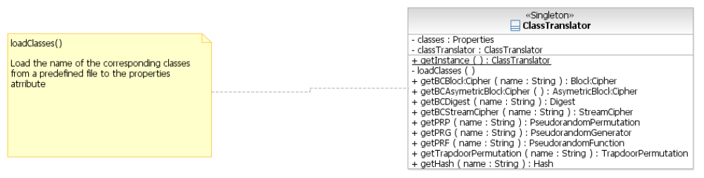
The file to load from will be as follows:

classnames.properties

# This file contains the name of the classes of the SDK as well
# as names of Bouncy castle

DES = DES
BC_DES = DESEngine

SDK Provider
The SDK Provider will be built based on the interfaces. The functionality of the interfaces resembles the functionality of the engines of JCA/JCE and thus implementing the engines is simply writing a general adapter for each interface from which the concrete classes extend to.
Below is an example of generating MessageDigest using the Hash interface/abstract class. Note that the general classes such as the class SDKMessageDigest do not change any of the functionality of the concrete implemented classes of the interfaces. Thus providing a provider accompanying the required engines can be done separately after the projects matures or in parallel.

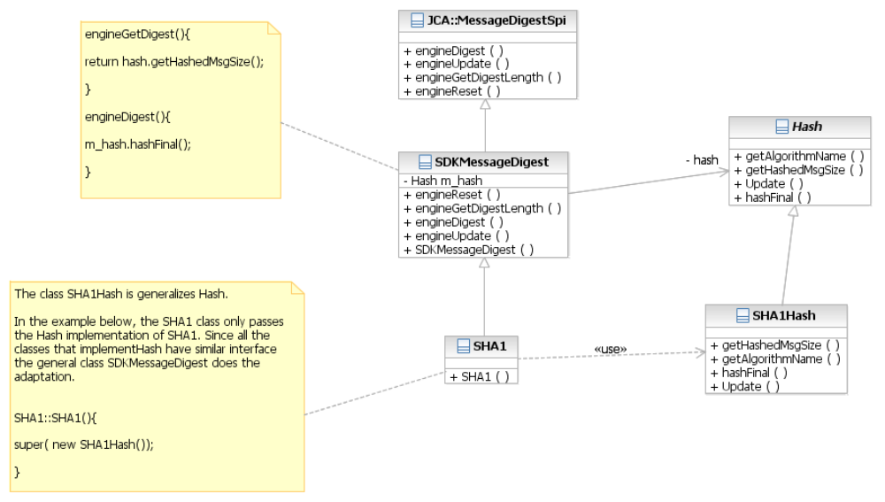

JNI technology

As a test of concept we have implemented one call from Java to a native function from crypto++. We have implemented a call to a function that returns the name of the Rabin Algorithm. Check files JavaCryptopp.java, JavaInterface.cpp and rabin.cpp
in the appendix.

The lib file is integrated into the environment of the C++ dll project and thus creating the object CryptoPP::Rabin rb; is possible. The dll JavaInterface.dll is built and the java file loads it by the call: System.loadLibrary("JavaInterface");
It then able to call the function: jc.loadRabinName(); which is the related function (whose name is automatically generated and should not be changed): JNIEXPORT jstring JNICALL Java_JavaCryptopp_loadRabinName
(JNIEnv *env, jobject) in the dll. This function simply returns the string from the native function StaticAlgorithmName().

The actual function: static std::string StaticAlgorithmName() {return "Rabin-Crypto++Variant";} in crypto++ is called from java.
The java program output the string "Rabin-Crypto++Variant" to the screen due to the following two lines in the java file:

String str = jc.loadRabinName();
System.out.println(str);

In order to convert more functions from crypto++ to Java more functions should be added to the C++ JavaInterface.dll. Only functions that are converted in the dll can be called from Java. Hopefully as the project progresses more and more functionality will be added to the dll and dll's for other native libraries.

Performance
In some cases the C/C++ implementations are faster than the Java implementation. After testing JNI, we conclude that the JNI adds few milliseconds to thousands of calls and thus adds a negligible amount of time to the overall running time.

Multi-Platform Issues
We would like the program to run on different platforms. Thus implementation is done in java. However since we intend to use packages that are written in different languages, the use of these packages may be platform dependent.
There are two options to overcome this. The first option is to refrain from using packages written in languages other than Java and thus provide a slimmer SDK package.
The other option is to build a version for each platform. This means that the integrated used package is build for each platform separately and we keep a version for each platform.

Backward-Compatibility

Benchmarking
We have checked the raw RSA (encrypt and decrypt) of crypto++ and Bouncy Castle and received the following results.

Encrypt 1024
Package/iterations | 100 | 1000 | 10000 | 100000
Crypto++ release |  | 0.031 | 0.421 | 4.235
BC |  | 0.062 | 0.657 | 6.578
Decrypt 1024
Package/iterations | 100 | 1000 | 10000 | 100000
Crypto++ release | 0.265 | 2.719 | 27.125
BC | 0.718 | 7.109
Encrypt 2048
Package/iterations | 100 | 1000 | 10000 | 100000
Crypto++ release |  | 0.109 | 1.093 | 10.953
BC |  | 0.25 | 2.469 | 24.65
Decrypt 2048
Package/iterations | 100 | 1000 | 10000 | 100000
Crypto++ release | 1.578 | 15.843
BC | 4.547 | 45.516

Open Issues

- As a first step of deciding which functionality the interfaces of the API require we examined the JCA/JCE engines and the BC light-weight API. This in the following table in the file: [2] SDK_interface.xlsx.
- 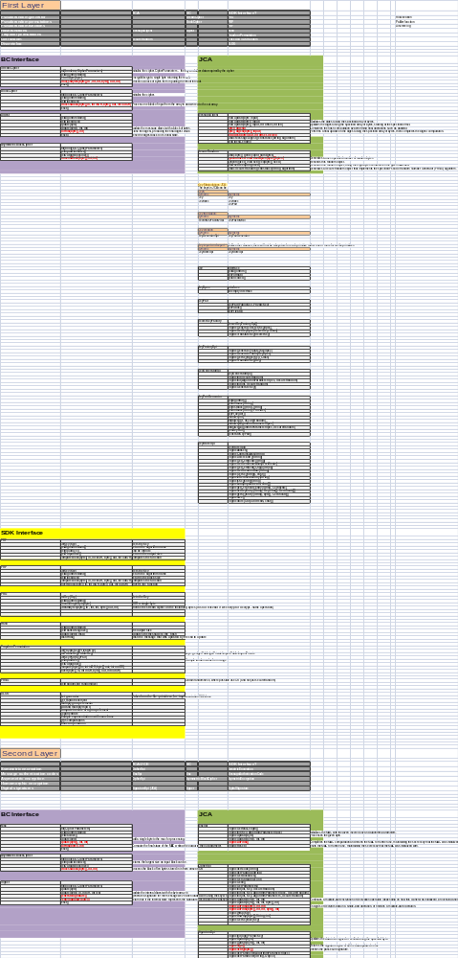2. Wrapping from SDK : In order to use code from other packages we may want to wrap our implementation. For example, if we would like to use CBC-MAC we need a pseudorandom permutation. If we would like to get the CBC-MAC implementation from bouncy castle we need to wrap our implementation of PRP to Bouncy castle BlockCipher. This wrapping is shown in the following class diagram.

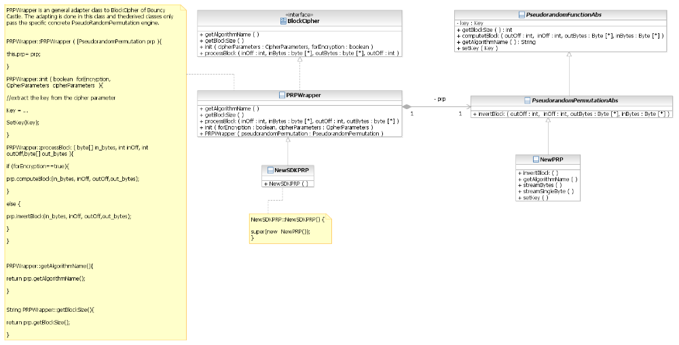

Appendix A

9.1 From crypto++ to Java using JNI.
The following files are needed for the use of JNI.

- Java file:

JavaCryptopp.java

public class JavaCryptopp {

private native String loadRabinName();
public static void main(String[] args) {
JavaCryptopp jc = new JavaCryptopp();

String str = jc.loadRabinName();
System.out.println(str);
}
static {
System.loadLibrary("JavaInterface");
}
}

- C++ dll
JavaInterface.cpp

// JavaInterface.cpp : Defines the entry point for the DLL application.
//

#include "jni.h"
#include "stdafx.h"
#include "filter.h"
#include "rabin.h"
#include <string>
#include "JavaCryptopp.h"

using namespace std;

BOOL APIENTRY DllMain( HANDLE hModule,
DWORD ul_reason_for_call,
LPVOID lpReserved
)
{

return TRUE;
}

JNIEXPORT jstring JNICALL Java_JavaCryptopp_loadRabinName
(JNIEnv *env, jobject)
{
CryptoPP::Rabin rb;
string ls = rb.StaticAlgorithmName();

return env->NewStringUTF(ls.c_str());
}

- Crypto++ related code in file:

rabin.cpp

//! Rabin
struct Rabin
{
static std::string StaticAlgorithmName() {return "Rabin-Crypto++Variant";}
typedef RabinFunction PublicKey;
typedef InvertibleRabinFunction PrivateKey;
};

