SDK Primitive Layer

R&D Team

High Level

First Level – Primitive Layer

Software Design Description

Written by Meital Levy

Approved by

Created September 20, 2010

Modified

Change Control Information
Version No. | Date | Changed by | Scope of Change
1.00 | 20-Sep-2010 | Meital Levy | Initial version
1.1 | 11-Oct-2010 | Meital Levy | Added the required interfaces.

Table of Contents
1. Scope 4
1.1 Introduction 4
1.2 Goals 4
2. Definitions Acronyms and Abbreviations 4
3. References 5
4. Wide Design Decisions 5
5. Design Considerations 6
6. Detailed design 7
7. Performance 11
8. Multi-Platform Issues 11
Open Issues 11

Scope
The Crypto SDK exists as a service for high-level multi-party computation protocols as well as a standalone product. High-level protocols will be built upon the low-level primitives in the SDK. The Crypto SDK is composed of the following three layers.
- Low-level crypto functions.
- Non-interactive mid-level crypto functions.
- Interactive mid-level crypto functions.
The purpose of this SDD is to design the low level crypto functions based on existing packages.

Introduction
The Crypto SDK is a wide set of cryptographic tools that is the basis to higher-level cryptographic protocols as well as a standalone tool.
As mentioned above it can be divided into three logical layers. From the first layer including cryptographic primitives to the last layer that includes mid-level cryptographic protocols.
Functions in the first level are independent of other functions. They are the building blocks of functions of other layers as well as independent applications and as such should supply an easy to use API.

Goals
The purpose is to provide a reliable, efficient, flexible cryptographic low level layer as the basis of the development of the two higher cryptographic layers.
We aim to provide a rich layer and thus import functionality of good existing packages in parallel. The first layer provides the user ability to choose which source of a specific cryptographic function to use in run time, e.g. the version provided by Bouncy Castle, crypto++ and so on.

Definitions Acronyms and Abbreviations

MPC | Multi Party Computation
JCA | Java Cryptography Architecture
JNI | Java Native Interface

References

[1] Crypto SDK Software Requirements Specifications (SRS)
[2] SDK_interface.xlsx
[3] primitives_for_implementationV2.2.docx

Wide Design Decisions

- Our implementation will be written in Java. We use the provider architecture of the JCA to supply our own provider as well as a detailed API containing interfaces for abstract concepts such as:
  - Pseudorandom generator
  - Pseudorandom permutation
  - Pseudorandom function
  - Hash function
  - Trapdoor permutations
  - Get random
  - Discrete log Library
New interfaces may be added as needed in newer versions of the SDK.
The required functionality that the SDK should provide can be found in the following table that is part of the file [3] primitives_for_implementationV2.2.docx

Layer 1 – Low-Level Primitives
Libraries to use: Bouncy Castle, CACE, Crypto++
General
1. GetRandom: use cryptographic call, if possible from OS
2. Randomness extraction HKDF: http://eprint.iacr.org/2010/264
Pseudorandom generator
1. RC4 (throw out first 1024 bytes)
2. SHA-based PRG
Pseudorandom permutations
1. AES_128
2. AES_256
3. 3DES
4. PRP for arbitrary input/output length
Pseudorandom functions
1. All of the pseudorandom permutations
2. HMAC_SHA-1
3. HMAC_SHA-256
4. HMAC_SHA-512
5.
PRFs with arbitrary input and output length

a. Arbitrary input length: using any of the HMAC-SHA constructions
b. Arbitrary output length:
i. If shorter than basic, truncate
ii. If longer than basic: apply multiple times with CTR index
(if do this, then the concrete instance with a given key must ALWAYS use this mode)
Hash functions
1. SHA-1
2. SHA-256
3. SHA-224 (this is truncated SHA-256)
4. SHA-512
5. SHA-384 (this is truncated SHA-512)
6. Universal one-way/target collision-resistant hashing: http://webee.technion.ac.il/~hugo/rhash/rhash.pdf
7. Perfect universal hash functions (use package giving GF[2^{k}] computations)
a. GF[2k] operations: http://www.shoup.net/ntl/doc/tour-modules.html
b. http://www.cosic.esat.kuleuven.be/publications/article-73.ps
Trapdoor permutations
1. RSA_1024
2. RSA_2048
3. RSA_4096
4. Rabin_1024
5. Rabin_2048
Discrete log
1. Z_{p}* for p of length 1024, with p=2q+1 and q prime (group of order q); fine also with general q
2. Z_{p}* for p of length 2048, with p=2q+1 and q prime (group of order q)
3. Elliptic curve groups: as given by NIST and implemented in bouncy castle, CACE or whatever you find
Minimal operations:
a. Get generator
b. Get random element
c. Multiply group elements
d. Add and multiply mod q
e. Compute inverse of a group element
f. Exponentiate
g. Multiple exponentiations with same base
h. g^{r}h^{s} computations
i. Bilinear operations
Quadratic residuosity (QR)
1. Modulus of length 1024
2. Modulus of length 2048
Lattice constructions

The infrastructure will be built upon several cryptographic packages.
  - Java JDK(Java)
  - Sun Provider (Java)
  - Crypto++ (C++)
  - CACE – salt (C)
  - Bouncy castle (Java)
  - Any other cryptographic low level implementation we will find suitable including possibly our own.
- An interface dll translating from crypto++ and CACE-salt to Java will be provided by using JNI. JNI is a programming platform that allows Java code running in a JVM to call and to be called by native applications and libraries written in other languages, such as C and C++.
On top of these interfaces, a wrapping will be written to match our java interfaces mentioned above.
Also, in a later stage we may provide engines and providers for each package.
We will write JNI interface, wrappings and provider/engines only for the functionality we intend to use. However, in the future, as the code progresses the cryptographic community may use our provider and JNI interface to add more functionality from native crypto++ and CACE-salt.
- Bouncy castle is written in Java and uses the provider architecture of the security package of Java and thus will be easy to integrate into this layer. In order to use the BC code we will write wrappings for written classes to match our first layer API interfaces.
- The crypto SDK provider chooses one default implementation for each cryptographic primitive, if a specific implementation is needed by the user it can be easily retrieved by a specific call to the required provider (if provided).
- The performance of calling many functions on the way to the specific native function should be taken into account. If a good java implementation can be found it will be preferred on a native implementation that requires a number of steps just to get to the required native function. It is recommended that only functionality that has clear superiority over other java implementations should be call/implemented. Note that the java interface that converts a function from a native language is both complicated and prone to error.

Design Considerations
The functionality of this layer is taken from different well already written and tested known packages. An easy to use API via interfaces as well as a provider will be supplied in this layer. The concrete implementation of these interfaces will be either our own implementations or wrappings from other packages. Also, for each cryptographic package we would like to write a java provider if one is not already provided.

Below one can find the main ideas of the provider architecture and a link for further information.

The provider architecture:
The following text is taken from chapter 8 of the book Java™ Security by Scott Oaks. For further information, follow this link: http://docstore.mik.ua/orelly/java-ent/security/ch08_01.htm

"The security provider abstracts two ideas: engines and algorithms. In this context, "engine" is just another word for operation; there are certain operations the security provider knows about, and in Java, these operations are known as engines. An algorithm defines how a particular operation should be executed. An algorithm can be thought of as an implementation of an engine, but that can lead to confusion, because there may be several implementations of an algorithm.
As a simple example, the Java security package knows about message digests. A message digest is an engine: it is an operation a programmer can perform. The idea behind a message digest is independent of how any particular message digest may be calculated. All message digests share certain features, and the class that abstracts these common features into a single interface is termed an engine. Engines are generally abstract, and are always independent of any particular algorithm.
A message digest may be implemented by a particular algorithm, such as MD5 or SHA. An algorithm is generally provided as a concrete class that extends an abstract engine class, completing the definition of the class. However, there may be many classes that provide a particular algorithm; you may have an SHA class that came with your Java platform, and you may also have obtained an SHA class from a third party. Both classes should provide the same results, but their internal implementations may be vastly different.
Security providers are the glue that manages the mapping between the engines used by the rest of the security package (such as a message digest), the specific algorithms that are valid for those engines (such as an SHA digest), and the specific implementations of that algorithm/engine pair that might be available to any particular Java virtual machine. The goal of the security provider interface is to allow an easy mechanism where the specific algorithms and their implementations can be easily changed or substituted. The security provider allows us to change the implementation of the SHA digest algorithm that is in use, and to introduce a new algorithm to generate a digest.
Hence, a typical programmer only uses the engine classes to perform particular operations. You don't need to worry about the classes that actually perform the computation. The engine classes provide the primary interface to the security package."

The crypto SDK primitive layer will be written also using the provider architecture and thus will supply the SDK provider. This will give the user a simple and known way to call functionalities.
Part of this layer is to write providers for other known packages and java interface if required.

JNI (Java Native Interface ) technology

The following text is taken from chapter 5 of Sun Developer Network. For further information follow the following links: http://java.sun.com/developer/onlineTraining/Programming/JDCBook/jni.html
http://java.sun.com/docs/books/jni/html/jniTOC.html

" The Java platform is relatively new, which means there could be times when you will need to integrate programs written with the Java language with existing non-Java language services, API toolkits, and programs. The Java platform provides the Java Native Interface (JNI) to help ease this type of integration.
The JNI defines a standard naming and calling convention so the Java¹ virtual machine can locate and invoke native methods. In fact, JNI is built into the Java virtual machine so the Java virtual machine can invoke local system calls to perform input and output, graphics, networking, and threading operations on the host operating system.
This chapter explains how to use JNI in programs written in the Java language to call any libraries on the local machine, call Java language methods from inside native code, and how to create and run a Java VM instance."
An interface translating from crypto++ and CACE-salt to Java will be provided by using JNI. Since We do not intend to change the provided libraries of crypto++ and CACE we will provide an independent dll's for each library including the functionality we choose.

Detailed design

In this section we present the API interfaces as conceived by the researcher and the programmer. The wrapping mechanism is presented and we also elaborate on the JNI thecnology.

The API interfaces.

Researcher view
Below is a class diagram of the abstract interfaces (in italic) this layer supports and the derived concrete functionality requested by the researcher. These are taken from the table in reference [3] (there are some concrete classes missing). Note that the derived elements are not classes in code, rather the demanded functionality. In the implementation some concepts will be merged to form a single. For example RSA_1024, RSA_2048, RSA_4096 are all supplied in a single class.

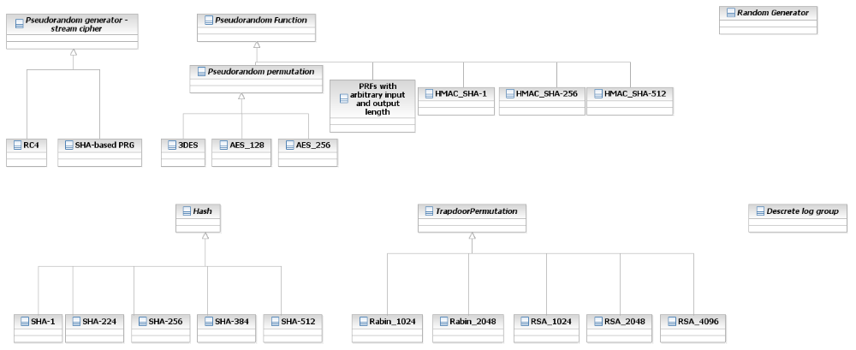

Programmer view

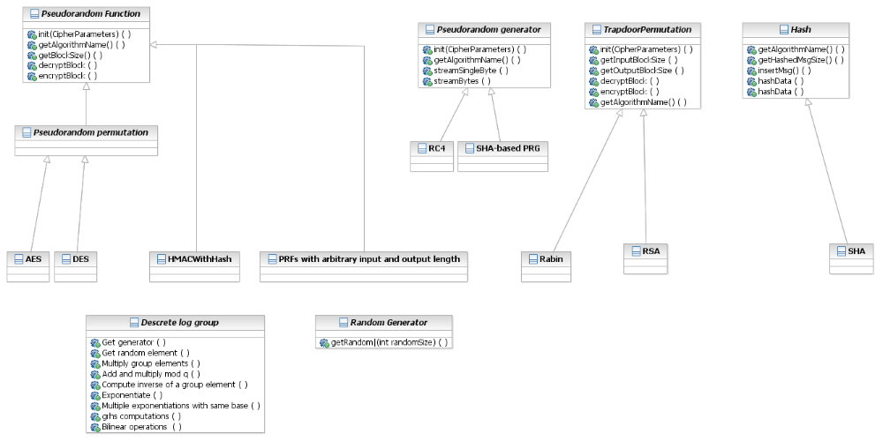

Wrapping
If a good given implementation is given we will wrap this implementation using the adapter design pattern. Below are some examples wrappings of Bouncy castle implementations.
In general if the wrapped package has a general interface/abstract class similar to our primitive we would prefer a general class with a reference to that interface/abstract class. An example of such general classes can be found in the examples of PRP and Hash using the interfaces of Bouncy Castle. If there is no such interface/abstract class we would have to wrap each concrete primitive one by one similar to the example of trapdoor permutation below.

Our wrappings are done using the adapter design pattern.
The adapter design pattern class diagram:

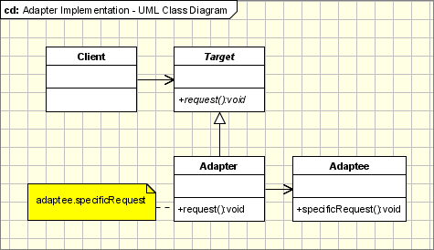

PRP

The pseudorandom permutation class represents the target class in the adapter design pattern, the adapter is the class BC_PRP and the adaptee is the implementation of BC of DES in the class DESEngine. The BC_ PRP (adapter) implements the pseudorandom permutation interface (for example the functions decrypt, getAlgorithmName and so on) and calls functions implemented in the DESEngine such as processBlock().

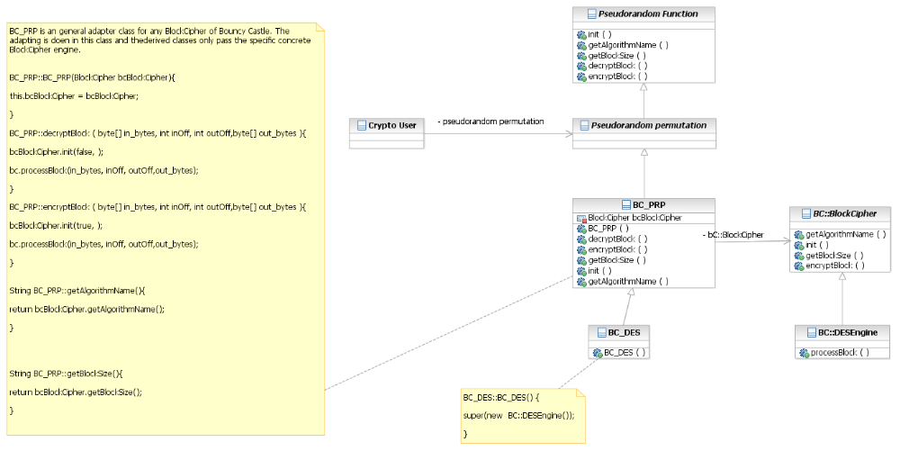

Hash
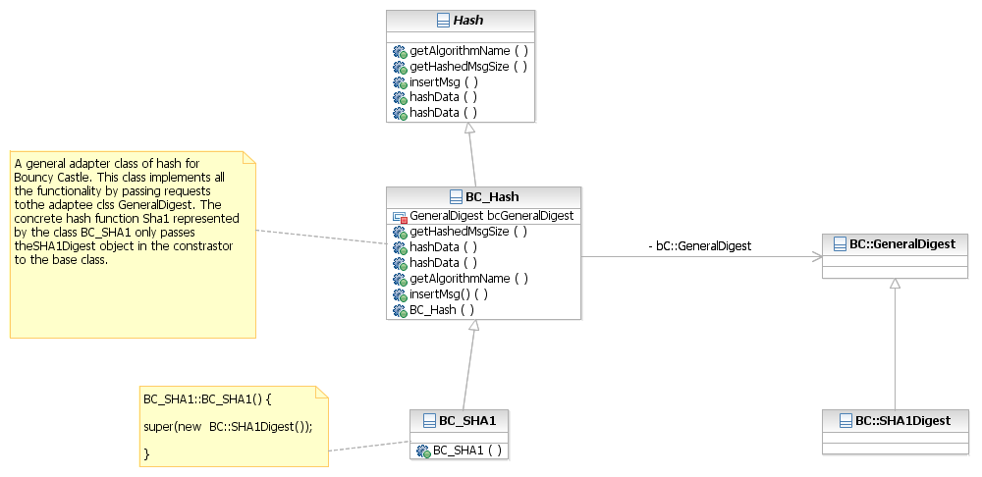

JNI technology

As a test of concept we have implemented one call from Java to a native function from crypto++. We have implemented a call to a function that returns the name of the Rabin Algorithm. Check files JavaCryptopp.java, JavaInterface.cpp and rabin.cpp
in the appendix.

The lib file is integrated into the environment of the C++ dll project and thus creating the object CryptoPP::Rabin rb; is possible. The dll JavaInterface.dll is built and the java file loads it by the call: System.loadLibrary("JavaInterface");
It then able to call the function: jc.loadRabinName(); which is the related function (whose name is automatically generated and should not be changed): JNIEXPORT jstring JNICALL Java_JavaCryptopp_loadRabinName
(JNIEnv *env, jobject) in the dll. This function simply returns the string from the native function StaticAlgorithmName().

The actual function: static std::string StaticAlgorithmName() {return "Rabin-Crypto++Variant";} in crypto++ is called from java.
The java program output the string "Rabin-Crypto++Variant" to the screen due to the following two lines in the java file:

String str = jc.loadRabinName();
System.out.println(str);

In order to convert more functions from crypto++ to Java more functions should be added to the C++ JavaInterface.dll. Only functions that are converted in the dll can be called from Java. Hopefully as the project progresses more and more functionality will be added to the dll and dll's for other native libraries.

Performance
Each call to a primitive function may cause a number of steps. Finding the right provider by the security infrastructure might be just is the first step. If the required package is not written in Java then there are additional steps ending at a call to the native function in the native package. This may take a while and thus we will prefer Java providers over native packages.

Multi-Platform Issues
We would like the program to run on different platforms. Thus implementation is done in java. However since we intend to use packages that are written in different languages, the use of these packages may be platform dependent.
There are two options to overcome this. The first option is to refrain from using packages written in languages other than Java and thus provide a slimmer SDK package.
The other option is to build a version for each platform. This means that the integrated used package is build for each platform separately and we keep a version for each platform.

Appendix

9.1 From crypto++ to Java using JNI.

- Java file:

JavaCryptopp.java

public class JavaCryptopp {

private native String loadRabinName();
public static void main(String[] args) {
JavaCryptopp jc = new JavaCryptopp();

String str = jc.loadRabinName();
System.out.println(str);
}
static {
System.loadLibrary("JavaInterface");
}
}

- C++ dll
JavaInterface.cpp

// JavaInterface.cpp : Defines the entry point for the DLL application.
//

#include "jni.h"
#include "stdafx.h"
#include "filter.h"
#include "rabin.h"
#include <string>
#include "JavaCryptopp.h"

using namespace std;

BOOL APIENTRY DllMain( HANDLE hModule,
DWORD ul_reason_for_call,
LPVOID lpReserved
)
{

return TRUE;
}

JNIEXPORT jstring JNICALL Java_JavaCryptopp_loadRabinName
(JNIEnv *env, jobject)
{
CryptoPP::Rabin rb;
string ls = rb.StaticAlgorithmName();

return env->NewStringUTF(ls.c_str());
}

- Crypto++ related code in file:

rabin.cpp

//! Rabin
struct Rabin
{
static std::string StaticAlgorithmName() {return "Rabin-Crypto++Variant";}
typedef RabinFunction PublicKey;
typedef InvertibleRabinFunction PrivateKey;
};

Open Issues

As a first step of deciding which functionality the interfaces of the API require we examined the JCA/JCE engines and the BC light-weight API. This in the following table in the file: [2] SDK_interface.xlsx.
