⚡ CompliScan – Evaluator-Level Website Review
I've reviewed the live website entry point and the GitHub repository for your project:
- Live prototype: https://prototype-complisca.vercel.app/
- GitHub: https://github.com/mufaddalbatti53/prototype-complisca
My initial verdict: CompliScan already covers a surprisingly large portion of SIH26262. You should not rebuild it from scratch. You need to make it more regulation-aware, technically defensible, reliable and impressive during a live demonstration.
There is an important distinction in this review: the GitHub README describes the intended capabilities, but a feature described in documentation is not automatically a verified, working feature. I will distinguish documented capabilities from improvements that need implementation or testing.

1. What CompliScan already has
The repository documents eight major modules, a configurable APH workflow engine, five user personas, an AI document-processing pipeline and a simulated clock for testing deadline escalation.
mufaddalbatti53/prototype-complisca · GitHub

Existing product coverage
Application workflow
90% coverage estimate
Automatic route determination, stage transitions and deficiency returns
Pendency monitoring
90% coverage estimate
Ageing buckets, regional workloads and bottleneck analysis
EVC management
85% coverage estimate
Inspection queues, visit scheduling and reports
Compliance monitoring
90% coverage estimate
Undertakings, evidence submission and verification
Document monitoring
90% coverage estimate
Lease, safety certificate and expiry tracking
AI integration
80% coverage estimate
OCR, case briefs and evidence analysis
Audit and access control
85% coverage estimate
Role isolation, activity records and audit exports
My subjective estimate of documented feature coverage against the problem statement, not measured implementation quality or SIH marks.

Existing strengths worth preserving
Existing capability | My assessment
APH workflow engine | Core product differentiator
8 functional modules | Broad PS coverage
Time-machine simulator | Excellent live demo opportunity
Role-based dashboards | Important enterprise capability
AI executive case brief | Directly relevant to the PS
OCR document extraction | Useful practical AI application
Four-level escalation | Strong automation demonstration
Audit trail | Essential for regulatory trust
Do not waste your development time rebuilding these features.
Instead, focus on what could make CompliScan stand out from other teams implementing the same problem statement.

2. The biggest weaknesses I would fix
I found several areas in the repository that deserve attention. Some are more important than adding new features.

P0 – Critical

A. Regulatory accuracy and legal safeguards
This is the biggest issue.
The README describes:
- Scrutiny SLA of 15 days.
- Re-scrutiny SLA of 10 days.
- EVC timelines of 21 days.
- Lease alerts at 90, 60 and 30 days.
- Four escalation levels.
- Level 4 escalation potentially leading to approval revocation.
- Automatic approval holds when documents expire.
These are documented prototype rules, not automatically verified statutory requirements.
mufaddalbatti53/prototype-complisca · GitHub
What needs to change:
- Every rule should have an official source reference.
- Each rule should identify the APH edition, clause, effective date and applicability.
- Differentiate statutory deadlines from configurable internal operational targets.
- Never automatically revoke, suspend or block approval based only on an AI prediction or a simulated timer.
- Require an authorised officer to approve consequential regulatory action.
I would introduce a rule classification:
Rule category | Example | Behaviour
Statutory | Verified APH requirement | Enforce according to authorised configuration
Administrative | Internal processing target | Monitor and alert
Institution-specific | An undertaking deadline | Track the actual prescribed due date
Advisory | AI-generated risk indication | Recommend human review
My recommendation
Replace the label "Statutory SLA" with "Applicable Processing Timeline" wherever the rule has not been verified against an authoritative source.
A government compliance platform must never confuse a developer-defined rule with a legal requirement.

P0 – Critical

B. Your AI evidence verifier is overclaiming
The README says Gemini and OpenCV can verify:
- Land lease conditions.
- Stamp registration information.
- GPS location.
- OEM serial numbers.
- GST invoice matching.
- Equipment authenticity.
Extracting these details is not the same as proving that a document or piece of equipment is genuine.
Change the feature from:
"AI Document Verification"
To:
"AI-Assisted Document Intelligence & Verification Support"
Build this process:
Document intelligence workflow
Institution uploads document
OCR extracts fields and dates
Validation engine checks formats, completeness and inconsistencies
AI flags potential discrepancies with evidence and confidence
Authorised officer reviews and records the verification decision
Add:
- Extracted field versus original document comparison.
- Source page and bounding-box references.
- Confidence scores with uncertainty handling.
- Manual correction facility.
- Duplicate document detection.
- Verification history.
Why this matters: Judges will appreciate AI, but they will trust a system that understands the limitations of AI more than one that claims to authenticate legal documents automatically.

P0 – Critical

C. Improve authentication and audit security
The repository describes role switching, institution isolation and event-sourced audit logs.
mufaddalbatti53/prototype-complisca · GitHub
However, a role switcher in a prototype is not proof of production-grade RBAC.
Make sure:
- Permissions are checked on the backend for every sensitive endpoint.
- Institutions cannot change their own institution ID to access another institution's data.
- Regional officers cannot access unauthorised regional records.
- Critical actions require explicit authorisation.
- Audit events cannot be edited or deleted by ordinary administrators.
- File uploads have type, size and malware checks.
- API secrets never reach frontend code.
- Every consequential action records actor, timestamp, previous value, new value and reason.
For the prototype, demonstrate a negative permission test:
Try accessing another institution's application using a modified API request. It must return 403 Forbidden.
That is much more convincing than simply changing a role dropdown.

3. Features I would add to make CompliScan genuinely different
These are the additions I would prioritise, in order.

P1 – Highest differentiation

1. APH Rule Traceability Engine
My strongest recommendation
Currently, CompliScan describes an editable APH configuration. Take this further.
Every workflow transition should explain exactly why it is permitted.
For example:
Application APH-2026-1041
Route determined
Selected workflow: Scrutiny → EVC → SAC/SHC
Why was this route selected?
- Application category: New Institution
- Applicable rule: Configured application-category mapping
- Rule version: APH configuration v1.2
- Source reference: Handbook edition and verified clause
- Effective date: Configured effective date
Decision trace
Application category validated
Workflow rule matched
Authorised transition available
Why it stands out: Judges can see that your platform is not just automatically moving applications. It can explain and trace the regulatory basis for its actions.

2. Smart Case Handover & Workload Balancing
High impact
The README already describes workload bars and regional pendency analytics. Add a proper task-assignment and handover system.
Features:
- Officer-wise pending tasks.
- Current case owner.
- Assignment and reassignment history.
- Leave/unavailability handover.
- Workload distribution suggestions.
- Unassigned application detection.
- Escalation when ownership is missing.
Example:
An application is pending with Officer A, who becomes unavailable.
The system:
- Detects the unavailability.
- Identifies eligible officers.
- Suggests reassignment based on jurisdiction and workload.
- Requests authorised reassignment.
- Records the handover in the audit trail.
Do not automatically transfer statutory responsibility without authorisation.

3. Predictive Pendency Intelligence
High impact
Move beyond showing how many applications are overdue.
Introduce a feature called Pendency Intelligence Centre.
Illustrative Pendency Intelligence Dashboard

12
Critical pending cases

18
At risk of delay

7
Unassigned cases

4
Bottleneck stages
Example AI-assisted insight
EVC scheduling bottleneck
8 applications have remained in the EVC queue longer than their configured target.
Suggested action: Review committee availability and outstanding scheduling tasks.
Illustrative synthetic dashboard data, not actual AICTE statistics.
Add these capabilities:
- Average stage processing time.
- Median stage processing time.
- Region-wise comparison.
- Officer-wise workload.
- Historical bottleneck patterns.
- Forecast of cases likely to breach configured targets.
Start with rule-based forecasting and historical statistics. Only introduce machine learning when you have sufficient trustworthy historical data.

4. Deadline Calendar & Compliance Command Centre
Currently, the repository describes compliance and document modules separately.
Connect them into one unified calendar.
Compliance Reminder Software & Compliance Task Management | CSTrax
Compliance Deadline Tracking | CSTrax Use Cases
Configure the Workspace Site [Case Management Studio]
9
Include:
- Upcoming undertaking deadlines.
- Lease expiry.
- Fire NOC expiry.
- Building safety certificate expiry.
- EVC scheduling.
- Pending document verification.
- Overdue actions.
Add filters by institution, region, responsible officer and compliance category.
This gives officials one place to see everything that needs attention.

5. Notification Delivery & Acknowledgement Tracking
The README describes automated reminders and notifications. Make the entire delivery lifecycle visible.
Notification state | Meaning
Generated | System created alert
Queued | Awaiting delivery
Delivered | Provider confirmed delivery
Failed | Delivery unsuccessful
Acknowledged | Recipient acknowledged
Resolved | Underlying action completed
Also add:
- Retry mechanism.
- In-app notifications.
- Email integration.
- Configurable reminder preferences.
- Notification history.
- Escalation delivery confirmation.
An alert being generated is not the same as an official receiving it.

6. Integration Gateway for Existing AICTE Systems
The problem statement specifically mentions integration with existing authorised AICTE systems wherever feasible.
Add an integration architecture rather than merely promising integration.
AICTE Integration Gateway
Existing authorised AICTE systems
Integration Gateway
- API authentication
- Data mapping
- Validation
- Duplicate detection
- Error handling
- Synchronisation logs
CompliScan Core Platform
Demonstrate this with a mock API or sample data import if live AICTE access is unavailable.
Be clear that this is a simulated integration.

4. What should be changed in the existing eight modules?
Rather than adding eight more tabs, I would improve the existing structure.
Existing module | Recommended change
Applications | Add regulatory decision trace and complete case timeline
Pendency | Add bottleneck forecasting and workload handover
EVC | Add committee availability and scheduling conflict detection
Compliance | Add evidence comparison and verification workflow
Documents | Add OCR confidence, page references and discrepancy review
Institutions | Replace unsupported compliance scoring with transparent indicators
Timelines | Add APH versioning, clause references and effective dates
Audit Trail | Add tamper-evident logs and actor/action verification
One particularly important change:
The README describes a compliance score with a 40% approvals, 30% documents and 30% undertakings weighting.
Unless AICTE has prescribed and authorised this formula, do not present it as an official compliance score.
Instead, show transparent indicators:
- Approval process status.
- Documents valid / expiring / expired.
- Undertakings fulfilled / pending / overdue.
- Open verification issues.
If you want an internal risk score, label it as an experimental decision-support indicator and explain its calculation.

5. Features you should NOT add right now
Your project already has considerable functionality. Adding everything will make the prototype complicated and increase the risk of bugs.
Avoid these distractions:
- Generic chatbot just to claim AI integration.
- Blockchain without a genuine audit requirement.
- Facial recognition for institutional verification.
- Complicated predictive AI without historical data.
- More dashboards that duplicate existing information.
- Autonomous approval or rejection decisions.
- Unverified statutory scoring systems.
Also remove claims such as "0% failure rate" from the AI fallback description. No production AI or OCR system can honestly guarantee zero failure.

6. My recommended development priority
Recommended roadmap
Priority | Improvement | Expected value
P0 | Regulatory rule traceability | Very high
P0 | Human-authorised regulatory decisions | Very high
P0 | Backend RBAC and audit security | Very high
P1 | Smart case handover | High
P1 | Pendency Intelligence Centre | High
P1 | Unified compliance calendar | High
P1 | OCR confidence and evidence review | High
P2 | Notification acknowledgement | Medium–High
P2 | Integration gateway | High
P2 | Historical analytics and forecasting | Medium
If you have limited development time, complete P0 first and choose two or three P1 improvements.

7. The demo that I would present to SIH judges
I would change the demonstration from a feature-by-feature tour into a real administrative scenario.

CompliScan 2.0 – The Regulatory Intelligence Demo
Recommended 5–7 minute demonstration
Scenario: An institution's application and compliance are at risk.
- Start as an institution
Submit an application and upload a lease document.
Show AI extracting its expiry date and identifying a discrepancy for review.
- Switch to Regional Officer
Show automatic application routing, scrutiny and the rule-based decision trace.
- Show the EVC bottleneck
Display pending EVC applications, scheduling availability and workload distribution.
- Switch to Bureau Officer
Show a case that is approaching its configured deadline and recommend an appropriate administrative action.
- Show compliance intelligence
Simulate an upcoming undertaking deadline and a document expiry alert.
- Show human verification
An authorised officer reviews the uploaded evidence, records a decision and provides a reason.
- Finish with the audit trail
Demonstrate the complete history of the application, notifications, escalation and verification.
Final message to judges:
"CompliScan does not merely track applications. It provides an explainable, configurable and accountable regulatory operations platform that connects approval workflows with institutional compliance throughout their lifecycle."

8. Final comparison: Current CompliScan vs recommended CompliScan
Dimension | Current documented design | Recommended direction
Workflow | APH-based routing | Source-traceable workflow rules
AI | OCR and case summaries | Explainable AI with human verification
Pendency | Ageing and workload | Predictive bottleneck intelligence
EVC | Scheduling and queue | Scheduling optimisation
Compliance | Deadline and evidence tracking | Unified compliance intelligence
Documents | OCR and expiry | Evidence provenance and discrepancy review
Security | Role-based isolation | Backend-enforced permissions and secure audit
Notifications | Four-level escalation | End-to-end delivery and acknowledgement
Integration | API-oriented architecture | Demonstrable integration gateway

9. Three questions before we start changing the code
I want to avoid recommending changes that your existing codebase already supports or that your team cannot implement in time.
1. What is the current development stage?
Website is working; all major modules are implemented
Some modules work, others are incomplete
Mostly frontend with simulated data
Frontend and backend are connected
We are planning a major rebuild
2. How many developers are available?
1–2 members
3–4 members
5–6 members
7–8 members
3. What is your biggest goal?
Stand out in SIH evaluation
Improve technical depth
Improve UI/UX
Production-level architecture
Anything else I should know? (Optional)
Submit development details
One limitation of my current review: I could inspect the repository's documentation and architecture description, but the live deployment did not expose its rendered interface to my web inspection. I have therefore not claimed to have visually tested every screen or verified every feature in execution. Screenshots or a screen recording would let me perform a detailed UI/UX audit as well.
CURRENT STAGE
Phase 3 – Solution Validation / Existing Prototype Improvement
🚀 RECOMMENDED NEXT STEP
Turn CompliScan into a more defensible regulatory intelligence platform without rebuilding its existing eight modules.
My final advice: Don't try to win by having the most features. Win by demonstrating that every important workflow works, every regulatory rule has a traceable basis, and every consequential decision remains accountable to a human authority.

🚀 CompliScan – Prioritised SIH Implementation Plan
Existing website is working
Team of 3–4
Enhancement, not rebuild
My recommendation is to position CompliScan as an AICTE Regulatory Workflow & Compliance Intelligence Platform, rather than simply an approval management dashboard.
Since your website is already working, your biggest opportunity is to improve the depth of existing features, demonstrate real automation and make the system more defensible to SIH evaluators.
I would not add 15 new modules.
I would focus on making five things exceptionally good:
- Regulatory intelligence.
- Automated workflow orchestration.
- Predictive pendency monitoring.
- AI-assisted document verification.
- Accountability and auditability.

1. Your development strategy

CompliScan 2.0

From workflow management to regulatory intelligence
The product should help AICTE officials understand what is happening, why it is happening, what needs attention and who must act.
Workflow intelligence
Rule-based application routing
Pendency intelligence
Bottleneck and risk identification
Document intelligence
OCR and evidence review
Compliance intelligence
Deadlines and verification

2. Priority-wise implementation roadmap
I recommend dividing the work into four development sprints.

Sprint 1 – Make the existing system trustworthy
P0 – Must do first
Foundation sprint
Objective: Ensure the system behaves like a genuine regulatory platform, not a collection of simulated dashboards.
Task | What to implement | Acceptance criteria
APH rule traceability | Rule source, version, effective date | Every configured transition has an explanation
Workflow validation | Validate allowed transitions | Invalid transitions are rejected
Role-based security | Backend permission checks | Unauthorised requests return 403
Audit trail | Actor, timestamp, action, reason | Every consequential action is traceable
Human oversight | Approval and verification controls | AI cannot make statutory decisions
Deadline validation | Configurable and sourced deadlines | No invented statutory SLA
The most important feature: APH Rule Traceability Engine
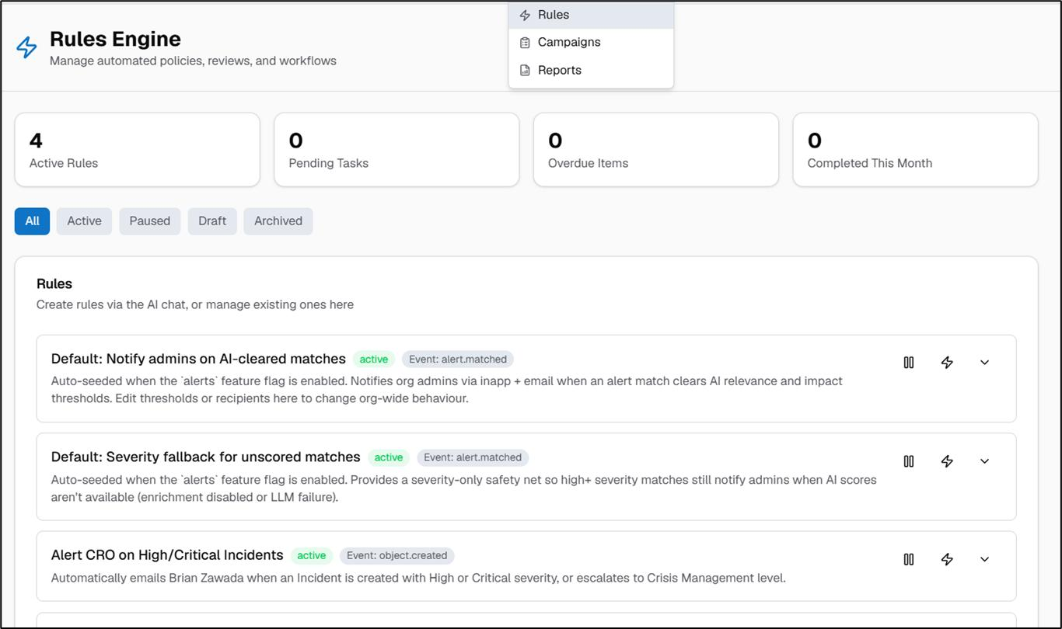
Contxt Risk | AI-Powered Business Continuity and Operational Resilience
contxt-risk.com
When an application moves from scrutiny to EVC, show:
- Why this transition is allowed.
- Which configured rule triggered it.
- Which APH version applies.
- Which official is responsible.
- Whether human authorisation is required.
This is a much stronger demonstration than showing an application status changing automatically.
Definition of done: A judge should be able to ask, "Why did this application move to EVC?" and your platform should provide a traceable answer.

Sprint 2 – Build your strongest differentiator
P1 – Highest innovation opportunity
Intelligence sprint
Objective: Make CompliScan proactive rather than reactive.
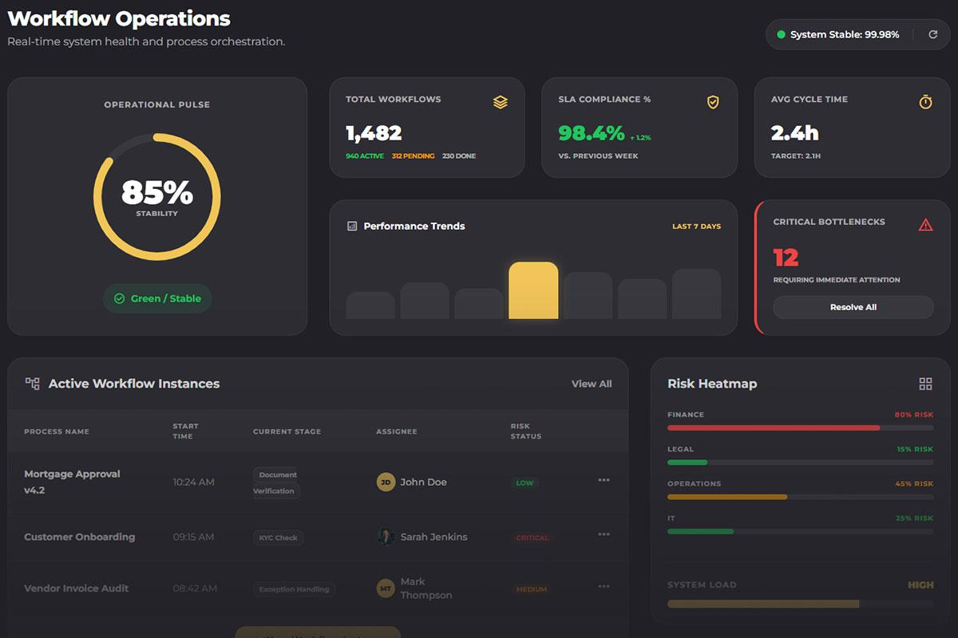

Feature A: Pendency Intelligence Centre
BPMS.Ai — Governed Intelligent Operations Platform
bpms.ai
Add:
- Applications approaching deadlines.
- Applications exceeding configured timelines.
- Stage-wise processing time.
- Region-wise pendency comparison.
- Officer workload distribution.
- Unassigned application detection.
- Bottleneck identification.
- Suggested administrative actions.
Example insight:
The EVC queue has 8 applications approaching their configured processing targets. Two applications have no assigned scheduling action.
The numbers should come from your database, not hardcoded dashboard cards.
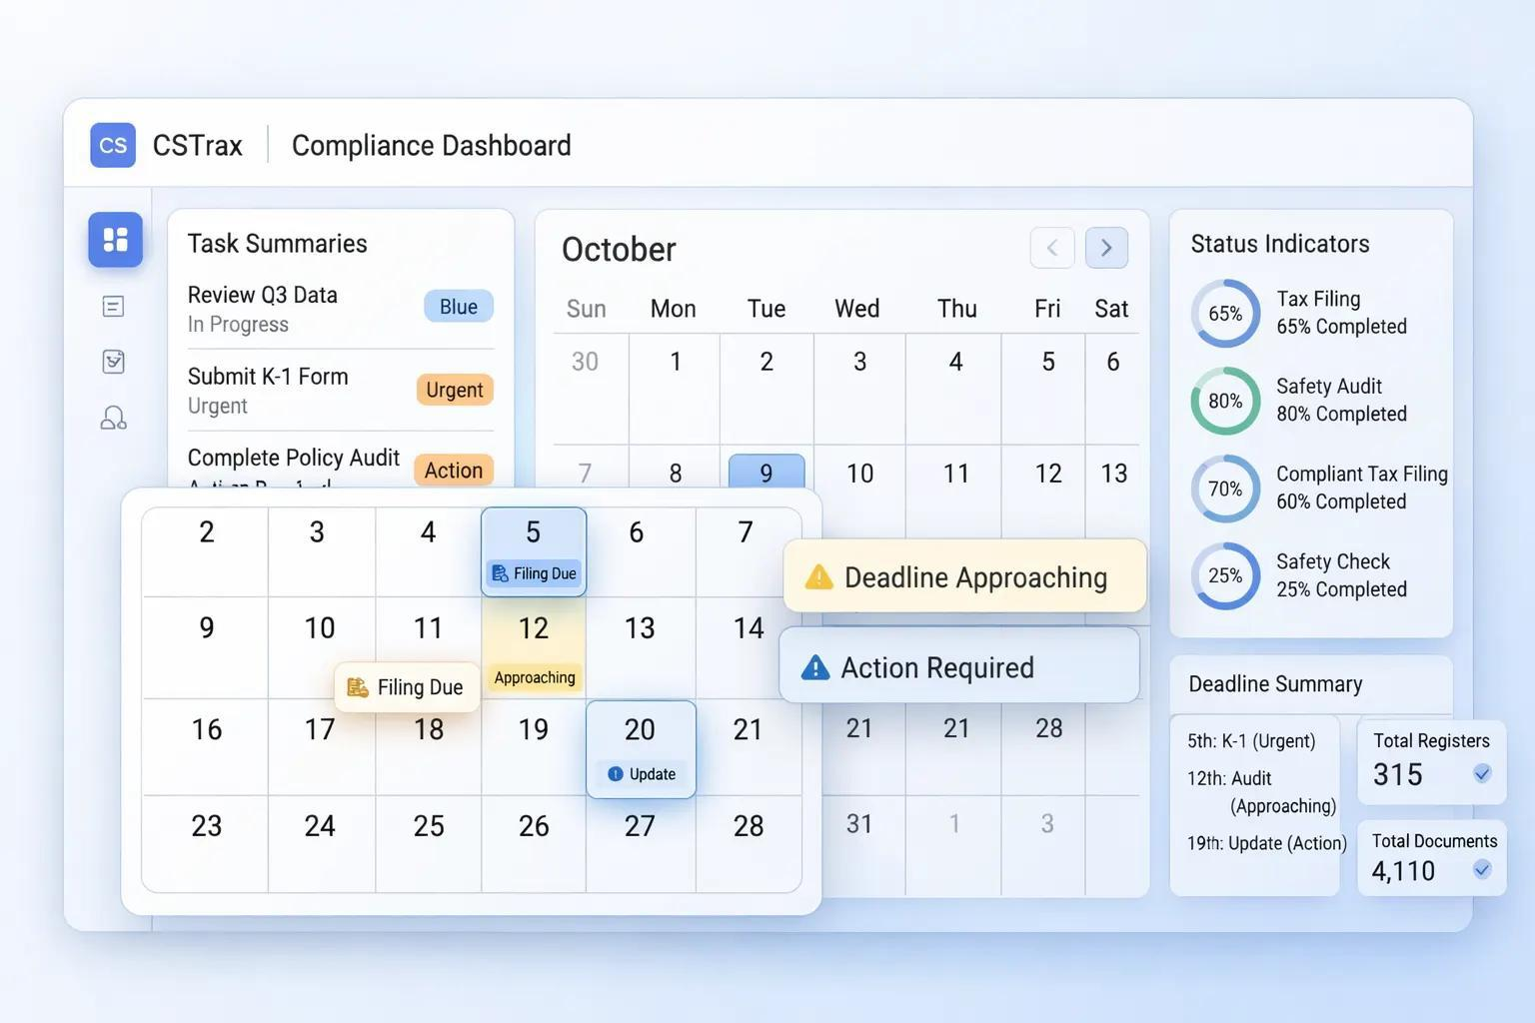

Feature B: Unified Compliance Calendar
Compliance Reminder Software & Compliance Task Management | CSTrax
cstrax.com
Connect the existing compliance and document modules.
The calendar should display:
- Undertaking due dates.
- Lease expiry dates.
- Document renewal dates.
- Pending verification.
- EVC scheduling.
- Overdue actions.
Allow officials to filter by institution, region, document category and responsible officer.

Feature C: Smart Case Handover
Add an officer workload and reassignment workflow.
When an officer becomes unavailable:
- Identify pending cases.
- Identify eligible replacement officers.
- Suggest reassignment based on jurisdiction and workload.
- Obtain authorised confirmation.
- Record the handover in the audit trail.
Definition of done: The system should identify an operational problem and recommend an actionable response, rather than merely displaying a red warning.

Sprint 3 – Make AI genuinely useful
P1 – AI differentiation
Document intelligence sprint
Your AI capabilities should solve a real administrative problem.
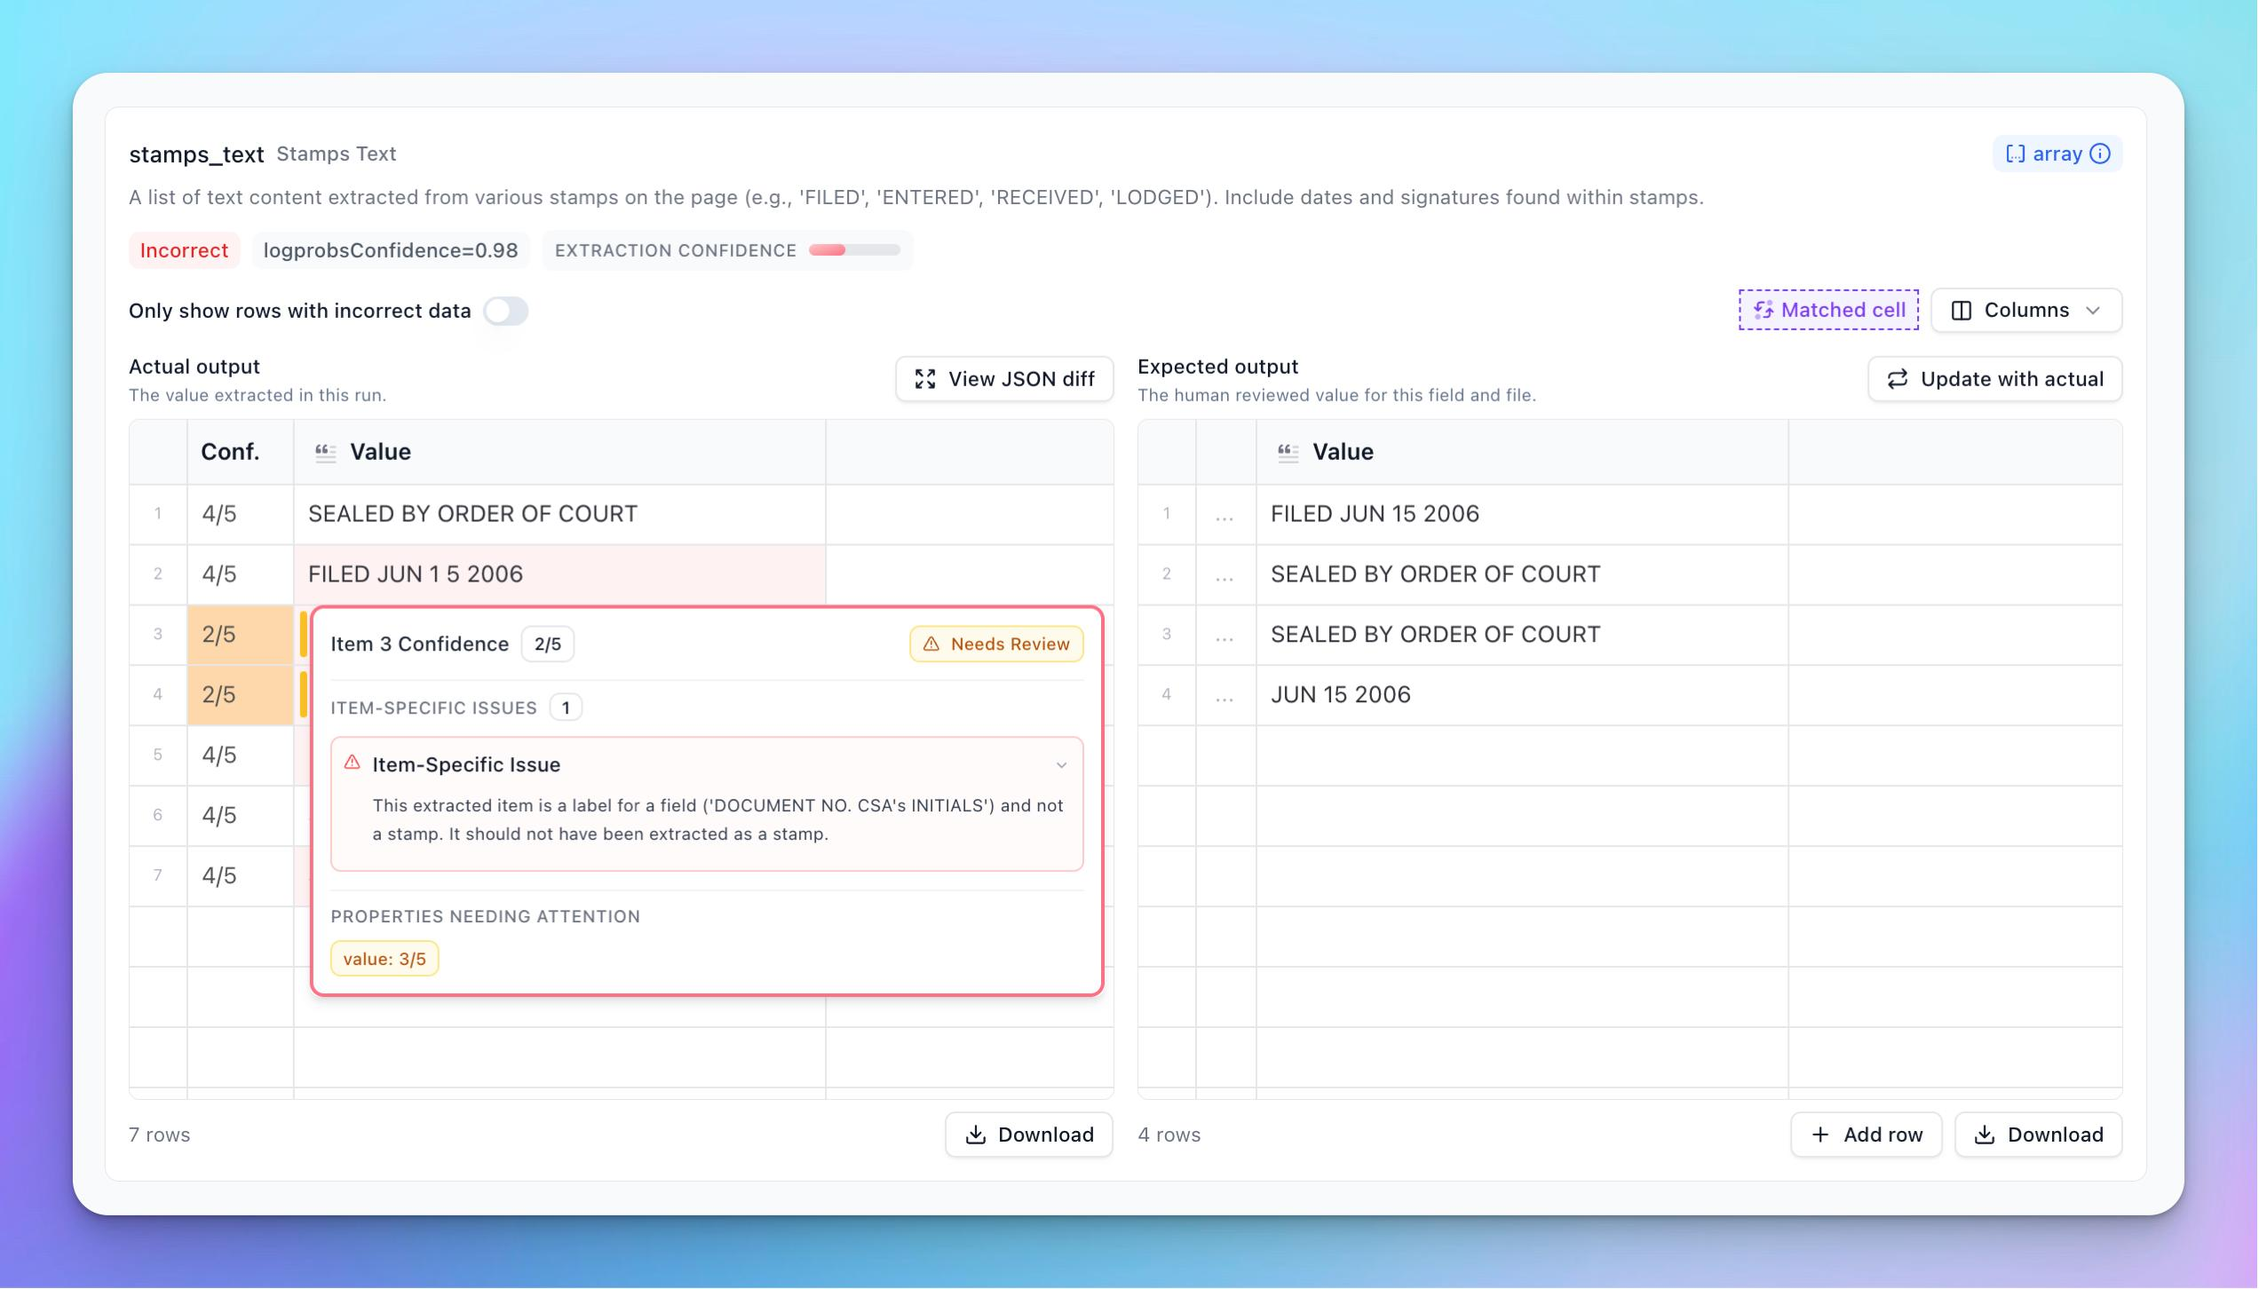

Feature A: AI-assisted document intelligence
Review Agent | Extend Documentation
docs.extend.ai
Improve your existing OCR pipeline.
For every uploaded document, display:
Extracted information | Example
Document type | Lease agreement
Institution | ABC Engineering College
Issue date | 01-04-2025
Expiry date | 31-03-2028
Registration details | Extracted value
Extraction confidence | 94%
Review status | Awaiting officer verification
The values above are illustrative.
Add:
- Original document preview.
- Highlighted extracted text.
- Field-level confidence.
- Manual correction.
- Missing information detection.
- Duplicate document warnings.
- Verification decision and reason.
Do not claim the AI has established legal authenticity merely because it extracted the correct fields.

Feature B: AI-generated executive case brief
When an official opens an application, generate:
Application summary
- Institution and application type.
- Current processing stage.
- Previous observations.
- Pending actions.
- Compliance status.
- Relevant document expiry.
- Recommended next administrative action.
The brief must link back to the underlying records and documents so officials can verify it.

Feature C: Explainable alerts
Instead of:
"Application at risk."
Show:
"Application is approaching its configured scrutiny deadline. It has been awaiting an authorised review action for 9 days. Assigned responsibility: Regional Officer."
This makes your AI and automation much more credible.
Definition of done: An officer should understand the status of an application without manually opening ten different records.

Sprint 4 – Make the product presentation-ready
P2 – Evaluation readiness
Demonstration sprint
Focus on the following:
Feature | What to complete
Notification tracking | Generated, delivered, failed, acknowledged
Integration gateway | Mock API with import and sync logs
Security testing | Cross-institution access prevention
Audit dashboard | Complete application action history
Analytics | Real database-driven charts
Error handling | Failed uploads, failed notifications and retries
Demo data | Realistic synthetic application lifecycle
UI consistency | Consistent terminology and role-specific navigation
Do not spend this sprint adding unnecessary AI features.

3. Team allocation – 3 to 4 developers
This is how I would distribute responsibilities.

Recommended team structure
Developer 1 – Backend & Workflow
Critical
- APH rule engine
- Application routing
- Deadline calculation
- API development
- Audit event generation
Developer 2 – Frontend & Product UX
- Officer dashboards
- Pendency Intelligence Centre
- Compliance calendar
- Application timeline
- Responsive design
Developer 3 – AI & Automation
- OCR improvements
- Document extraction
- Case summaries
- Alert engine
- Notification integration
Developer 4 – QA, Security & Integration (if available)
- Role and permission testing
- Database validation
- Mock AICTE integration
- End-to-end testing
- Demo preparation
If you only have three developers, Developer 1 should own backend security, and Developer 2 should coordinate UI testing. Share QA responsibilities across the team.
Important: All developers should work against one agreed API contract and database schema. Avoid independently creating overlapping versions of the same application status or compliance records.

4. What should you build first? My top 5 selections
If development time becomes limited, follow this order.

01
APH Rule Traceability Engine
Must have
Makes your regulatory automation defensible.

02
Pendency Intelligence Centre
Differentiator
Shows problems before they become overdue.

03
Unified Compliance Calendar
Differentiator
Connects approval and post-approval obligations.

04
AI Document Intelligence
AI capability
Makes AI useful, explainable and verifiable.

05
Secure Audit & Accountability
Must have
Builds confidence in a government regulatory platform.

5. Your SIH evaluation testing checklist
Before the final demo, test these scenarios yourself.
Implementation readiness

0/12
Application follows the correct configured workflow.
An unauthorised role cannot perform a restricted action.
An application can be returned with a mandatory reason.
APH rule version and transition explanation are visible.
An approaching deadline generates a notification.
An overdue action follows the configured escalation hierarchy.
An institution can submit renewed documents.
An officer can verify or return a compliance submission.
OCR extracts document fields and allows manual correction.
The audit trail records all important actions.
The dashboard reflects actual database records.
A failed notification or upload is handled gracefully.
Reset checklist

6. What I would measure to impress judges
Don't just say that CompliScan reduces administrative workload. Demonstrate it.
Create a before-and-after simulation using the same synthetic dataset.
Metric | Before | After
Manual deadline checking | Manual tracking | Automated monitoring
Application status visibility | Multiple records | Unified dashboard
Pending action identification | Manual review | Automatic detection
Compliance follow-up | Manual reminders | Scheduled alerts
Action accountability | Scattered records | Central audit trail
For numerical improvements, use measured prototype results rather than invented percentages.

7. Your biggest strategic advantage
I want your team to understand one thing:
Most teams will demonstrate what their software can do. Your team should demonstrate what an AICTE officer can accomplish because of your software.
For example:
- Not just a dashboard showing overdue applications.
- A system identifying the bottleneck and responsible queue.
- Not just an OCR document reader.
- A system identifying missing information and assisting verification.
- Not just an automated notification.
- A system proving whether the action was delivered, acknowledged and resolved.
That is the difference between a functional prototype and a compelling GovTech product.

🎯 Current Stage
Phase 4 – Product Building
You already have a working prototype. Now focus on making its core workflows reliable, explainable and demonstrable.

🚀 Recommended Next Step
I suggest we now move from planning to actual implementation.
My recommendation is to start with the APH Rule Traceability Engine. It provides the foundation for your workflow automation, pendency intelligence and regulatory accountability.
I can create a developer-ready implementation specification containing:
- Database schema and migrations.
- Backend API endpoints.
- Frontend screens and components.
- Rule-engine logic.
- Role permissions.
- Test cases.
- Integration instructions for your existing CompliScan codebase.
This will give your three-to-four-member team a concrete development blueprint without rebuilding the working website.

