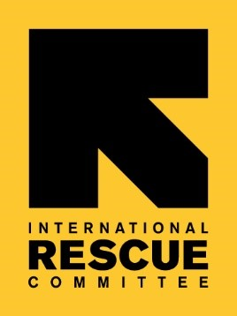

Coronavirus

**COVID-19**

Coronavirus

**COVID-19**

Staff health advice

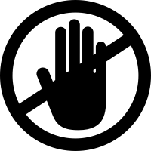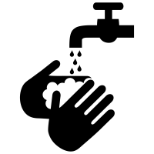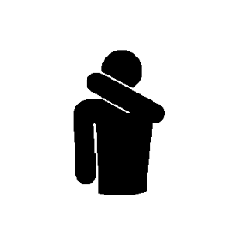

**What is COVID-19, and how bad is it?**

Novel coronavirus (COVID-19) is a new virus strain spreading from person-to-person in many countries, including the United States. Health experts are concerned because little is known about this new virus.

At this time, there are a small number of cases in the U.S. Reported cases range from mild illness (like a normal cold) to severe pneumonia that requires hospitalization. So far, deaths have been reported mainly in older adults who had other health conditions.

**Symptoms:**

* A cough
* Shortness of breath
* Breathing difficulties
* Fever (high temperature)

**Please note:**

* Masks are NOT advised: except for those who are ill or health care workers caring for the sick
* Follow your local government’s guidance: staff should first follow local government advice and restrictions. Where they don’t exist, follow the IRC’s guidance

**Avoid**

**Wash**

**How can I help prevent?**

Here are 4 everyday measures that can help prevent you from getting COVID-19 or spreading it to others. They should be practiced by **all people in IRC,** in ***all***locations, at ***all times.***

**Stay home**

**Cover**

your hands often, using soap and water or alcohol-based hand rub. Avoid touching your face, unless your hands are thoroughly cleaned.

mouth & nose when coughing and sneezing.

Discard any used tissue immediately and

wash hands.

if you feel sick

with fever or cough. Follow guidance from your local health authorities and notify your manager.

close contact with anyone who has cough or fever. Maintain at least three feet / one metre distance.