Predicting Stock Prices using LSTM and a Sliding Window Approach

# Abstract

With proper knowledge of any companies stock and insight, one can gain large profit sitting at home. Stock market of a company is a time series data and stock price prediction is one of the field where many researchers had gathered interest to predict the stock prices or trend in future using historical data and technical indicator with high accuracy. A good prediction model of a stock’s future price will increase trader’s profits. In this report, the proposed model uses deep learning model LSTM — Long short-term memory to predict the stock trend in a sliding window approach.

**Index Terms**– **Long Short Term Memory**, Historical Data, Technical Indicators and Stock price Prediction.

# 1 1. Introduction

2 Stock price prediction is a topic that attracts

3 many data researchers and data analytics as

4 a good stock prediction can capitulate notable

5 profit. Stock of a company cannot just be pre-

6 dicted easily. Stock market is volatile, haywire,

7 uncertain and non-linear data. The stock price of

8 any given company is very much uncertain. Find-

9 ing patterns in these stocks is a very difficult task.

10 And the very first step for predicting the stock is

11 to find some pattern in the stock chart using the

12 raw data or extracting dome of the useful fea-

13 tures. The random change in the stock market is

14 referred as random-walk behavior of stock prices

15 with time by [1]. This statement holds very much

16 true as there are many uncertain factors as if the

17 country’s progress, any natural disaster or the po-

18 litical status of the country. Firstly, for prediction

19 of any stock price, we need to analyze the data.

20 For analysis, two approaches are used Fundamen-

21 tal and Technical indicators used to forecast stock

22 prices. Fundamental analysis usually deals with

23 the cause of the market, it takes all the economic,

24 to be more precise macro economic, factors such

25 as the company’s growth the climate etc to predict

26 the trend of the future stocks. Technical analy-

27 sis uses stock charts to analyze the patterns in

28 the stock price. After analyzing the data vari-

ous linear and non-linear models are being used 29 to predict the data like ARIMA (auto regressive 30 model) and ANNs. Artificial Neural networks like 31 RNN, CNN, and LSTM are commonly used model 32 in stock price prediction [2] . ANN was inspired 33 from function of human brain and implementing 34 a complex network of neurons. In [3], they pro- 35 posed a fusion model implementing HMM, ANN 36 and GA for predicting stock price. These Mod- 37 els are widely used in areas like Image Process- 38 ing, Natural Language Processing, Time Series 39 Analysis, etc. Over-fitting and under-fitting of 40 data is a big problem while using ANN model for 41 stock price prediction [4]. ANNs are very use- 42 ful for short term forecasting. While non-linear 43 model are better choice to predict stocks, many 44 factual researchers had shown that non- linear 45 models might not outperform linear models every 46 time [5] [6] [7]. Recently in [8] they tried to com- 47 pare linear model with nonlinear model and tried 48 to find the accuracy, which shows how the non- 49 linear model outperform linear model. The linear 50 model in the comparison was ARIMA whereas the 51 nonlinear model were GRU and LSTM in which 52 the LSTM outperform every other model. Also 53 in [9], they tried to predict the effect of demoneti- 54 zation on stocks of seven Indian companies CNX, 55 NIFTY50. ANN were used to predict the future 56 values of these stocks. [10] here they used Deep 57

58 learning models to predict the stock price move-

59 ment and analyzed the accuracy of many models

60 such as LSTM, CNN, RNN and many other non-

61 linear models. Also in [11] compared SVM, back

62 propagation and LSTM and analyzed the accu-

63 racy.

64 In this model, I have implemented LSTM

65 model. LSTM was proposed back in 1997 by Fe-

66 lix Gers and his adviser Jürgen Schmidhuber and

67 Fred Cummins who introduced the forget gate

68 to deal with the vanishing gradient problem as

69 stated in [12]. LSTM is one of the most important

70 model because of the introduction of forget gate

71 and memory cell. In this model, the information

72 flows through a mechanism known as cell states.

73 Due to these memory cells now, LSTM selects and

74 remember or forget things according to its impor-

75 tance. Therefore, LSTM can learn and identify

76 patterns of data dynamically with time and pro-

77 duces huge prediction accuracy. FA GersD, EckJ

78 and Schmidhuber first used LSTM for time series

79 forecasting long back in 2002 in [13].

# 80 2. Methodology

81 For Prediction of Stock Market, we need to deal

82 with huge historical data that is highly nonlinear.

83 To deal with this high non-linearity we need to

84 find hidden pattern in our data and analyze them

85 for prediction of future prices. Yet pattern identi-

86 fication given a nonlinear data is a trivial task and

87 therefore there is a need of a dynamic model that

88 could analyze our data and find all the hidden pat-

|  |  |  |
| --- | --- | --- |
| 89 terns. ANNs are very useful and capable of find- | *2.2.2. Correlation* | 121 |
| 90 ing all the hidden patterns and exploiting the data | After extracting all these features we cannot | 122 |
| 91 to predict the future prices through self-learning | use all these features in our model the as not all | 123 |
| 92 process. These Neural networks are very efficient | features are relevant some of them are irrelevant | 124 |
| 93 to predict the stock future prices and therefore | and introduces noise in our model. Also, having | 125 |
| 94 are widely used. To predict a financial time se- | redundant features confuses our model and there- | 126 |
| 95 ries data Using Neural networks was introduced | fore increases the computational time. Therefore, | 127 |
| 96 in [14]. In this report, I have used Long Short | we only need to select those features that are re- | 128 |
| 97 Term Memory as a prediction model to predict the | lated to our stock price, and we could discard | 129 |
| 98 stock price of Netflix using Historical data of past | other features. | 130 |
| 99 17 years from **https://ftnance.yahoo.com/**. | The selection of features was based on the cor- | 131 |
| 100 In this report I have divided the prediction ap- | relation coefficient value of all these features with | 132 |
| 101 proach into subtopics and the subtopics are as | the original stock’s closing prices. The features | 133 |
| 102 follows: | with the highest correlation value was selected. | 134 |

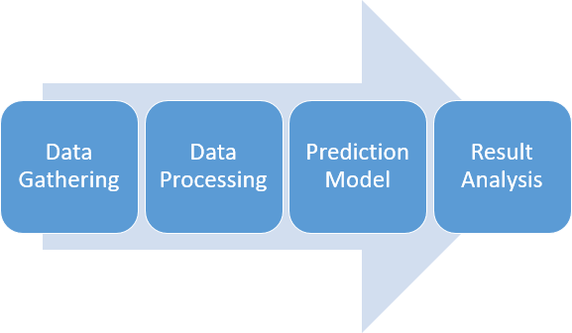

Figure 1: Sequence Flow of this Report

* 1. *Data Gathering* 103

17 years of data of Netflix from March 104

2002 to March 2019 is used in this prediction 105

model. All the data has been collected from 106

**https://ftnance.yahoo.com/** and downloaded 107

under the historical data section. This Historical 108

data is used to predict the future stock prices. 109

* 1. *Data Processing* 110
     1. *Data Extraction* 111

The historical data gathered was raw unpro- 112

cessed data with high volatility. Prediction using 113

this raw data is not a good option so first we need 114

to process this data. Therefore, I have calculated 115

technical indicators. Technical Indicators are the 116

detailed study of past Market action for the pur- 117 pose of forecasting future prices. It helps in fore- 118 casting the price direction and the current trend. 119

120

135

136

137

138

Table 1: Technical Indicators

Technical Indicators

Simple Moving Average - SMA Exponential Moving Average - EMA

Triple Exponential Moving Average - TEMA Kaufman’s Adaptive Moving Average - KAMA Moving Average Convergence/Divergence

-MACD

Bollinger Bands

%B

Relative Strength Index - RSI Average True Range - ATR Chandelier Exit - CE

Chande Momentum Oscillator - CMO Force Index - FI

Elder-ray Stochastic %k Stochastic %D Williams %R

Accumulation Distribution Oscillation - ADO Commodity Channel Index - CCI

The correlation techniques used over here where Scatter diagram and Pearson Correlation value.

*Scatter Diagram.* Scatter diagram is a graph which represents the relation between to data set.

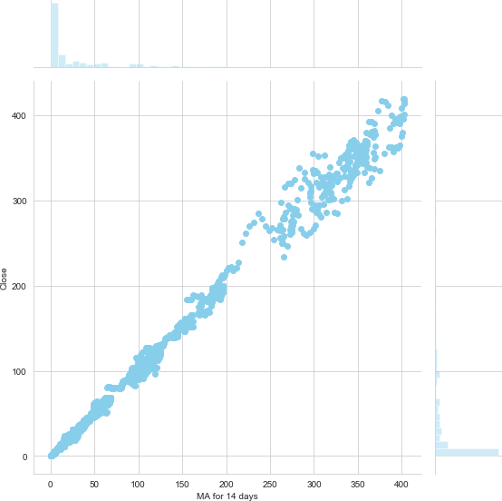

Figure 2: Scatter Diagram for SMA for 14 days vs Close

flix. A Simple moving average for 14 days of clos- 155 ing price of a stock is defined as the rolling average 156 of closing price of the stocks over the last 14 days. 157 A Simple Moving Average helps in smoothing out 158 the curve which helps in reducing the volatility in 159 the curve. 160

*2.2.3. Data Transformation* 161

After getting the best feature, the next thing

139

140

141

142

In this graph the values of the two data set are plotted along the two axises and the pattern of the resulting graph gives a basic idea about the correlation between the two data set.

we do is data transformation. Data transforma- tion is used to normalize the data and make the data stationary, which helps in pattern finding. Normalization helps improve convergence of the

162

163

164

165

166

143

144

145

146

147

148

149

.,

*Pearson Correlation..* Pearson Correlation gives a numerical response for finding the relation be- tween different data set. It assigns a number to the extent of relation between two data sets. Its value lies from -1 to 1, 1 representing exactly lin- ear relation between two data sets and 0 repre- senting no relation.

data. The data was transformed/mapped in the 167

range 0 to 1. 168

After the data set is transformed into a clean 169

data set, the data set is divided into training and 170

testing sets to evaluate the prediction accuracy of 171

my model. The training set is 95 percent of the 172

total data set and the testing data is the rest of 173

150

(*y − y*)2

*r* = ‚ΣΣ((*x − x*)Σ(*y − y*))

(*x − x*)2

*j x* = *mean of x*

the data. 174

**3. Prediction Model** 175

151

152

After analysis the Data using Pearson correla-

tion and verifying using scatter diagram Simple

|  |  |  |
| --- | --- | --- |
|  |  | 176 |
| 153 moving average for 14 days was chosen as the pa- | into the LSTM network for training. The model | 177 |
| 154 rameter for the input for stock prediction for Net- | was trained for 40 epochs and a batch size of | 178 |

After normalizing the data this data was fed

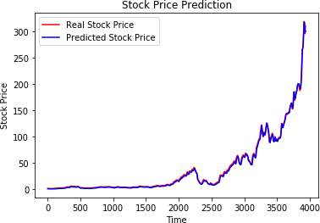179 60. Initially the number of epochs were 100 and

180 changed to find a good prediction model. This

181 LSTM model was initialized of an input sequen-

182 tial layer lead by 4 LSTM layers each having neu-

183 rons lesser than the previous and then finally a

184 dense output layer with Adam optimizer.

Figure 3: Result of LSTM model for Train data set

|  |  |  |
| --- | --- | --- |
| 185  186 | 1 | regressor = Sequential() |
| 187 | 2 | regressor.add(LSTM(units = 60, |
| 188 |  | return_sequences = True, |
| 189 |  | input_shape =(X_train.shape |
| 190 |  | [1], 1)))regressor.add( |
| 191 |  | Dropout(0.2)) |
| 192 | 3 | regressor.add(LSTM(units = 45, |
| 193 |  | return_sequences = True)) |
| 194 |  | regressor.add(Dropout(0.2)) |
| 195 | 4 | regressor.add(LSTM(units = 30, |
| 196 |  | return_sequences = True)) |
| 197 | 5 | regressor.add(Dropout(0.2)) |
| 198 | 6 | regressor.add(LSTM(units = 15)) |
| 199 | 7 | regressor.add(Dropout(0.2)) |
| 200 | 8 | regressor.add(Dense(units = 1)) |
| 201 | 9 | regressor.compile(optimizer = ’ |
| 202 |  | adam’, loss = ’ |
| 203 |  | mean_squared_error’) |
| 204 | 10 | regressor.fit(X_train, y_train, |
| 205  206 | | epochs = 40, batch_size = 60) |

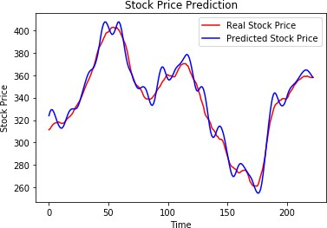

Code Snippet 1: Code for LSTM Neural Network

Figure 4: Result of LSTM model for Test data set

207

# Experimental Result

1. **Conclusion** 215

In this work, I tried to predict the future stock 216

|  |  |  |
| --- | --- | --- |
| price using LSTM. Simple moving average for 14 | | 217 |
| Table 2: Epoch = 40, Feature input = MA14 days was used as an input parameter of a 60-day | | 218 |
| Input RMSE Size sliding window approach. I would like to high- | | 219 |
| Train 2.5983488911838393 3934 | light forecasting stock prices are very much help- | 220 |
| Test 6.39236469202595 223 | ful for investors to earn huge profit. Predicting | 221 |
|  | future price of a given stock to produce an accu- | 222 |
|  | rate result is encouraging researchers to find some | 223 |
| 208 After performing continuous simulations | new technique to improve the accuracy. RNNs | 224 |
| 209 for different number of features and epochs, | like LSTM are very good at processing sequen- | 225 |
| 210 we have observed that by taking MA14 fea- | tial time series data. LSTM has been proven a | 226 |
| 211 ture with 40 epochs we are able to achieve | very good solution while dealing with sequential | 227 |
| 212 nearly the best results with training RMSE of | data streams. In this work, I was able to produce | 228 |
| 213 **2.5983488911838393** and testing RMSE of | significantly good result using a sliding window | 229 |
| 214 **6.39236469202595.** | approach and LSTM model to predict the future | 230 |

231 price of Netflix stocks.

# 232 6. List of abbreviations

233 **References**

234 [1] B. G. Malkiel, E. F. Fama, Efficient capital markets:

235 A review of theory and empirical work, The journal

236 of Finance 25 (2) (1970) 383–417.

237 [2] O. Coupelon, Neural network modeling for stock

238 movement prediction A state of the art, Blaise Pascal

239 University (2007) 83.

240 [3] M. R. Hassan, B. Nath, M. Kirley, A fusion model

241 of HMM, ANN and GA for stock market forecasting,

242 Expert systems with Applications 33 (1) (2007) 171–

243 180.

244 [4] X. Tao, H. Renmu, W. Peng, X. Dongjie, Input di-

245 mension reduction for load forecasting based on sup-

246 port vector machines, in: 2004 IEEE International

247 Conference on Electric Utility Deregulation, Restruc-

248 turing and Power Technologies. Proceedings, Vol. 2,

249 2004, pp. 510–514.

250 [5] A. A. Adebiyi, A. O. Adewumi, C. K. Ayo, Compari-

251 son of ARIMA and artificial neural networks models

252 for stock price prediction, Journal of Applied Mathe-

253 matics 2014.

254 [6] C. K. Lee, Y. Sehwan, J. Jongdae, Neural network

255 model versus SARIMA model in forecasting Korean

256 stock price index (KOSPI), Issues in Information Sys-

257 tem 8 (2) (2007) 372–378.

258 [7] K. J. Lee, A. Y. Chi, S. Yoo, J. J. Jin, Forecasting

259 korean stock price index (kospi) using back propaga-

260 tion neural network model, bayesian chiao’s model,

261 and sarima model, Journal of Management Informa-

262 tion and Decision Sciences 11 (2).

263 [8] X. Zhang, C. Li, Y. Morimoto, A Multi-factor Ap-

264 proach for Stock Price Prediction by using Recurrent

265 Neural Networks, Bulletin of Networking, Comput-

266 ing, Systems, and Software 8 (1) (2019) 9–13.

267 [9] S. Chopra, D. Yadav, A. N. Chopra, Artificial Neu-

268 ral Networks Based Indian Stock Market Price Pre-

269 diction: Before and After Demonetization, J Swarm

270 Intel Evol Comput 8 (174) (2019) 2.

271 [10] W. Long, Z. Lu, L. Cui, Deep learning-based fea-

272 ture engineering for stock price movement prediction,

273 Knowledge-Based Systems 164 (2019) 163–173.

274 [11] N. Arora, et al., Financial Analysis: Stock Market

275 Prediction Using Deep Learning Algorithms.

276 [12] F. A. Gers, J. Schmidhuber, F. Cummins, Learning

277 to forget: Continual prediction with LSTM.

278 [13] F. A. Gers, D. Eck, J. Schmidhuber, Applying LSTM

279 to time series predictable through time-window ap-

280 proaches (2002).

281 [14] H. White, Economic prediction using neural net-

282 works: The case of IBM daily stock returns.