z
Project Procurement Management & Project Quality Management
Prepared by
TAN WENG SIANG TP012563

Project Procurement Management
7. | The PC and server hardware technical specifications were constantly being changed to suit new or added requirements.
8. | The hardware and software delivery was still being negotiated while there were only 3 months to complete the project.
12. | The current network infrastructure needed a major upgrade to support the PCs and servers for the new system (see section VII).

Project Quality Management
10. | The testing plan was not developed yet.
14. | There is no evidence that a proper project management process was followed.
Project Quality Management
Kathy Schwalbe (Information Technology Project Management, 2000) said that, “The main purpose of project quality management is to ensure that the project will satisfy the needs for which it was undertaken.” In other words, the purpose of quality management is to ensure project stakeholders will satisfy the delivered project. To achieve stakeholder satisfaction, it can be done by following processes:

- Quality Planning
Identifying project quality standard through communicate with project stakeholders to understand their requirements and expectations.

- Quality Assurance
Ensure the processes of entire project development are achieving the quality standards. Therefore project team must assure the quality of their works during development period.

- Quality Control
Monitoring project results by using technical tools or techniques (i.e. Pareto Charts, Statistical Sampling) to ensure project meet the quality standards.

Problem Description
MMPM project has 2 problems are related to quality management:

- The testing plan was not developed yet.
Without a proper test plan developers can’t evaluate project and it will lead the project to be failure. In other words, the quality of project is unwarranted.

- There is no evidence that a proper project management process was followed.
MMPM project has the risk of failure, since project management process is lack of standards.

Proposed Solution
In order to solve mentioned problems effectively, project team should follow proper quality management process. The first step is to identify relevant project quality and standards. Based on those quality and standards, project team should able to develop test plans for each development stages. Kathy Schwalbe (Information Technology Project Management, 2000) comments that, “Testing needs to be done during almost every phase of the product development life cycle.”

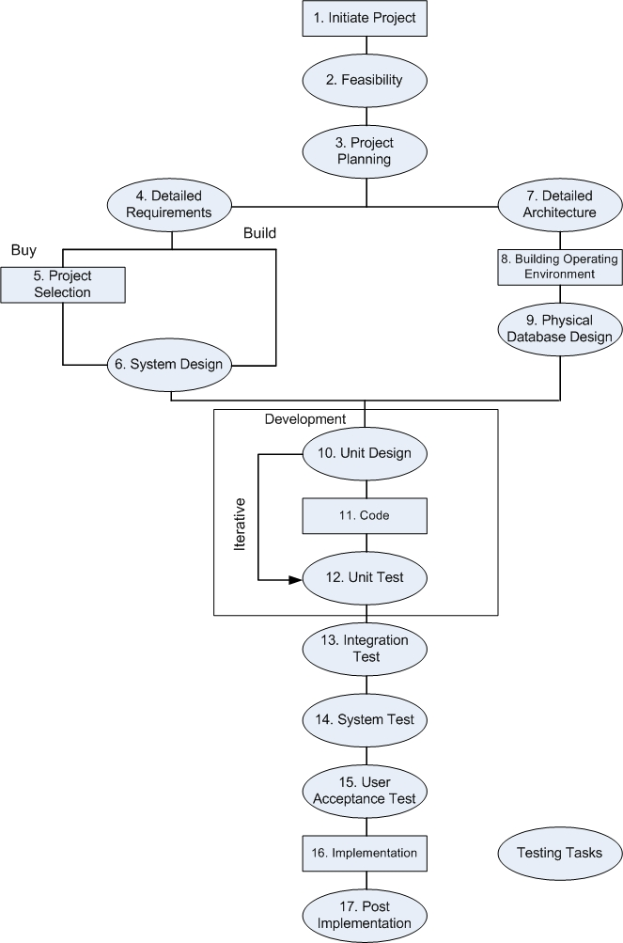

Testing Task in Software Development Life Cycle
Source: Hollstadt Associates, 1998
Picture above shows that there are 4 types of standard testing in SDLC, it might be suitable to implement in MMPM project as well.

- Unit Test
It is done individually to ensure each component in system is free of bugs.
(MMPM project: Test the installed PC and server individually to ensure each of them is function well.)

- Integration Test
Test the functionality of a group of components and ensure them compatible with each other.
(MMPM project: Test the LAN connection of PCs and servers within each department is function well.)

- System Test
Test the entire system to ensure it function well.
(MMPM project: Test the entire MMPM system to ensure the system is available to each department and each user.)

- User Acceptance Test
End user test the delivered system to assure the system meets their expectations and fit to their business needs.
(MMPM project: Ask organization employees to evaluate the system to ensure the MMPM system fit to organization business needs.)

Due to the time limitation (3 months), the author advice project team testing should focuses on certain part of MMPM project. The reason is Pareto principle applies to testing “80% of all defects occur in 20% of the work and vice versa.” It will save a lot of time if project team uses previous results to plan which part should test more or less.

Beside that, APIIT (Project Management, Learnfinity) was point out some guidelines will helpful to develop MMPM project test plan, such as:
- Asking third party to conduct testing will be more effective than testing by project team.
- Testing should begin in the “small” and progress toward testing in the “large”.

To reduce the risk of MMPM project failure, project team should follow proper management process. The risk can be reduced if MMPM project manager follow project process group guidelines:

- Initiating Processes
Project manager should initiate the activities of each phase at the beginning of phase.

- Planning Processes
Project manager should create project plans to define related activities to the current phase.

- Executing Processes
Project manager should order people (project team) to execute those plans and activities of current phase.

- Controlling Processes
Project manager should ensure project objectives are met and take corrective actions if required.

- Closing Processes
Project manager should prepare for administrative activities such as archiving project files.

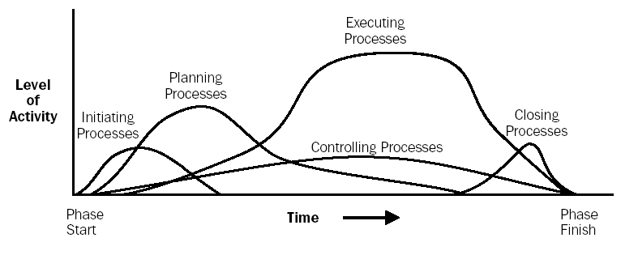
Level of Process Group Activity over Time
Source: PMBOK Guide, 2000

Picture above shows the amount of activities carried in each project management process groups. The control processes and executing processes are covering all the phases, failure on those processes obviously will affect entire project. So that MMPM project manager should be more careful in controlling and executing activities.

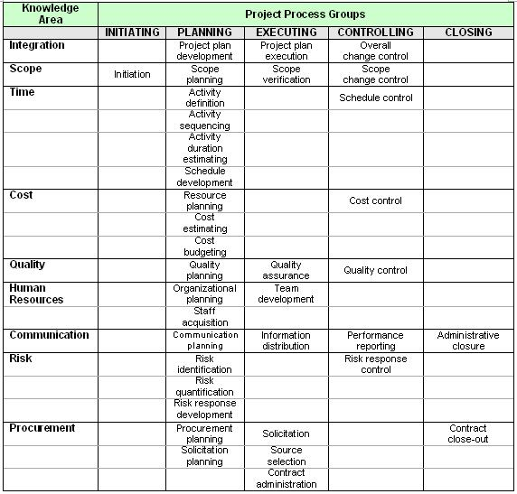
Relationship among Project Process Groups, Activities, and Knowledge Areas
Source: Kathy Schwalbe, Information Technology Project Management 2000

The author believes that, table above will provide sufficient information to MMPM project manager about the relationship of process groups and knowledge areas. Referring to this table MMPM project manager can be easily to understand what activities should be carried out and how to manage project processes.

Project Procurement Management
Project procurement management is the processes of purchasing goods or services from outside organization. There are series of procedures (i.e. planning, solicitation…) in procurement management which assist project manager towards successful procurement. According to Kathy Schwalbe (Information Technology Project Management, 2000) many organizations are turning to outsourcing with the purpose of:

- Reduce both fixed and recurrent costs.
- Allow the client organization to focus on its core business.
- Access skills and technologies.
- Provide flexibility.
- Increase accountability.

Problem Description
MMPM project has 3 problems are related to procurement management:

- The PC and server hardware technical specifications were constantly being changed to suit new or added requirements.
The author assumed that the technical specifications being changed in past 9 months is because of project team lack of the ability to analysis the actual business needs.

- The hardware and software delivery was still being negotiated while there were only 3 months to complete the project.
The time constraint to complete this task is tight, if they don’t able to deliver on time then it will delay entire MMPM project.

- The current network infrastructure needed a major upgrade to support the PCs and servers for the new system (see section VII)
From problem no.13 knows that the organization lack of technical skill in network area, therefore upgrade network infrastructure might be difficult to them especially the project remain 3 months to end.

Proposed Solution
Evidently the best solution for above problems is out-sourcing (procurement). First of all, the organization should out-source the project of purchasing hardware and software to a vendor who expert in that area. Through the assist of experts and professionals from vendor, the hardware technical specifications can be identified immediately. Beside that the contract should state the out-source project completion date in order MMPM project can deliver on time. The author suggests project team to appoint outside consultants to upgrade network infrastructure for them. Since hire network professional worker is hard and time consuming but outside network consultants is available directly.

The out-sourcing solution will bring a lot of benefits to organizations, those are:

- Solve the problem effectively.
Vendor specialize in hardware technical specification area thus they able to analysis the actual business needs of MMPM project effectively.

- Enjoy economies costs
The cost of purchasing been minimized through select the economic quotation from vendors.

- Warranty project deliver on time
The risk of project delaying (MMPM) was transfer to vendor and they take responsible for it.

- Allow project team focus on its core business
MMPM project team should focus their resources (people, funds, time) in certain part of project to produce high quality outcomes.

- Reduce organization burden
Hired contract employees will more flexible to organization because organization takes less responsible to them (they leaved when the project ended).

The author was highly recommended MMPM project team follow the processes below to out-source their works.

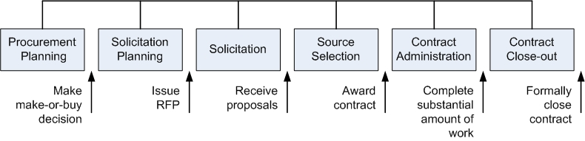
Project Procurement Management Processes and Key Outputs
Source: Kathy Schwalbe, Information Technology Project Management 2000
The first step is procurement planning the project team should analyst the MMPM project scope to know what to procure. At the end of process they should make make-or-buy decision whether out-source the project. (As author discussed earlier, project team should out-source the project).

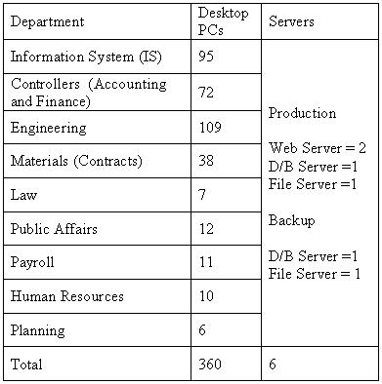
MMPM Project Specification
Source: APIIT Project Management Assignement Question

Next step is solicitation planning. The project team should define specification requirements and deadline for vendors. Example: the hardware must able to support at 5 years. At the end of this process, they should produce Request for Proposal (RFP) documents to solicit proposals from vendor.
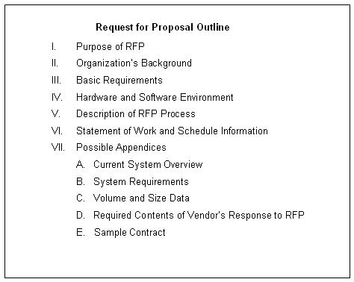
Outline for a Request for Proposal (RFP)
Source: Kathy Schwalbe, Information Technology Project Management 2000
The next process is solicitation. Project team should collect proposals or quotations from those potential vendors. After that they should filter those proposals to produce the qualified list. Those qualified vendors should propose the detailed hardware requirements to organization.

The following is source selection process. Project team should compare the proposals from different vendors. The author suggests that, project manager should consider the proposal with higher hardware specification to avoid the rapid change of technology. Based on the results of proposal criteria evaluation project manager should able to know which proposal fit their needs. Finally project manager should negotiate with the selected vendor about the issues of price, contract and ensure the project must be done within the given deadline.

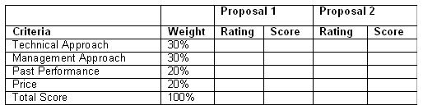
Sample Proposal Evaluation Sheet
Source: Kathy Schwalbe, Information Technology Project Management 2000

There are 3 major types of contract that project manager should consider when negotiate with vendor since they are different risks to the buyer and seller.

- Fixed Price or lump sum contracts
Involve a fixed total price for a project, which include: fixed price incentive and firm fixed price contracts.

- Cost reimbursable contracts
Involve direct and indirect actual cost payments to seller, which include: cost plus incentive fee, cost plus fixed fee, cost plus percentage of costs contracts.

- Unit price contracts
Kathy Schwalbe (Information Technology Project Management, 2000) said that “It also known as time and materials contracts which require the buyer to pay the seller a predetermined amount per unit of service, and the total value of the contract is a function of the quantities needed to complete the work.”
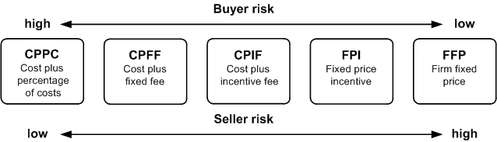
Contract Types versus Risk
Source: Kathy Schwalbe, Information Technology Project Management 2000

The picture above shows the risks of different contracts, as the buyer (MMPM project manager) he / she should select the contract with risk as low as possible.

Contract administration is a process to ensure the performance of vendor meet the contract requirements. If MMPM project team unsatisfied with the delivered project then they can request, claims or appeal to the vendors.

The last process is contract close-out which involves settlement and completion of contract. MMPM project manager should audit the results of procurement and prepare the procurement completion documents.

