**Indicator: Ambient air pollution attributable deaths in children under 15 years**

**Cause:** Lower respiratory infections

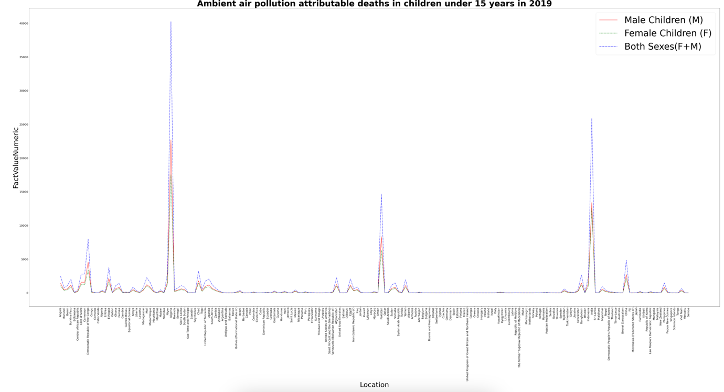

Figure Line plot

Figure 1 indicates the deaths encountered by male and female children of ambient air pollution in 2019 causing lower respiratory infections. Using the above plot, it is visible that in certain locations high deaths have occurred. Having such a plot helps determine any data analyst to determine the location of high deaths. This helps them to take necessary actions based on the location instead of manual computation and data analysis

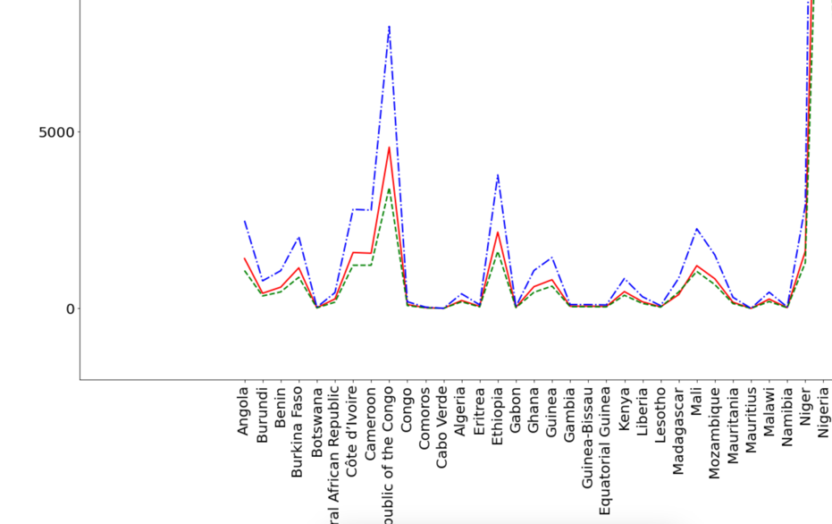

Figure Close up of Line plot

Figure 2 shows the close up view of the line plot and it is seen that the data is clear to minute details when zoomed and thus the plot is more accurate and can be used for any data anlysis.

Moreover, Scatter plot and Box plot visualization graphs were selected to demonstrate the raw data into more meaningful information as the data used here is based on demographic analysis and these plots are most commonly used as they give much more accurate descriptive analysis aids to determine the spread.

Figure Scatter plot

Figure 3 indicates the distributions of deaths occurred across the parent countries. Above plot was drawn by getting the summation of deaths in all the sub countries under the parent countries mentioned above in the x-axis. It is visible that Africa has considerably higher death count when compared to others which crosses the 80,000 mark while Europe and Americas are relatively lower when compared with others.

Figure Ambient air pollution attributable deaths in Africa children under 15 years in 2019. Male (left), Female (middle), Both sexes (right)

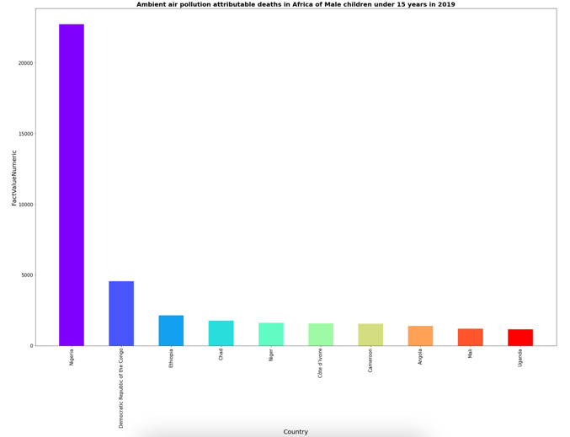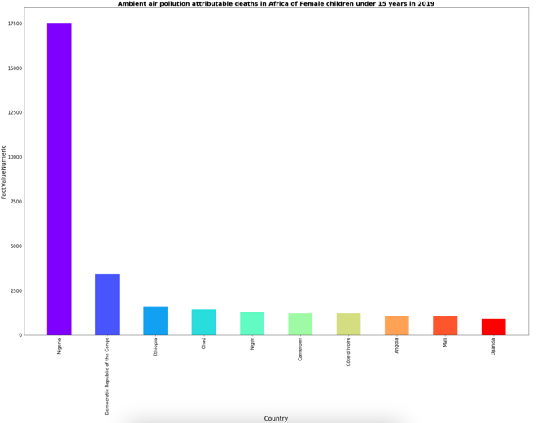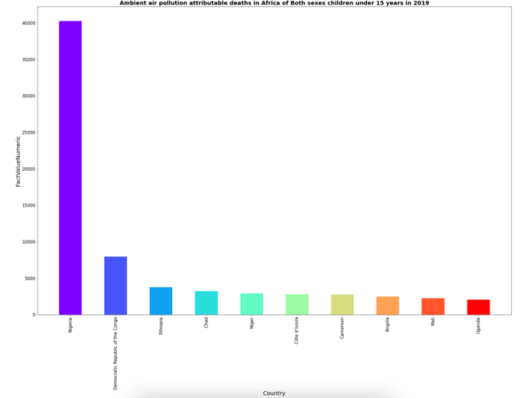

Figure 4 illustrates the children deaths occurred in Africa by the respective gender. The Y axis values are adjusted such that the graphs are well spread. It is seen that Nigeria has shown many deaths while Uganda being the lowest.

Figure Ambient air pollution attributable deaths in Americas children under 15 years in 2019. Male (left), Female (middle), Both sexes (right)

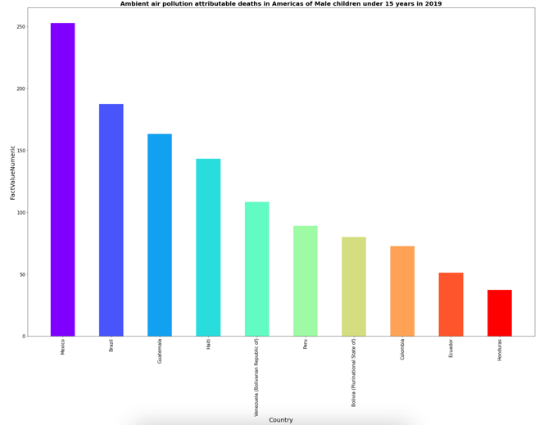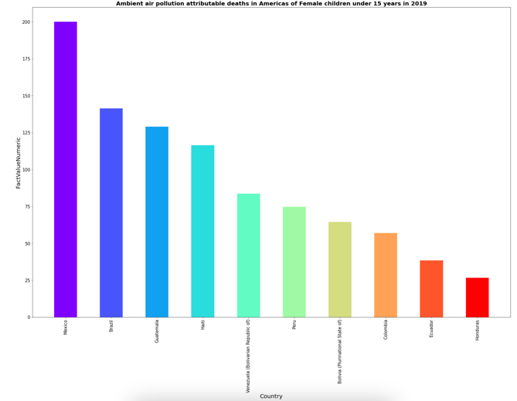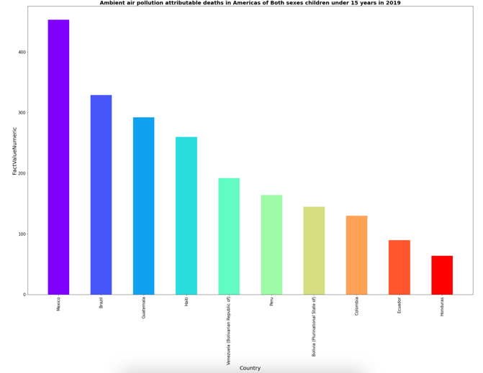

Figure 5 illustrates the children deaths occurred in Americas by the respective gender. The Y axis values are adjusted such that the graphs are well spread. It is seen that Mexico has shown many deaths while Honduras being the lowest.

Figure Ambient air pollution attributable deaths in Eastern Mediterranean children under 15 years in 2019. Male (left), Female (middle), Both sexes (right)

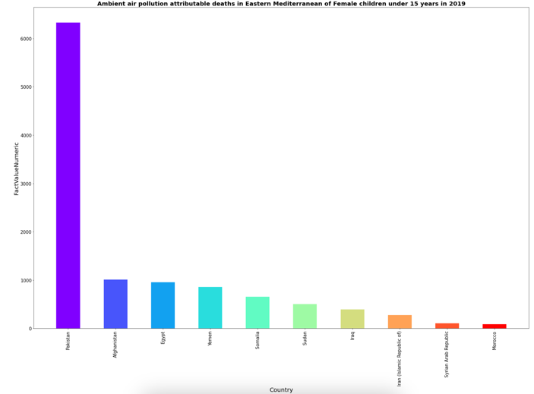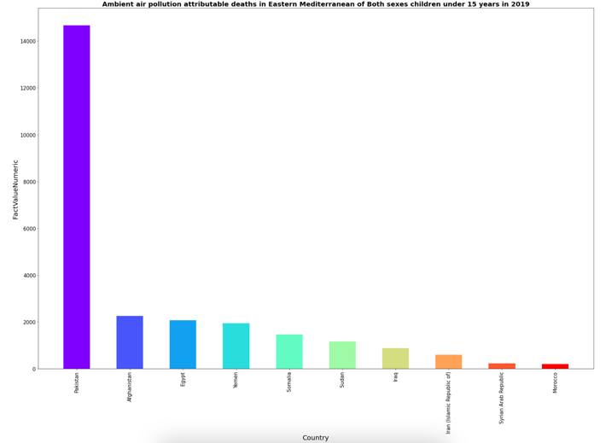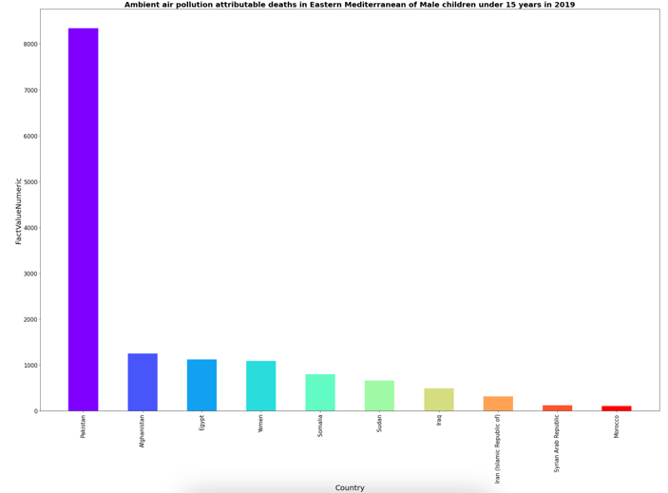

Figure 6 illustrates the children deaths occurred in Eastern Mediterranean by the respective gender. The Y axis values are adjusted such that the graphs are well spread. It is seen that Pakistan has shown many deaths while Morocco being the lowest.

Figure Ambient air pollution attributable deaths in Europe children under 15 years in 2019. Male (left), Female (middle), Both sexes (right)

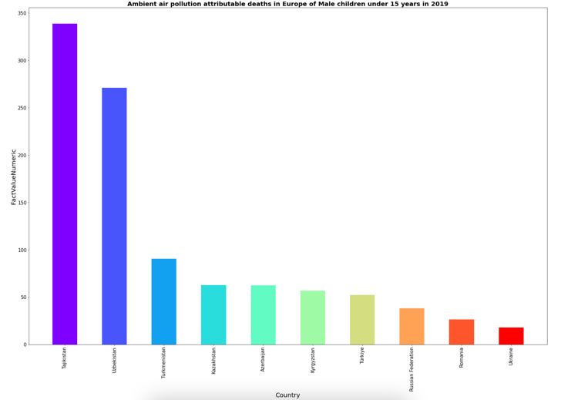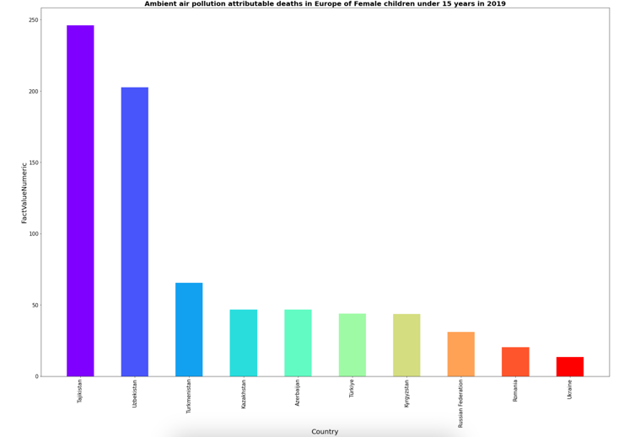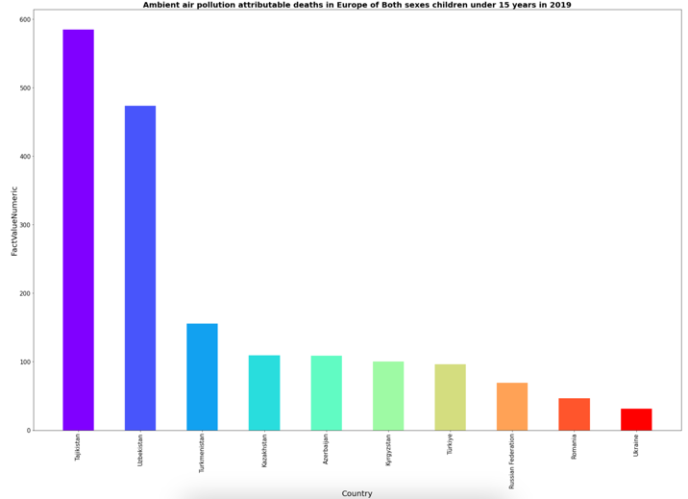

Figure 7 illustrates the children deaths occurred in Europe by the respective gender. The Y axis values are adjusted such that the graphs are well spread. It is seen that Tajikistan has shown many deaths while Ukraine being the lowest.

Figure Ambient air pollution attributable deaths in South-East Asia children under 15 years in 2019. Male (left), Female (middle), Both sexes (right)

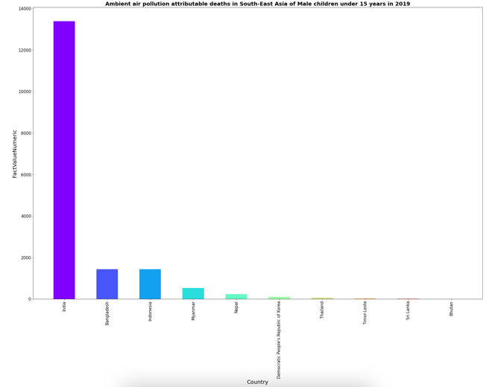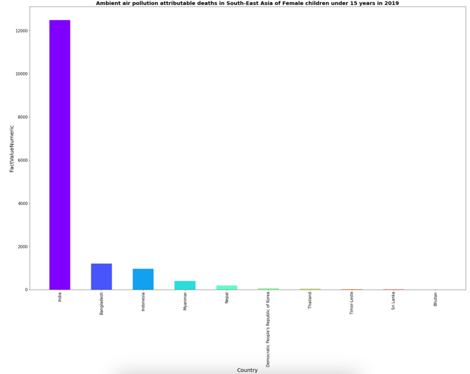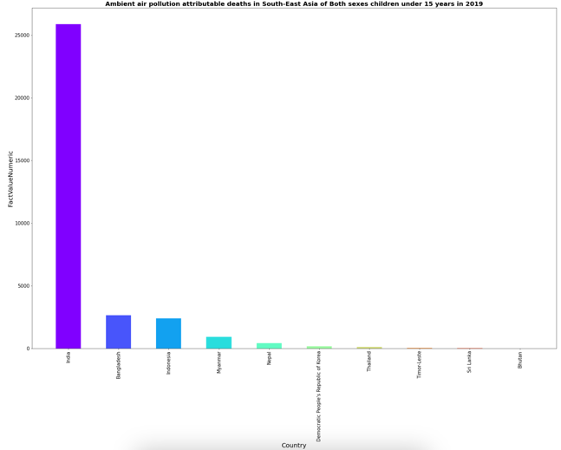

Figure 8 illustrates the children deaths occurred in South East Asia by the respective gender. The Y axis values are adjusted such that the graphs are well spread. It is seen that India has shown many deaths while Bhutan being the lowest.

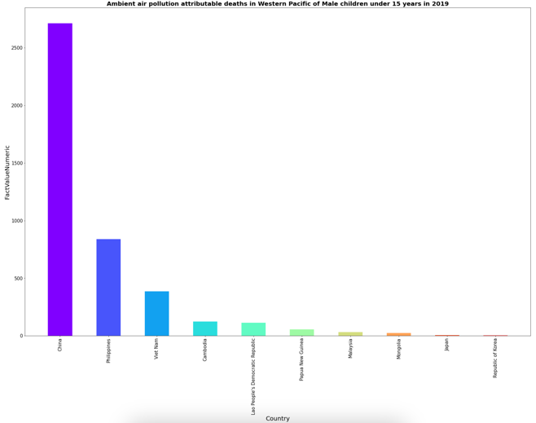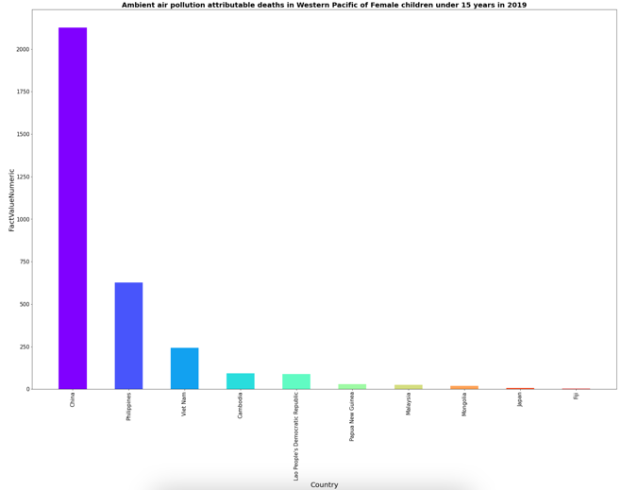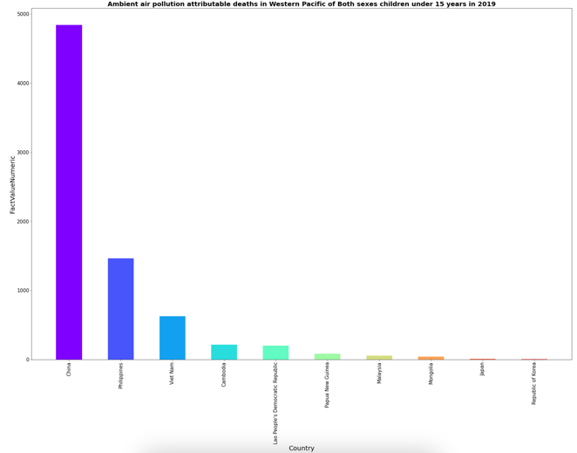

Figure Ambient air pollution attributable deaths in Western Pacific children under 15 years in 2019. Male (left), Female (middle), Both sexes (right)

Figure 9 illustrates the children deaths occurred in Western Pacific by the respective gender. The Y axis values are adjusted such that the graphs are well spread. It is seen that China has shown many deaths while Republic of Korea being the lowest.